**Lesson 8 Activity:**

**Joining 3 or More Tables**

For every request, show the code for the query, any code calling it, the results below, and a listing of the records so we can see what happened to the data.

1. Display all records and fields for the Cars table.  
   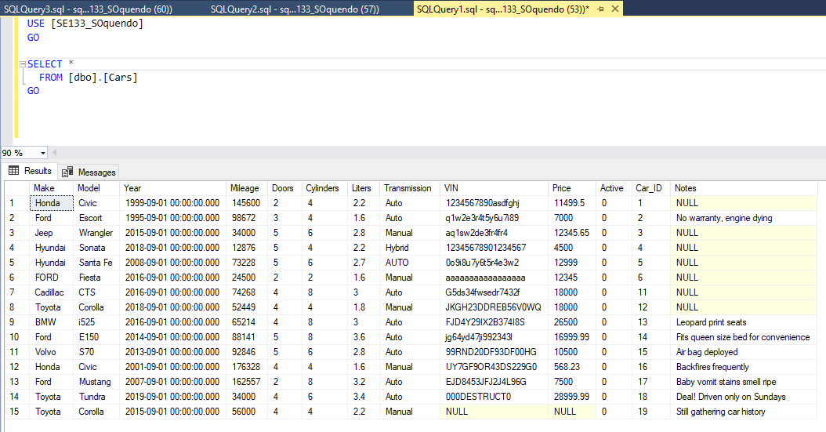
2. Display all records for the CarBuyers table.  
   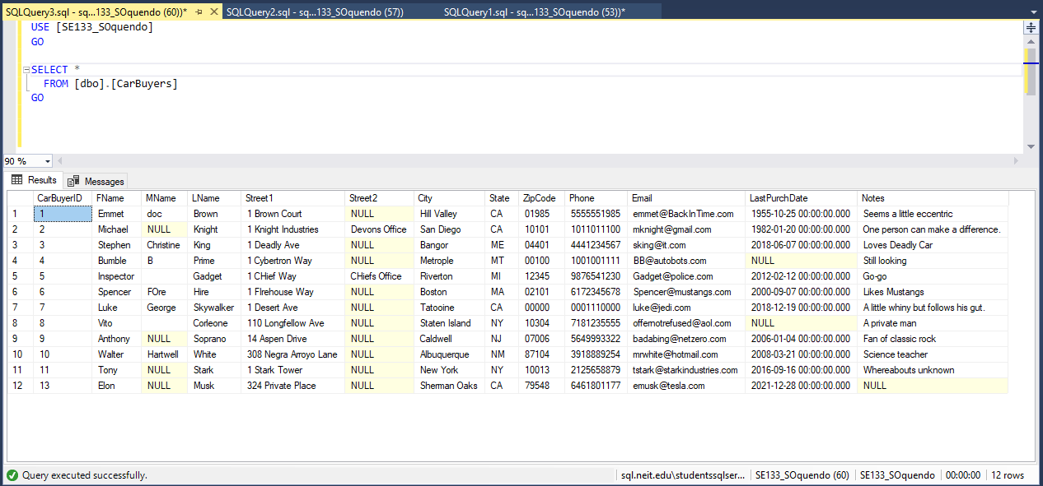
3. Display all records for the CarPurchases table.  
   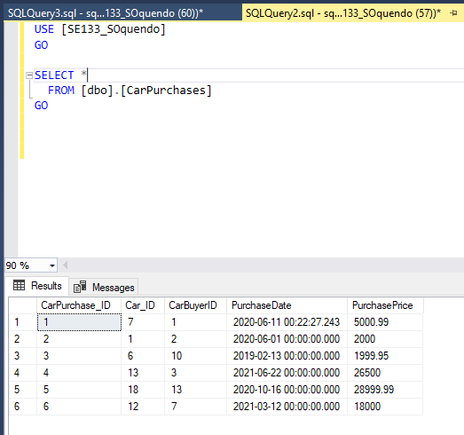
4. Car Recall Phase 1: Use the Cars table to find all Hyundai, Honda, and Toyota Vehicles.  
   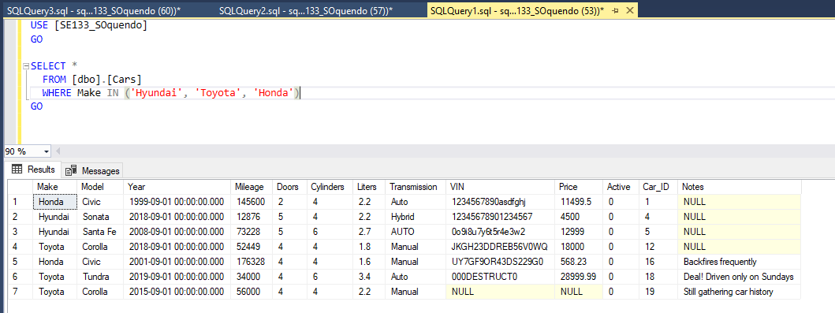
5. Car Recall Phase 2: Starting with the query created in #4, add an Inner Join with the CarPurchases table to find the purchases that involved the specified Makes. List as much info about the purchase, as well as the Make, Model, Year, VIN.  
   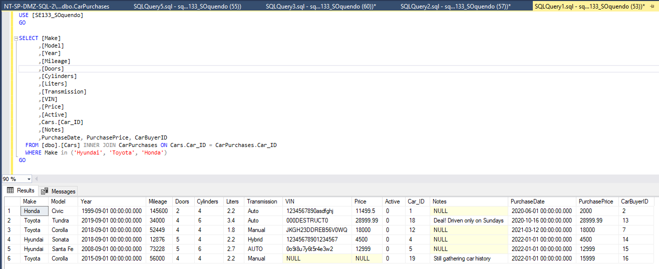
6. Car Recall Phase 3: Starting with the query created in #5, add another Inner Join with the CarBuyers table to add the buyers’ contact info.

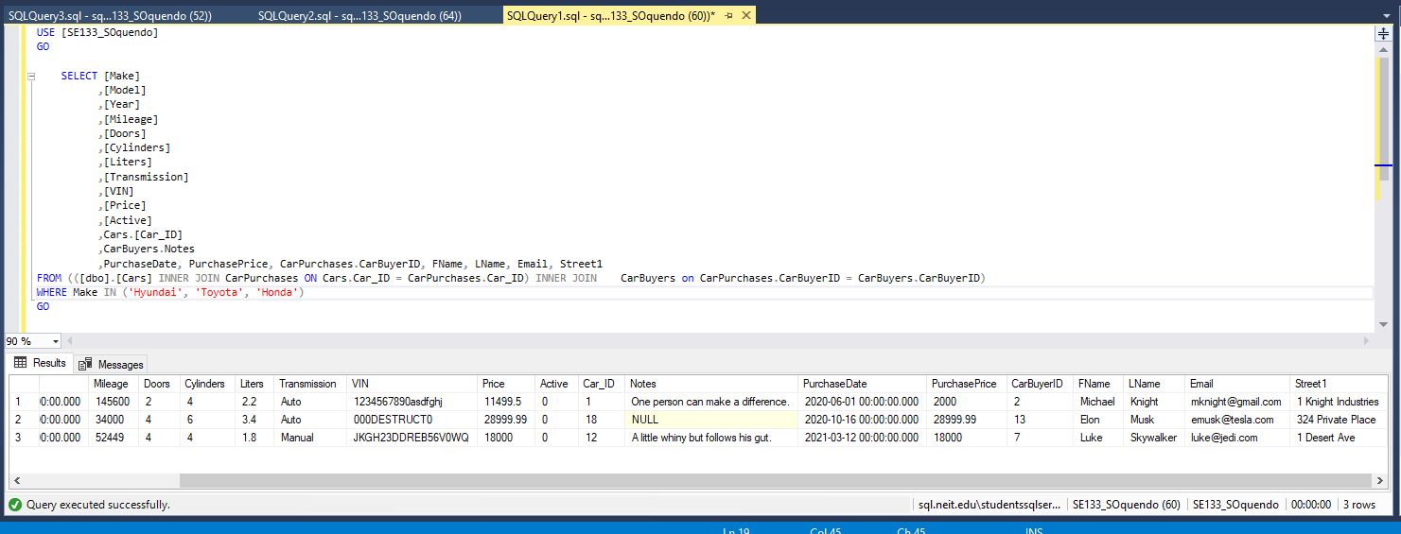

1. Group Discussion and Response: 3 customers in our grocery store have all gotten sick. We want to find all possible information that can connect our 3 customers that got sick. How would you solve the following issue? (Explain in your own words.  Do not try to write the SQL Code, because you do not have the exact data for this scenario.)   Break down the steps and list out factors that these customers could have in common.

* **I’d start by searching for customer IDs and which days they made purchases. Next, I’d check if any of them were in the store at the same time, opening the possibility that they infected each other, however likely or unlikely. Following that, I’d check individual purchase items and look for any of the same products they may have purchased. Assuming it was a result of a bad batch of a specific product, I’d go on to search lot numbers for that product to check if it was a random occurrence or all their products originated from the same place/batch and place a recall on those items.**