**Lab 6: Joining Multiple Tables to Get Usable Data**

For every request, show the code for the query, any code calling it, the results below, and a listing of the records so we can see what happened to the data.

1. Display all records and fields for the Products table.  
   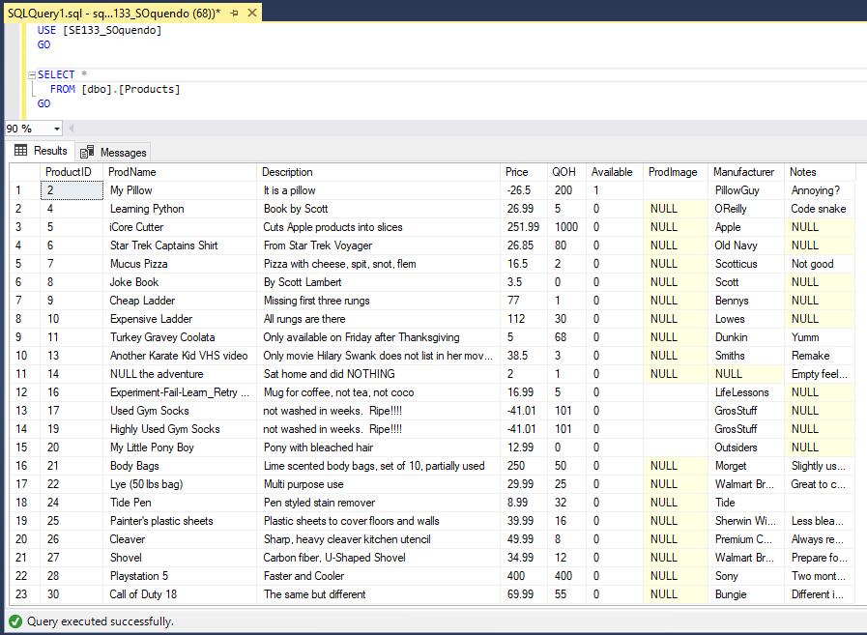
2. Display all records and fields for the Purchases table.   
   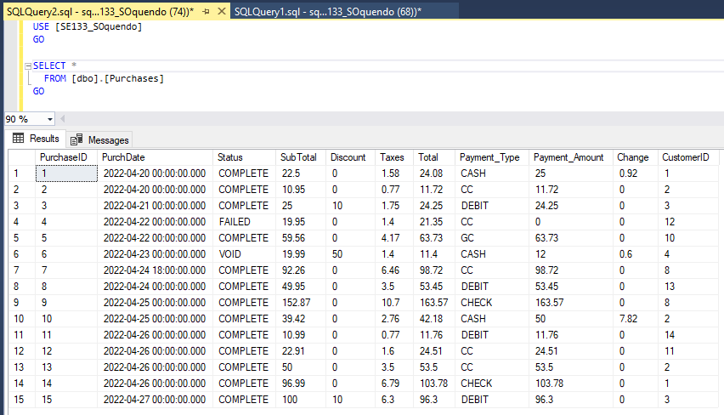
3. Display all records and fields for the PurchasedProducts table.  
   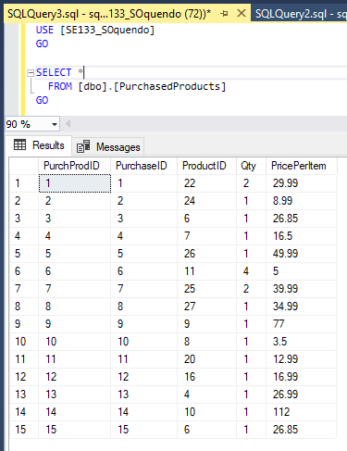
4. Display all records and fields for the Customers table.  
   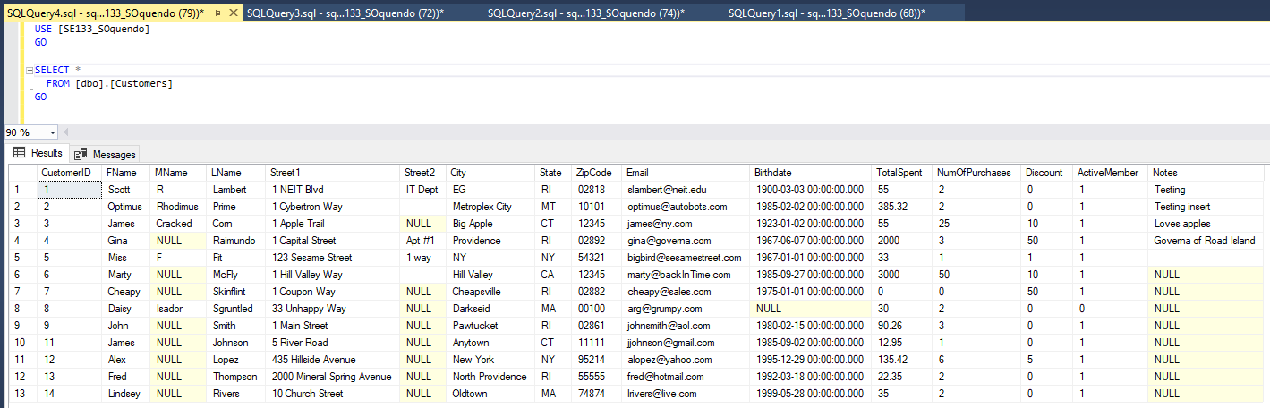
5. Basic Receipt: Create a query that receives a Purchase_ID and selects the basic purchase information for the purchase within the Purchases table.

Wasn’t clear on if you meant to create an SP to “receive” any purchaseID later on or just searching for one ‘manually’ so I did both

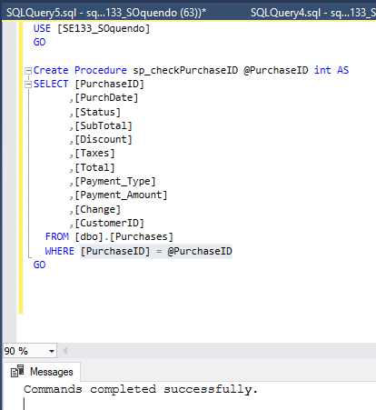

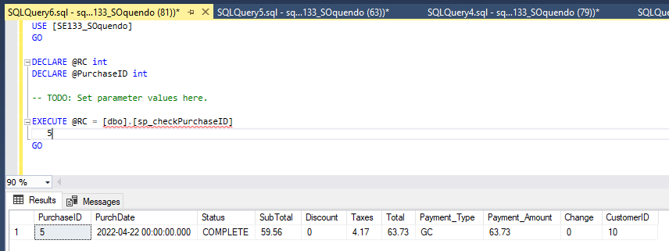

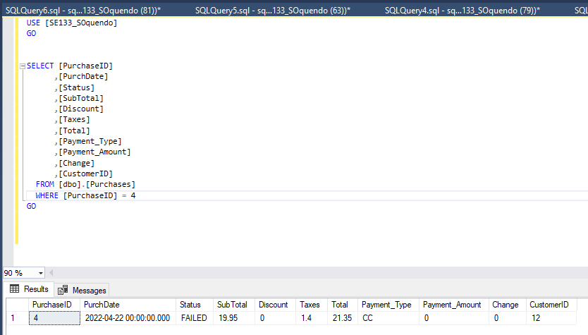

1. Receipt with Customer Info: Building on the query from #5, add one Inner Join to gather information about the Customer that made this purchase, such as First Name, Last Name, Email Address, Total number of purchases and Total dollar amount spent, from the Customers table.

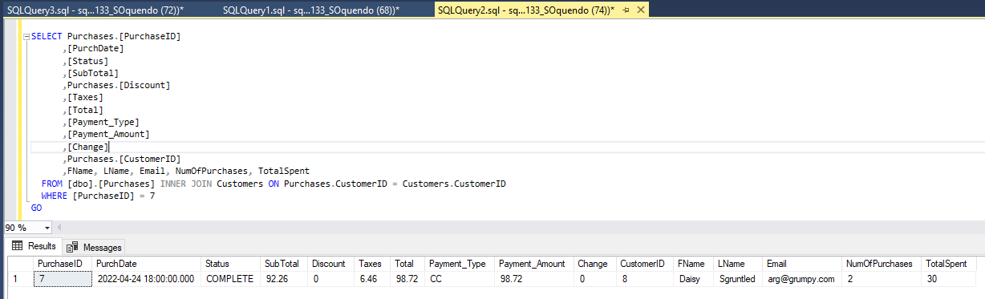

Receipt with ID’s of Purchased Items: Building on the query from #6, add another Inner Join to get information about each of the Products purchased, such as Product ID, Quantity, Price per item. (I am not asking for product names…yet.)  
USE [SE133_SOquendo]

GO

SELECT Purchases.[PurchaseID]

,[PurchDate]

,[Status]

,[SubTotal]

,Purchases.[Discount]

,[Taxes]

,[Total]

,[Payment_Type]

,[Payment_Amount]

,[Change]

,Purchases.[CustomerID]

,FName, LName, Email, NumOfPurchases, TotalSpent, ProductID, Qty, PricePerItem

FROM ((([dbo].[Purchases] INNER JOIN Customers ON Purchases.CustomerID = Customers.CustomerID)

INNER JOIN PurchasedProducts On Products.ProductID = PurchasedProducts.ProductID)

INNER JOIN Purchases on PurchasedProducts.PurchaseID = Purchases.PurchaseID)

WHERE Purchases.[PurchaseID] = 7

1. GO
2. Receipt with Product names: Building on the query from #7, add another Inner Join to get the name of each product being bought within the current purchase. This join will be with the Products table.
3. Lost & Found: A member of the cleaning crew for our store returns a diamond ring they found on the floor this morning. The last time the floor was swept was just before the store opened yesterday, so we know this ring was lost yesterday. Pick a date that purchases were made in your purchases table, and find all customers that made purchases on that date as well as their contact information. You will need to use an inner join to accomplish this.
4. Inventory Control: Create one query using one or more inner joins to create a list of all products, and their information, that matches all the following criteria:  
   * Have a QOH less than 40  
   * AND Purchased within a year of the current day  
   * AND people bought more than 1 at a time