Republic of the Philippines

Laguna States Polytechnic University

Province of Laguna

***CONNECTING JOMALIG: BRIDGING THE DIGITAL DIVIDE IN QUEZON PROVIDING FREE INTERNET ACCESS TO UNDERSERVED COMMUNITIES IN JOMALIG, QUEZON***

A Project Proposal in Networking presented to the Faculty of

College of Computer Studies

Laguna State Polytechnic University

Siniloan Campus

In Partial Fulfillment of the Requirements for the

Subject of ITEP 309 – Networking II

By:

Ricky Jhon V. Tayam – Project Leader

Kyla Marie G. Laco – Project Researcher

Adviser

Mr. Jemar A. Banawa

December 2023

**TABLE OF CONTENTS**

1. **FESIBILITY STUDY**

Situation in which the Project Exists ............................................................................ **4**

Network Scope ............................................................................................................. 5

Objective of the Network ............................................................................................. 5

Intended User ............................................................................................................... 6

Design Assumptions ..................................................................................................... 6

Study Methodology ...................................................................................................... 6

Potential Benefits of Free Wi-Fi Network ................................................................... 7

1. **NETWORK NEED ANAYLSIS**

Reliability Requirements .............................................................................................. **8**

Transmission Speed Requirements .............................................................................. 8

Security Requirements ................................................................................................. 8

Existing Network .......................................................................................................... 8

1. **HIGH-LEVEL NETWORK DESIGN**

Geographical Map of Jomalig Island ........................................................................... **9**

Geographical Map of Barangay Bukal, Jomalig Quezon ........................................... 10

Barangay Bukal Physical Network Infrastructure .................................................. 11

Geographical Map of Barangay Apad, Jomalig Quezon .............................................12

Barangay Apad Physical Network Infrastructure ................................................... 13

Barangay Bukal Network Design Diagram ................................................................ 13

Barangay Apad Network Design Diagram ..................................................................18

1. **DETAILED DESIGN DOCUMENTATION**

WS-C3650-24PS-S Catalyst 3650 Multilayer Switch Quezon .................................. **23**

ASA5505-SSL10-K8 Firewall ................................................................................... 24

TP-Link Archer C4000 AC4000 MU-MIMO Tri-Band WiFi Router ....................... 24

Huawei B315Bs-936(ALTERNATIVE) .................................................................... 27

HP 8300 USFF Computer Desktop PC ...................................................................... 28

HP EliteBook x360 (4SU65UT) Laptop .................................................................... 29

TIA/EIA-568-B.2-1: Patch Cable ............................................................................... 30

TP-Link EAP225-Outdoor Omada ............................................................................. 31

1. **COST-BENEFITS ANALYSIS**

Cost Analysis Table ................................................................................................... **32**

Benefits Analysis Table ............................................................................................. 33

Cost Benefits Ratio ..................................................................................................... 34

1. **CONCLUSION** ......................................................................................................... **34**
2. **RECOMMENDATION** ........................................................................................... **34**
   1. **FEASIBILITY STUDY**

**Situation in which the Project Exists**

The absence of internet connectivity has had a significant impact on the lives of residents in Jomalig. Many communities do not have access to the internet, or their connectivity is slow and unreliable. This lack of access has made it difficult for residents to access online resources and services, such as healthcare information, educational materials, and job opportunities. Without access to these resources, residents are at a disadvantage compared to those who have reliable internet connectivity (United Nations Development Programme, 2018).

The lack of internet connectivity has also hindered collaboration and knowledge sharing between different communities and sectors in Jomalig. Without reliable connectivity, people find it challenging to communicate, share information, and work together on common goals. This has led to a lack of coordination and cooperation between different groups, which has further hindered the development of the region. (Asian Development Bank, 2019)

The high cost of internet services in Jomalig is also a significant barrier for many residents. The necessary equipment and subscription fees can be prohibitively expensive, which has led to a digital divide between those who have access to the internet and those who do not. This divide has further exacerbated the challenges faced by underserved communities in Jomalig. (Pew Research Center, 2018).

The lack of local technical expertise in Jomalig hinders the maintenance of reliable internet connectivity, causing increased costs and delays in repairs. The complex nature of internet infrastructure also increases vulnerability to service gaps and delays. Financial constraints also pose a significant burden, potentially impacting internet quality and accessibility. To overcome these challenges, innovative financing models or public-private partnerships are needed to secure long-term funding and promote reliable connectivity for underserved communities in Jomalig.(Department of Information and Communications Technology, 2019).

In the final analysis, the lack of reliable internet connectivity in Jomalig, Quezon has had a significant impact on the lives of residents, hindering access to essential resources and services, collaboration and knowledge sharing, and economic opportunities. The absence of local technical expertise, high costs of internet services, and complex infrastructure have further exacerbated these challenges. To address these issues, a proposal for providing free internet access to underserved communities in Jomalig is presented. This proposal aims to promote digital inclusion, reduce inequality, and facilitate access to essential resources and services. However, innovative financing models or public-private partnerships are needed to secure long-term funding and promote reliable connectivity for underserved communities in Jomalig. By addressing these challenges, we can promote sustainable development and improve the quality of life for residents in Jomalig.

**Network Scope**

The proposed network is designed to serve the residents of 2 Baranggay in Jomalig, Quezon which is Baranggay Bukal and Baranggay Apad. The Baranggay Bukal has 3 buildings and 1 school, the estimated distance from Barangay Bukal Elementary School to the church is around 240 meters, to Barangay Bukal Hall is around 230 meters, to Barangay Bukal Health Center is around 200 meters, and to the town plaza is around 700 meters. These distances are only estimated and may vary depending on the route taken.

While the Baranggay Apad has 2 buildings and 1 school, the estimated distances from Baranggay Apad Elementary School to the Apad Baranggay Hall is around 140 meters, to Apad Town Plaza is around 1500 meters, and the distance between the Health Center is not indicated.

**Objective of the Network**

* To provide universal access to high-speed and reliable internet connectivity to all communities in Jomalig, Quezon, regardless of their location or socioeconomic background.
* To eliminate the digital divide in Jomalig by ensuring that all residents have access to affordable and reliable internet services.
* To improve access to online resources and services, including healthcare information, educational materials, and job opportunities.
* To have maintenance and support for the internet infrastructure in Jomalig, the proposed network will prioritize the recruitment and training of local technical personnel.

**Intended User**

The network primarily serves the residents of Baranggay Bukal, which has a population of 1,296, and Barangay Apad, with a population of 1,597. These individuals rely on the network for various communication and connectivity needs, including accessing essential services, conducting business, and staying connected with their communities. As such, it is crucial to ensure that the network infrastructure is robust and capable of meeting the demands of these populations. Additionally, understanding the specific requirements and usage patterns of these users can help in tailoring the network services to better serve their needs and enhance their overall quality of life.

**Design Assumptions**

The island community will have a reliable and high-speed internet network built using a mix of wired and wireless technologies. Wired connections will be provided through fiber optic cables, connecting key locations like schools, hospitals, and government buildings. Wireless connections will be used to reach remote areas, such as rural areas, using Wi-Fi and 4G/LTE technologies. A firewall will be installed at the network's edge to protect user data and prevent unauthorized access. The network will be scalable and flexible, using modular components and open standards. Redundancy and backup systems will ensure the network remains operational in case of failures or disruptions. This approach will provide a robust and reliable internet infrastructure, promoting economic development by providing businesses with the necessary connectivity and improving access to education, healthcare, and other essential services.

**Study Methodology**

To adequately conduct this analysis, analysts undertook the following tasks:

* Conduct a survey of residents in Jomalig to determine their current level of internet access, usage patterns, and needs.
* Collect data on internet service providers (ISPs) operating in Jomalig, including their coverage areas, service packages, and pricing.
* Develop a cost-benefit analysis of different options for providing free or subsidized internet access.
* Analyzing the existing infrastructure in Jomalig, such as power lines and communication tower, to determine the feasibility of different internet connectivity solutions.
* Monitoring and evaluating the impact of the solution on the community’s access to internet services, as well as any unintended consequences or negative impacts that may arise.

**Potential Benefits of Free Wi-Fi Network**

* Ensuring universal access to high-speed and reliable internet connectivity across all communities in Jomalig, Quezon, fosters inclusivity and equality. This connectivity serves as a fundamental utility, empowering residents to engage in the digital world, regardless of their geographical location or socioeconomic status.
* By eliminating the digital divide in Jomalig, the network promotes social equity. Affordable and reliable internet services become a catalyst for equal opportunities, bridging gaps between different economic strata. This not only empowers individuals but also contributes to the overall development of the community.
* Improving access to online resources, such as healthcare information, educational materials, and job opportunities, has a cascading effect on the overall well-being of the community. Residents gain the ability to pursue education, access essential health services, and explore employment opportunities, thereby contributing to the holistic development of Jomalig.
* The proposed network in Jomalig aims to provide reliable and sustainable internet connectivity to underserved communities. It addresses the lack of local technical expertise, reduces service gaps, and promotes cost-effectiveness. It also focuses on local skill development, economic opportunities, and digital inclusion, ensuring long-term reliability and sustainability.
  1. **NETWORK NEED ANALYSIS**

**Reliability Requirements**

* Uptime of 99.9% or higher.
* Regular maintenance and monitoring to identify and address issues quickly. Equipment built to withstand typhoons and heavy rains.
* Scalable infrastructure to handle peak traﬃc volumes.

**Transmission Speed Requirements**

* Ensure a minimum download speed of 10 Mbps and a minimum upload speed of 5 Mbps to meet the demands of online activities like video streaming, online learning, and e-commerce.
* Optimize the network infrastructure to handle high traﬃc volumes, particularly during peak hours.
* Delivering reliable speeds for a positive user experience.

**Security Requirements**

* The network must use a strong password to protect the user data and prevent the eavesdropping.
* Block unauthorized access to the network.
* Use the user authentication to verify user identity for secure access control.

**Existing Network**

* No existing network infrastructure
  1. **HIGH-LEVEL NETWORK DESIGN**

**Geographical Map of Jomalig Island**

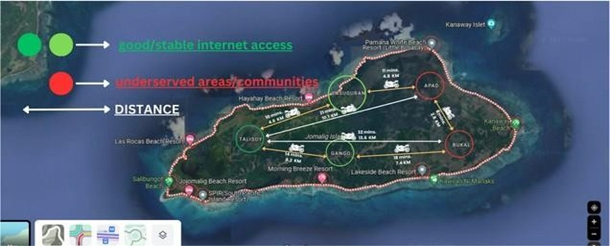

**Figure 1:** Geographical Map of Jomalig Island

The geographic map of Jomalig Island shows areas with good or stable internet access and areas that are underserved. The map also shows the distances between some important areas of the island. Looking at the geographic map of Jomalig Island, you can see that areas with good/stable internet access are concentrated in the central and southern parts of the island. The most underserved areas are in the northern part of the island.

The map shows that there is a digital divide on Jomalig Island. Residents of areas with good or stable internet access have access to a wide range of educational, economic, and social opportunities. Residents of underserved areas do not have the same access to these opportunities

**Geographical Map of Barangay Bukal, Jomalig Quezon**

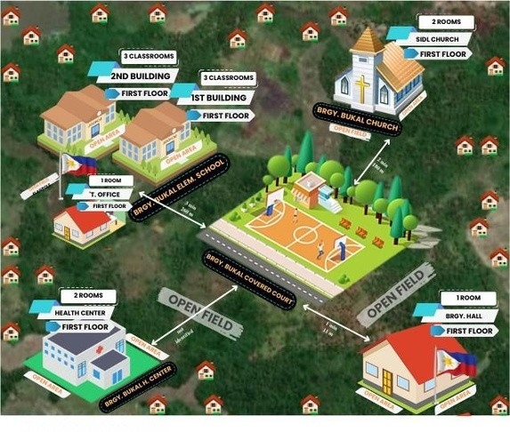

**Figure 2:** Geographical Map of Barangay Bukal

Barangay Bukal, located in the northern part of Jomalig Island in Quezon. As depicted on the geographic map illustration, Barangay Bukal is situated in a less developed area compared to the central and southern parts of the island. This lack of development is reflected in the limited infrastructure and resources available in the area, which has resulted in poor internet connectivity.

The map highlights the distances between some major areas within Barangay Bukal, providing insight into the physical layout of the community. The map shows that Barangay Bukal is surrounded by water on three sides, with only one land route connecting it to the rest of Jomalig Island. This geographic isolation has further contributed to the community's lack of access to modern amenities, including reliable internet connectivity.

The map also reveals that Barangay Bukal is relatively small in size, with a population density that is lower than other areas on Jomalig Island. This low population density may explain why internet service providers have not prioritized investing in infrastructure in this area. However, this lack of investment has left the community at a disadvantage, as residents struggle to access essential services such as online education and telemedicine.

**Barangay Bukal Physical Network Infrastructure**

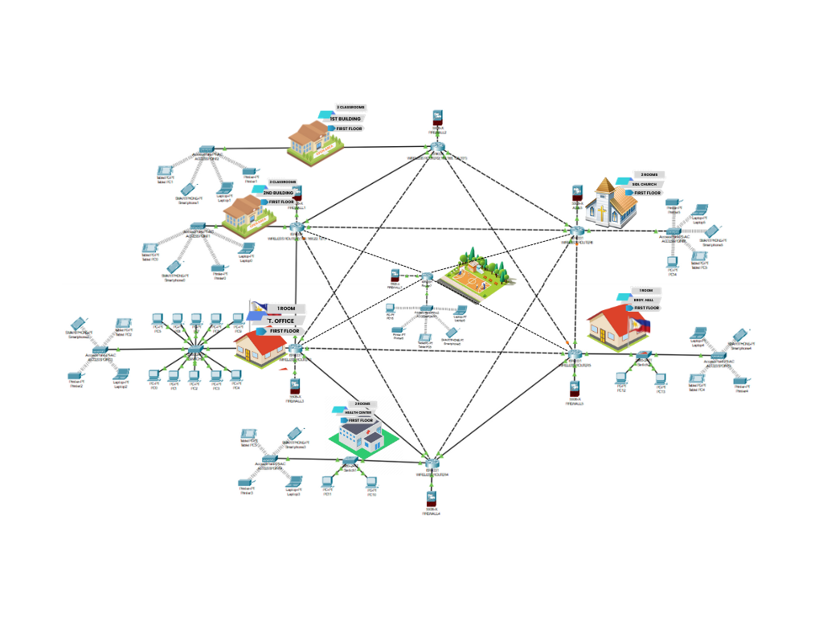

**Figure 2.1:** Barangay Bukal Physical Network Infrastructure

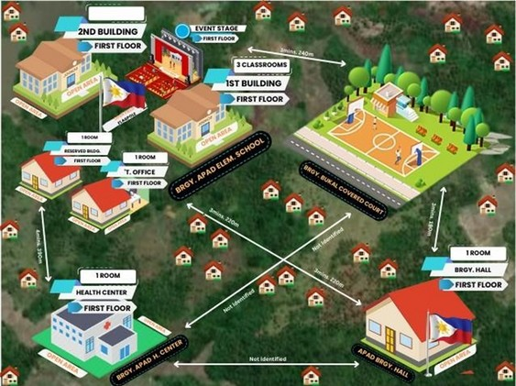**Geographical Map of Barangay Apad, Jomalig Quezon**

**Figure 3:** Geographical Map of Barangay Apad

The geographic map illustrations provided can be a valuable resource for residents of Barangay Apad in Jomalig, Quezon, as they help to identify the locations of free WiFi hotspots in the area. These hotspots are typically installed in public places such as the Barangay Hall, Elementary School, and Health Center, which are all situated in the central part of the barangay.

The distance to these locations from any point in Barangay Apad may vary depending on the specific location of the resident. However, as they are all located in the central part of the barangay, they are likely to be within walking distance for most residents. This makes it easy for people to take advantage of these free WiFi hotspots and enjoy faster and better connectivity in their daily lives.

**Barangay Apad Physical Network Infrastructure**

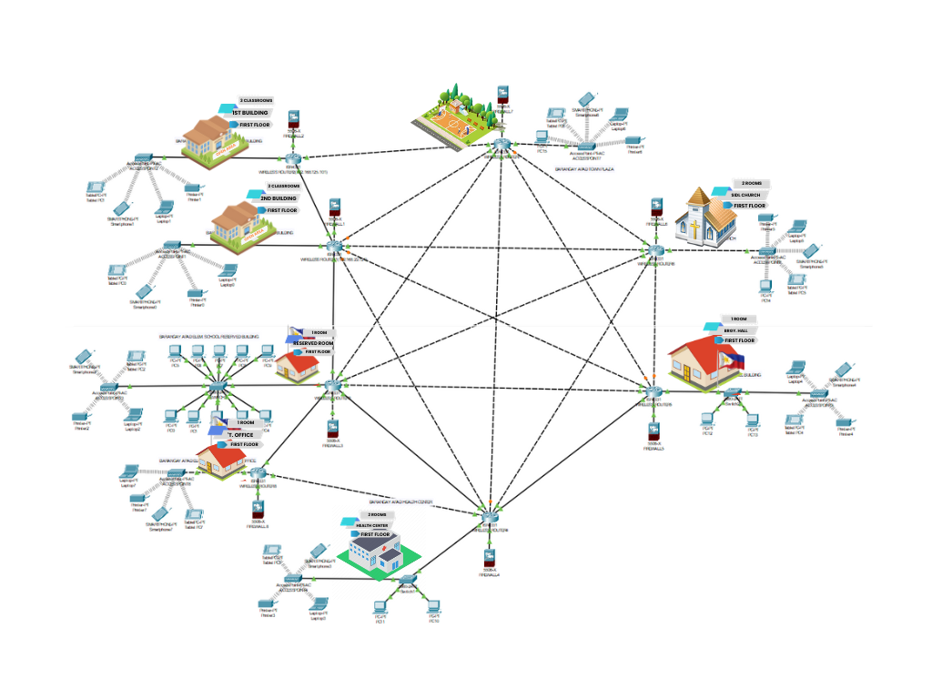

**Figure 3.1:** Barangay Apad Physical Network Infrastructure

**Barangay Bukal Network Design Diagram**

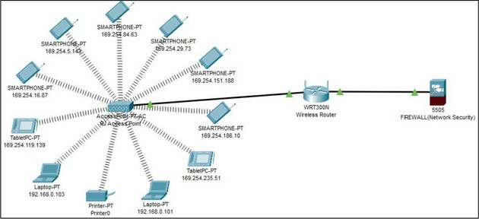**Barangay Bukal Elementary School 1st Building Network Diagram**

**Figure 1:** Barangay Bukal Elementary School 1st Building Network Diagram

The network design diagram aims to enhance wireless connectivity at Barangay Bukal Elementary School's first building, providing uninterrupted internet access for students and teachers. Key components include strategically placed access points, a central router for eﬃcient data flow, and a firewall for protection against unauthorized access and malicious online threats. The router manages network traﬃc, prioritizing critical data and ensuring all devices have access to the necessary bandwidth.

The wireless network infrastructure ensures reliable, high-speed internet access, allowing students and teachers to utilize digital learning resources and collaborate seamlessly in the classroom. The strategic placement of access points and central router ensure the network's security, eﬃciency, and scalability for future growth.

**Barangay Bukal Elementary School 2nd Building Network Diagram**

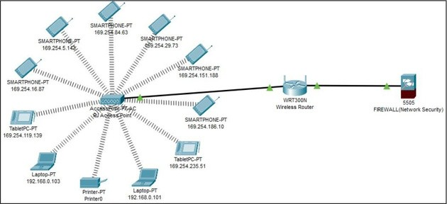

**Figure 2:** Barangay Bukal Elementary School 2nd Building Network Diagram

In this figure, all students and teachers at Barangay Bukal Elementary School "2ND BUILDING" are to have seamless and dependable wifi connectivity due to the proposed wireless network architecture. The network will be made up of carefully positioned access points that will form a wireless network that covers the entire school and guarantee constant internet access. By serving as the traﬃc director, the central router will reduce latency and enhance network performance in general.

Additionally, a firewall will protect the network from unauthorized access and malicious online threats, safeguarding sensitive student and school data. This wireless network design is tailored to meet the demands of a modern learning environment, where digital devices and online resources are integral components of teaching and learning. It will provide reliable, high-speed wireless connectivity that supports digital devices, online resources, and collaborative learning experiences.

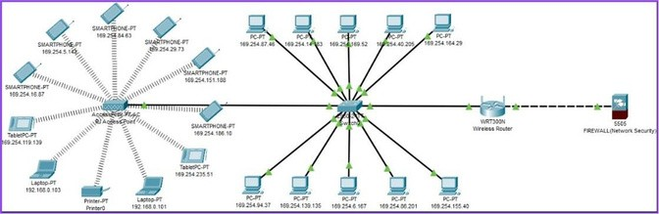**Barangay Bukal Elementary School Teacher's Oﬃce Network Diagram**

**Figure 3:** Barangay Bukal Elementary School Teacher's Oﬃce Network Diagram

The diagram illustrates the internal network setup in a teacher's oﬃce, a crucial part of the school's network infrastructure. It includes desktop computers, printers, and possibly a server, all interconnected via a central switch or router for wired and wireless communication. Desktop computers are used for tasks like lesson planning, grading, and student record management. Printers are connected via Ethernet cables or wireless connections, enabling direct printing without external storage.

A server may be a central hub for storing and sharing resources, connected via high-speed connections for eﬃcient access. The internal network setup enables teachers to carry out their teaching duties eﬃciently, ensuring seamless connectivity and reliable communication between devices and the internet.

**Barangay Bukal Health Center Network Diagram**

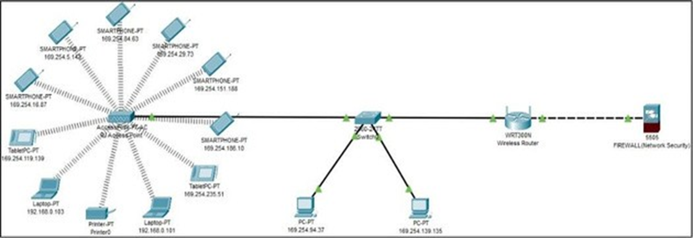

**Figure 4:** Barangay Bukal Health Care Network Diagram

The Barangay Bukal Health Center network layout includes a central device that connects all devices, facilitating eﬃcient communication and data transmission. Computers, including those used by healthcare professionals and administrative staff, are connected via Ethernet cables or Wi-Fi, running software applications like EHRs and medical imaging software. Printers enable easy printing of medical reports and prescriptions.

Medical equipment, such as blood pressure monitors and ECG machines, can also be connected through specialized interfaces or wireless communication protocols. Personal devices like smartphones and tablets can also be connected to the network, facilitating seamless integration and collaboration

**Barangay Bukal Hall Building Network Diagram**

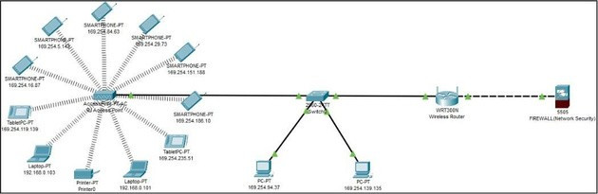

**Figure 5:** Barangay Bukal Hall Building Network Diagram

The Barangay Bukal Hall Building network design consists of a central switch or router as the backbone, connecting all devices in the building. This router manages and distributes network traﬃc, ensuring each device receives the necessary bandwidth and resources. Administrative staff use desktop computers for accounting, human resources, and oﬃce work, connected via Ethernet cables.

Printers and servers store and manage important data. Staff members can connect to the network using Wi-Fi or Ethernet cables, facilitating seamless integration and communication. The design aims to provide reliable and secure connectivity, enabling eﬃcient administrative operations for the community it serves.

**Barangay Bukal Town Plaza Network Diagram**

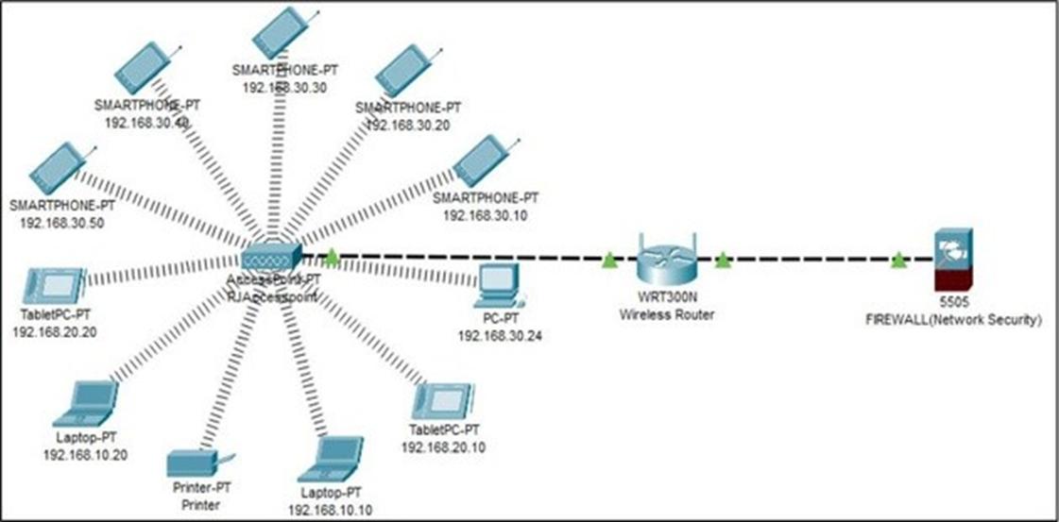

**Figure 6:** Baranggay Bukal Town Plaza Network Diagram

In this diagram, a router is a central hub that connects multiple devices to the internet and local networks. It receives incoming and outgoing traﬃc and determines the best path for data transmission based on factors like network congestion and bandwidth. Each device is assigned a unique IP address, which allows communication with other devices and external networks.

Access points like Wi-Fi routers or Ethernet switches extend the network's reach and allow devices to connect wirelessly or via Ethernet cables. A firewall is a security device that filters incoming and outgoing traﬃc, preventing security threats like malware infections, denial-of-service attacks, and unauthorized access attempts.

**Barangay Apad Network Design Diagram**

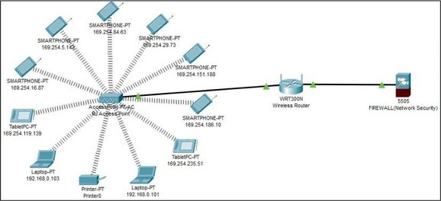**Barangay Apad Elementary School 1st Building Network Diagram**

**Figure 1:** Baranggay Apad Elementary School 1st Building Network Diagram

The network design diagram aims to enhance wireless connectivity at Barangay Apad Elementary School's first building, providing uninterrupted internet access for students and teachers. Key components include strategically placed access points, a central router for eﬃcient data flow, and a firewall for protection against unauthorized access and malicious online threats. The router manages network traﬃc, prioritizing critical data and ensuring all devices have access to the necessary bandwidth.

The wireless network infrastructure ensures reliable, high-speed internet access, allowing students and teachers to utilize digital learning resources and collaborate seamlessly in the classroom. The strategic placement of access points and central router ensure the network's security, eﬃciency, and scalability for future growth.

**Barangay Apad Elementary School 2nd Building Network Diagram**

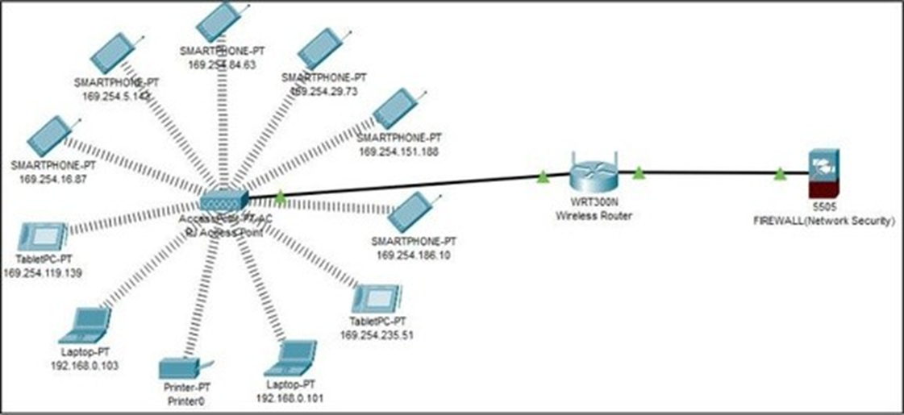

**Figure 2:** Baranggay Apad Elementary School 2nd Building Network Diagram

In this figure, all students and teachers at Barangay Apad Elementary School 2nd building are to have seamless and dependable wifi connectivity due to the proposed wireless network architecture. The network will be made up of carefully positioned access points that will form a wireless network that covers the entire school and guarantee constant internet access. By serving as the traﬃc director, the central router will reduce latency and enhance network performance in general.

Additionally, a firewall will protect the network from unauthorized access and malicious online threats, safeguarding sensitive student and school data. This wireless network design is tailored to meet the demands of a modern learning environment, where digital devices and online resources are integral components of teaching and learning. It will provide reliable, high-speed wireless connectivity that supports digital devices, online resources, and collaborative learning experiences.

**Barangay Apad Elementary School Reserved Building Network Diagram**

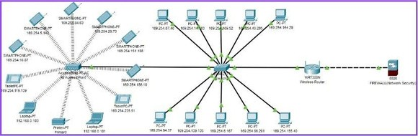

**Figure 3:** Baranggay Apad Elementary School Reserved Building Network Diagram

The Baranggay Apad Elementary School Reserved Building Network Diagram illustrates a well-designed and secure network that caters to the connectivity requirements of its users. The network consists of various devices, including smartphones, laptops, desktop PCs, and a printer, all interconnected through a wireless router and a firewall. The network is segmented into two primary segments, the Faculty and Staff network and the Pupils and Teachers network, each with its own IP address range. This segmentation helps in managing bandwidth allocation and enhancing security by separating faculty/staff traﬃc from pupil/teacher traﬃc.

The firewall provides protection against external threats and manages traﬃc flow between segments. Additionally, the wireless router provides centralized internet access for the entire network. The use of private IP addresses for the network suggests that it is an internal network. The specific model of firewall, Cisco ASA 5505, indicates that it is a popular choice for small to medium-sized businesses.

## Barangay Apad Elementary School Teacher's Oﬃce Network Diagram

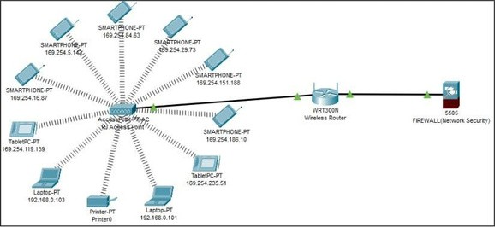

**Figure 4:** Baranggay Apad Elementary School Teacher's Oﬃce Network Diagram

The diagram illustrates the internal network setup in a teacher's oﬃce, a crucial part of the school's network infrastructure. It includes desktop computers, printers, and possibly a server, all interconnected via a central switch or router for wired and wireless communication. Desktop computers are used for tasks like lesson planning, grading, and student record management. Printers are connected via Ethernet cables or wireless connections, enabling direct printing without external storage.

A server may be a central hub for storing and sharing resources, connected via high-speed connections for eﬃcient access. The internal network setup enables teachers to carry out their teaching duties eﬃciently, ensuring seamless connectivity and reliable communication between devices and the internet.

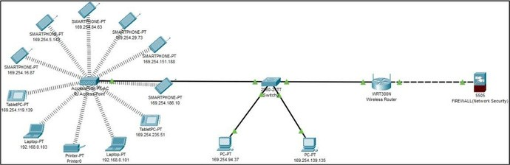**Barangay Apad Hall Building Network Diagram**

**Figure 5:** Baranggay Apad Hall Building Network Diagram

The Barangay Apd Hall Building network design consists of a central switch or router as the backbone, connecting all devices in the building. This router manages and distributes network traﬃc, ensuring each device receives the necessary bandwidth and resources. Administrative staff use desktop computers for accounting, human resources, and oﬃce work, connected via Ethernet cables.

Printers and servers store and manage important data. Staff members can connect to the network using Wi-Fi or Ethernet cables, facilitating seamless integration and communication. The design aims to provide reliable and secure connectivity, enabling eﬃcient administrative operations for the community it serves.

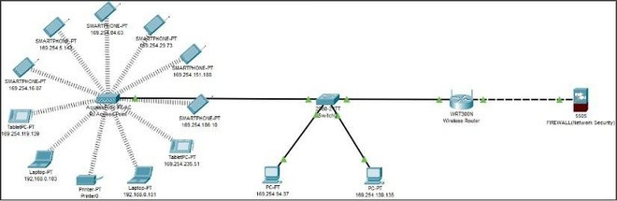**Barangay Apad Healthcare Center Network Diagram**

**Figure 6:** Barangay Apad Healthcare Center Network Diagram

The Barangay Bukal Health Center network layout includes a central device that connects all devices, facilitating eﬃcient communication and data transmission. Computers, including those used by healthcare professionals and administrative staff, are connected via Ethernet cables or Wi-Fi, running software applications like EHRs and medical imaging software. Printers enable easy printing of medical reports and prescriptions.

Medical equipment, such as blood pressure monitors and ECG machines, can also be connected through specialized interfaces or wireless communication protocols. Personal devices like smartphones and tablets can also be connected to the network, facilitating seamless integration and collaboration

**Barangay Apad Town Plaza Network Diagram**

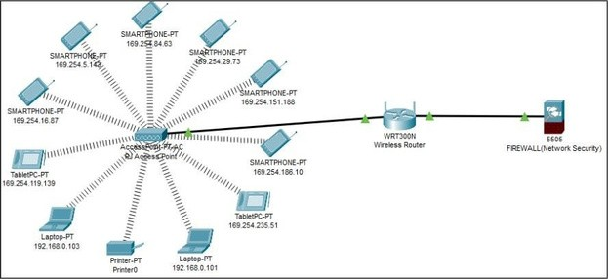

**Figure 7:** Baranggay Apad Town Plaza Network Diagram

In this diagram, a router is a central hub that connects multiple devices to the internet and local networks. It receives incoming and outgoing traﬃc and determines the best path for data transmission based on factors like network congestion and bandwidth. Each device is assigned a unique IP address, which allows communication with other devices and external networks.

Access points like Wi-Fi routers or Ethernet switches extend the network's reach and allow devices to connect wirelessly or via Ethernet cables. A firewall is a security device that filters incoming and outgoing traﬃc, preventing security threats like malware infections, denial-of-service attacks, and unauthorized access attempts.

* 1. **DETAILED DESIGN DOCUMENTATION**

|  |  |  |
| --- | --- | --- |
| **PRODUCT** | **DESCRIPTION/SPECS** | **AMOUNT** |
| **WS-C3650-24PS-S Catalyst 3650 Multilayer Switch**    **Image source:** [https://www.router-](https://l.facebook.com/l.php?u=https%3A%2F%2Fwww.router-switch.com%2Fws-c3650-24ps-s-p-5426.html%3Ffbclid%3DIwAR0870TJ_rNq-Z2Gu9CaIRT27wlIaO2lIOqgT_cRlp-yq4m75epgGhmd6m8&h=AT1hoEcvd9XdFG4zJ3qSPAV4nh5E2eB6aUrOBTANGhyN9HyLCIAHNrbhhDDvobe0ad9HFzIpfJWfVsqsBPGNR-d2csr4fgBwIab0ssq_xFoMeFCXBzgLq0m2XuDqRJHkfpMghw) [switch.com/ws-c3650-24ps-s-p-](https://l.facebook.com/l.php?u=https%3A%2F%2Fwww.router-switch.com%2Fws-c3650-24ps-s-p-5426.html%3Ffbclid%3DIwAR0870TJ_rNq-Z2Gu9CaIRT27wlIaO2lIOqgT_cRlp-yq4m75epgGhmd6m8&h=AT1hoEcvd9XdFG4zJ3qSPAV4nh5E2eB6aUrOBTANGhyN9HyLCIAHNrbhhDDvobe0ad9HFzIpfJWfVsqsBPGNR-d2csr4fgBwIab0ssq_xFoMeFCXBzgLq0m2XuDqRJHkfpMghw) [5426.html](https://l.facebook.com/l.php?u=https%3A%2F%2Fwww.router-switch.com%2Fws-c3650-24ps-s-p-5426.html%3Ffbclid%3DIwAR0870TJ_rNq-Z2Gu9CaIRT27wlIaO2lIOqgT_cRlp-yq4m75epgGhmd6m8&h=AT1hoEcvd9XdFG4zJ3qSPAV4nh5E2eB6aUrOBTANGhyN9HyLCIAHNrbhhDDvobe0ad9HFzIpfJWfVsqsBPGNR-d2csr4fgBwIab0ssq_xFoMeFCXBzgLq0m2XuDqRJHkfpMghw)  The Cisco Catalyst 3650-24PS- S is a versatile and reliable networking solution for organizations looking to enhance their network infrastructure. | * The WS-C3650-24PS-S Catalyst 3650 Multilayer Switch is a high- performance switch designed to provide reliable and secure network connectivity. It offers a range of features suitable for the project's goal of bridging the digital divide in Jomalig, Quezon. * Port Type: 24 x 10/100/1000 (POE+) + 4 x 1G SFP * Power over Ethernet (PoE): Supports PoE, allowing for the delivery of power to connected devices such as access points or IP cameras. * Switching Capacity: 88Gbps * VLAN Support: Supports VLANs to segregate and manage network traﬃc effectively. * Management: Offers management capabilities for configuration, monitoring, and control of the network. Security Features: Provides security features like access control lists (ACLs) and port security to protect the network. * Stacking: Supports stacking for scalability and simplified management. | PHP 176,066.07 |
| **ASA5505-SSL10-K8 Firewal**    **Image Source:**  [https://www.amazon.ca/Cisco-](https://www.amazon.ca/Cisco-ASA5506-SEC-BUN-K8-5506-X-FirePOWER-Services/dp/B00X8CG2G8?fbclid=IwAR17VhMw0tb3ik5cF1Y7mqk8Jc-xwLxEbJEAPMkXDEEeU2Nm514xvpvWVKk)  [ASA5506-SEC-BUN-K8-5506-X-](https://www.amazon.ca/Cisco-ASA5506-SEC-BUN-K8-5506-X-FirePOWER-Services/dp/B00X8CG2G8?fbclid=IwAR17VhMw0tb3ik5cF1Y7mqk8Jc-xwLxEbJEAPMkXDEEeU2Nm514xvpvWVKk)  FirePOWER-[Services/dp/B00X8CG2G8](https://www.amazon.ca/Cisco-ASA5506-SEC-BUN-K8-5506-X-FirePOWER-Services/dp/B00X8CG2G8?fbclid=IwAR17VhMw0tb3ik5cF1Y7mqk8Jc-xwLxEbJEAPMkXDEEeU2Nm514xvpvWVKk)  The Cisco ASA5505-SSL10-K8 firewall is a powerful and flexible security solution for organizations looking to protect their networks and data. | * ASA 5505 VPN Edition w/ 10 SSL Users * 50 Firewall Users, DES, Cisco ASA 5500 Series VPN Edition Bundles * Special Features: FirePOWER Services (ASA5506-FPWR),Security Plus License Upgrade (ASA5506-SEC-PL) | PHP 101,250.00 |
| **TP-Link Archer C4000 AC4000 MU-MIMO Tri-Band WiFi Router**    **Image Source:** [https://www.tp-](https://www.tp-link.com/ph/home-networking/wifi-router/archer-c4000/?fbclid=IwAR18SyUAFYo-1BGKEqG5m8o3YZptIQMHpB0Yj_tojiyW8Jh8Jva7sGwMRWg) [link.com/ph/home-](https://www.tp-link.com/ph/home-networking/wifi-router/archer-c4000/?fbclid=IwAR18SyUAFYo-1BGKEqG5m8o3YZptIQMHpB0Yj_tojiyW8Jh8Jva7sGwMRWg) [networking/wifi-router/archer-](https://www.tp-link.com/ph/home-networking/wifi-router/archer-c4000/?fbclid=IwAR18SyUAFYo-1BGKEqG5m8o3YZptIQMHpB0Yj_tojiyW8Jh8Jva7sGwMRWg) [c4000/](https://www.tp-link.com/ph/home-networking/wifi-router/archer-c4000/?fbclid=IwAR18SyUAFYo-1BGKEqG5m8o3YZptIQMHpB0Yj_tojiyW8Jh8Jva7sGwMRWg)  The TP-Link Archer C4000 AC4000 MU-MIMO Tri-Band WiFi Router is a versatile and powerful networking solution for organizations looking to enhance their wireless connectivity | * Part Number: Archer C400   HARDWARE FEATURES:   * Processor: 1.8 GHz quad-core CPU and three co-processors Memory: 512 MB Standards and Protocols: 802.11a/b/g/n/ac, 802.3ab Ports: 1x 10/100/1000 WAN * 4x 10/100/1000 LAN, 1x USB 2.0, 1x USB 3.0 * 1x Power, 1x Wi-Fi On/Off, 1x WPS, 1x Reset,1x LED On/Off, LED Panel: * 1x Power, 1x 2.4 GHz, 1x 5 GHz-1, 1x 5 GHz-2, 1x Ethernet, 1x Internet, 1x WPS 1x USB 2.0, 1x USB 3.0, Weight: 1.79 lb, 0.81 kg * Dimensions ( W x D x H ): 7.9 x 7.9 x 1.5 in Dimensions: 200 x 200 x 39 mm * Antenna 6 external antennas, Wi-Fi Chipset Features MU-MIMO, Beamforming Airtime Fairness * RangeBoost NitroQAM   **WIRELESS FEATURES**   * Signal Rate: 750Mbps @ 2.4GHz 1625Mbps @ 5GHz 1625Mbps @ 5GHz   **SOFTWARE FEATURES**   * System Tools: Time Settings Diagnostics * Fw OTA Upgrade Config backup/restore Administration Syslog SNMP * Statistics LED Control * Basic Function: Network Map (Internet Status / Client List / Speedtest) Internet Settings * Wireless Settings * USB Sharing Settings (USB Storage Sharing / FTP Server / Print Server / Media Server) HomeCare (Parental Control / Antivirus / QoS) * Guest Network Settings TP-Link Cloud Settings * Multiple Languages Protocols: IPv4, IPv6 * Advanced Functions: Working Mode (Router Mode or AP Mode) Wireless Schedule * Time Machine TP-Link DDNS Parental Controls/Antivirus/QoS IPv6 VPN Server (OpenVPN and PPTP Servers) * NAT Forwarding (DMZ / UPnP), Link Aggregation (WAN / LAN) Airtime Fairness, Smart Connect * Supported Operating Systems OS Independent, Up to Windows 10, Mac OS 10.12 and Linux   **SECURITY:**   * Attack Defense: Malicious Content Filter * Intrusion Prevention System, Infected Device Quarantine Access Control: Device- based whitelist/blacklist * Wi-Fi Security: Open * WEP, WPA-PSK, WPA2-PSK * Firewall Features: Malicious Content Filter Intrusion Prevention System Infected Device Quarantine   OTHERS:   * Smartphone/Tablet Requirements Andriod 4.1 or higher Windows PCs iOS 8 or higher Certifications FCC CE CE DFS * Power Supply: 100-240V 50/60Hz ENVIRONMENT: * Operating Temperature: 0~40(32~104) * Storage Temperature: -40~70(-40~158) * Operating Humidity: 10%~90% non-condensing | PHP 14, 690.00 |
| **Huawei B315Bs-936(ALTERNATIVE)**    **Image Source:** [https://easy-](https://l.facebook.com/l.php?u=https%3A%2F%2Feasy-firmware.com%2Fsolution%2Fen%2F2020%2F03%2F01%2Ffirmware-huawei-b315s-607%2F%3Ffbclid%3DIwAR1g1CkvDGRcM_13BD5JAx0OjYP0Gc5IWsFICvKEPb-2Oqzhh7SyNGPwzC4&h=AT1hoEcvd9XdFG4zJ3qSPAV4nh5E2eB6aUrOBTANGhyN9HyLCIAHNrbhhDDvobe0ad9HFzIpfJWfVsqsBPGNR-d2csr4fgBwIab0ssq_xFoMeFCXBzgLq0m2XuDqRJHkfpMghw)  [firmware.com/solution/en/2020/03](https://l.facebook.com/l.php?u=https%3A%2F%2Feasy-firmware.com%2Fsolution%2Fen%2F2020%2F03%2F01%2Ffirmware-huawei-b315s-607%2F%3Ffbclid%3DIwAR1g1CkvDGRcM_13BD5JAx0OjYP0Gc5IWsFICvKEPb-2Oqzhh7SyNGPwzC4&h=AT1hoEcvd9XdFG4zJ3qSPAV4nh5E2eB6aUrOBTANGhyN9HyLCIAHNrbhhDDvobe0ad9HFzIpfJWfVsqsBPGNR-d2csr4fgBwIab0ssq_xFoMeFCXBzgLq0m2XuDqRJHkfpMghw)  [/01/firmware-huawei-b315s-607/](https://l.facebook.com/l.php?u=https%3A%2F%2Feasy-firmware.com%2Fsolution%2Fen%2F2020%2F03%2F01%2Ffirmware-huawei-b315s-607%2F%3Ffbclid%3DIwAR1g1CkvDGRcM_13BD5JAx0OjYP0Gc5IWsFICvKEPb-2Oqzhh7SyNGPwzC4&h=AT1hoEcvd9XdFG4zJ3qSPAV4nh5E2eB6aUrOBTANGhyN9HyLCIAHNrbhhDDvobe0ad9HFzIpfJWfVsqsBPGNR-d2csr4fgBwIab0ssq_xFoMeFCXBzgLq0m2XuDqRJHkfpMghw)  The HUAWEI B315s-607 is a convenient and versatile  networking solution for  individuals and organizations that require reliable and portable internet connectivity. | Device type: WiFi Wireless Router Category: LTE Category 4 Model: B315  Dimensions: 139 x 186 x 46 mm  **Networks:**  LTE/DC- HSPA+/HSPA+/HSPA/WCDMA/EDG E/GPRS/GSM  B315s-936: FDD 1800/2100(B1/B3) & TDD 2300/2600(B40/B41)Mhz  3G UMTS B1/B8 1900/2100Mhz, GSM B2/B3/B5/B8 850/900/1800/1900 MHz  **Download Speeds:**  TE FDD: DL 150 Mbps, 50 Mbps UL, LTE TDD DL 112 Mbps, 10 Mbps UL DC-HSPA + DL 42 Mbps, 5.76 Mbps UL  HSPA + DL 21 Mbps (64QAM) / 28 Mbps (MIMO) STREET 5.76 Mbps HSPA DL 14.4 Mbps, 5.76 Mbps UL, WCDMA PS: 384 kbps  EDGE: DL 296 kbps, 236.8 kbps UL  **Features:**  LTE 2*2 MIMO  Wi-Fi 802.11b/g/n, up to 32 users connected, intelligent Wi-Fi interference elimination algorithm, 250 meters coverage  Support VPN Passthrough, convenient for small enterprise to set up private network  4 Gigabit Ethernet port & 1 telephone port to support data service & voice service  **Ports:**  3 inputs LAN (RJ45), Port WAN / LAN (RJ45)  USB 2.0 port to support USB storage and printer  Phone port (RJ11), Two antenna connectors, The entrance to the SIM card  Indicators: Power, Connection status, Indicators Wi-Fi / WPS, LAN light, signal  Supported OS: Windows 8.1, Windows 8, Windows 7, Windows Vista SP1 / SP2, Windows XP SP3, Mac OS X 10.9, | PHP 1,999.00 |
| **HP 8300 USFF Computer**  **Desktop PC**    Image Source: [https://www.amazon.com/HP-](https://l.facebook.com/l.php?u=https%3A%2F%2Fwww.amazon.com%2FHP-Computer-Processor-Bluetooth-Wireless%2Fdp%2FB096N8LQPY%3Ffbclid%3DIwAR2PM7mJTeRY7UDT7i9cv_nBGL9VzBCABEhVmDqYCPoUHLHLkoZUQnnaNWM&h=AT1hoEcvd9XdFG4zJ3qSPAV4nh5E2eB6aUrOBTANGhyN9HyLCIAHNrbhhDDvobe0ad9HFzIpfJWfVsqsBPGNR-d2csr4fgBwIab0ssq_xFoMeFCXBzgLq0m2XuDqRJHkfpMghw) [Computer-Processor-Bluetooth-](https://l.facebook.com/l.php?u=https%3A%2F%2Fwww.amazon.com%2FHP-Computer-Processor-Bluetooth-Wireless%2Fdp%2FB096N8LQPY%3Ffbclid%3DIwAR2PM7mJTeRY7UDT7i9cv_nBGL9VzBCABEhVmDqYCPoUHLHLkoZUQnnaNWM&h=AT1hoEcvd9XdFG4zJ3qSPAV4nh5E2eB6aUrOBTANGhyN9HyLCIAHNrbhhDDvobe0ad9HFzIpfJWfVsqsBPGNR-d2csr4fgBwIab0ssq_xFoMeFCXBzgLq0m2XuDqRJHkfpMghw) [Wireless/dp/B096N8LQPY](https://l.facebook.com/l.php?u=https%3A%2F%2Fwww.amazon.com%2FHP-Computer-Processor-Bluetooth-Wireless%2Fdp%2FB096N8LQPY%3Ffbclid%3DIwAR2PM7mJTeRY7UDT7i9cv_nBGL9VzBCABEhVmDqYCPoUHLHLkoZUQnnaNWM&h=AT1hoEcvd9XdFG4zJ3qSPAV4nh5E2eB6aUrOBTANGhyN9HyLCIAHNrbhhDDvobe0ad9HFzIpfJWfVsqsBPGNR-d2csr4fgBwIab0ssq_xFoMeFCXBzgLq0m2XuDqRJHkfpMghw)  The HP 8300 USFF Computer Desktop PC is a versatile desktop computer that caters to the computing needs of small businesses, professionals, and individuals requiring a reliable and eﬃcient computing platform. | * Intel Core i5 3.2GHz Processor, 8GB RAM, 120GB Solid Drive, WiFi | Bluetooth, 1080p Webcam, Wireless Keyboard & Mouse, 19 Inch Monitor, Windows 10 (Renewed). * Ram Memory Installed Size 8 GB * Operating System Windows 10 Home CPU Model Core i5 * Brand HP * CPU Manufacturer Intel Screen Size 19 Inches * Resolution 1920 x 1080 * Hard Disk Interface Solid State CPU Speed 3.2 GHz | PHP 9,997.00 |
| **XPS 13 Plus Laptop - 13th Gen Intel® Core™ i7-1360P (18 MB cache, 12 cores, up to 5.00 GHz**  **Turbo)**    Image Source:  [https://www.dell.com/en-](https://l.facebook.com/l.php?u=https%3A%2F%2Fwww.dell.com%2Fen-us%2Fshop%2Fdell-laptops%2Fxps-13-laptop%2Fspd%2Fxps-13-9315-laptop%3Ffbclid%3DIwAR0XWPeb2VdQV4TMcep2RRBTtWmN-9NZ-WGGowsl6PXtPGvmpiVSzcct_cw&h=AT1hoEcvd9XdFG4zJ3qSPAV4nh5E2eB6aUrOBTANGhyN9HyLCIAHNrbhhDDvobe0ad9HFzIpfJWfVsqsBPGNR-d2csr4fgBwIab0ssq_xFoMeFCXBzgLq0m2XuDqRJHkfpMghw)  [us/shop/dell-laptops/xps-13-](https://l.facebook.com/l.php?u=https%3A%2F%2Fwww.dell.com%2Fen-us%2Fshop%2Fdell-laptops%2Fxps-13-laptop%2Fspd%2Fxps-13-9315-laptop%3Ffbclid%3DIwAR0XWPeb2VdQV4TMcep2RRBTtWmN-9NZ-WGGowsl6PXtPGvmpiVSzcct_cw&h=AT1hoEcvd9XdFG4zJ3qSPAV4nh5E2eB6aUrOBTANGhyN9HyLCIAHNrbhhDDvobe0ad9HFzIpfJWfVsqsBPGNR-d2csr4fgBwIab0ssq_xFoMeFCXBzgLq0m2XuDqRJHkfpMghw)  [laptop/spd/xps-13-9315-laptop](https://l.facebook.com/l.php?u=https%3A%2F%2Fwww.dell.com%2Fen-us%2Fshop%2Fdell-laptops%2Fxps-13-laptop%2Fspd%2Fxps-13-9315-laptop%3Ffbclid%3DIwAR0XWPeb2VdQV4TMcep2RRBTtWmN-9NZ-WGGowsl6PXtPGvmpiVSzcct_cw&h=AT1hoEcvd9XdFG4zJ3qSPAV4nh5E2eB6aUrOBTANGhyN9HyLCIAHNrbhhDDvobe0ad9HFzIpfJWfVsqsBPGNR-d2csr4fgBwIab0ssq_xFoMeFCXBzgLq0m2XuDqRJHkfpMghw)  The Dell XPS 13 Plus Laptop with the 13th Gen Intel® Core™ i7-1360P processor is a versatile laptop that caters to the computing needs of professionals and power users in various fields such as content creation, software development, data analysis, multimedia editing, and business applications. | Processor: 13th Gen Intel® Core™ i7- 1360P (18 MB cache, 12 cores, up to 5.00 GHz Turbo)  Operating System: Dell Technologies recommends Windows 11 Pro for business  Graphics Card: Intel® Iris® Xe Graphics  Display: 13.4", FHD+ 1920x1200, 60Hz, Touch, Anti-Reflect, 500 nit, InfinityEdge  Memory :16 GB: LPDDR5, 6000 MT/s (onboard), dual-channel  Storage: 512 GB, M.2, PCIe NVMe, SSD | PHP 82,900 |
| **TIA/EIA-568-B.2-1: Patch**  **Cable (Stranded Conductor), 24 AWG x 4P(CAT6)**    **Image Source:** [https://www.amazon.com/Etherne](https://l.facebook.com/l.php?u=https%3A%2F%2Fwww.amazon.com%2FEthernet-Connector-Stranded-Unshielded-CableWholesale%2Fdp%2FB000OYHTQ0%3Fth%3D1%26fbclid%3DIwAR0870TJ_rNq-Z2Gu9CaIRT27wlIaO2lIOqgT_cRlp-yq4m75epgGhmd6m8&h=AT1hoEcvd9XdFG4zJ3qSPAV4nh5E2eB6aUrOBTANGhyN9HyLCIAHNrbhhDDvobe0ad9HFzIpfJWfVsqsBPGNR-d2csr4fgBwIab0ssq_xFoMeFCXBzgLq0m2XuDqRJHkfpMghw) [t-Connector-Stranded-](https://l.facebook.com/l.php?u=https%3A%2F%2Fwww.amazon.com%2FEthernet-Connector-Stranded-Unshielded-CableWholesale%2Fdp%2FB000OYHTQ0%3Fth%3D1%26fbclid%3DIwAR0870TJ_rNq-Z2Gu9CaIRT27wlIaO2lIOqgT_cRlp-yq4m75epgGhmd6m8&h=AT1hoEcvd9XdFG4zJ3qSPAV4nh5E2eB6aUrOBTANGhyN9HyLCIAHNrbhhDDvobe0ad9HFzIpfJWfVsqsBPGNR-d2csr4fgBwIab0ssq_xFoMeFCXBzgLq0m2XuDqRJHkfpMghw) Unshielded-CableWholesale/dp/B000OYHTQ 0?th=1  The TIA/EIA-568-B.2-1: Patch Cable (Stranded Conductor), 24 AWG x 4P(CAT6) is a versatile networking cable that caters to various applications in networking, data center, telecommunications, testing, and backup/disaster recovery scenarios. | Conductor: Stranded Bare Copper (7 x 32 AWG)  Insulation: HDPE (CMI-75E)Nominal Wall Thickness: 0.178mm, Min.  Thickness: 0.153mm, Length: 100cm Color Code:  Pair 1: Blue & White/Blue  Pair 2: Orange & White/Orange Pair 3: Green & White/Green Pair 4: Brown & White/Brown  Jacket (Grey): 75°C LSZH Compound Nominal Wall Thickness: 0.585mm Min. Thickness: 0.458mm  Overall Diameter: 5.8mm ± 0.3mm   * Electric Requirements: (Cable length: 100m) Characteristic Impedance (Zo): 85~115Ω (1~250 MHz) DC. Resistance Capacitance Unbalance: 5% * Pair-to-Ground Capacitance Unbalance: 330 pF/100m Max. Conductor Resistance: 14.00Ω/100m 20o Max. * Mutual Capacitance: 5.6nF/m Max. Spark Test: 2.5kV | PHP 5,509.01 |
| **TP – Link EAP225 – Outdoor Omada AC1200 Wireless Access Point**  AC1200 Wireless MU-MIMO Gigabit Indoor/Outdoor Access Point 1  **Image Source:** [https://www.tp-link.com/us/business-networking/omada-sdn-access-point/eap225-outdoor/](https://l.facebook.com/l.php?u=https%3A%2F%2Fwww.tp-link.com%2Fus%2Fbusiness-networking%2Fomada-sdn-access-point%2Feap225-outdoor%2F%3Ffbclid%3DIwAR27EoZ4QIcXaQKVMLgogS4cuD40wQuvTcY02opBYB0zthbdPHt6aDc1Ng0&h=AT0neqDK8uSn99RTZYW5gUVmuIJWNwdRLKqL2yZAoKGsw_nTfkt5RceUSkndifm4D3hsuevxMfUS0E_JmjUH7F6pYBahciDC-7ARlFAs_W6lDPADgVD6d2YZgBP-8ZOUmLW8vw) | * Key Specification:   Wireless Standards:   * IEEE 802.1 1ac/n/g/b/a   Frequency:   * 2.4 GHz: Up to 300 mbps * 5 GHz: Up to 867 mbps   Antenna:   * 2x internal Omni directional antennas (2.4 GHz) * 2x internal Omni directional antennas(5 GHz)   Ethernet Port   * 1x Gigabit Ethernet (RJ-45) port (Supports IEEE 802.3af/at PoE)   Power Method:   * 802.3af PoE or 24V Passive PoE   Protection:   * IP65-rated weatherproof enclosure * Built-in Omada SDN Platform * Centralized cloud Management * Dimensions: * 8.5 x 1.8 x 1.1 in(215 x 46 x 27 mm)   Mounting:   * Pole or wall mount   Management:   * Omada Cloud-Based Controller * Omada Software Controller | PHP 3,190.00 |

* 1. **COST BENEFITS ANALYSIS**

|  |  |  |  |
| --- | --- | --- | --- |
| **COST ANALYSIS** | | | |
| Tangible Costs | | | |
| **PRODUCT** | **COST** | **QUALITY** | **TOTAL** |
| WS-C3650-24PS-S Catalyst 3650 Multilayer Switch | PHP 176,066.07 | 6 | PHP 1,056,396.42 |
| ASA5505-SSL10-K8 Firewall TP-Link Archer C4000 | PHP 101,250.00 | 14 | PHP 1,417,500.00 |
| AC4000MU MIMOTri-Band WiFi Router | PHP 14, 690.00 | 13 | PHP 190,970.00 |
| HuaweiB315Bs- 936(ALTERNATIVE) | PHP 1, 999.00 | 12 | PHP 23,988.00 |
| HP 8300 USFF Computer Desktop PC | PHP 9, 997.00 | 30 | PHP 299,910.00 |
| XPS 13 Laptop 13th Gen Intel® Core™ i7-1360P (18 MB cache, 12 cores, up to 5.00 GHz Turbo) | PHP 82,900 | 2 | PHP 165,800 |
| TIA/EIA-568-B.2-1: Patch Cable (Stranded Conductor), 24 AWG x 4P(CAT6) | PHP 5, 509.01 | 6 | PHP 33,054.06 |
| TP-LinkEAP225 Outdoor Omada AC1200 Wireless Access Point | PHP 3,190.00 | 13 | PHP 41,470.00 |
| Subtotal of Tangible Cost: | | | **PHP 3,283,088.48** |

|  |  |  |
| --- | --- | --- |
| **BENEFITS ANALYSIS** | | |
| **PRODUCT** | **PRICE** |  |
| Increased Productivity | 50 * 2,893 * 12 = | 1,735,800 |
| 70 * 2,893 * 12 = | 2,430,120 |
| 90 * 2,893 * 12 = | 3,124,440 |
| 100 * 2,893 * 12 = | 3,471,600 |
| 500 * 2,893 * 12 = | 17,358,000 |
| 1500 * 2,893 * 12 = | 52,074,000 |
| Increased Security | 600 * 31 days * 12 = | 223,200 |
| Maintain Connectivity | 2127.07 * 12 = | 25,524.84 |
| Total Benefit Analysis: | | **PHP 80,442,684.84** |

* **Increased Productivity:** Without reliable internet connectivity, remote work and online learning opportunities are limited, making it challenging for residents to work from home or access educational resources. This limits the potential for increased productivity as individuals are unable to take advantage of the flexibility and convenience of remote work or online learning.
* **Increased Security:** Without secure connections, data can be easily intercepted or stolen, potentially leading to identity theft or other cybersecurity threats. This puts both individuals and organizations at risk, as they may not have access to the necessary security measures to protect their data.
* **Maintain Connectivity:** The lack of reliable internet connectivity also makes it challenging to maintain connectivity between remote workers and their teams. This can lead to communication breakdowns, delays in decision-making, and reduced productivity as team members are unable to collaborate effectively. Additionally, the lack of reliable connectivity can make it challenging for residents to access essential services such as healthcare information or job opportunities, further limiting their potential for increased productivity.

|  |  |  |
| --- | --- | --- |
| **COST BENEFITS RATIO** | | |
| Total Cost | Total Benefits | Ratio |
| **PHP 3,283,088.48** | **PHP 80,442,684.84** | **0.040** |
| * Annual benefit exceeds annualized cost. * This project is expected to pay for itself in about 12 months. * The time to functional obsolescence of the equipment is estimated at about 24 months. | | |

* 1. **CONCLUSION**

The feasibility study has determined that providing free internet access to underserved communities in Jomalig, Quezon is not only viable but also essential in bridging the digital divide in the area. The study has identified the technological and infrastructural requirements, as well as the potential socio-economic impact of such an initiative. Access to free internet can significantly enhance communication, information dissemination, and access to educational resources within the community. It can also open up opportunities for economic growth and development, thereby contributing to the overall well-being of the residents.

* 1. **RECOMMENDATION**
* Proceed with the implementation of the plan to provide free internet access to underserved communities in Jomalig, Quezon. This should involve the establishment of necessary infrastructure, such as Wi-Fi hotspots, and the provision of devices where needed.
* Collaborate with local authorities, non-governmental organizations, and telecommunication companies to ensure the sustainability and effectiveness of the project. This may involve securing partnerships for ongoing maintenance, technical support, and potential expansion of the initiative.
* Establish a comprehensive monitoring and evaluation framework to assess the impact of free internet access on the community. This will enable the identification of any challenges or areas for improvement, as well as the measurement of the project's success in meeting its objectives.
* Develop a community engagement strategy to ensure that the benefits of free internet access are maximized. This may involve providing digital literacy training, promoting responsible internet usage, and encouraging the utilization of online resources for education and entrepreneurship.
* Seek funding and support from government agencies, private sector entities, and philanthropic organizations to facilitate the successful execution of the project. This may involve presenting a detailed proposal outlining the potential impact and benefits of providing free internet access to the underserved communities in Jomalig, Quezon.