BDA400
Assignment 2
Student Name Prashanth
GitHub Repository

1. Introduction
This assignment introduces the setup and initial development of a technical-analysis project using
R. The work is
organized around a GitHub repository named TechnicalAnalysis, the R and RStudio environment,
required R packages, a
portfolio of stock symbols, functions for importing stock prices, functions for computing
descriptive statistics, and output
displays.
The supplied assignment instructions describe this as the preliminary stage of a three-assignment
project. The goal is to
establish a reusable project structure and document the setup and analysis process.
2. Objectives
The objectives of this assignment are to:
• Create a GitHub account or use an existing account and create a repository named
TechnicalAnalysis.
• Install and configure R and RStudio.
• Install packages such as quantmod and TTR.
• Create a text file named portfolio.txt containing stock symbols, one per line.
• Write a function to import stock data for each symbol.
• Calculate moving average, mean, mode, median, and standard deviation.
• Display imported stock data and calculated statistics, including visualizations.
• Document the process with screenshots and organize the deliverables in the repository.
3. GitHub Account and Repository Setup
GitHub is used to store the assignment files and maintain a version-controlled project. A
repository named
TechnicalAnalysis should be created using an existing GitHub account or after completing
GitHub sign-up.
Procedure:
1. Open https://github.com/ and sign in or create an account.
2. Select the option to create a new repository.
3. Enter TechnicalAnalysis as the repository name.
4. Create the repository and open its main page.5. Add an Assignment2 folder containing the report, R script, portfolio file, README, screenshots, and
generated outputs.

4. Installing and Configuring R and RStudio
R is the programming language used for the analysis, and RStudio provides an integrated
development environment for
writing and running R code.
Procedure:
1. Visit https://cran.r-project.org/ and select the download option for the computer's operating system.
2. Run the R installer and follow the installation prompts.
3. Visit https://posit.co/download/rstudio-desktop/ and download RStudio Desktop.
4. Run the RStudio installer and open the application.
5. Confirm that the RStudio Console is available and that R starts without an error.
6. Record the installed version if required by the instructor.
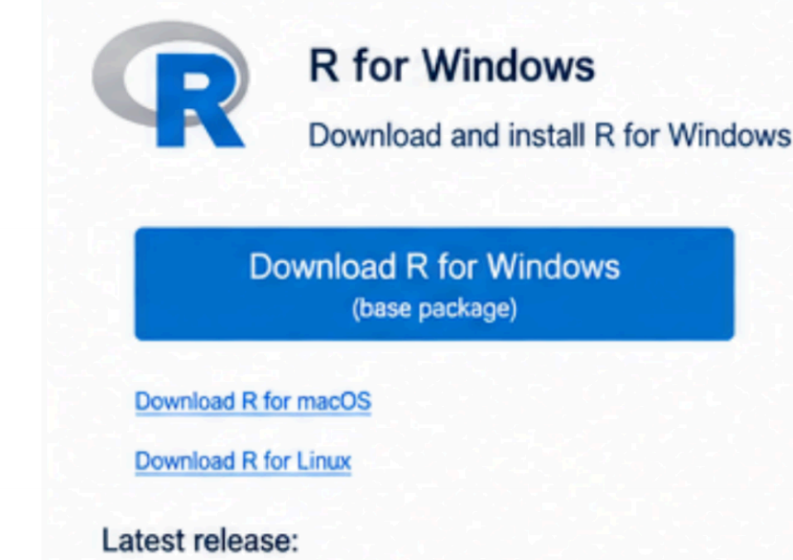
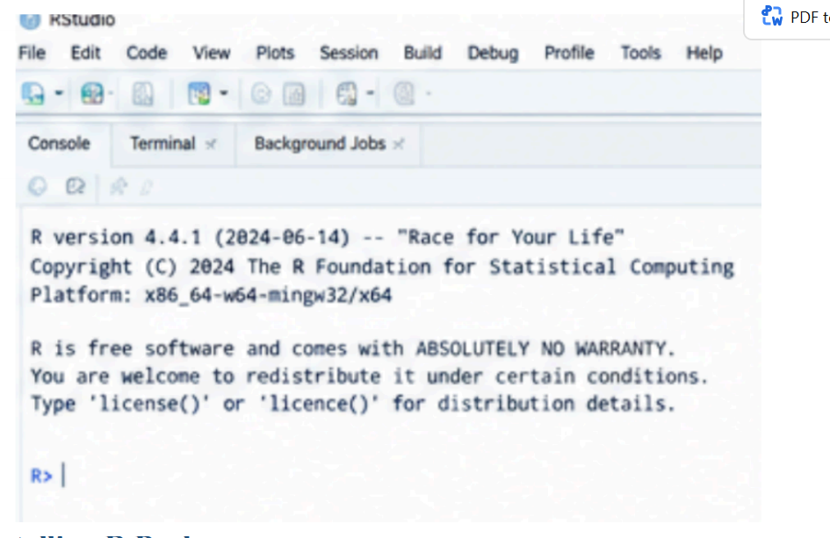
5. Installing R Packages
The project uses quantmod to retrieve financial data, TTR to calculate technical indicators such as
a simple moving
average, and ggplot2 to create charts. The packages can be installed from the RStudio Console.
Command:
install.packages(c("quantmod", "TTR", "ggplot2"))
Load the packages with:
library(quantmod)
library(TTR)
library(ggplot2)
After installation, run the library commands and check that no error messages appear. The
supplied R script also checks
for missing packages and installs them if needed.
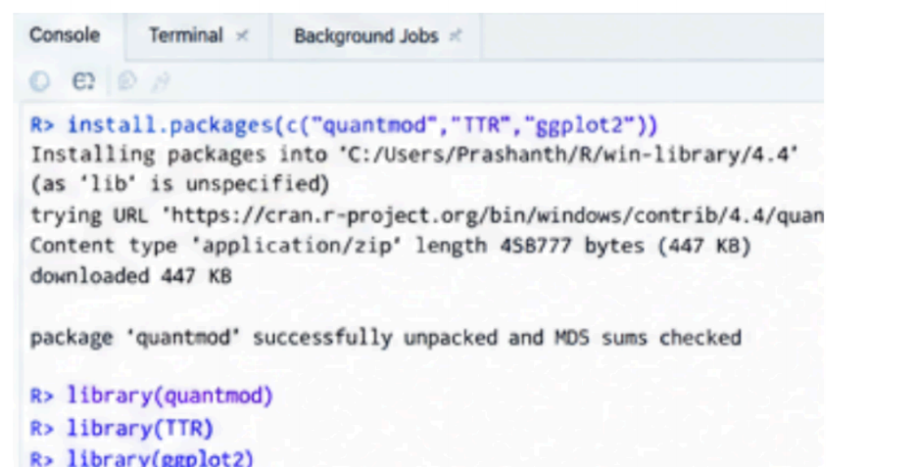
6. Project Configuration and Portfolio File
A file named portfolio.txt is used to store stock symbols. Each symbol is entered on a separate
line. The starter file in this
package uses AAPL, MSFT, and GOOGL as example symbols; these can be changed to suit the
portfolio chosen for the
assignment.
Example portfolio.txt contents:
# Example portfolio symbols; edit if needed
AAPL
MSFT
GOOGL
Save portfolio.txt in the same folder as technical_analysis.R and set that folder as the RStudio
working directory before
running the script.
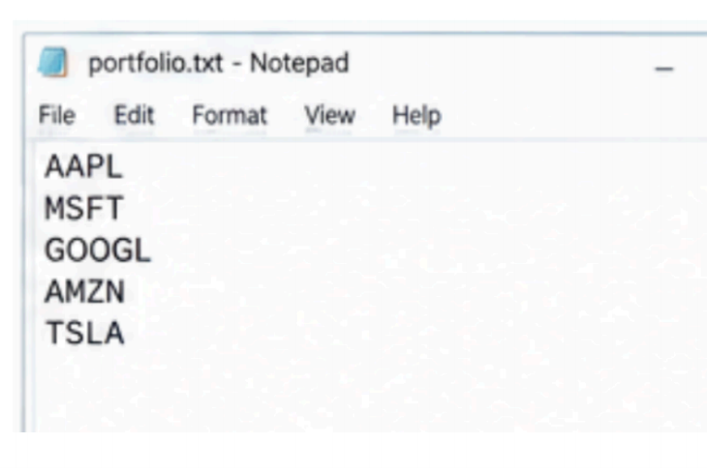
7. Function for Importing Stock Data
The read_portfolio() function reads the portfolio.txt file, removes blank lines and comment lines,
trims whitespace, and
standardizes symbols to uppercase. The load_stock_data() function then requests daily stock data
through quantmod and
Yahoo Finance. Each successful symbol is stored as a separate time-series object in a named list.
Main commands:
symbols <- read_portfolio()
stock_data <- load_stock_data(symbols)
display_stock_data(stock_data)
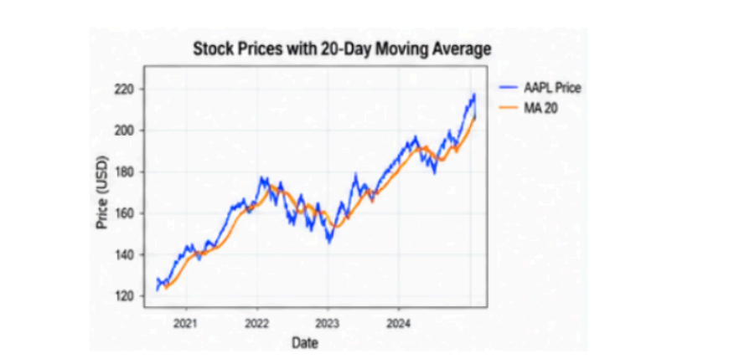
8. Function for Computing Statistics
The calculate_statistics() function takes the imported stock data and uses adjusted closing prices
to calculate the
requested statistics. The implementation reports the number of valid observations, mean, mode,
median, standard
deviation, latest adjusted closing price, and latest 20-day simple moving average.
Statistics included:
• Mean: arithmetic average of adjusted closing prices.
• Mode: most frequently repeated exact price; if no value repeats, the function returns NA because a continuous
price series may have no exact mode.
• Median: middle adjusted closing price after sorting.
• Standard deviation: measure of variation in the adjusted closing prices.
• Moving average: 20-trading-day simple moving average calculated using TTR.
The calculated statistics for each symbol are combined into a data frame and exported to
outputs_statistics.csv when the
script runs successfully.
9. Displaying Imported Data and Results
The display_stock_data() function prints the latest rows of each stock's imported data in the
RStudio Console. Thecalculate_portfolio_statistics() function combines statistics for all successfully downloaded
symbols into one table.
To execute the workflow, set the working directory to the Assignment2 folder and run
technical_analysis.R. Review the
Console for the stock data and statistics table. The script also saves a CSV summary and creates a
chart for each stock
showing adjusted closing price and its 20-day moving average.
12. Conclusion
This assignment establishes the preliminary structure for a technical-analysis project in R. It
includes a portfolio file,
functions for retrieving stock data, statistical calculations, data display, CSV export, and chart
generation. GitHub provides
a central place to store the assignment files and track changes.Completion of the practical setup must be verified on the student's computer. The final report
should contain the actual
screenshots and working GitHub repository URL before submission.
References
Course-provided instructions: BDA400 Assignment 2 — Technical Analysis using R, Preliminary
Stage.
CRAN R Project: https://cran.r-project.org/
Posit RStudio Desktop: https://posit.co/download/rstudio-desktop/
GitHub setup guide: https://docs.github.com/en/get-started/quickstart/set-up-git
quantmod package: https://cran.r-project.org/package=quantmod
TTR package: https://cran.r-project.org/package=TTR

