INDIRA GANDHI NATIONAL OPEN UNIVERSITY

­

**ONLINE MAINTENANCE MANAGEMENT SYSTEM**

By

SORABH

Under Guidance of

Raj kumar

Submitted to the School of ***UNIVERSAL INSTITUE OF COMPUTER AND TECHNOLOGY*** in partial fulfilment of the requirements for the degree of

**Masters**

**Of**

**Computer Applications**

Table of Contents

1. INTRODUCTION 3

1.1 Background 3

1.2 Objectives 3

1.3 Purpose and Scope 4

1.3.1 Purpose 4

1.3.2 Scope 4

2. SURVEY OF TECHNOLOGIES 5

2.1. Technology Explanation 6

2.2. Used Languages 7

3. REQUIREMENTS AND ANALYSIS 8

3.1. Problem Definition 8

3.2. Requirements Specification 8

3.3. Planning and Scheduling 8

3.3.2 GANTT CHART 8

3.3.2 Feacibility Studies 9

3.4. Software and Hardware Requirements 10

3.4.1. Software Requirements: 10

3.4.2. Hardware Components: 10

3.5. Preliminary Product Description 11

3.5.1. Modules 11

3.6 Conceptual Models. 12

3.6.1. DATA FLOW DIAGRAMS 12

3.6.2. ER DIAGRAM 23

3.6.3. Database Schema 24

4. REFERENCES 28

Table of Figures

Figure 1- Gantt Charts 9

Figure 2 DFD Level 0 12

Figure 3 DFD level 1 13

Figure 4 DFD Level 2 (Registration 1.0) 14

Figure 5 DFD Level 2 (Login 2.0) 15

Figure 6 DFD Level 2 (Fautl Repair Service 3.0) 16

Figure 7 DFD Level 2 (Service Subscription 4.0) 17

Figure 8 DFD Level 2 (Hire/Discharge Engineer 5.0) 18

Figure 9 DFD Level 2 (Product 6.0) 19

Figure 10 DFD Level 2 (Product Category 7.0) 20

Figure 11 DFD Level 2 (Customer Info 8.0) 21

Figure 12 DFD Level 2 (Maintenance Service 9.0) 22

Figure 13 - Entity Relationship Diagram 23

# 1. INTRODUCTION

## 1.1 Background

The “Online Maintenance Management System” has been developed to override the problems prevailing in the practicing manual system. The currently service request done manually or through phone calls, in which the customers are given choice of dates when they visit to the Service Center and it should be approved by the member of staff. If customer book their service request then they have to wait for automate machine to answer and then choose available dates. This Software can help to eliminate and in some cases reduce the hardships faced by existing system that needed to used paper work as well as human resources for entering each activity as well as executing them. The application can reduced as much as possible to avoid errors while entering the data. It also provide error message while entering invalid data. Thus by this all it proves it is user-friendly, error free, secure, reliable and fast management system. It can assist the user to concentrate on their other activities rather to concentrate on the record keeping. Thus it will help hospital in better utilization of resources.

## 1.2 Objectives

Every Service Center, whether big or small, has challenges to overcome and managing the information’s of customers, service orders, records for progress of their employees, etc. Every Electronic product have need different type of expert engineer’s, therefore we are going to design a Online Maintenance Management System that are adapted to your managerial requirements. This is designed to assist in strategic planning, and will help you ensure that your organization is equipped with the right level of information and details for future goals. The project is built at administrative end and client end, customers can register and login to access information, like list of devices, work in progress, booking of fault repair, purchase of maintenance services, etc. Administrator are responsible for entering information’s and keep track of availabilities that customer can access for requesting services for repairing their devices. It is the user friendly application for Service Center which reduces the burden and helps to manage all sections, like employees, customers, devices and Billing etc., which improve the processing efficiency.

## 1.3 Purpose and Scope

### 1.3.1 Purpose

The purpose is to provide a way to our customer to go online, by sitting at home request a fault repair service for their electrical or electronic devices or subscribe to a maintenance service for their home or business devices. We have to automate our existing manual system by the help of computerized equipment’s and full-fledged computer software, fulfilling their requirements, so that their valuable data/information can be stored for a longer period with easy accessing and manipulation of the same. Basically describes how to manage for good performance and better services for the clients.

### 1.3.2 Scope

The Customer of this system can register their information like name, address, phone number, etc. After registration customer can add their products/device details, like name, brand name, choose a category, date of purchase, serial number of device (if any), purchased price, fault description, etc. and request for services. Once order for fault repair is submitted, he will be get contacted by selected engineer, and he will visit to given address for collecting the faulty device. Once fault resolved, repaired device will be sent back to customer with bill.

The System Admin can manage customers, engineers, products and their categories from their own area. This will help to reduce extra staff needed for keeping records. Admin can get notification after login and can easily select required engineer, who can do such task. He is in control of managing this Online Maintenance System. After getting a request of required service onto a device he can easily contact the customer with their given phone number and assign a engineer to take over to fix the possible problem.

# 2. SURVEY OF TECHNOLOGIES

We are creating a ONLINE MAINTENANCE MANAGEMENT SYSTEM for Service Center, who is providing two kinds of services for electrical and electronics product such as TV, Washing Machine, Refrigerator, Air Conditioners, Air Coolers, Microwave Ovens, etc. Our System will be shared across internet to access anywhere at any point of time.

For our management system, basically three technology required :

1. **Client :** Technology for client side, frameworks those can send request or receive information from http protocol or https protocol, i.e. web browser can request to any server via different protocols like http, https, ftp, etc.

For Client side we commonly used HTML, CSS and JavaScript, those are commonly used languages and fully documented, learning those are much more easy because of all online documentation and tutorials on internet.

1. **Database :** Technology for saving data, as it is important to save records for information at some place, we can call it a database.

We have large numbers of database management system to choose from, some of are SQLite, MySQL, Oracle Express, MongoDB, etc.

1. **Server :** Technology for server side, this is a module that exist at any server that communicate on web, based on request from client side response are given.

There is also a wide range of servers available for our development process some of are IIS – Window servers, Glassfish, Tomcat, Apache, Node.js Express Server, and many more.

Why we select Apache Server?

We are selecting Apache Server on Linux platform (Apache, MySQL, PHP) stack, reason are discus below :

1. Linux Server are more secured and cheap as compare to any other servers.
2. There are full community support and updates.
3. There are many distribution available as per your needs and budgets.
4. Those are Cross Platform Compatible, means you can easily run them by setting up apache server on windows, macOS, or any other Linux distribution.
5. It is totally open-source, and completely free, we can get there full source code for further scope.
6. This is a fully secured environment due to have large community support, updates are maintained by apache federation in continuous intervals.
7. Documentation are well maintained.
8. Finding helps are much easy on different community forms like https://stackoverflow.com .

## 2.1. Technology Explanation

There are three types of webservers, each of them have their own scope of functionality, those are as mention below:

1. **Web Server :** Server on which your website is hosted. This server will have installed web servers such as IIS, apache, etc. The Web server deals with HTTP(S) requests, and passes these requests on to "handlers". They have built-in handlers for file requests - HTML pages, images, CSS, JavaScript etc. You can add additional handlers for requests that they cannot manage - e.g. dynamic pages delivered by the application server. Web servers implement the HTTP specification, and know how to manage request and response headers.
2. **Application Server** : Server on which your created applications which are utilizing your database, web service, etc. This application server will host business layer (wrapped with web services), scheduled jobs, windows services, etc. The application server handles requests which create dynamic pages. So instead of serving an HTML page that is stored on the hard drive, they dynamically generate the HTML sent to the end user. Common languages/frameworks for this are Java/JSP, .Net (aspx), PHP, Ruby (on Rails or not), Python etc. Most of the time, this application server software is running on the same physical server machine as the web server.
3. **Database Server** : Database server will have your one or more database hosted such as Oracle, Sql Server, MySQL, etc. The database server software is where the application stores its structured information. Typically, this means custom software which allows the application server to ask questions like "how many items does user x have in their basket?", using a programming language. Examples are MySQL, SQL Server, Oracle (all "relational databases"), and MongoDB, Redis and CouchDB ("NoSQL" solutions).

The database software can run on the same physical machine as the web server, but it's usually the first thing that gets hosted on separate physical hardware when the site needs to scale.

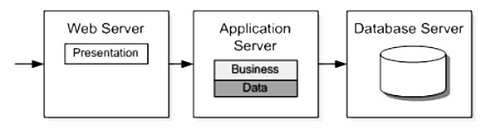

2.2. Used Languages:

1. **HTML :** We can say it as, Hypertext Markup Language. It is the set of markup symbols or codes inserted in a file intended for display on world wide web browser page. Each individual markup code is referred to as an element, many peoples also refer to as tag. Some elements comes with pairs, to define display starting position to display ending position, but there are few of them, that doesn’t follow this scenario.
2. **CSS :** It stands for Cascading Style sheets. CSS basically work is to provide look and feel to existed HTML elements. It was developed to distribute work amongs website designers and website developer. CSS saves a lot of work. It can control the layout of multiple pages all at once. There are external stylesheet as well as internal stylesheet.
3. **JavaScript :** It is a programming language commonly used in web development, also known as ECMA script. JavaScript ("JS" for short) is a full-fledged dynamic programming language that, when applied to an HTML document, can provide dynamic interactivity on websites. It was invented by Brendan Eich, co-founder of the Mozilla project, the Mozilla Foundation, and the Mozilla Corporation.
4. **PHP :** PHP originally stood for Personal Home Page, but it now stands for the recursive acronym PHP : Hypertext Pre-processor. PHP code may be embedded into HTML code, or it can be used in combination with various web template systems, web content management systems, and web frameworks.
5. **SQL :** SQL is an abbreviation for structured query language. It is a standardized query language for requesting information from a database, is a standard computer language for relational database management and data manipulation. SQL is used to query, insert, update and modify data. Most relational databases support SQL, which is an added benefit for database administrators (DBAs), as they are often required to support databases across several different platforms.

# 3. REQUIREMENTS AND ANALYSIS

## 3.1. Problem Definition

The old manual system are not much maintainable, it kinds of suffering from a series of drawbacks. Maintaining and retrieving the information was very tedious and lengthy. The records were never used to be in a systematic order, it will be lots of difficulties in associating any particular transaction with a particular context. Finding information from a room filled with entry-registers are kind of feels like a nightmare. If any information was to be fount it was required to go through the different registers, documents there would never exist anything like report generation. There would always be unnecessary consumption of time while entering records and retrieving records. One more problem was that it was very difficult to find errors while entering the records. Once the records were entered it was very difficult to update these records.

## 3.2. Requirements Specification

The proposed system has the following requirements:-

* System needs to store information about new entry of Customer & their Products/Devices.
* System needs to provide a way to customer so they can easily access to services provided by Service Center for repairing & maintenance for Electrical or Electronic devices like TV, Washing Machine, Refrigerator, Air Conditioners, Air Coolers, Microwave Ovens, etc.
* System need to also provide various maintenance contract to their customers to subscribe or purchase.
* System need to manage engineers for organization maintenance & repair team.

## 3.3. Planning and Scheduling

### 3.3.2 GANTT CHART

Gantt charts mainly used to allocate resources to activities. The resources allocated to activities include staff, hardware, and software. Gantt charts (named after its developer Henry Gantt) are useful for resource planning. A Gantt chart is special type of bar chart where each bar represents an activity. The bars are drawn along a timeline. The length of each bar is proportional to the duration of the time planned for the corresponding activity.

Gantt chart is a project scheduling technique. Progress can be represented easily in a Gantt chart, by coloring each milestone when completed. The project will start in the month of August and end after 4 months at the end of November.

|  |  |  |  |  |  |  |
| --- | --- | --- | --- | --- | --- | --- |
| Requirement Analysis |  |  |  |  |  |  |
| System Design |  |  |  |  |  |  |
| Implementation & Code |  |  |  |  |  |  |
| Testing |  |  |  |  |  |  |
| Deployment |  |  |  |  |  |  |
| Maintenance |  |  |  |  |  |  |
|  | Jul | Aug | Sep | Oct | Nov | Dec |

Figure 1- Gantt Charts

### 3.3.2 Feasibility Studies

After doing the project, study and analysing all the existing or required functionalities of the system, the next task is to do the feasibility study for the project.

The proposed solution should satisfy all the user requirements and should be flexible enough so that future changes can be easily done based on the future upcoming requirements.

#### 3.3.2.1. Economical Feasibility

* All hardware and software cost has to be minimum based on organization budget.
* We have to estimated that it will benefits the organization overall. The initial costs and the later on running cost for system will be minimum.

#### 3.3.2.2. Technical Feasibility

We have to study of function, performance and constraints that may affect the ability to achieve an acceptable system. For this feasibility study, we studied complete functionality to be provided in the system, and checked if everything was possible using different type of frontend and backend platform.

#### 3.3.2.3. Operational Feasibility

The proposed system is fully Web Based that is going to run inside of any browser, like firefox, safari, internet explorer, google chrome, etc. We will have an admin section for maintaining records so a proper training has been conducted to let know the essence of the system to the users so that they feel comfortable with new system.

## 3.4. Software and Hardware Requirements

### 3.4.1. Software Requirements:

|  |  |
| --- | --- |
| Operating System | Any of Windows, MAC, Linux Distribution (Recommended Windows 10) |
| Font End Languages & Technologies | HTML, CSS, JavaScript |
| Back End Languages & Technologies | PHP, SQL |
| Server | Any stack of (Linux, Apache, MySQL, PHP), i.e. XAMPP, WAMP, LAMP. (based on OS) |
| Code Editor | Sublime Text 3 |

### 3.4.2. Hardware Components:

|  |  |
| --- | --- |
| Processor | Inter core 2 Duo or above |
| Memory | 2 GB RAM or above |
| Cache Memory | 128 KB or above |
| Hard Disk | 30 GB or above [at least 3 MB free space required] |
| Printer | Inkjet or laser printer |

## 3.5. Preliminary Product Description

### 3.5.1. Modules

**Customer Module**

In this module, customer activities included. Customer can do such activities

* + Customer Login
  + Customer Registration
  + Customer Profile
  + Edit Profile
  + Logout
  + Add Product details
  + Request Fault Repair Service
  + Subscribe Maintenance Service

**Admin Module**

* + Admin Login
  + Dashboard
  + View Customer List
  + Add / Edit / Delete Customer
  + View Product List
  + Add / Edit / Delete Product
  + View Employee List
  + Add / Edit / Delete Employee
  + View Product Category List
  + Add / Edit / Delete Product Category
  + View Maintenance Services List
  + Add / Edit / Delete Maintenance Service
  + View Fault Repair Service Request List
  + Add / Edit / Delete Fault Repair Service
  + Admin Logout

## 3.6 Conceptual Models.

### 3.6.1. DATA FLOW DIAGRAMS

#### LEVEL – 0

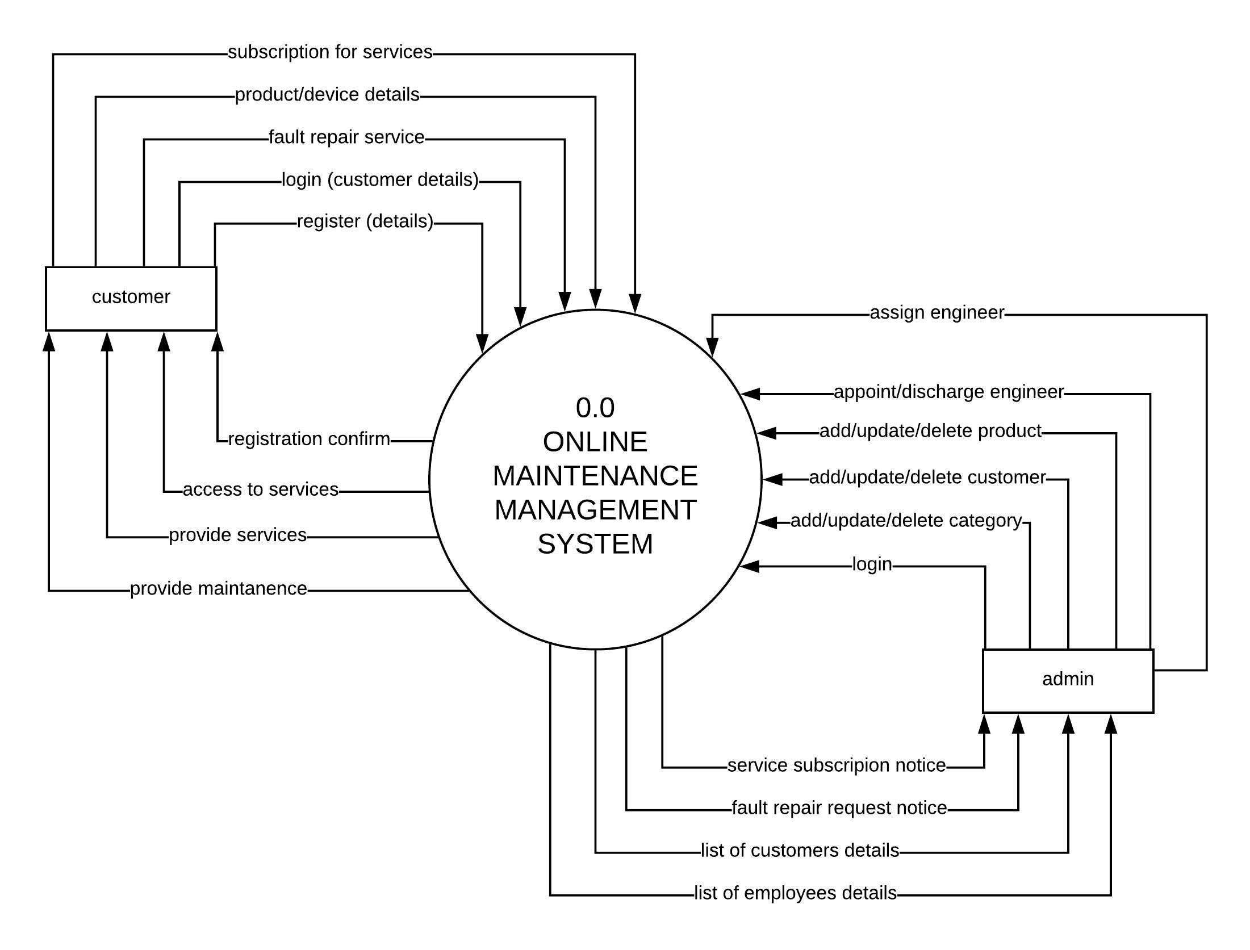

Figure 2 DFD Level 0

#### LEVEL – 1

##### 

Figure 3 DFD level 1

#### LEVEL – 2

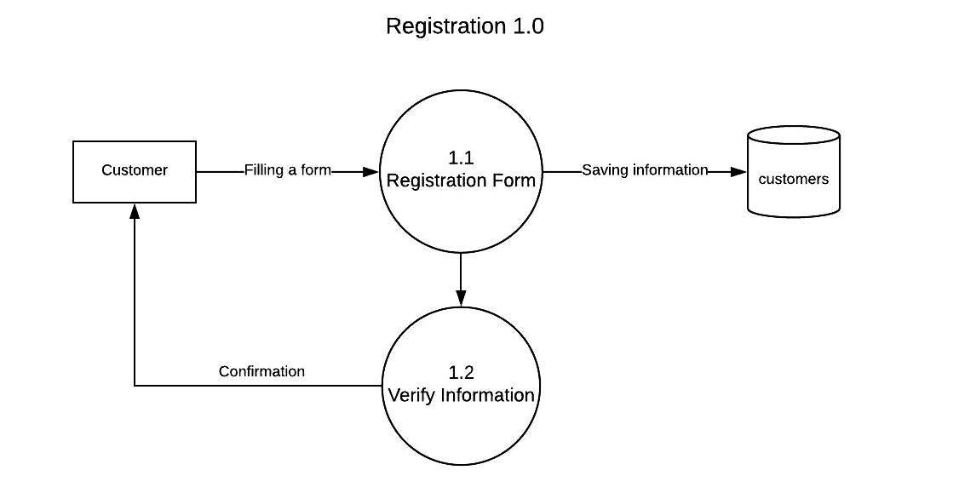

Figure 4 DFD Level 2 (Registration 1.0)

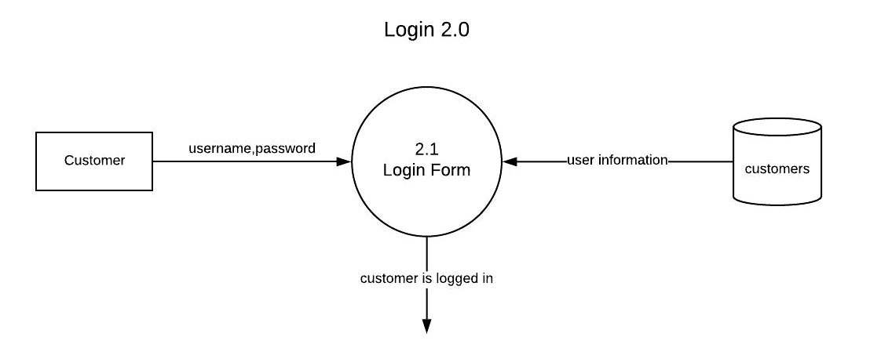

Figure 5 DFD Level 2 (Login 2.0)

##### 

Figure 6 DFD Level 2 (Fault Repair Service 3.0)

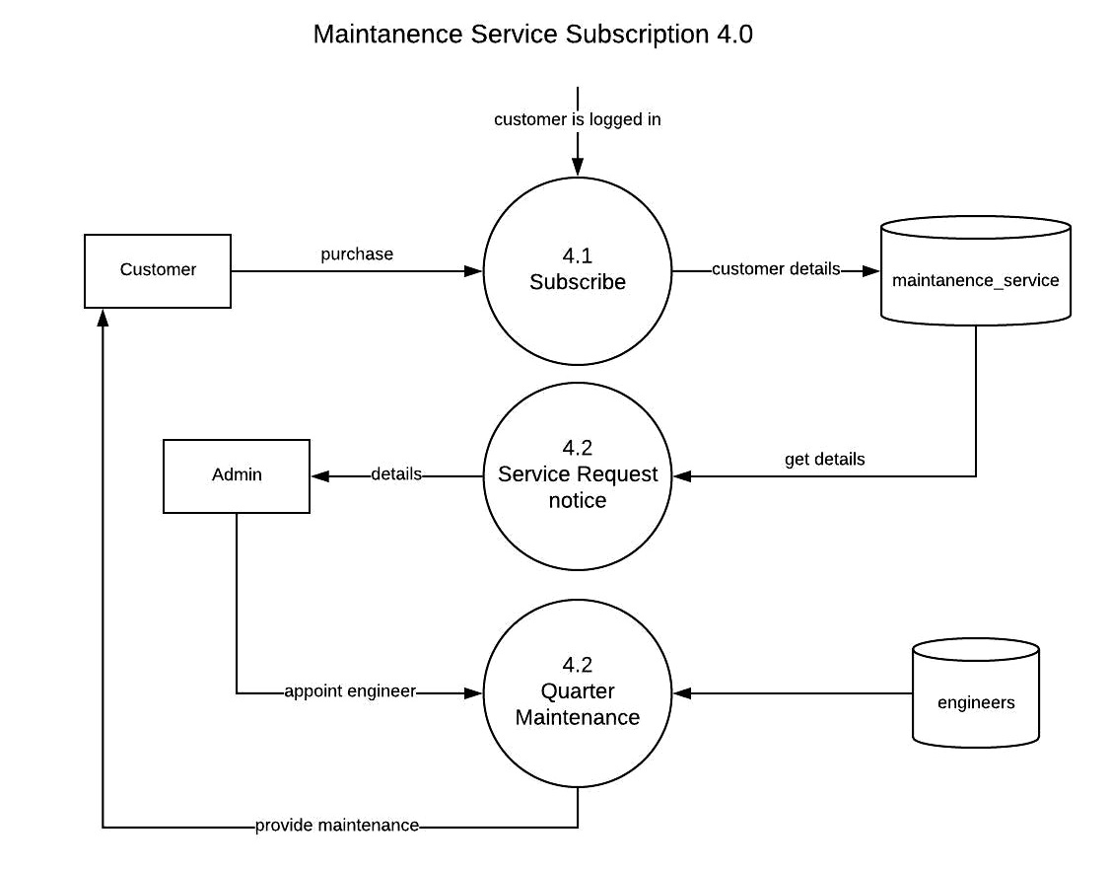

Figure 7 DFD Level 2 (Service Subscription 4.0)

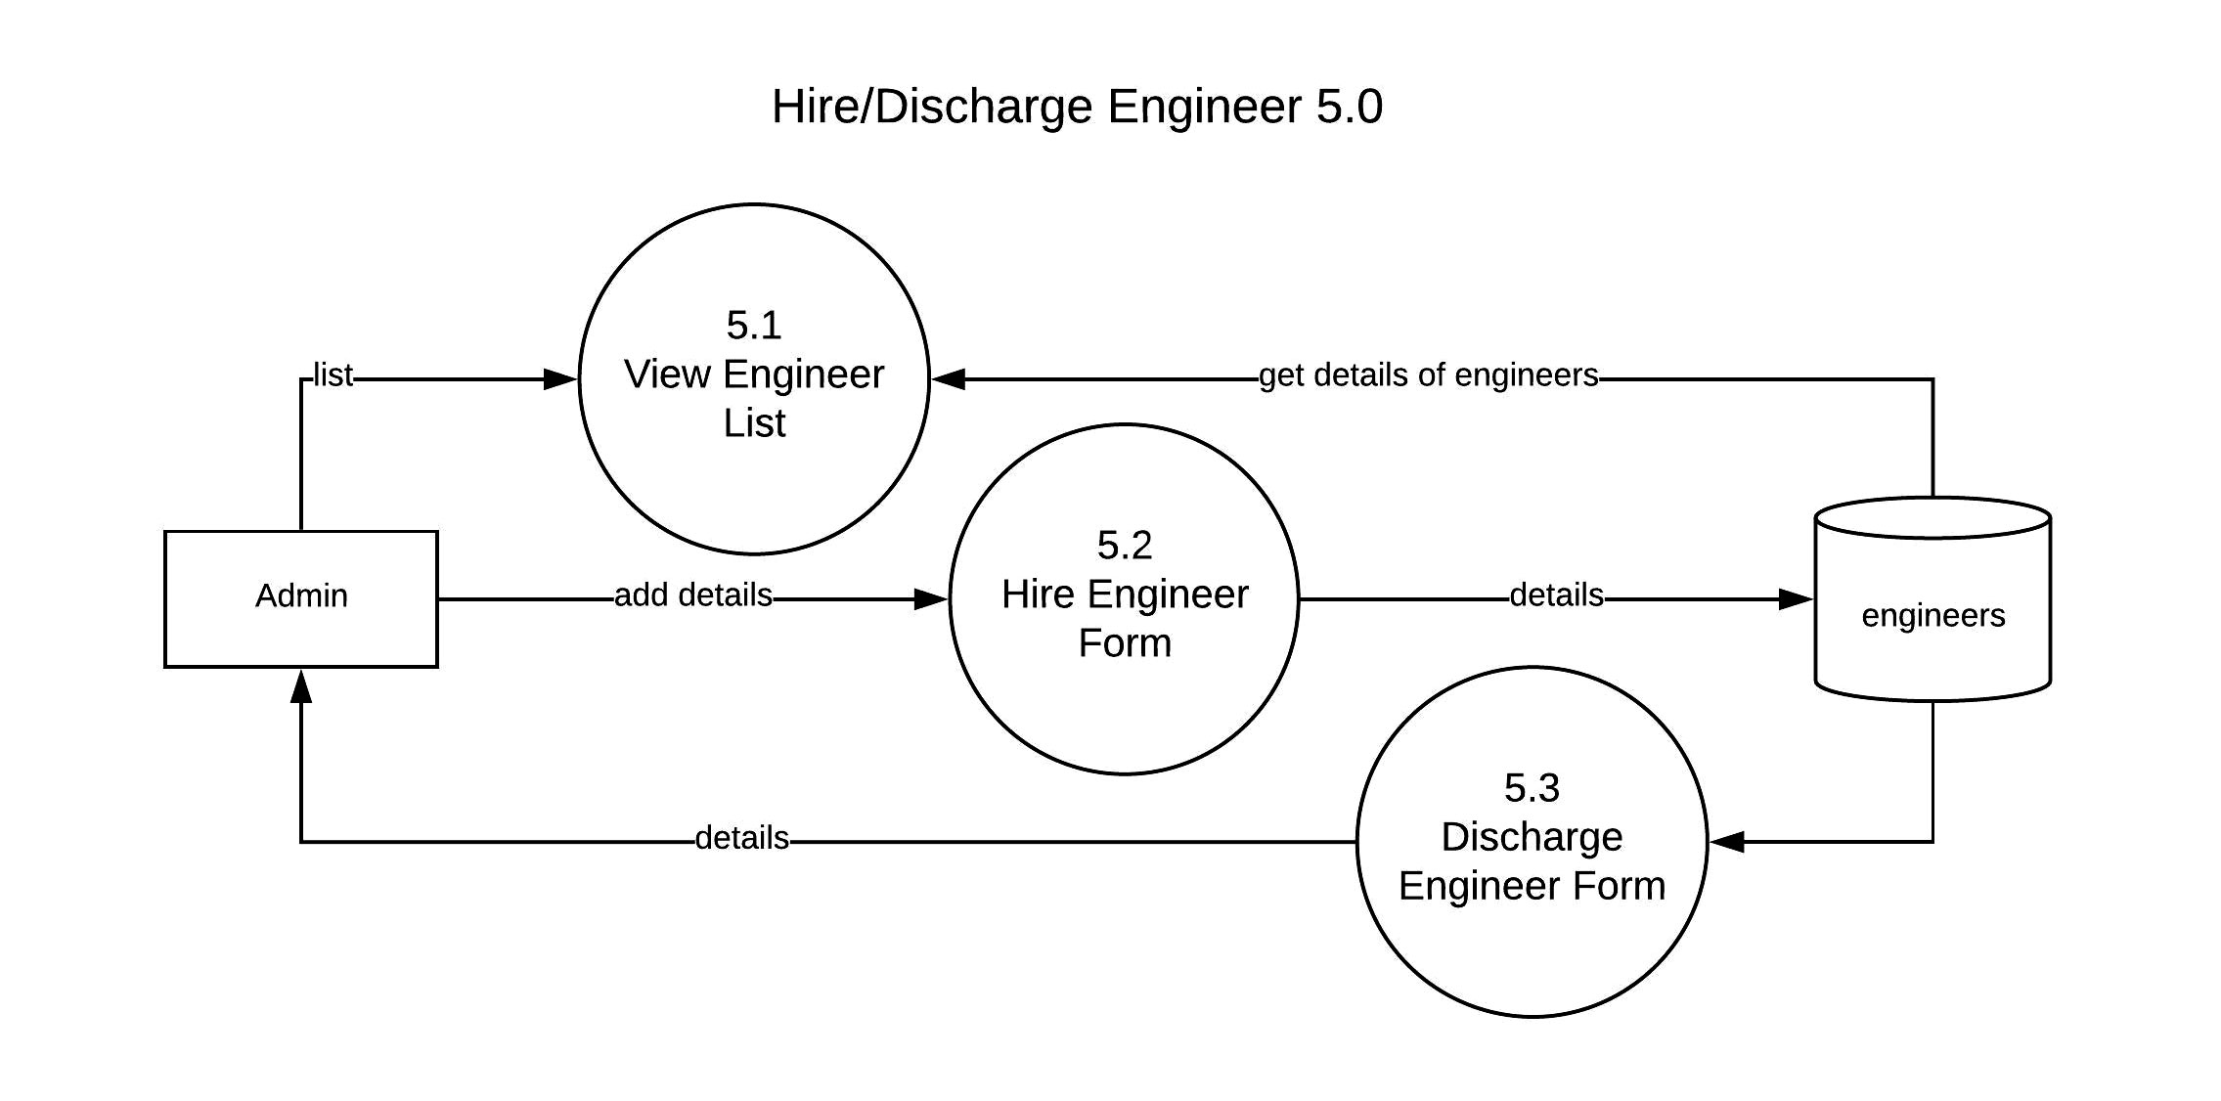

Figure 8 DFD Level 2 (Hire/Discharge Engineer 5.0)

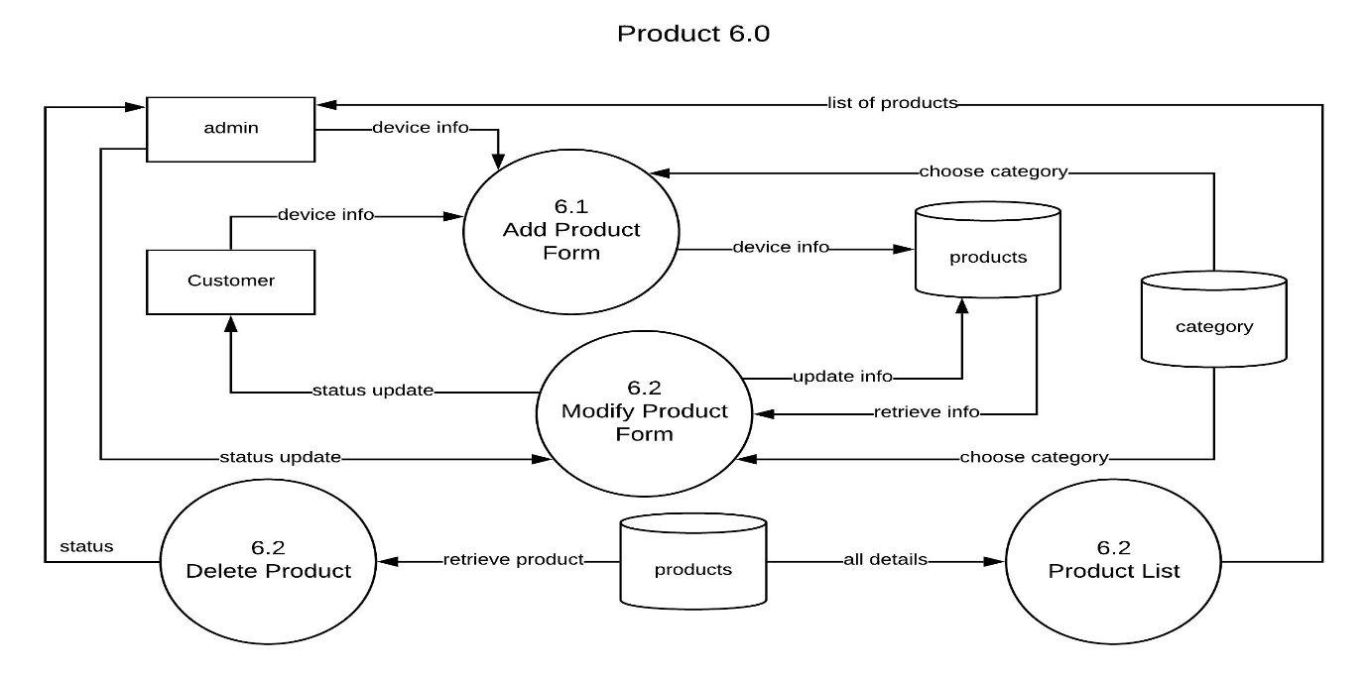

Figure 9 DFD Level 2 (Product 6.0)

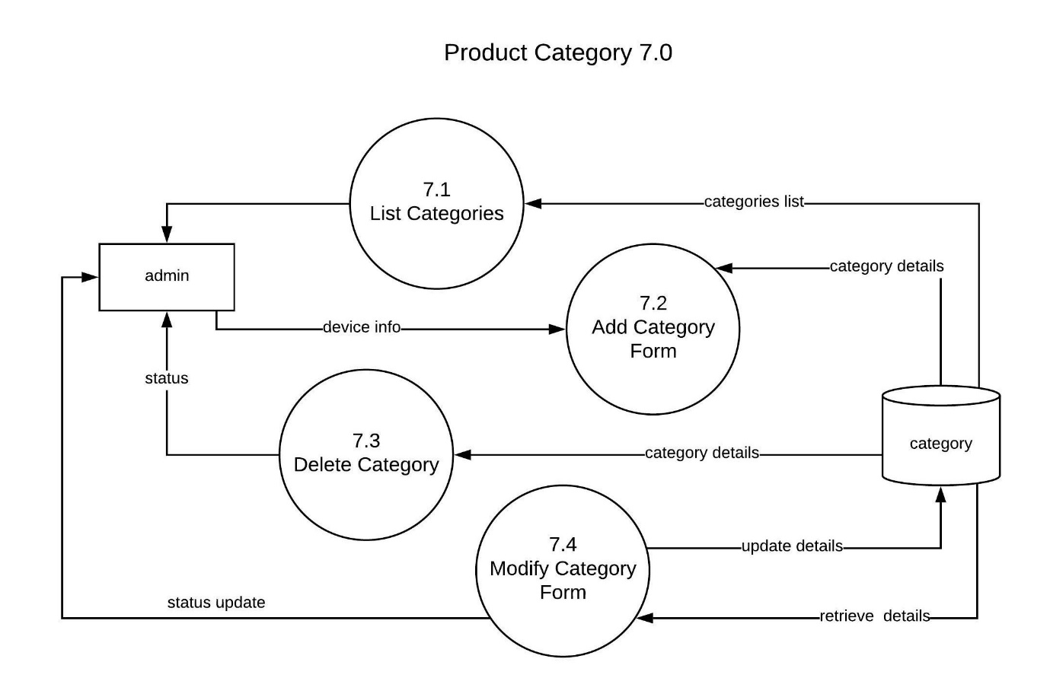

Figure 10 DFD Level 2 (Product Category 7.0)

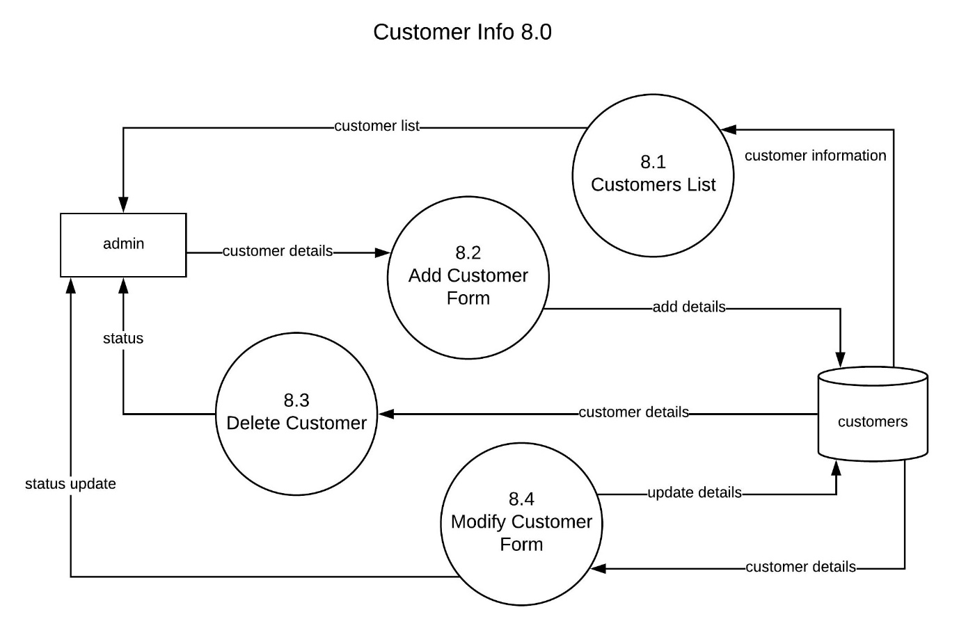

Figure 11 DFD Level 2 (Customer Info 8.0)

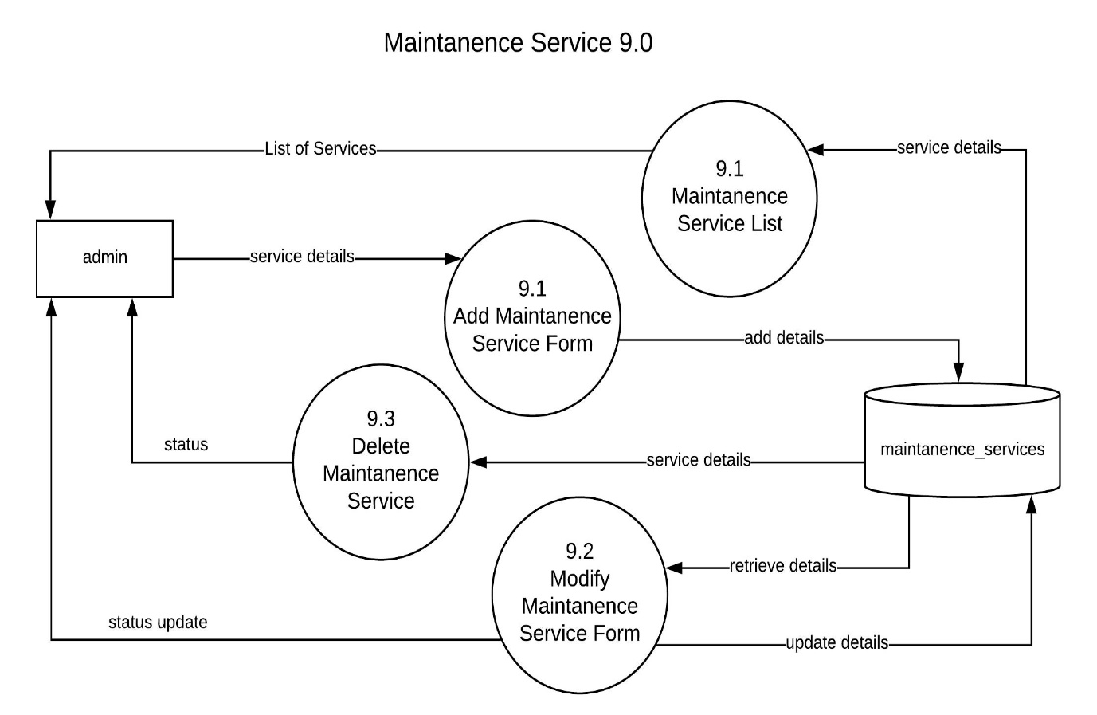

Figure 12 DFD Level 2 (Maintenance Service 9.0)

### 3.6.2. ER DIAGRAM

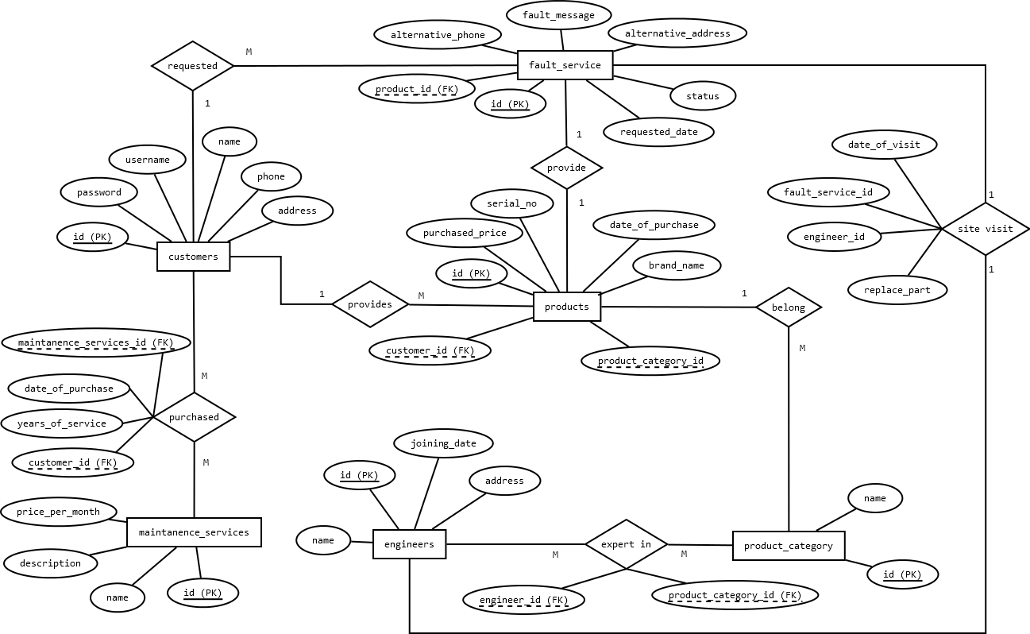

Figure 13 - Entity Relationship Diagram

### 3.6.3. Database Schema

**Table 1:**

**customers ( id, username, password, name, address, phone )**

This table contains all records for customer, admin can add new customer based on there existing records, any customer can register online.

|  |  |  |  |
| --- | --- | --- | --- |
| Field Name | Data Type | Description | Relation |
| id | int(8) | Unique id for each record | Primary key |
| username | varchar(255) | It will be used for login after registration | Not Null |
| password | varchar(255) | It will be used for login after registration | Not Null |
| name | varchar(255) | Full Name of customer | Not Null |
| address | varchar(255) | Full Address of customer | Not Null |
| phone | varchar(50) | Contact details of customer | Not Null |

**Table 2:**

**products ( id, customer_id, product_category_id, brand_name, serial_no, purchase_price, date_of_purchase )**

This table contains each product/device input by any customer or by admin.

|  |  |  |  |
| --- | --- | --- | --- |
| Field Name | Data Type | Description | Relation |
| id | int(8) | Unique id for each record | Primary key |
| customer_id | int(8) | Refer to owner of device, who requested repair | Foreign key |
| product_category_id | Int(8) | Category like, TV, Washing Machine, Refrigerator, etc, which describe the product category | Foreign key |
| brand_name | varchar(255) | Name of manufacturer | Not Null |
| serial_no | varchar(255) | Serial Number of product if any. | Not Null |
| purchase_price | decimal(8,2) | Purchase price of product. | Not Null |
| date_of_purchase | Date | Date of purchase of product. | Not Null |

**Table 3:**

**product_category ( id, name )**

This table will be used to save product category as defined by administrator because he know what kinds of devices their staff can repair.

|  |  |  |  |
| --- | --- | --- | --- |
| Field Name | Data Type | Description | Relation |
| id | int(8) | Unique id for each record | Primary key |
| name | varchar(255) | Name of product category like, TV, Washing Machine, Refrigerator, Air Conditioners, Air Coolers, Microwave Ovens etc. | Not Null |

**Table 4:**

**fault_services ( id, product_id, status, requested_date )**

This table contains details of services requested by customer, specifically the fault repair services for their products.

|  |  |  |  |
| --- | --- | --- | --- |
| Field Name | Data Type | Description | Relation |
| id | int(8) | Unique Id for each record | Primary key |
| product_id | int(8) | Reference of product that needed to be repaired | Foreign key |
| status | varchar(255) | This field indicate numbers of specific status message.  REQUESTED | ACCEPTED | IN PROGRESS | COMPLETE | COMPLETE & PAID | Not null |
| requested_date | Date | Date or requesting for service | Current date |

**Table 5:**

**maintenance_service ( id, name, description, price )**

This table is contain information of some predefined services package for maintenance for customer in both household as well for business. Customer can purchase those services after registration.

|  |  |  |  |
| --- | --- | --- | --- |
| Field Name | Data Type | Description | Relation |
| id | int(8) | Unique id for each record | Primary key |
| name | varchar(255) | Name of service, for example Quarter Maintenance for home, business, etc. | Not Null |
| description | varchar(255) | Full description of service, and terms and conditions, etc | Not Null |
| price | decimal(8,2) | Price as per annum | 0 |

**Table 6:**

**site_visit ( fault_service_id, engineer_id, date_of_visit, replace_part )**

This table is a relation between table that store information when a engineer visit a site based on request from customer.

|  |  |  |  |
| --- | --- | --- | --- |
| Field Name | Data Type | Description | Relation |
| fault_service_id | int(8) | Reference of fault_service | Foreign key |
| engineer_id | int(8) | Reference of engineer | Foreign key |
| date_of_visit | Date | We can consider a date of visit as the replacement of parts included in this table | Not Null |
| replace_part | varchar(255) | Parts details those are replaced during repair | Not Null |

**Table 7:**

**customers_maintenance_service ( maintenance_service_id,customer_id )**

This table is a relational table that stored information like how many services customer had purchased, basically this is a external table for showing many to many relation between table customers and maintenance_service table.

|  |  |  |  |
| --- | --- | --- | --- |
| Field Name | Data Type | Description | Relation |
| maintenance_service_id | int(8) | Reference of maintenance_service | Foreign key |
| customer_id | int(8) | Reference of customer | Foreign key |
| date_of_purchase | Date | Date when customer purchase a maintenance service | Current Date |
| year_of_service | int(8) | Total Number of years | 0 |

**Table 8:**

**engineers ( id, name, address, date_of_joining )**

This table keep track of available engineers.

|  |  |  |  |
| --- | --- | --- | --- |
| Field Name | Data Type | Description | Relation |
| id | int(8) | Reference of maintenance_service | Primary key |
| name | varchar(255) | Name of engineer | Not Null |
| address | varchar(255) | Address of engineer | Not Null |
| date_of_joining | Date | Date in which join the organisation | Date |

**Table 9:**

**engineers_expertise ( product_category_id, engineer_id )**

This table keep track our engineer skill set, for example one engineer can repair only TV, other can repair TV and Microwaves, etc. This table will contains relationship between engineers and product_category table.

|  |  |  |  |
| --- | --- | --- | --- |
| Field Name | Data Type | Description | Relation |
| product_category_id | int(8) | Reference of product_category | Foreign key |
| engineer_id | int(8) | Reference of engineer | Foreign key |

# 4. REFERENCES

Here are some sites, that would help me going to the all development process, Many existing websites, those used while gathering and inspiration.

1. <http://www.serviceman.in/>
2. <https://dir.indiamart.com/indianservices/>
3. <https://www.housejoy.in/electrical-services>
4. [*https://github.com/sorabh86*](https://github.com/sorabh86)
5. <https://getbootstrap.com/>
6. <https://jquery.com/>
7. <http://php.net>
8. <http://w3schools.com>