**What is an e-Document ?**

e-Document also known as Digital Document.

It is a combination of two words :-

* “Digital”, and
* “Document”

**Digital:** “Expressed in discrete numerical form, especially for use by a computer or other electronic device.”

**Document: “**A written or printed paper that bears the original, official, or legal form of something and can be used to furnish decisive evidence or information.**”**

Ordinarily the word "document" denotes a textual record. Early this century, attempts to provide access to the rapidly growing quantity of available documents raised questions about which should be considered a "document". Paul Otlet and others developed a functional view of "document" and discussed whether, for example, sculpture, museum objects, and live animals, could be considered to be "documents". Suzanne Briet equated "document" with organized physical evidence. These ideas resemble notions of "material culture" in cultural anthropology and "object-as-sign" in semiotics. Others, especially in the USA (e.g. Jesse Shera and Louis Shores) took a narrower view. Old confusions between medium, message, and meaning are renewed with digital technology because technological definitions of "document" become even less realistic when everything is in bits.

When we refer to a paper document, a papyrus document, or a microfilmed document, the meaning is clear. However, the idea of a "digital document" is more difficult. We can recognize e-mail and a technical report generated by a wordprocessor as digital documents, but beyond these simple examples the concept of a "document" becomes less clear. Is a software program a document? It has lines of language-like text. Is an operating system a document? One can enumerate different types of digital documents and this is necessary because of the need to specify standards in order to achieve efficiency and interoperability. But if one seeks completeness, the process becomes arbitrary and intellectually unsatisfying because it is not clear where the frontier between documents and non-documents should be.   
  
A paper document is distinguished, in part, by the fact that it is on paper. But that aspect, the technological medium, is less helpful with digital documents. An e-mail message and a technical report exist physically in a digital environment as a string of bits, but so does everything else in a physical environment. "Multimedia," which used to denote multiple, physically-different media, is now of renewed interest, because, ironically, the multiple media can be reduced to the mono-medium of electronically stored bits.

Following are the Advantages and the Major Needs of Digital Documents :-

1. **Automatic Routing.** Let’s say you’re the second person to handle a document in a process. In a paper-based world, the person before you may have completed their task, but the document still needs to be physically moved to your location. In a digital world, you receive the document electronically as soon as your colleague’s task has been carried out in the system. Even better, you don’t have to take it to the next person.
2. **Constant Motion.** What happens when a paper document lies on someone’s desk for an extended period or becomes lost and isn’t handled in a normal amount of time? You guessed it! The paper sits there until a client, customer, or vendor calls and complains. You can easily overcome this pitfall using document management software. Simply establish rules in the system to automatically move documents forward or alert you when delays occur.
3. **E-mail Alerts.** When you’re sitting at your desk, you always know when someone places documents in your inbox. But what about when you leave for lunch or you’re absent on appointments? Document management software can e-mail you immediately when documents have been routed to you for any reason.
4. **No Sort Piles.** Sometimes a document’s destination depends on details of the document. For example, a purchase order under $1,000 may go directly to purchasing, whereas a PO for $1,000 and higher may first need approval. Sure, a single condition like this isn’t terribly difficult to manage with paper, but a typical office has multiples of these workflow branches. In digital workflow the system determines these routes automatically because the details are part of the document itself in the form of indexing or metadata.
5. **Replication without Duplication.** If a workflow in your office requires two or three people to have access to a single document at the same time, someone’s making copies, and they’re making them frequently. In document management software, there’s only one document, and anyone with access can view it at the same time.
6. **Faster Travel Time.** Paper documents tend to move slowly. For instance, outbound invoices move through snail mail, and each day that the invoice is working its way through the mail service, you aren’t being paid. Digital documents move fast! Do your customers have e-mail addresses? Document management software can e-mail invoices to your customers as soon as they’re generated.
7. **Knowledge When Needed.** There are very few things more aggravating in life than being in the dark when it comes to processes. Whether you’ve sent off an application for approval or need to know the status of an order, paper trails are painful to follow and usually require you to contact every person in the workflow path until you reach the stage where the paper is. This is time stealing and costly, but it doesn’t have to be. Document management software generates a trail of every document movement, content change, and notification, and it does it automatically. All you need to know is a few details about the document or process (a customer’s name and type of document, for example) and in a matter of a few seconds you will know where the document has been and where it is now.

The Following are the Ages of Documentation :-

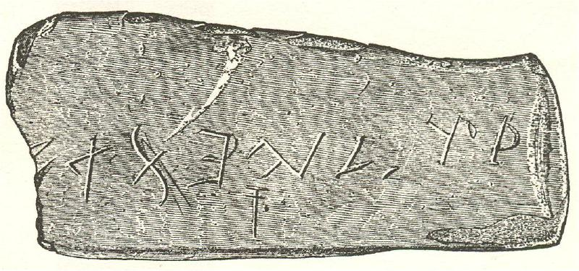

**1. Stone Carving / Stone Scriptures -** The earliest of the ages of documentation of human kind was Stone carving and scriptures. In this age, the human being depicted the life’s work and stored it for longer time using scriptures and carvings on stones and other longer lasting things.

There were quite some disadvantages with this technique that lead to its downfall.  
  
- Time Consuming

- Not Portable



**2. Paperwork Generation -** We developed dyes and inks to overcome the earlier problems of more and more time consumption and inability to be portable. We moved to paperwork which were easier to carry anywhere and quicker to write down at any instance in time. The looks were greatly improved by the help of better precision over the brushes and the pens that were being used to make use of these inks and dyes.  
  
Though this solved the two phases that the earlier phase lagged but it had its own set of disadvantages.

- Inability to store the data for a longer period of Time.

- Hard to manage and to maintain.



**3. Basic e-Documentation Generation –** With the urgent need of powers that were in the Paperwork generation with a longer period of storage, the first concept of Digital Storage of documents first came into being and at the very first he longer codes and important information was used to be stored for a longer period of time.

There were quite some disadvantages with this technique that lead to its downfall.  
  
- Inability to edit and to attach various forms of Multimedia Files.

- Size and Security Issues.

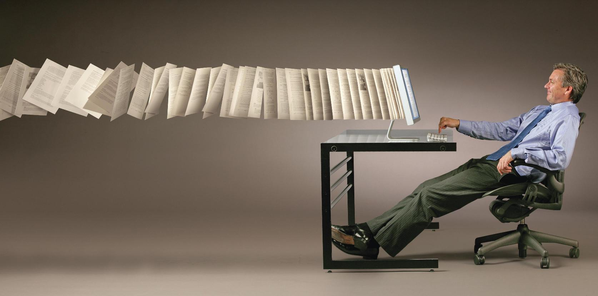

**4. Advanced e-Documentation Generation –** The Advanced Generation of e-Documentation was mainly targeted towards removing the previously existing issues in the system of e-Documentation and thus, imparting to us the power to not only manage and maintain the data in a better way using up the least of space in the memory, but also to provide better looks to the data that we are having and presenting to the others.

We are now able to attach many types of files and embed them into one digital document for more interactive features.

**Some Very Famous and Important Documentation Types of Today:-**

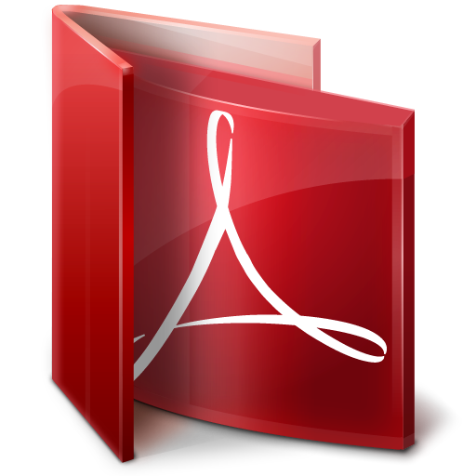**ADOBE PDF :-**

Portable Document Format (PDF) is a file format used to represent documents in a manner independent of application software, hardware, and operating systems.[1] Each PDF file encapsulates a complete description of a fixed-layout flat document, including the text, fonts, graphics, and other information needed to display it. In 1991, Adobe Systems co-founder John Warnock outlined a system called "Camelot"[2] that evolved into PDF.

**ePUB :-**

EPUB (short for electronic publication) is a free and open e-book standard by the International Digital Publishing Forum (IDPF). Files have the extension .epub.

EPUB is designed for reflowable content, meaning that an EPUB reader can optimize text for a particular display device. EPUB also supports fixed-layout content. The format is intended as a single format that publishers and conversion houses can use in-house, as well as for distribution and sale. It supersedes the Open eBook standard.[3]

**Comic Book Archives (.cbz, .cbr, .cb7, etc.) :-**

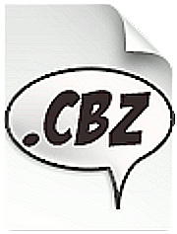A comic book archive or comic book reader file is a type of archive file for the purpose of sequential viewing of images, especially comic books. The idea was made popular by the CDisplay image viewer; since then, many viewers for different platforms have been created.

The file name extension indicates the archive type used:

* .cb7 → [7z](http://en.wikipedia.org/wiki/7z)
* .cba → [ACE](http://en.wikipedia.org/wiki/ACE_%28file_format%29)
* .cbr → [RAR](http://en.wikipedia.org/wiki/RAR)[[1]](http://en.wikipedia.org/wiki/Comic_book_archive#cite_note-1)
* .cbt → [TAR](http://en.wikipedia.org/wiki/Tar_%28file_format%29)
* .cbz → [ZIP](http://en.wikipedia.org/wiki/ZIP_%28file_format%29)[[2]](http://en.wikipedia.org/wiki/Comic_book_archive#cite_note-2)

**Future prospects of e-Documentation :-**

Digital preservation has become a common topic in digital library research and development for several reasons. First, digital libraries have gone through a transition from research and experimental projects to an important part of the infrastructure for research and teaching. In many scientific fields, research depends on access to persistent stores of digital information that are built and refined continuously. Consistent with the cumulative nature of scholarly research, journals that report research findings and that make references to previous studies constitute a continuous record of research and discovery. As scholarly communications have shifted rapidly from print-based journals to either hybrids of print and electronic journals or to exclusive publication in digital form, the need to preserve a comprehensive record of research and scholarly achievement has not diminished. Moreover, libraries, archives, and other organizations have made considerable investments in acquiring digital content and in converting older print-only materials into digital form to improve access to disparate sources that were difficult to locate and retrieve. According to the 1998-1999 statistics from the Association of Research Libraries, major research libraries in the United States spent between slightly less than three percent to more than twenty-one percent of their acquisition budgets on electronic journals and other digital resources [1]. Few aspects of contemporary society and culture are untouched by changes in the creation, distribution, and access to information. There have also been concerted efforts to raise awareness of the preservation issues associated with new information technologies out of concern over the survival of digital information to document this rapid shift in communications [9, 13, 26, 29].

The rapid acceptance of digital technologies and the growth of digital libraries created three primary motivations for investments in digital preservation research and program development. First, there is an increasing demand for continuing access to the resources that digital libraries make available. Once users become accustomed to accessing information on-line they do not want those resources to be removed or diminished. Second, there is an interest on the part of digital library developers to protect the investments made in digital resources, whether those investments are subscription fees paid to publishers for on-line content, the costs of initial data collection and preparation, or the costs of converting print and other analog materials into digital form. Third, there is a concern about preserving digital communications for the future study of our present time and culture. This includes the content of digital documents that might be considered ephemeral as well as evidence of the impact of digital communications on many aspects of society.

**Why do we need Digital Documents?**

**Ages of Documentation**

Contents

* What is an e-Document?
* Needs and Requirements of e-Documents.
* Generations of e-Documents.
* Current In-Trend Documentation Techniques.
* Post-Script
* Future Prospects of e-Documentation.

**Post Script :-**

**PostScript (PS) is a dynamically typed concatenative programming language created by John Warnock and Charles Geschke in 1982. It is best known for its use as a page description language in the electronic and desktop publishing areas.**

**PostScript Level 1**

The first version of the PostScript language was released to the market in 1984. The term "Level 1" was added when Level 2 was introduced.

**PostScript Level 2**

PostScript Level 2 was introduced in 1991, and included several improvements: improved speed and reliability, support for in-RIP separations, image decompression (for example, JPEG images could be rendered by a PostScript program), support for composite fonts, and the form mechanism for caching reusable content.

**PostScript 3**

PostScript 3 (Adobe dropped the "level" terminology in favor of simple versioning) came at the end of 1997, and along with many new dictionary-based versions of older operators, introduced better color handling, and new filters (which allow in-program compression/decompression, program chunking, and advanced error-handling).

PostScript 3 was significant in terms of replacing the existing proprietary color electronic prepress systems, then widely used for magazine production, through the introduction of smooth shading operations with up to 4096 shades of grey (rather than the 256 available in PostScript Level 2), as well as DeviceN, a color space that allowed the addition of additional ink colors (called spot colors) into composite color pages**.**

**PostScript Vs Bitmap Type**

