Requirements Specification and Database Design – Tutoring System

**Background**

The student academic success and tutoring system will allow faculty and peer tutors to track the progress of students who visit the tutoring center. As students come to the tutoring center, they will have sessions with peer tutors. Students can get a list of tutors and a list of courses that offer academic support at the tutoring center. This application will allow tutors to keep a record of previous sessions to facilitate a smoother experience in the tutoring center. Faculty and staff will be able to see these records as needed and permitted.

**Scope and Requirements**

A student is a person who is currently enrolled in at least one course at the university. A tutor is a student who is employed with the tutoring center; there may be other types of students. Students will be able to look up all of the courses offered through the tutoring center and the associated tutors for these courses. A tutor must offer tutoring in at least one course. Overall, a tutor may tutor many students, and likewise, a student may have many tutors. However, session is a verified interaction between one tutor and one student in the tutoring center that exceeds five minutes pertaining to one course. The session will have a duration and a description of what was covered. There may be multiple sessions between a student and a tutor. After a session has been recorded, this recorded session will become available for tutors or faculty to view. A faculty member is an employee of the university who may teach any number of courses. They will be able view a recorded session of only students currently enrolled in their course. A tutor or faculty can see the total number of hours a student spent in the tutoring center for a specific course.

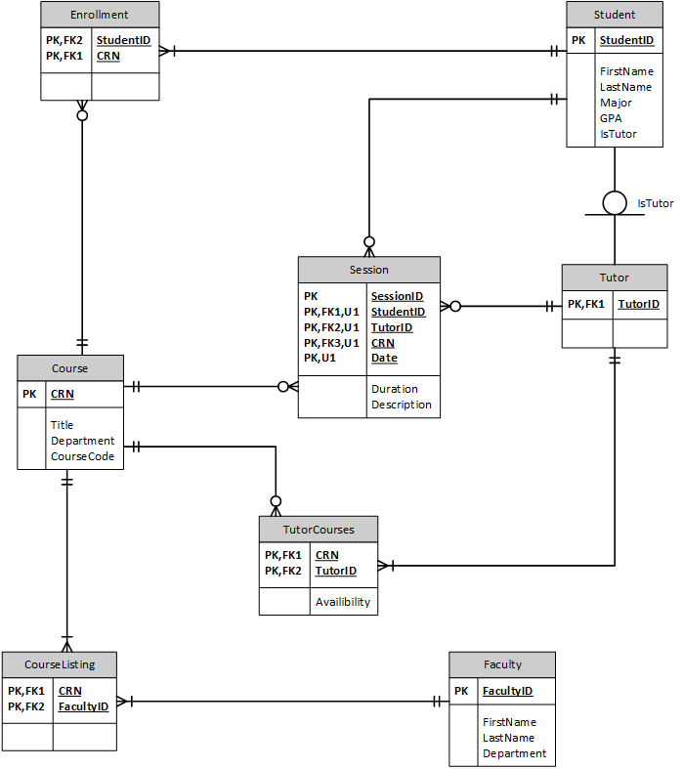

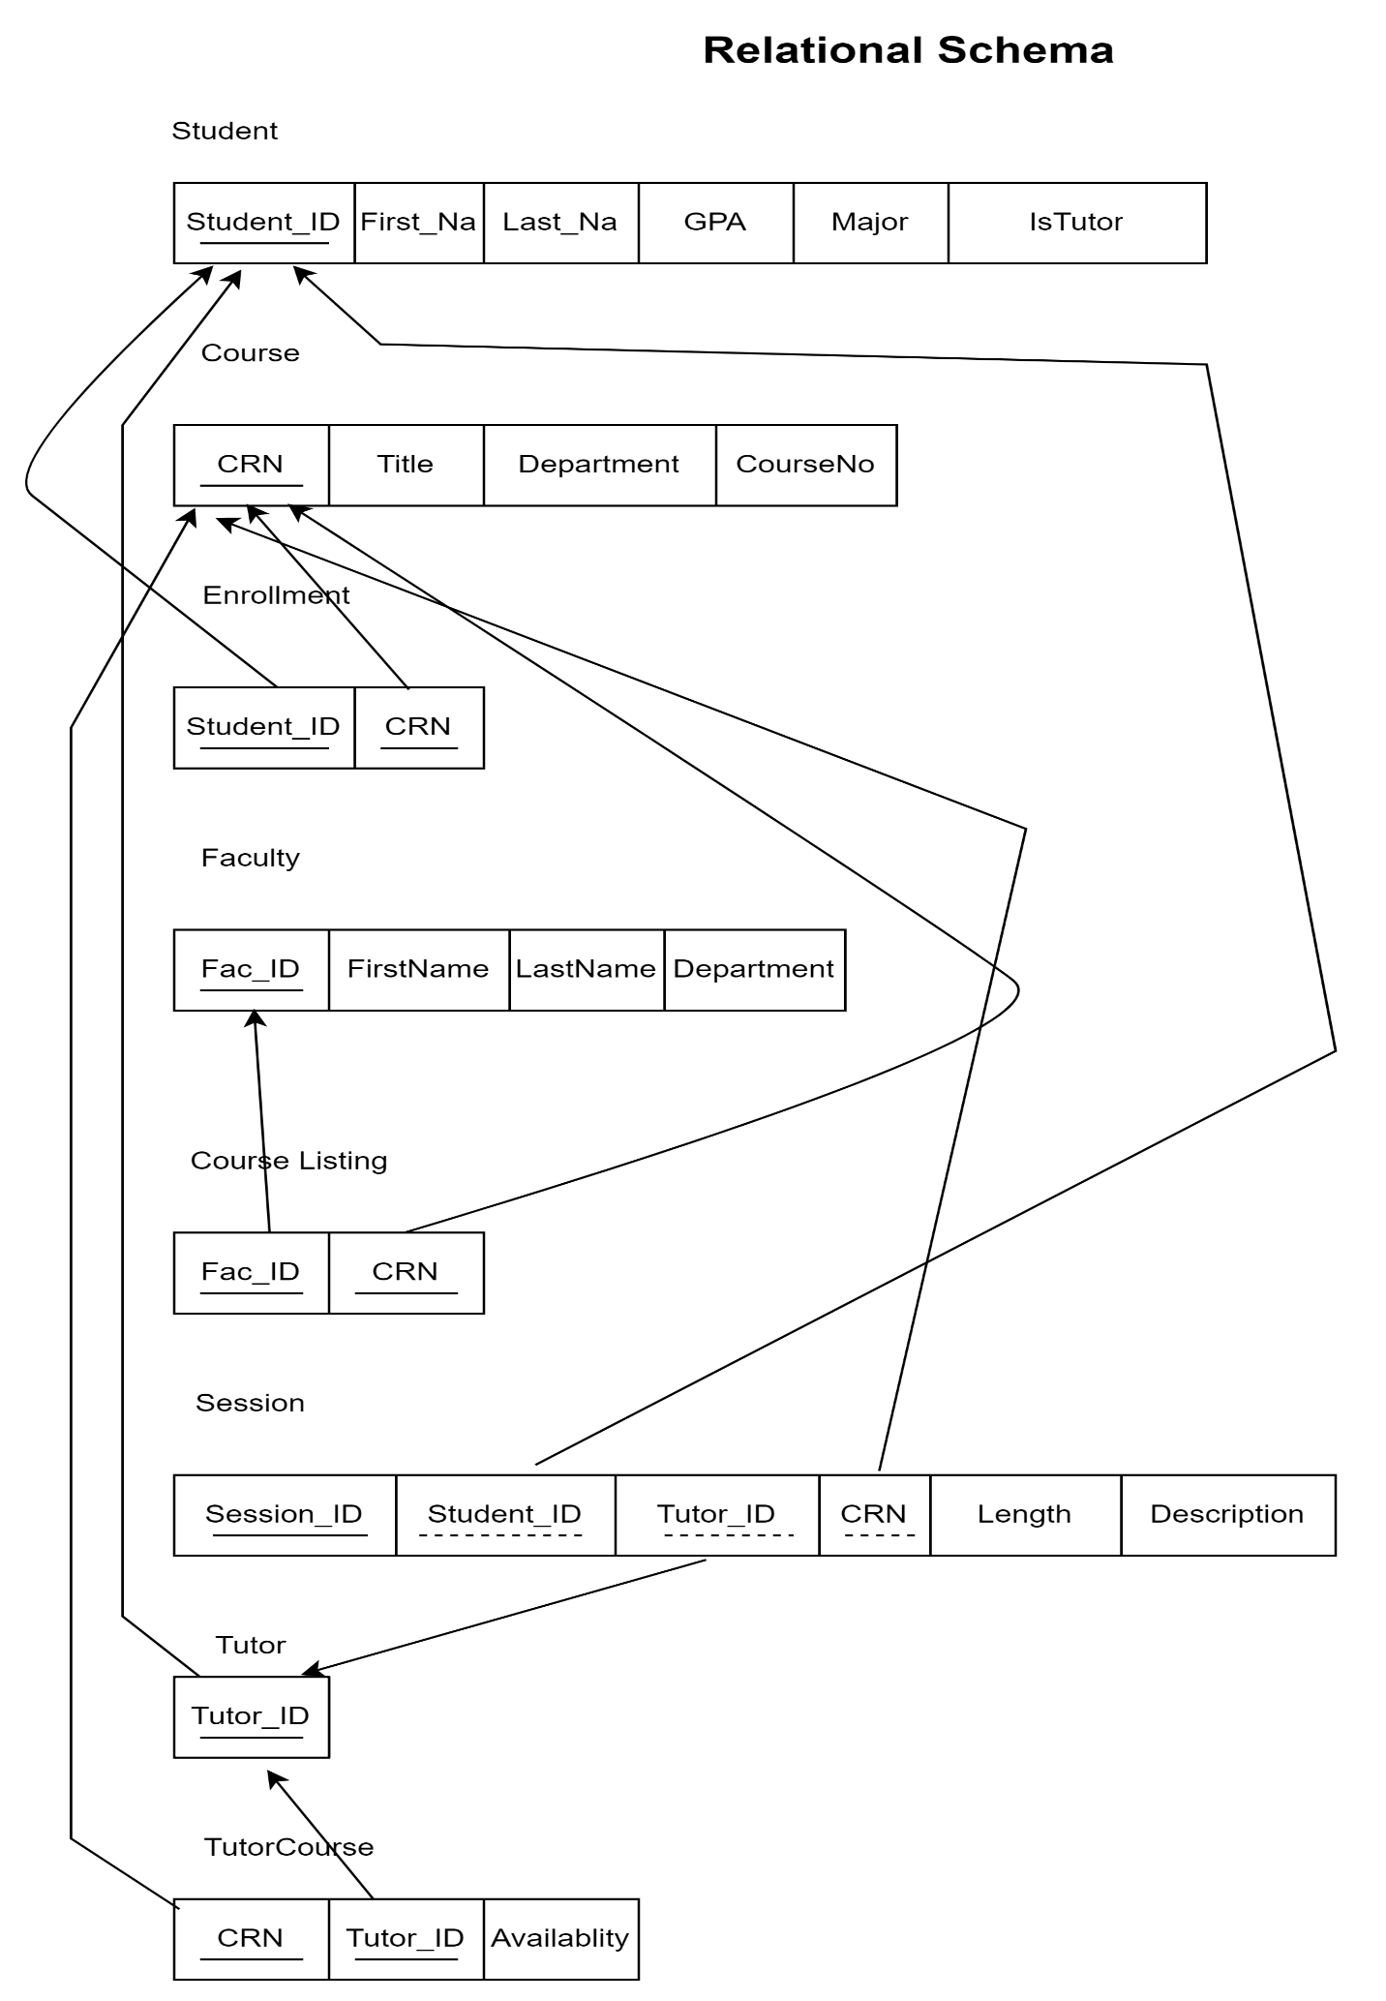

Log of work done

* Patrick
  + Created the relational schema
  + Brainstormed attributes for the faculty, course and enrollment entities
  + Refined the business rules for faculty
  + DML SQL queries
* Chad
  + Created the Entity-Relationship diagram
  + Brainstormed attributes for the student, tutor, session, tutor courses, and course listing entities
  + Application background and scope and other business rules
  + DDL
  + Put together PowerPoint presentation