Python Pipeline Methodology Report
Part 2 — Building a reproducible traffic analytics pipeline
Student Sora
Programme NUS/Emeritus Applied Machine Learning and Data Science
Capstone Smart City Traffic Intelligence: From Data Analytics to AI-Powered Mobility

1. Objective and design
Part 2 turns the one-off analysis of Part 1 into a reproducible pipeline: four Python stages that take the raw CSV to an ML-ready feature table, six diagnostic figures, and a command-line application for querying the result. Every stage is a separate script with its own entry point, every data change is logged with a count and a reason, and the whole chain re-runs from the raw file with three commands. The design goal was that a grader — or a colleague six months from now — could read `logs/pipeline.log` and reconstruct exactly what happened to every row without opening the code.
Stage | Script | Input → output | Rows in → out
1. Clean | pipeline.py | raw CSV → data/processed/traffic_clean.csv | 48,204 → 40,575
2. Features | feature_engineering.py | clean CSV → traffic_features.csv (67 columns) | 40,575 → 40,575
3. Visualise | visualizations.py | features → figures/*.png + INTERPRETATIONS.md | 6 figures
4. Query | mini_app/traffic_app.py | features → answers on the console | 6 commands

2. Pipeline methodology (Task 1)
Loading and schema validation. The file is read with `keep_default_na=False`, which matters more than it sounds: `"None"` is one of pandas' default missing-value tokens, so the default reader silently converts the holiday sentinel on 48,143 rows into NaN and every later holiday count is wrong. Each I/O failure mode (missing file, permission, empty file, parse error, encoding) has its own `except` clause; there is no bare `except`. Schema validation runs before any other processing and checks column presence, coercibility of numeric columns, and that the file is non-empty, raising a `SchemaValidationError` that the entry point logs with `exc_info=True` and converts to exit code 2.
Cleaning, one logged step at a time. Step 1 standardises the three text columns (1,730 `weather_description` values were re-cased). Step 2 parses timestamps against an explicit format, drops any that fail, and quantifies the coverage gap — 11,976 hours, 22.8% of the span, are absent because the sensor was offline. Step 3 removes 17 exact duplicates and then 7,612 duplicate-timestamp rows; these are not errors but the weather feed's one-record-per-condition convention, and keeping them inflates every sum by 7–21%, so the most severe condition per hour is retained. Step 4 repairs impossible values: 10 temperatures of 0 K and one rainfall of 9,831 mm are imputed with the median for the same calendar month, computed in an explicit loop over months so a January fault is never patched with a July value; one daytime reading of zero vehicles is imputed from the same-hour median, while the single overnight zero is retained as plausible. Every step emits its own WARNING with the row count and the reason.

3. Feature engineering (Task 2)
The feature stage adds 57 columns and removes no rows. Time: hour, day of week, weekend flag, month, day of year, rush-hour flags, part-of-day band and season. Cyclical encodings of hour (period 24), day of week (7), month (12) and day of year (365.25) as sine/cosine pairs, so that 23:00 and 00:00 sit next to each other in feature space; a unit-circle check (sin² + cos² = 1) is logged at DEBUG. Weather: an ordinal severity score (0–10), binary indicators for severe weather, low visibility, precipitation, freezing and overcast, a composite adverse-conditions score, and 11 one-hot columns. Scaling: z-score and min-max versions of temperature, cloud cover, precipitation and severity; the target is deliberately left unscaled to avoid leaking test-period statistics into training.
Target. Two congestion definitions coexist and are never mixed. `congestion_category` follows the Part 3 brief: quartiles of traffic volume (Q1 = 1,249, median = 3,428, Q3 = 4,952) split the data into Low / Medium / High / Severe, each holding 25% of hours — balanced classes by construction, and cut-points that transfer to another corridor without re-tuning. `is_congested` keeps Part 1's fixed 5,500-vehicle threshold (15.05% of hours) so the two parts can be compared. The quartile thresholds are logged at DEBUG only, as the brief requires; the shape before (40,575 × 10) and after (40,575 × 67) is logged at INFO.

4. What the figures show (Task 3)
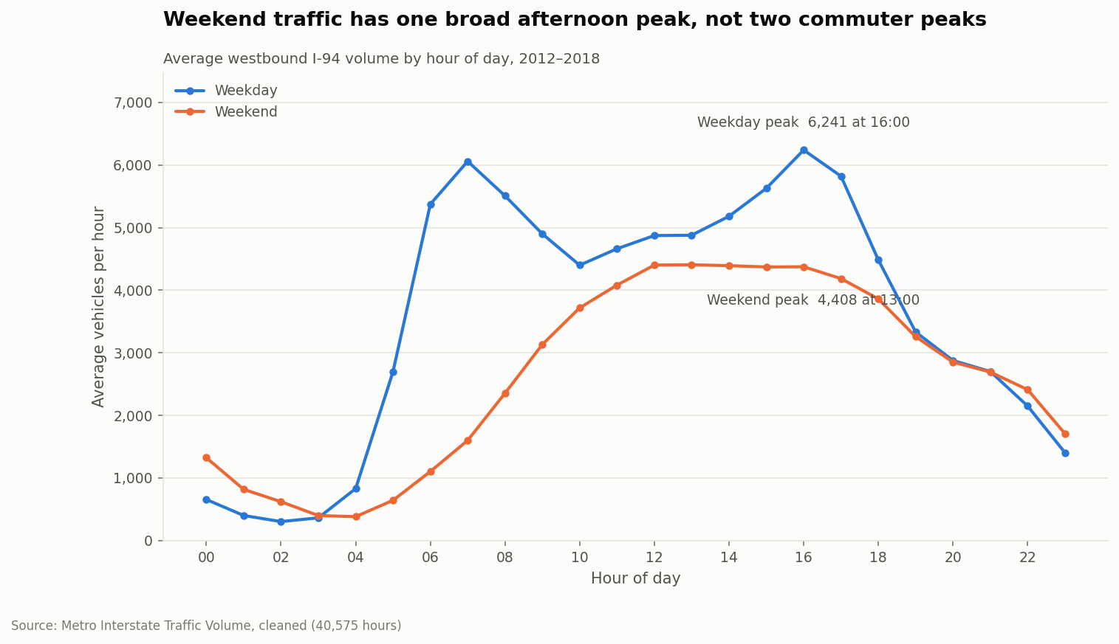
Figure 1 — Weekday demand has two peaks; the evening one (16:00, 6,241 veh/h) is the larger. Weekends have one broad midday plateau.
Six figures were produced, each with a written interpretation in `figures/INTERPRETATIONS.md`. Three findings carry through to Part 3. First, the weekday and weekend profiles are different shapes, not scaled copies: weekdays peak twice (07:00 and 16:00), weekends once (13:00, at 4,408 veh/h, 1.42× lower than the weekday maximum). Any model without a day-type feature is wrong two days in seven. Second, volume is bimodal — overnight and daytime masses with a near-empty valley between — which is why the mean (3,291) and median (3,428) describe no actual hour and why quartile-based classes were chosen over fixed thresholds. Third, the weather ranking is a time-of-day artefact: Clouds averages 3,617 veh/h and Fog 2,654 because fog forms at 04:00; faceting the temperature scatter by part of day dissolves the r = +0.139 correlation inside every band. The heatmap identifies Wednesday 16:00 as the single busiest cell of the week, and the congestion-over-time chart masks any month with fewer than 400 recorded hours, because an earlier draft that plotted them produced a dramatic — and entirely fictitious — collapse through 2014–2015.

5. The mini application (Task 4)
`traffic_app.py` exposes six sub-commands via `argparse`: `summary`, `query DATE [--hour H]`, `peak`, `compare`, `recommend` and `weather`. Every invocation logs the command and its arguments at INFO to `logs/app.log`. Invalid input — a malformed date, an hour of 25, an unknown weather condition, a departure window that ends before it starts — raises a `UserInputError` that is logged as a single ERROR line and printed as a two-line message; no traceback reaches the user. `print()` appears only in this module, only for the answers themselves, which is the one use the brief permits. The recommend command already produces the plain-language sentence the Part 3 recommender formalises ("For a weekday journey, consider travelling between 19:00 and 21:00…").

6. Logging configuration (Task 5)
`logging_config.py` is imported by every module but configures nothing on import. Each entry-point script calls `configure_logging()` inside its own `main()`, which attaches two handlers to the root logger: a console handler at INFO and a file handler at DEBUG writing to `part2_python/logs/pipeline.log` (the CLI writes to `logs/app.log`). Library modules obtain their logger with `logging.getLogger(__name__)` and attach no handlers. The formatter is `timestamp | level | module | message`. Because the file handler sits at DEBUG while the console sits at INFO, intermediate values — quartile thresholds, per-month medians, scaler parameters — are preserved in the log file for audit but never clutter a normal console run; `--debug` on any script raises the console to DEBUG. INFO marks milestones (loaded, saved, shape before/after), WARNING marks every change to the data with a count and reason, ERROR is used only with `exc_info=True` immediately before a graceful non-zero exit.
Reproducibility is closed by the repository itself: incremental commits per task, a `.gitignore` that keeps caches out, a `requirements.txt`, and a README that lists the three commands needed to regenerate every output in this report from the raw CSV.

