**การ Deploy OurCSTU Passport**

# ไฟล์ USER_DATA

#!/bin/bash

# Update the instance

sudo yum update -y || sudo apt-get update -y

# Install Git

sudo yum install -y git || sudo apt-get install -y git

# Install Node.js and npm for Amazon Linux 2

sudo yum install -y nodejs npm || {

# For Ubuntu-based instances

curl -sL https://deb.nodesource.com/setup_14.x | sudo -E bash -

sudo apt-get install -y nodejs

}

# Install pm2 globally using npm

sudo npm install pm2 -g

# Go to the home directory of the current user

cd /home/ec2-user

โคลนน Git Repository มาไว้ยังหน้า home/ec2-user

git clone -b master https://github.com/soravitt/CS100-Project-G27.git

# Navigate to the project directory and install dependencies

cd CS100-Project-G27/Backend

sudo npm install

# Start the application using pm2

sudo pm2 start index.js

# Save the current pm2 processes

sudo pm2 save

# Ensure pm2 starts on boot

sudo pm2 startup

sudo yum install -y nginx

sudo systemctl start nginx

sudo systemctl enable nginx

แก้ไข path ในการ copy ไฟล์จากที่ clone จาก github มายัง usr/share/ngix/html

sudo cp -r /home/ec2-user/CS100-Project-G27/CSS /usr/share/nginx/html/

sudo cp -r /home/ec2-user/CS100-Project-G27/image /usr/share/nginx/html/

sudo cp -r /home/ec2-user/CS100-Project-G27/html /usr/share/nginx/html/

sudo cp -r /home/ec2-user/CS100-Project-G27/JS /usr/share/nginx/html/

sudo cp /home/ec2-user/CS100-Project-G27/index.html /usr/share/nginx/html/

# Restart Nginx to reflect the changes

sudo systemctl restart nginx

# ภาพ AWS Console ของ ec2

# 

# หน้าเว็บที่เชื่อมต่อกับ Sever

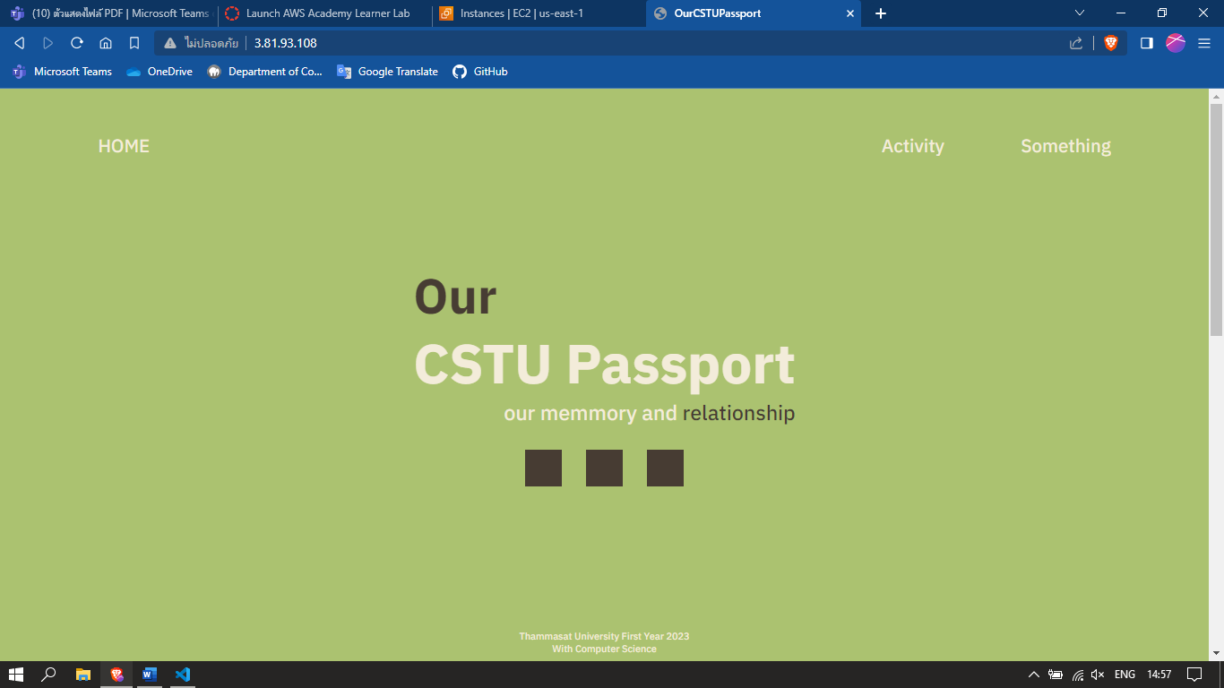

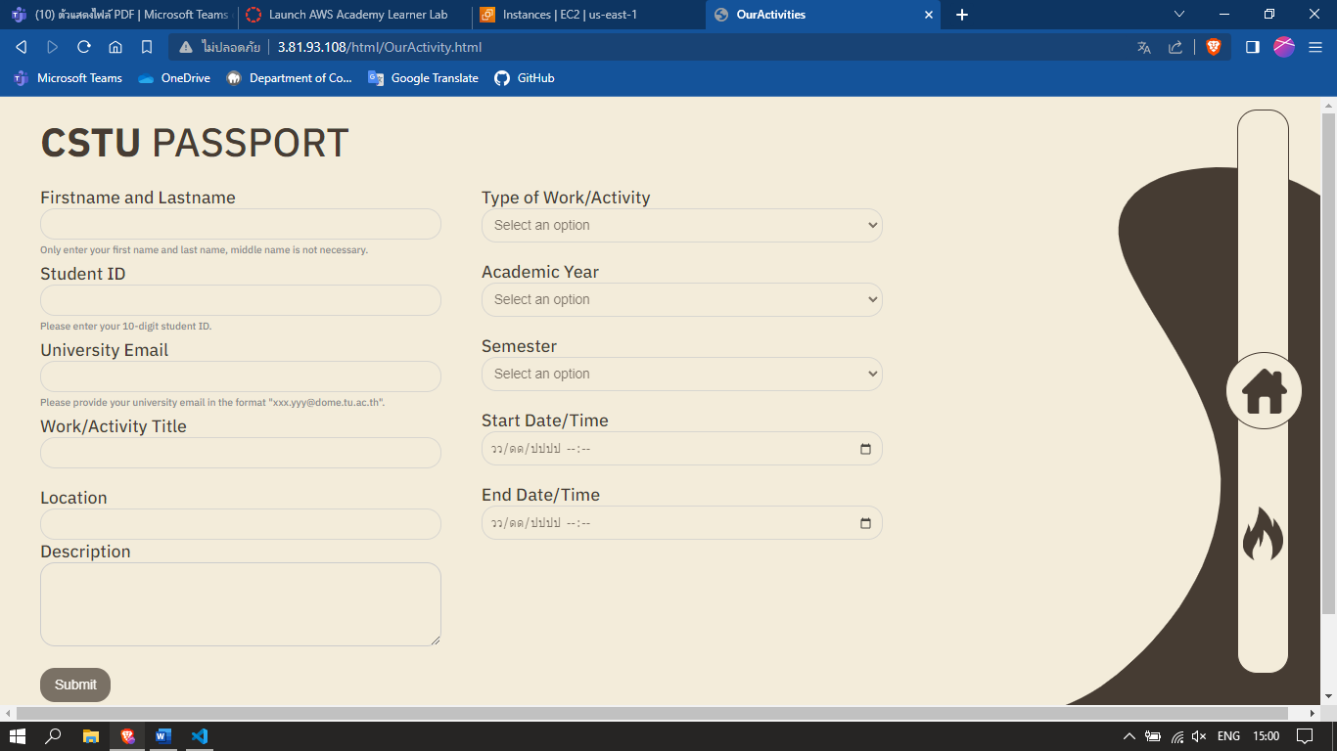

# Putty

