Technical note

E-PRTR Development of website
Dataflow Process Cookbook
Project ref.: 1010175 Date: 2009-03-05

Project ref: 1010175 |  | DOCUMENT REF: 0000.doc
Version | Remarks | Author | Reviewer | Approved | Date
1.0 | First draft. | HES | KTH | KTH | 2009-03-11

Introduction
This document describes the Dataflow Processes followed from the xml files are delivered in Reportnet till data are published on the website. The data process within Reportnet (uploading, submitting, validation etc.) is not a part of this document.

This document will evolve as the tools to support the processes are developed.

Overall dataflow
This section describes the overall timeline and dataflow for reporting and publishing the E-PRTR data.

Timeline
The generic timeline for reporting E-PRTR data is shown below.
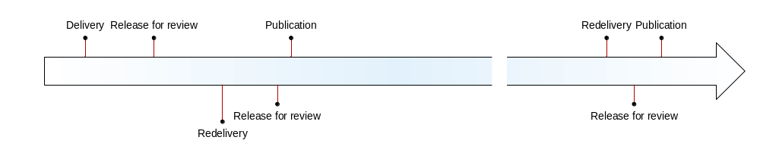

The RS must deliver the E-PRTR report before the deadline. After the delivery, data will be made available for review by the RS on the Review website. The RS is allowed to redeliver the report if the review reveals errors. The new report will be presented on the Review website instead of the now rejected data. The RS might repeat this process as many times as possible before the publication deadline if agreed with COM.

It will be possible to redeliver already published reports once or twice a year. This redelivery will follow the same process as the original delivery. This redelivery is not restricted to the latest reporting year, but might correct datasets from previous reporting years (including reporting years under the EPER reporting obligation).

For the first reporting round under E-PRTR, a timeslot of three months is available between the official submission and the final publication of the data. This allows three months for a correction round to complete from upload to publication. By 2010 this interval must be reduced to one calendar month in order to accommodate the move from triennial to annual reporting.

Data flow
A diagram is shown below describing the overall data flow of the E-PRTR data. The circles show the actions, with the transition arrows between actions showing the type of data transferred. The individual processes of the dataflow are described in the following.

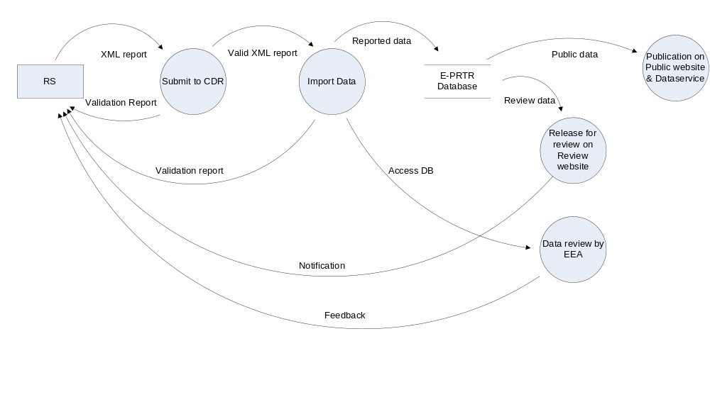

The E-PRTR report is delivered in XML format by use of the Central Data Register (CDR) of Reportnet. This process will be covered in the general description to the Reporting States (RS) on the uploading procedure.

After the XML file has been submitted to CDR, data are imported into the E-PRTR database. This process will be initiated by Atkins when the reporting deadline is reached. During the import process a manual QA (e.g. spatial validations) will be performed and a validation report will be placed in the CDR Envelope. Also Microsoft Access databases will be generated for use by the COM, EEA and European Topic Centre(s) for data review. The import process is further described in section 3.

EEA will coordinate with the ETC(s) for data review of the received and entered data. Any feed back to the RS will be communicated directly to the RS by EEA or the ETC(s). This process is not described any further in the present document.

In continuation of the data import, data will be made available for review by the RS on the Review website. A notification that data are ready for review will be given to the RS, e.g. through a message placed in the CDR Envelope. This process is further described in section 4.

If the RS finds any errors during the review a new report can be submitted in CDR before the deadline for redelivery (2009-09-01 for the first redelivery of 2007 data). How to handle redeliveries is described in section 6.

At the deadline for publication data will be made publicly available on the public part of the E-PRTR website. This process is initiated by Atkins. At the same time data will be made available for download from the EEA Dataservice. This process is further described in section 5.

Import Data
A flowchart describing the import process is shown below.

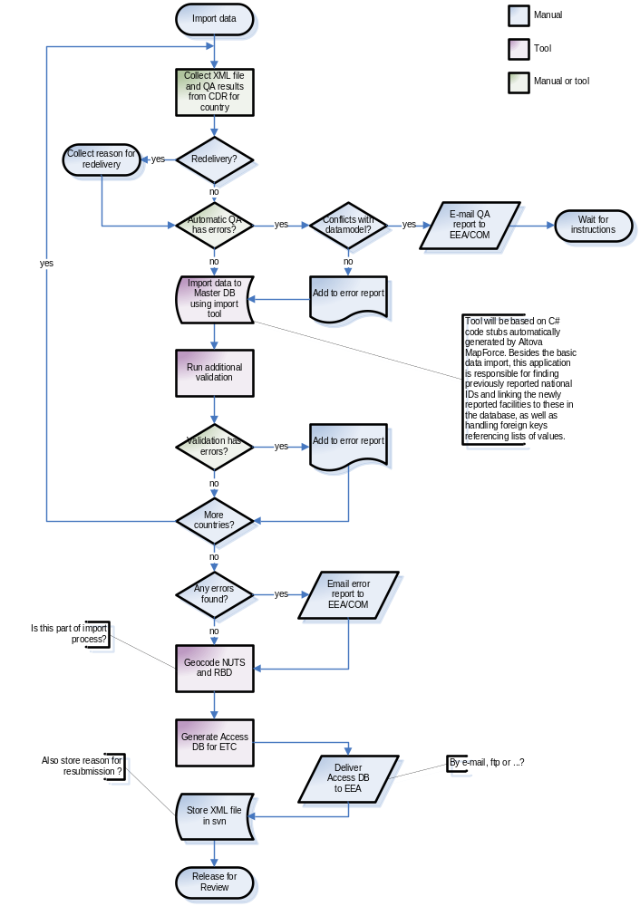
More detailed descriptions of how to process each step will be added when these are developed.

Release for review
A flowchart describing the process of releasing data to the Review website is shown below.

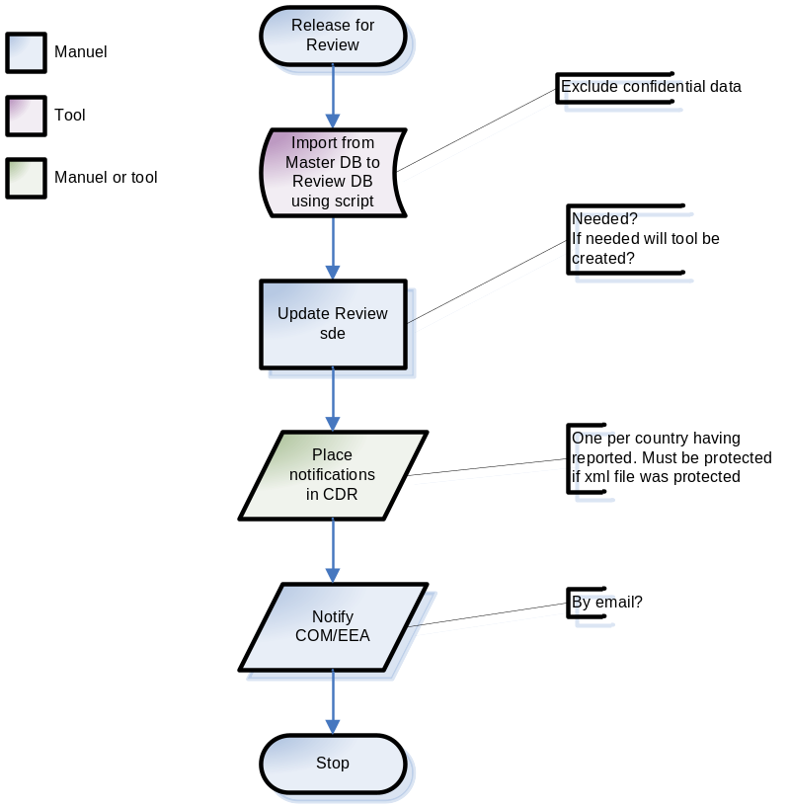

More detailed descriptions of how to process each step will be added when these are developed.

Publication
A flowchart describing the process of publishing data to the Public website and EEA Dataservice is shown below.

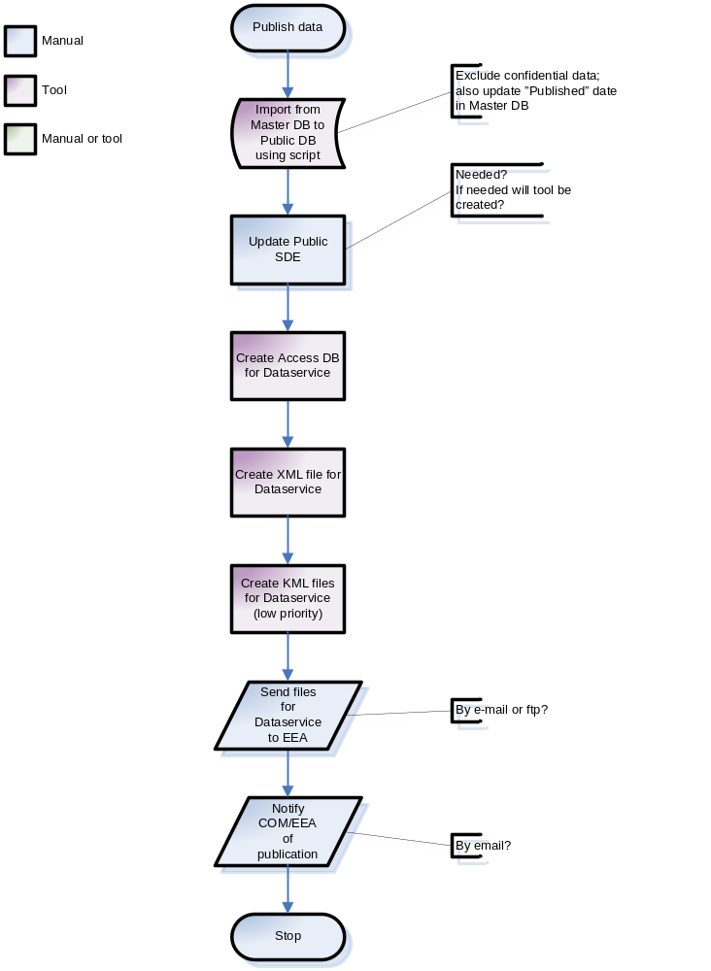

More detailed descriptions of how to process each step will be added when these are developed.

Redeliveries
When data are redelivered, the import process includes the sub-process “Collect reason for resubmit” as shown in section 3. A flowchart describing this sub-process is shown below.

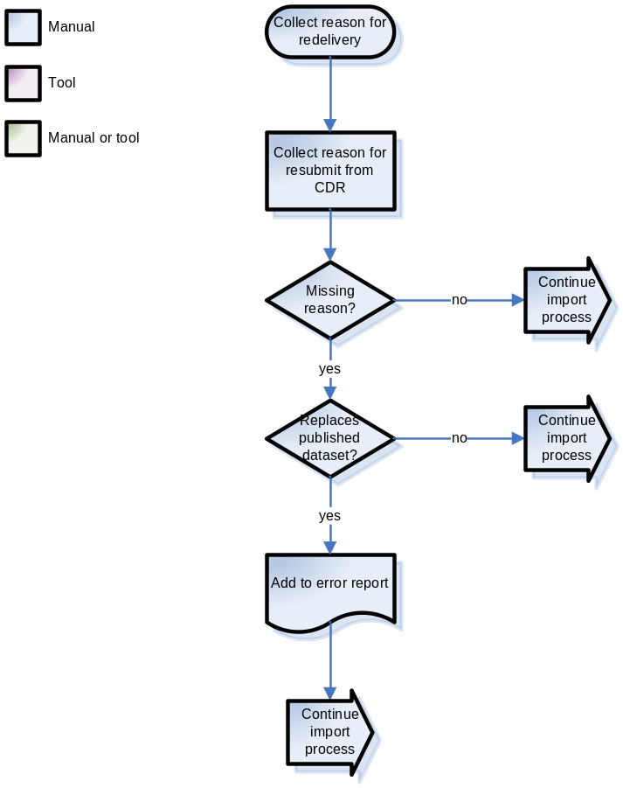

More detailed descriptions of how to process each step will be added when these are developed.

