

Development of the European PRTR website

Detailed Specification
CSV Downloads
Development of the European PRTR website

Detailed Specification – CSV Downloads

Project ref: 1010175 |  | DOCUMENT REF: 0000.doc
Version | Remarks | Author | Reviewer | Approved | Date
1 | Specification for top 3 priorities | HES | ARH/SHH |  | 2009-04-27
1a | Minor restructure after comments from SHH | HES |  |  | 2009-04-29
1b | Updated after comments from Dania. | HES |  |  | 2009-05-13
2 | Added specification of remaining CSV downloads decided on status meeting 2009-11-05. | HES | ARH |  | 2009-11-06

Table of Contents
1. Introduction 2
1.1 References 2
2. CSV Downloads – Overview 3
3. CSV Downloads – specifications 4
3.1 Structure of CSV Files 4
3.2 Search Facility (Use Case 3) 5
3.3 Search Waste Transfers (Use Case 8) 6
3.4 Time series on Facility level (Use case 25-27) 7
3.5 Time series on Aggregated level (Use case 25-27) 9

Introduction
This document defines detailed specifications of the content of the CSV downloads appearing throughout the E-PRTR website.
Decision from Status Meeting 5th November 2009:
CSV downloads will be included in the follow sheets:

- Facility search – "Facility list" sheet
- Waste Transfer search – "Hazardous transboundary" sheet.
- Time series on facility level
- Time series on aggregated level

Except for the Facility list sheet, these sheets represents all sheets that includes charts where the data is not also presented in a table within the sheet itself or in one of the other sheets within the same search.

References
Ref. | Title | Identification
[TS] | Technical Specification | https://svn.eionet.europa.eu/repositories/DotNet/Eprtr/tags/TechnicalSpecificationv2e

CSV Downloads – Overview
The following CSV downloads have been identified and prioritized. The use cases and sheet numbers refer to the Technical Specification, Appendix A [TS].
The CSV downloads are numbered according to the number of the result sheet on which they appear.
ID | Priority | Use case | Sheet | Described in section
6.5 | 1 | 8: Search Waste Transfers | 6.5:Transboundary hazardous waste | 3.3.1
1.1 | 2 | 3: Search Facility | 1.1: List of Facilities | 3.2.1
9.1.b | 3 | 25: Time series for Pollutant Releases (Facility level) | 9.1.b Time Series | 3.4.1
10.1.b | 3 | 26: Time series for Pollutant Transfers (Facility level) | 10.1.b Time Series | 3.4.2
11.1.b | 3 | 27: Time series for Waste Transfers (Facility level) | 11.1.b Time Series | 3.4.3
9.1.a | 4 | 25: Time series for Pollutant Releases (Aggregated level) | 9.1.a Time Series | 3.5.1
10.1.a | 4 | 26: Time series for Pollutant Transfers (Aggregated level) | 10.1.a Time Series | 3.5.2
11.1.a | 4 | 27: Time series for Waste Transfers (Aggregated level) | 11.1.a Time Series | 3.5.3

Status per 5th November 2009:
CSV downloads with priority 1-3 has already been implemented, except for the confidentiality warnings.

CSV Downloads – specifications
This section describes the detailed specifications for the CSV downloads identified in section 2.

Structure of CSV Files
The CSV files will consist of two parts: a “header” presenting the search criteria and a “body” presenting the search result. These two parts will be separated by a row with empty columns.
The delimiter to be used between columns will be “;”.
An example of the CSV file is shown below with the two parts indicated.
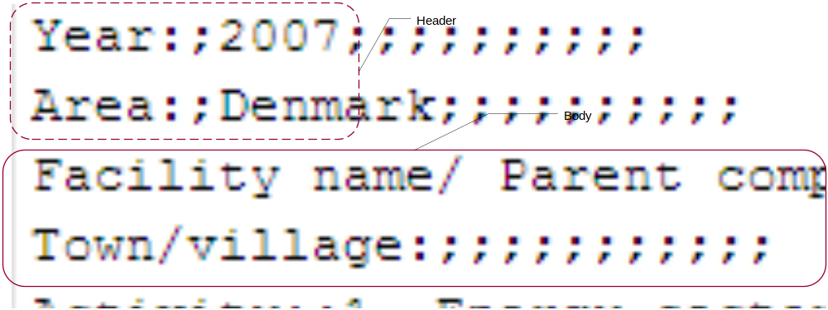
The header will contain the search criteria leading to the results at hand: Each criterion will be listed in a separate row. An example of how this will look when the CSV file is opened in Excel is shown below.
The parameters to be listed will be different for the different searches. In each case the parameters will correspond to the search options described in Appendix A of the Technical Specification document [TS].
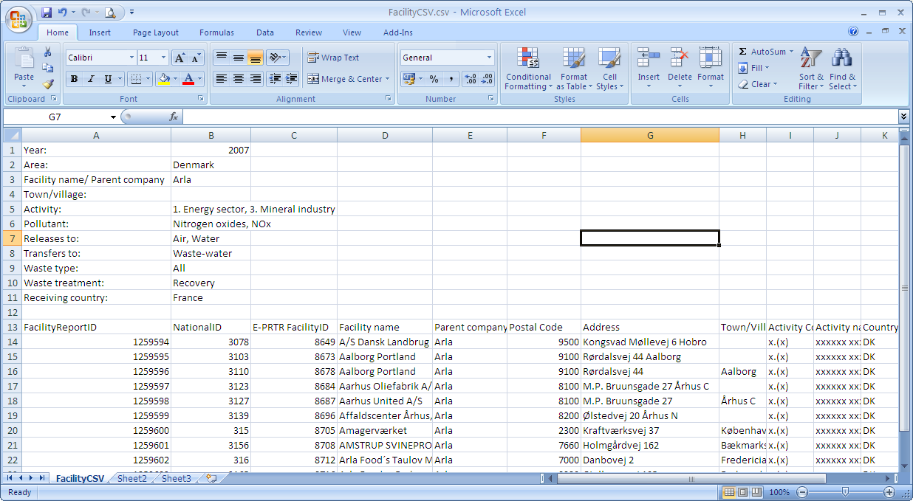
Decision from Status Meeting 5th November 2009:
The header will also include a warning if any confidentiality claims might affect the result. The text of the warning will be: "WARNING! Confidentiality claims may affect the result."

Search Facility (Use Case 3)

CSV 1.1: Facility list

Header
The following search criteria will be included in the header part of the CSV file:
- Year
- Area (Group, country, RBD / NUTS)
- Facility name/Parent company
- Town/village
- Activity incl. type (Industrial activity, Economic sector, IPPC)
- Pollutant
- Releases to (air, water and/or soil)
- Transfers to (waste water)
- Waste type (non hazardous, hazardous domestic and/or hazardous transboundary)
- Waste treatment (Recovery, Disposal and/or unspecified)
- Receiving country

If the advanced options (activity, pollutant or waste) are not included in the search, the rows concerning these will not be included in the header.

If confidentiality has been claimed, a warning will be included in the header as described in section 3.1. This will be coincident with the alert shown on the sheet.

Body
The following data will be included in the body part of the CSV file. Each row represents one row in the facility list presented in sheet 1.1:
- Year
- FacilityReportID
- NationalID
- E-PRTR FacilityID
- Facility Name
- Parent Company
- Postal Code
- Address
- Town/Village
- Activity: code and name (Two columns)
- Country: code and name (Two columns)
- River Basin district: code and name (Two columns)
- NUTS region : code and name (Two columns)
- “Permalink” URL for each facility (per data row), e.g.: http://prtr.ec.europa.eu/Popups/FacilityDetails.aspx?FacilityReportId=65560

The full result set corresponding to the search options will be included in the CSV file, independently of the paging used in the website.

Search Waste Transfers (Use Case 8)

CSV 6.5: Waste transfer grid
The waste transfer grid presents transferring of hazardous waste to other countries in a matrix as described in [TS].

The CSV download will contain data on aggregated level with one row per "dot" presented in the chart.

Header
The following search criteria will be included in the header part of the CSV file:
- Year
- Area
- Activity incl. type (Industrial activity, Economic sector, IPPC)
- Waste type

If the advanced option (activity) is not included in the search, the row concerning this will not be included in the header.

The confidentiality warning (see section 3.1) will be included if confidentiality has been claimed for hazardous transboundary waste fulfilling the search criteria. This may not coincide with the alert shown on the sheet, since the sheet alert goes for the total search result and thereby also includes any confidentiality claims for the other two waste types.

Body
The following data will be included in the body part of the CSV file. Each row represents one dot in the waste grid in sheet 6.5:
- Year
- From Country: code and name (Two columns)
- To Country: code and name (Two columns)
- Total HW: quantity and unit (Two columns)
- Recovery: quantity and unit (Two columns)
- Disposal: quantity and unit (Two columns)
- Unspecified: quantity and unit (Two columns)
- Number of facilities

Time series on Facility level (Use case 25-27)

CSV 9.1.b Pollutant Releases

Header
The following search criteria will be included in the header part of the CSV file:
- NationalID
- E-PRTR FacilityID
- Facility Name
- Address (including postal code and town/village)
- Country (Name)

If confidentiality has been claimed, a warning will be included in the header as described in section 3.1. This will be coincident with the alert shown on the sheet.

Body
The following data will be included in the body part of the CSV file. Each row represents one bar (i.e. one year) in the time series chart presented in sheet 9.1b:
- Year
- Pollutant: Name
- Medium (air, water or soil)
- Total release: quantity and unit (Two columns)
- Accidental release: quantity and unit (Two columns)
- Accidental percent

Notice that all rows will contain the same pollutant and medium, since time series is accessed per pollutant and medium on the facility level (from sheet 1.1.2).

CSV 10.1.b Pollutant Transfers

Header
The header will be the same as described for pollutant releases in section 3.4.1.

Body
The following data will be included in the body part of the CSV file. Each row represents one bar (i.e. one year) in the time series chart presented in sheet 10.1b:
- Year
- Pollutant: Name
- Total transfer: quantity and unit (Two columns)

Notice that all rows will contain the same pollutant, since time series is accessed per pollutant on the facility level (from sheet 1.1.3).

CSV 11.1.b Waste Transfers

Header
The header will be the same as described for pollutant releases in section 3.4.1.

Body
The following data will be included in the body part of the CSV file. Each row represents one bar (i.e. one year) in the time series chart presented in sheet 11.1b. As for the time series chart, data is aggregated per waste type:
- Year
- Waste type
- Total transfer: quantity and unit (Two columns)
- Recovery: quantity and unit (Two columns)
- Disposal: quantity and unit (Two columns)
- Unspecified: quantity and unit (Two columns)

Notice that all rows will contain the same waste type, since time series is accessed per waste type on the facility level (from sheet 1.1.4).

Time series on Aggregated level (Use case 25-27)

CSV 9.1.a Pollutant Releases
The aggregated time series on pollutant release level will be shown for one medium at a time selected by a radio button on the sheet (same principle as the summary page in the Pollutant Release search). The content of the CSV download corresponds to the medium currently selected on the sheet.

Header
The following search criteria will be included in the header part of the CSV file:
- Area (Group, country, RBD / NUTS)
- Activity incl. type (Industrial activity, Economic sector, IPPC)
- Pollutant
- Releases to (air, water or soil corresponding to the selected radio button on the sheet)

If confidentiality has been claimed for the medium selected, a warning will be included in the header as described in section 3.1. This warning may not coincide with the alert shown on the sheet since the sheet alert goes for the total search result and thereby also includes confidentiality claims for the other two mediums.

Body
The following data will be included in the body part of the CSV file. Each row represents one bar (i.e. one year) in the time series chart presented in sheet 9.1b:
- Year
- Pollutant: Name
- Medium (air, water or soil)
- Total release: quantity and unit (Two columns)
- Accidental release: quantity and unit (Two columns)
- Accidental percent
- Number of facilities
- Number of E-PRTR countries

Notice that all rows will contain the same pollutant and medium corresponding to the selected radio button.

CSV 10.1.a Pollutant Transfers

Header
The following search criteria will be included in the header part of the CSV file:
- Area (Group, country, RBD / NUTS)
- Activity incl. type (Industrial activity, Economic sector, IPPC)
- Pollutant

If confidentiality has been claimed, a warning will be included in the header as described in section 3.1. This will coincide with the alert shown on the sheet.

Body
The following data will be included in the body part of the CSV file. Each row represents one bar (i.e. one year) in the time series chart presented in sheet 10.1b:
- Year
- Pollutant: Name
- Quantity and unit (Two columns)
- Number of facilities
- Number of E-PRTR countriesError: Reference source not found

CSV 11.1.a Waste Transfers
The aggregated time series on waste transfer level will be shown for one waste type the time selected by a radio button on the sheet (same principle as the area comparison page in the waste transfer search). The content of the CSV download corresponds to the waste type currently selected on the sheet.

Header
The following search criteria will be included in the header part of the CSV file:
- Area (Group, country, RBD / NUTS)
- Activity incl. type (Industrial activity, Economic sector, IPPC)
- Waste type (non hazardous, hazardous domestic or hazardous transboundary)

If confidentiality has been claimed for the waste type selected, a warning will be included in the header as described in section 3.1. This warning may not coincide with the alert shown on the sheet, since the sheet alert goes for the total search result and thereby also includes confidentiality claims for the other two waste types.

Body
The following data will be included in the body part of the CSV file. Each row represents one bar (i.e. one year) in the time series chart presented in sheet 11.1b. As for the time series chart, data is aggregated per waste type:
- Year
- Waste type
- Total transfer: quantity and unit (Two columns)
- Recovery: quantity and unit (Two columns)
- Disposal: quantity and unit (Two columns)
- Unspecified: quantity and unit (Two columns)
- Number of facilities
- Number of E-PRTR countriesError: Reference source not found

Note that all rows will contain the same waste type corresponding to the selected radio button.

The number of countries with possibility of reporting for the year considered as shown on the sheet.

