Deployment manual for the European Pollutant Release and Transfer Register

Documentation

JOB NUMBER: |  |  | DOCUMENT REF:
Version | Purpose of issue | Originated | Checked | Reviewed | Authorised | Date
1.0 | Initial Draft | Martin Holleufer-Sørensen |  |  |  | 15.04 2009
1.1 | Updated patch procedure | Helle Spange |  |  |  | 10.03.2011
1.2 | Updated patch procedure | Helle Spange |  |  |  | 09.05.2011
ATKINS DANMARK

Table of Contents
1 Summary 3
2 Installation Prerequisites 4
3 Database Installation 5
4 Setup of Map Services 7
5 Front-end Installation EPRTR Website 12
6 Front-end Installation EPRTR CMS 16
7 Troubleshooting 20
8 Applying patches at EEA 23

Summary
This document explains all steps needed to deploy the E-PRTR system and the CMS system. The system consists of 4 Databases, a number of components with regards to map services, and a number of front-end and middle layer components.

Installation Prerequisites

Preface:
Deploying the E-PRTR and the CMS system will be done by implementing or adjusting the following features:
- Creating and importing the databases
- Setting up ArcGIS mapservices
- Installing the front-end and middlelayer components

Prerequisites:

- Microsoft Internet Information Server
- Microsoft ASP.NET
- Microsoft .NET Framework 3.5 SP1
- Microsoft Chart Controls for Microsoft .NET Framework 3.5
- Microsoft SQL Server 2008
- ArcGIS ArcSDE 9.3 for Microsoft SQL Server (incl. service pack 1)
- Access to a fully functional ArcGIS Server (NB incl. SQL Server 2008 Native Client)

Parameters:
Global parameters:
Name | Value
{SVN} | https://svn.eionet.europa.eu/repositories/EPRTR/trunk/
{SVN-Deploy} | https://svn.eionet.europa.eu/repositories/EPRTR/trunk/Deployment/
{SVN-Branches} | https://svn.eionet.europa.eu/repositories/EPRTR/branches/

Environment specific parameters:
Name | Build (Atkins) | Staging (Atkins) | Test/Prod (EEA)
{DB-SERVER} | sdkcga6302 | sdkcga6306 | TETRASQL
{DB-USER} | sa | gis | gis
{DB-USER-PWD}
{DB-SERVER-ADM} | sa | sa | eeadmz1\sorensen
{DB-SERVER-PWD}
{WEBSERVER REVIEW} | NA | sdkcga6306 | GOOSE
{WEBSERVER PUBLIC} | NA | sdkcga6306 | GOOSE/KILLERSLUG
{ARCGIS-SERVER} | sdkcga6307 | sdkcga6307 | KILLERWHALE
{EPRTRdocs} |  | c:\inetpub\wwwroot | s:\eprtrdocs

Database Installation

Steps required prior to deployment:

Execute C:\E-PRTR_DEPLOY_DB\Backup_and_zip_databases.cmd on the {DB-SERVER} at Atkins. This script produces a zip file containing a backup of the databases EPRTRmaster, EPRTRreview, EPRTRmaster and EPRTRcms.

Steps required:
To install the databases of the E-PRTR system follow the steps described below.

Steps required for setup:

- Log on to {DB-SERVER} as {DB-SERVER-ADM} e.g. via remote desktop
- Start “SQL Server Management Studio”. Log on by username {DB-USER} and password {DB-USER-PWD}.
- Download and unzip the file “{SVN-Deploy}/Database/TestDBs”.
- Perform below steps 5-6 for each one of the databases in the table below.

Database backup file | Database name
EPRTRmaster.bak | EPRTRmaster
EPRTRreview.bak | EPRTRreview
EPRTRpublic.bak | EPRTRpublic
EPRTRcms.bak | EPRTRcms

- Create Database by right clicking Databases and clicking New Database. The database name needs to correspond to the database name in the table below. Under Options make sure that the Collation is set to Latin1_General_CI_AS.
- Restore the created database by using the backup file corresponding to the database name. Right click the database node of the new database and click Tasks>Restore>Database. In the Restore Database dialogue set the Source for restore to From device and browse for the database backup file. On the EEA server only the S: and T: driver are accessible. The workaround is to specify the exact path and name of the backup file on the c-drive in the dialogue asking for file location. After adding the file check the checkbox in the list showing the backup sets to restore. Afterwards go to Options and select Overwrite the existing database(WITH REPLACE). Click OK.
- Run the script Grant_rights.sql
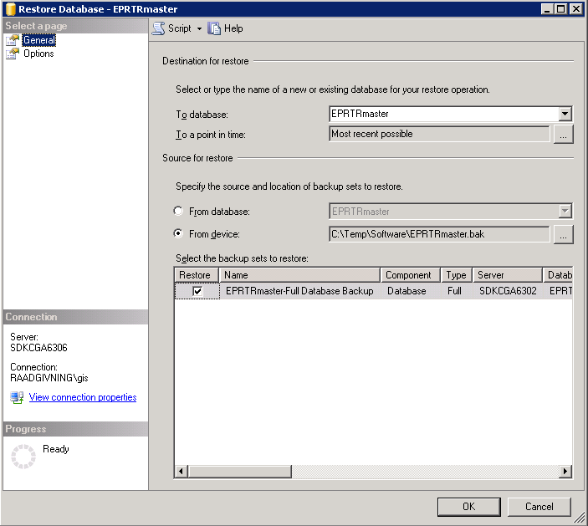
When the above steps are executed without errors, the E-PRTR databases are installed. All data are prepared now and the front end application can retrieve all database related information needed.

If the mapservices have already been set up it is necessary to restart all services using the ArcGIS Server Manager website.

Setup of Map Services

Steps required prior to deployment:
To prepare the maps of the E-PRTR system follow the steps described below. In general there will be two sets of mapservices. One set referencing the EPRTRreview database and another set referencing the EPRTRpublic database.

- Initialize the EPRTRreview and EPRTRpublic database with an ArcSDE license. On the {WEBSERVER} go to Start>Programs>ArcGIS>ArcSDE>ArcSDE for Microsoft SQL Server Post Installation.
- Choose Custom and click Next. Deselect all options except Authorize ArcSDE and click Next. Fill in the SQL Server instance name ({DB-SERVER}) and the Database name (EPRTRreview/EPRTRpublic). Make sure the default Windows Authentication method is choosed and click Next. In the next dialogue click Next and in the following dialogue choose the third option: I have received an authorization file from ESRI…. and click Next. Browse to the ecp-file and Click Next. Click Finish and Finish.
- Download the mxd-files in “{SVN}/map/mxd”.
- Open each one of the mxd-files in an ArcGIS Desktop Client and update the data source for each layer to point to the EPRTRreview/EPRTRpublic database at EEA. The data source is updated by right-clicking a layer and choosing Properties. In the Source tab click the Set Data Source Connection button in the lower right corner.

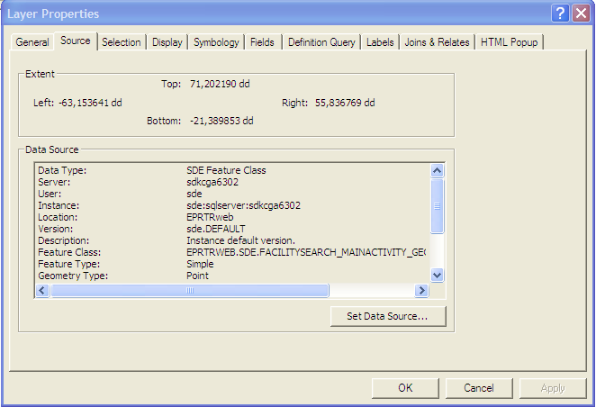
- Browse to Database Connections and choose the one pointing to {DB-SERVER}. Once the database connection is selected choose the feature class that the specific layer points. If in doubt the name of the feature class is given in the Soruce Tab. Please refer to the red circle in the above figure. If the {DB-SERVER} connection is not created already doubleclick the Add Spatial Database Connection and create a connection populating the dialogue below and clicking OK. Connection details need to be sde.default. Make sure the SQL Server is set up to handle remote connections. Please refer to the troubleshooting chapter for instructions on how to do this.

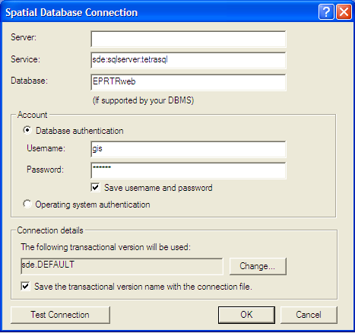
- Publish the modified mxd-file to a msd-file by selecting all layers in the left pane and clicking the Save Map Service Definition button marked with a red circle in the below figure. The button and functionality is only available in ArcGIS version 9.3.1. If the button is not visible the toolbar can be added by right clicking in the toolbar pane above the map window and selecting the Map Service Publishing toolbar.
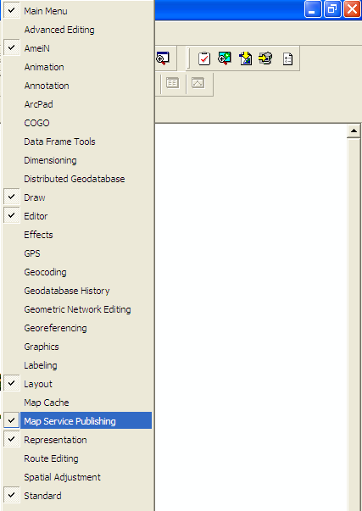
- Upload the modified mxd-files and produced msd-files to “{SVN-Deploy}/mxd”.

Steps required:
To install the map services of the E-PRTR system follow the steps described below.

Steps required:

- Download the msd-files in “{SVN-Map}/mxd” and place the files in a folder on {ARCGIS-SERVER} or a shared folder that can be accessed from {ARCGIS-SERVER}.
- Log on to the ArcGIS server manager: http:// {ARCGIS-SERVER}/arcgis/manager/ : Username {} and password {}.
- Click the Services menu from the list in the left part of the screen, click Manage Folders and choose Add. Type in EPRTR_REVIEW and click OK. Afterwards add another folder called EPRTR_PUBLIC.
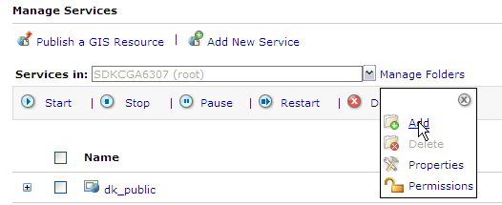
- Repeat below steps 4-7 for each one of the entries in the table below for each one of the folders EPRTR_REVIEW and EPRTR_PUBLIC.
- In the Services menu choose Add New Service and enter the name of the new service. Default Type is Map Service which is correct type. Click Next.
- In the Map Document field in the dialogue click browse and select the relevant msd-file from the folder where the msd-files were placed. Leave the rest of the fields with default information and click Finish.

Mapfile | Map Service Name
EPRTR_facilities.mxd | EPRTR_facilities
EPRTR_sector1_facilities.mxd | EPRTR_Sector1
EPRTR_sector2_facilities.mxd | EPRTR_Sector2
EPRTR_sector3_facilities.mxd | EPRTR_Sector3
EPRTR_sector4_facilities.mxd | EPRTR_Sector4
EPRTR_sector5_facilities.mxd | EPRTR_Sector5
EPRTR_sector6_facilities.mxd | EPRTR_Sector6
EPRTR_sector7_facilities.mxd | EPRTR_Sector7
EPRTR_sector8_facilities.mxd | EPRTR_Sector8
EPRTR_sector9_facilities.mxd | EPRTR_Sector9
EPRTR_RBDs.mxd | EPRTR_RBDs
EPRTR_diffuse_water_naggr.mxd

Make sure the SQL Server 2008 Native Client is installed on the ArcGIS server and make sure that a file called crossdomain.xml is placed in the wwwroot-folder on the ArcGIS server machine. This file enables Flex access. If it is missing no geometries will show up on the map. This file is a standard file and can e.g. be obtained from the sdkcga6307 machine at Atkins.
When the above steps are executed without errors, the Map services for the E-PRTR system are installed. All data are prepared now and the front end application can retrieve all map information needed.

Verification tests:

Test description | OK?
Log on to the ArcGIS server: http:// {ARCGIS-SERVER}/arcgis/rest/admin/ : Username {Username (NB case sensitive)} and password {}. Select Clear Cache Options and select Clear Cache Now. Logout of the REST Admin console. If the cache is not cleared the new services will not appear in the test page below.

Log on to the ArcGIS server: http:// {ARCGIS-SERVER}/arcgis/rest/services
For each one of the map services created above select the map service and view the map service in ArcGIS JavaScript. If the map services is working properly a new browser window will appear showing the specific map.

Front-end Installation EPRTR Website

Steps required prior to deployment:
To prepare the front-end of the E-PRTR system for deployment follow the steps described below.

- Log on to TeamCity on the build server: http://sdkcga6302:81
- Run Deploy Build on the Projects tab and make sure the build finishes with success.
- Tag the version in SVN.
- Zip the files generated in \\sdkcga6302\c$\E-PRTR_DEPLOY\PrecompiledWeb\EPRTRweb and upload the zipfile to “{SVN-DEPLOY}/EPRTRweb”.

Steps required:
To install the front-end of the E-PRTR system follow the steps described below. In general the system consists of two websites; the review website and the public website. Follow the steps below for each one of the websites.

- Download and unzip the zipfile located in “{SVN-DEPLOY}/EPRTRweb” and place the files in a folder named EPRTRweb on the {WEBSERVER}. E.g in the folders c:/inetpub/wwwroot/EPRTRreview and c:/inetpub/wwwroot/EPRTRpublic for the Review website and the Public website respectively.
- Download the file “{SVN-DEPLOY}/EPRTRweb.xml” to the {WEBSERVER}.
- Go to Start>Settings>Control Panel and doubleclick Internet Information Services (IIS) Manager.
- Expand the {WEBSERVER} node, right click the Web Sites folder and select New>Web Site (from file)…

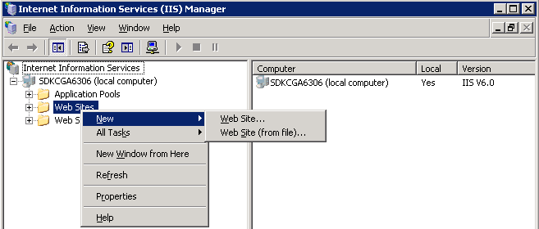

- Browse and locate the EPRTRweb.xml file that was downloaded from SVN, click Read File, select the E-PRTR Web Site and click OK.

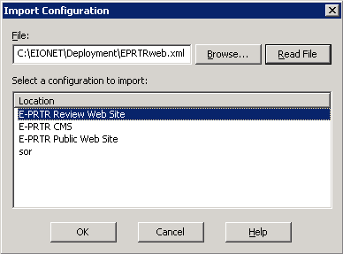
- Right click the new E-PRTR Web Site in the treeview at the left and select Properties. In the E-PRTR Web Site Properties dialogue select the Home Directory tab and update the Local path field to match the location of the downloaded EPRTRweb folder on the {WEBSERVER}. Click OK.

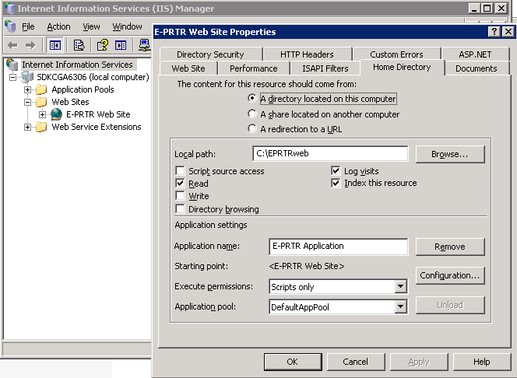
- In the EPRTRweb folder on the {WEBSERVER} update the connection string parameters in the web.config file to match the database on the {DB-SERVER} at EEA. The review website needs to reference the EPRTRreview database and the public website needs to reference the EPRTRpublic database. Also make sure that the login credentials for the databases are correct.
- With regards to the review website replace the following part of the web.config-file to enable login-procedure:
Replace:
<authentication mode="Windows"/>
<roleManager enabled="true"/>
<authorization>
<allow users="all"/>
<deny users="admin"/>
</authorization>

With:
<authentication mode="Forms">
<forms name="EEA" loginUrl="login.aspx" protection="All" />
</authentication>
<authorization>
<deny users="?" />
</authorization>

<membership defaultProvider="EEAMembershipProvider">
<providers>
<add name="EEAMembershipProvider" type="TestLogin.EEAMembershipProvider"/>
</providers>
</membership>
- With regards to the Review website make sure that the following line in the web.config file reads:
<add key="IsReview" value="true" />
instead of
<add key="IsReview" value="false" />
- In the EPRTRweb folder on the {WEBSERVER} replace the map service url’s in \Map\*.xml files to match the ArcGIS server at EEA. E.g. url="http://sdkcga6307/ArcGIS/rest/services/PRTR_REVIEW/EPRTR_Sector2/MapServer" →
url="http://killerwhale.eea.europa.eu/ArcGIS/rest/services/PRTR_REVIEW/EPRTR_Sector2/MapServer"
- To encrypt the connectionstring information in the web.config file run the following: cd C:\WINDOWS\Microsoft.NET\Framework\v2.0.50727
aspnet_regiis.exe -pef "connectionStrings" "<EPRTRweb folder>" -prov "DataProtectionConfigurationProvider"
- If not there already create an empty folder named “temp” in the EPRTRweb folder and make sure the IIS_WPG user has Write permission on the folder. Else why charts cannot be written to the folder and shown on the website.
- If not there already create an empty folder named “img” in the EPRTRweb\MapPrint folder and make sure that the IIS_WPG user has Write permission on the folder. Else why it is not possible to print maps.

The IIS needs to run in 32 bit mode. To switch a 64 bit server to run the ASP pages in 32 bit mode please visit:
http://support.microsoft.com/kb/894435
When the above steps are executed without errors, the front-end for the E-PRTR system is installed. All data are prepared now and the front end application can retrieve all information needed.

Verification tests:

Test description | OK?
Log on to the WEBSERVER from a client: http://{WEBSERVER}/ and try out the different parts of the functionality. E.g:
Expand the Search E-PRTR data and click Facility level. On the Facility levels page check to make sure that a map is appearing in the right hand side. After clicking
Search a list of facilities retrieved from the database should appear below the search box.
If error page appears please refer to the Troubleshooting chapter describing how to troubleshoot the E-PRTR system.

Front-end Installation EPRTR CMS

Steps required prior to deployment:
To prepare the front-end of the E-PRTR CMS system for deployment follow the steps described below.

- Log on to TeamCity on the build server: http://sdkcga6302:81
- Run CMS Deploy Build on the Projects tab and make sure the build finishes with success.
- Tag the version in SVN.
- Zip the files generated in \\sdkcga6302\c$\E-PRTR_CMS_DEPLOY\EPRTRcms and upload the zipfile to “{SVN-DEPLOY}/EPRTRcms”.

Steps required:
To install the front-end of the E-PRTR CMS system follow the steps described below.

- Download files from “{SVN-DEPLOY}/EPRTRcms” and place the files in a folder named EPRTRcms on the {WEBSERVER}. E.g in the folder c:/inetpub/wwwroot.
- Download the file “{SVN-DEPLOY}/EPRTRweb.xml” to the {WEBSERVER}.
- Go to Start>Settings>Control Panel and doubleclick Internet Information Services (IIS) Manager.
- Expand the {WEBSERVER} node, right click the Web Sites folder and select New>Web Site (from file)…

- Browse and locate the EPRTRweb.xml file that was downloaded from SVN, click Read File, select the E-PRTR CMS web Site and click OK.

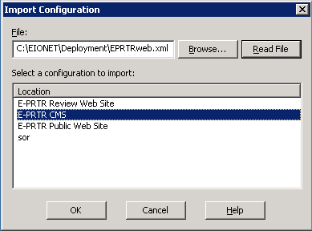
- Right click the new E-PRTR CMS Web Site in the treeview at the left and select Properties. In the E-PRTR CMS Web Site Properties dialogue select the Home Directory tab and update the Local path field to match the location of the downloaded EPRTRcms folder on the {WEBSERVER}. Click OK.

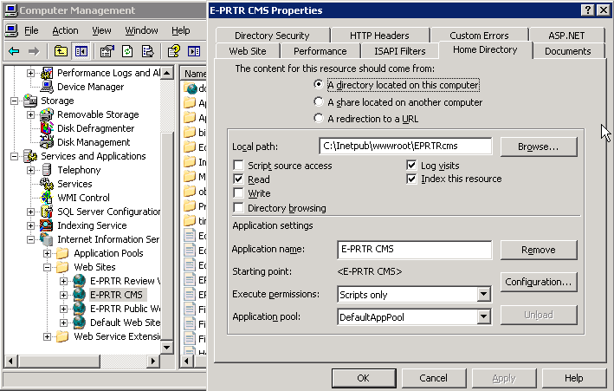

- In the EPRTRcms folder on the {WEBSERVER} update the connection string parameters in the web.config file to match the EPRTRcms database on the {DB-SERVER} at EEA.
- To encrypt the connectionstring information in the web.config file run the following: cd C:\WINDOWS\Microsoft.NET\Framework\v2.0.50727
aspnet_regiis.exe -pef "connectionStrings" "C:\Inetpub\wwwroot\EPRTRcms" -prov "DataProtectionConfigurationProvider"
- Replace the following part of the web.config-file to enable login-procedure:
Replace:
<allow users="?" />
With:
<deny users="?" />
- Create a shared folder named “eprtrdocs” and set up this folder as a virtual directory with the alias "docs" for the CMS website as well as for the Review and the Public website.

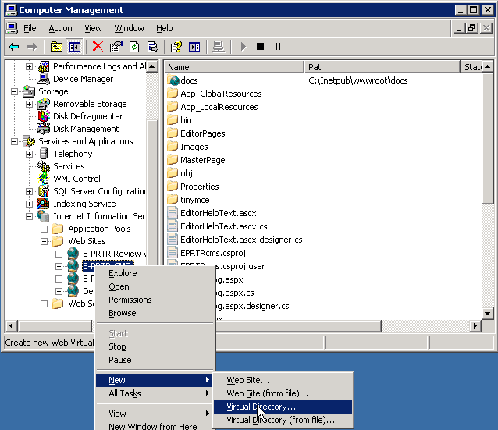
- Make sure the following part of the web.config references this folder and virtual directory, e.g.:
<add key="FileUploadPath" value="\\goose\docs" />
<add key="FileUploadVirtualDirectoryName" value="docs" />
and make sure the IIS_WPG user has Write permission on the folder. Else why CMS users cannot upload files to the directory.

Verification tests:

Test description | OK?
Log on to the WEBSERVER from a client: http://{WEBSERVER}/ and try out the different parts of the functionality. E.g:

Click the File catalog link on the main page. If error message appears check the FileUploadPath in the web.config file.

Try to upload a file to the File catalog. If this is not possible check write permissions on the File catalog folder.

Troubleshooting

IIS errors:

For detailed information about IIS errors please locate the web.config file in the EPRTRweb folder on the {WEBSERVER} and replace the below line
<customErrors mode="On" defaultRedirect="ErrorPage.aspx" > </customErrors>

with this line
<customErrors mode="Off"> </customErrors>

Microsoft Internet Information Server can be reset by going to Start>Run and execute iisreset.
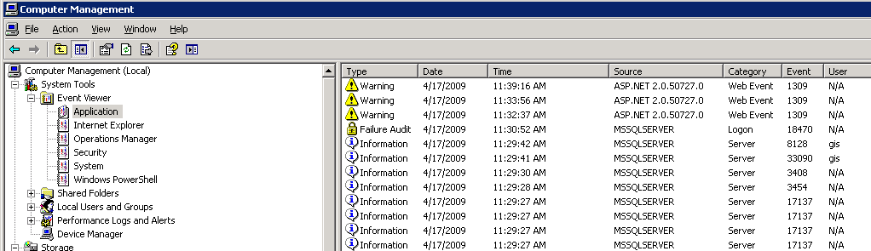
Another place to check for errors is in the Event Viewer in Computer Management. Start>Settings>Control Panel>Administrative Tools>Computer Management. Expand the System Tools and the Event Viewer and click Application. If a warning appears in the list around the time the error was received you can click the warning to see further error details.

System.Web.DataVisualization-error:

Make sure the Microsoft Chart Controls for Microsoft .NET Framework 3.5 is installed. Otherwise it can be downloaded from the following location:
http://www.microsoft.com/downloads/thankyou.aspx?familyId=130f7986-bf49-4fe5-9ca8-910ae6ea442c&displayLang=en

Map errors:
Make sure the SQL Server 2008 Native Client is installed on the ArcGIS server. Due to a bug in ArcSDE (http://forums.esri.com/Thread.asp?c=158&f=2290&t=274774) it is necessary to install the Native Client in order to be able to create a connection to a table with a native geometry colum in a SQL Server 2008.
The Native Client can be downloaded from:
http://www.microsoft.com/downloads/thankyou.aspx?familyId=c6c3e9ef-ba29-4a43-8d69-a2bed18fe73c&displayLang=en
Open the html-file and look for the paragraph describing the Microsoft SQL Server 2008 Native Client. Download the appropriate version according to your hardware.
If no tables show up in ArcGIS the database has probably not been initialized with an ArcSDE license. Please refer to chapter 4. Another common problem is if the tables have not been registered. To register the tables download and execute the file “{SVN}/map/register_tables_sde.bat” on the {WEBSERVER}.

After replacing the databases it is sometimes necessary to restart the mapservices:
- Log on to the ArcGIS server manager: http:// {ARCGIS-SERVER}/arcgis/manager/ : Username {} and password {}.
- Click the Services menu from the list in the left part of the screen, check the mapservices and click Restart.

If changes made to the maps don’t seem to affect the maps on the websites it may be due to the caching of maps. Please try to clear the cache using the rest-admin interface:
http:// {ARCGIS-SERVER}/arcgis/rest/admin
Type in username/password and choose Clear Cache Options and Clear Cache Now.
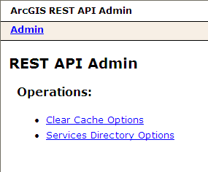
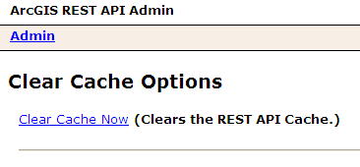

After launch of the website the mapserver was using a lot of resources (heavy load). Besides optimizing some of the map queries the following workaround was applied to the mapserver trying to solve the following problem:
On Windows 2003 Server, the Local Security Authority Subsystem Service (lsass.exe) grows in CPU usage and memory utilization under heavy load:
http://support.esri.com/index.cfm?fa=knowledgebase.techarticles.articleShow&d=32620

It is not possible to backup one database with SDE initialized and restore the database giving it another name. This is due to the fact that SDE hardcodes the databasename in some of the triggers/procedures. You’ll have to start all over setting up the database with the right databasename, creating tables and initialized the database with a SDE license.

Database connection problems:

To see the error message set <customErrors mode="Off"/> in the web.config file.
SQL Server needs to be set up to handle remote connections in order for ArcGIS Server to connect to the database. Go to Start>Programs>Microsoft SQL Server 2008>Configuration Tools>SQL Server Configuration Manager. Expand the SQL Server Network Configuration node and click Protocols for MSSQLSERVER. Make sure the TCP/IP protocol is Enabled. If not right click the protocol and enable it. Restart the SQL Server.
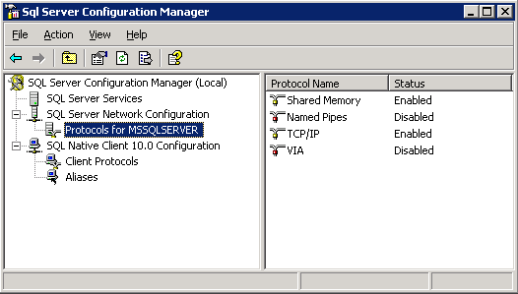

If you get the following error message. then the Service Broker need to be enabled on the EPRTRcms database.
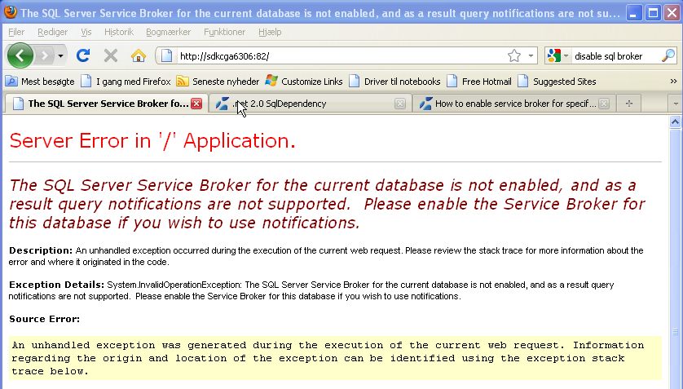

Use sql command: “alter database EPRTRcms set enable_broker with rollback immediate”

SqlDependency problem:
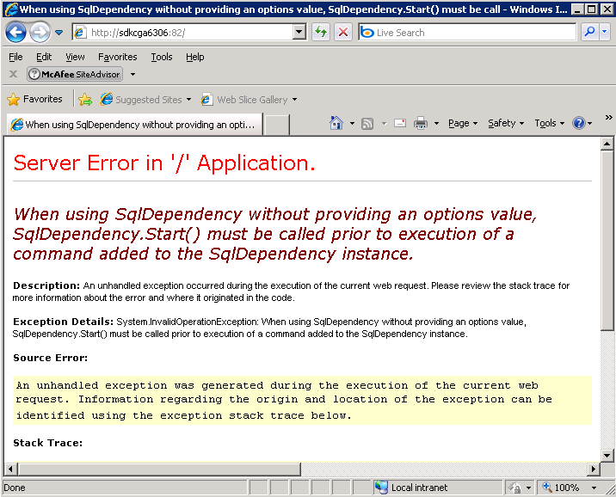

The GIS user needs to have the following privileges on the EPRTRcms in order for the service broker to work. After modifying the privileges you need to tweak (e.g. changing the username to gis1 and then back to gis) the web.config file in the website application. Make sure that the servername is correct (localhost at 6306)

<connectionStrings>
<add name="QueryLayer.Properties.Settings.EPRTRcmsConnectionString" connectionString="Data Source=localhost;Initial Catalog=EPRTRcms;User ID=gis;Password=tmggis" providerName="System.Data.SqlClient" />
<add name="QueryLayer.Properties.Settings.EPRTRresourceConnectionString" connectionString="Data Source=localhost;Initial Catalog=EPRTRcms;User ID=gis;Password=tmggis; Persist Security Info=True" providerName="System.Data.SqlClient" />
<add name="QueryLayer.Properties.Settings.EPRTRwebConnectionString" connectionString="Data Source=localhost;Initial Catalog=EPRTRpublic;User ID=gis;Password=tmggis" providerName="System.Data.SqlClient" />
</connectionStrings>

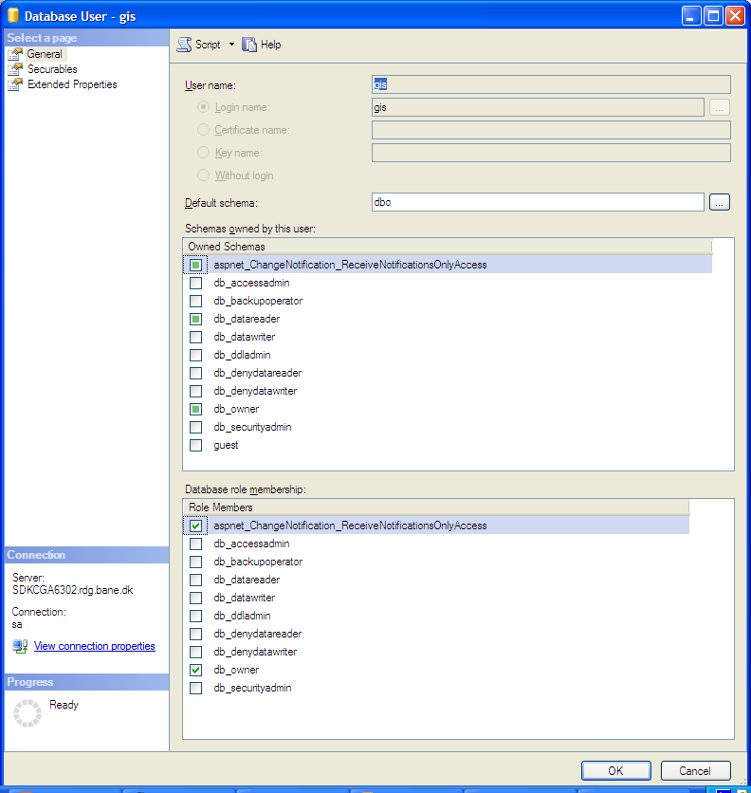

Versions of databases and .Net code:
Make sure that the versions of the databases and the .Net code match.
Also make sure they are the latest update.

Applying patches at EEA

Preparing the sites for test at Atkins

- Log on to TeamCity on the build server: http://sdkcga6302:81
- Run Deploy Build on the Projects tab and make sure the build finishes with success.
- Tag the version in SVN.
- Via Remote Desktop Execute the bat file \\sdkcga6306\c$\eprtr_ori\deploy_App\Copy_EPRTRweb_App.cmd. This will overwrite files for the Review and the Public website on the sdkcga6306 server with build files from sdkcga6302.
- Execute the bat file \\sdkcga6306\c$\eprtr_ori\deploy_App\Copy_EPRTRcms_App.cmd This will overwrite files for the CMS website on the sdkcga6306 server with build files from sdkcga6302.
- Update \\sdkcga6306\c$\EIONET\SQLScripts with files from “{SVN-branches}/EEA/SQLScripts” and execute \\sdkcga6306\c$\EIONET\ SQLScripts\DeltaScripts\master\upgrade.cmd and \\sdkcga6306\c$\EIONET \SQLScripts\DeltaScripts\cms\upgrade.cmd (Maybe an IISRESET is needed)
- Execute the test

Move the sites and database changes to EEA
- Executing the following bat file \\sdkcga6306\c$\eprtr_ori\deploy_App\Copy_EPRTR_App_EEA.cmd will copy newly build files from sdkcga6302 to sdkcga6306, replace connection strings and server names in the map files to match the environment at EEA. Afterwards the files are being zipped and the zip-file can be found in the folder C:\E-PRTR_Ori\Deploy_App with the name EPRTRwebsites_<DATE>.zip.
- Unzip the zip file at EEA and replace the files in the folder named EPRTRweb on the {WEBSERVER}. E.g in the folders c:/inetpub/wwwroot/EPRTRreview and c:/inetpub/wwwroot/EPRTRpublic for the Review website and the Public website respectively. With regards to the CMS site in the folder c:/inetpub/wwwroot.
- Execute the Import_CoreTexts.bat file to import the latest version of the static texts in the CMS database (csv file). Make sure that it points to the right database.
- Update Master database:
Correct the database connection etc. in SQLScripts\DeltaScripts\master\upgrade.cmd file to match the environment at EEA. Then run the script. Open "upgrade.log" and check that the script did run without errors.
- After updating the master database it is necessary to move the changes to the denormalised EPRTRpublic- and EPRTRreview-databases using the script copyEPRTRmasterViews2EPRTRwebTables.sql
- Update CMS database:
Correct the database connection etc. in SQLScripts\DeltaScripts\cms\upgrade.cmd file to match the environment at EEA. Then run the script. Open "upgrade.log" and check that the script did run without errors. (Maybe an IISRESET is needed)

Updates in Atkins environment when patch has been applied at EEA
- The deltascripts have been changed, now allowing for multiple executions. It is no longer needed to update the script files after running the scripts at EEA.

