

E-PRTR

Diffuse sources: specification of data

E-PRTR

Diffuse sources specification of data

Project no.: 1010175 |  | DOCUMENT REF: 0000.doc
Revision | Description | Author | Reviewer | Approved | Date
1.0 | Initial release | HG/HES | SHH | SHH | 20-01-2010

TABLE OF CONTENTS
1. Data 2
1.1 Reference system: 2
1.2 Formats: 2
2. Services 2
2.1 Mxd's: 2
2.2 Identify on map 2
3. Website Configuration and adjustments 2
3.1 .NET 2
3.1.1 Textual contents 2
3.1.2 Point source definition (facilities) 2
3.2 Flex Map configuration 2
4. Deliverables 2

SUMMARY
This document describes the data and services that are required to publish diffuse sources maps at the E-PRTR website, http://prtr.ec.europa.eu/.

Data

Reference system:
The maps will be presented on the website in WGS84 world reference system.

Formats:
The Grids shall be delivered in a file geodatabase; this can contain different projections of the datasets as well.

The datasets will be presented in the same format as delivered i.e. as grids or maybe as raster if this turns out to be a way to go in order to speed up performance of map services. No data processing will be performed.

Current diffuse source maps (water) are cached vector layers – but since caching in ArcGIS is a time- and space-consuming task, this is not necessarily the way to go – investigate performance with grid layers in a dynamic ArcGIS map service, compared to the effort of caching or transforming the dataset into raster.

The current water data is presented by river basin districts. If any of the datasets should be shown based on regions, these should be defined and the layers created and delivered ready and processed before they can be displayed on the PRTR website.

Services

Mxd's:
Each map shall be published as a separate service.

Create mxd's to use as base for the publishing of the ArcGIS services.

For map display the fields/values used in each map and the colour coding must be defined. In current water sets each map has two layers – one displaying value – the other displaying area type.

Identify on map
To enable identifies on map click on the PRTR website, a list must be delivered describing which fields from the layer attribute table to return for each map and display on map click (identify/selection). If these texts should be subject to translation, this must also be addressed prior to enabling display on PRTR website.

Website Configuration and adjustments

.NET
Including the maps in the .NET part of the website consists of the following activities:
- Create radio buttons in .NET for new maps
- Add textual content for each map

Textual contents
For each map a number of textual contents must be delivered as described in the following. These texts will be presented on the web site next to the maps. The text contents shall be delivered through the E-PRTR CMS. In order to prepare the CMS with the entries needed for this, a list of the maps including the short title of each map shall be delivered beforehand.

The texts must be delivered in all languages of the website. If the texts are delivered in the E-PRTR CMS before the generation of the XLIFF files for the translators, they will automatically be included in these.

Short Title
Will be shown next to the radio button selecting the map. Plain text – no formatting allowed. Notice that the short title is restricted to app. 50 characters.

Example:
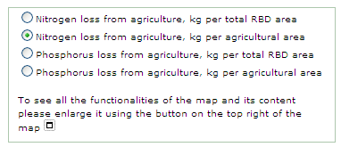

Full title
Will be shown as sub header in the sheets below the map. Plain text – no formatting allowed.

Example:
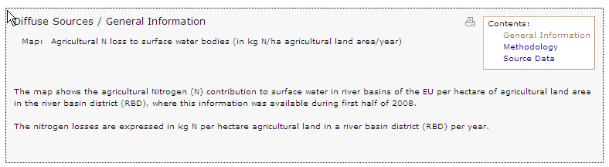

General Information
Content of the first sheet shown below the map. Formatting allowed.

Example:

Methodology
Content of the second sheet shown below the map. Formatting allowed.

Example:
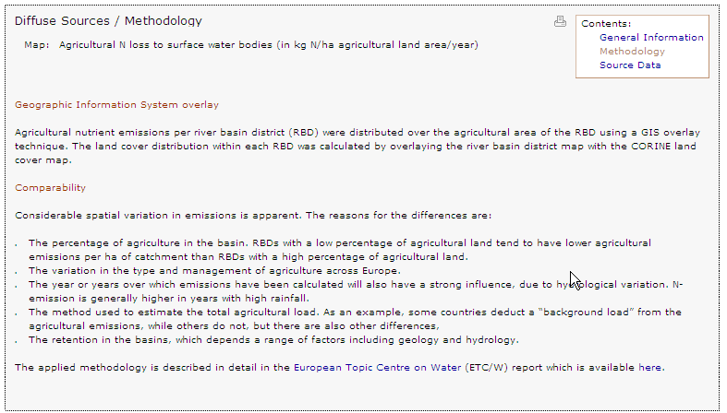

Source data
Content of the third sheet shown below the map. Formatting allowed.

Example:
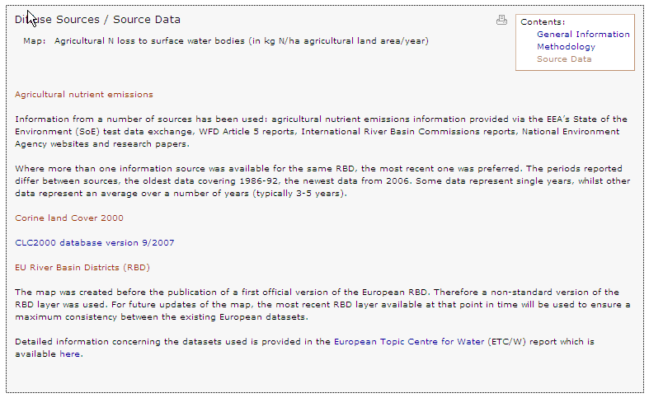

Point source definition (facilities)
Define the point source definition: Which facilities should be shown on each map? All criteria that are available from the main search in E-PRTR website page "pollutant release", http://prtr.ec.europa.eu/PollutantReleases.aspx, will be available to use in the filter for the point source map.

Information | Example
Pollutant Code  Mandatory. According to code list:  http://converters.eionet.europa.eu/xmlfile/EPRTR_PollutantCode_2.xml | TOTAL - NITROGEN
Medium  Mandatory. AIR or WATER | WATER
Year  Mandatory. The E-PRTR reporting year (i.e. 2007 or 2008) | 2007
Annex I Activity codes  Optional. According to code list:  http://converters.eionet.europa.eu/xmlfile/EPRTR_AnnexlActivityCode_1.xml | 7.(a)

The Annex I codes are optional. If not specified, all sectors will be included. Multiple Annex I coders are allowed in the same way as if these were selected in the activity search criteria in the pollutant release search (see below). This means that if more than one code is given, the codes must all belong to the same sector. Codes on sub-activity level should be avoided since reporting on this level is voluntary.
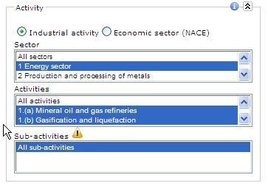

Flex Map configuration
Add the new map services to map configuration files (Air + Water)

Deliverables
Atkins requires the following deliverables in order to perform integration into the E-PRTR website:
- Metadata preparation
  - A list of the maps including short titles.
  - Point source definitions for each map as described in section 3.1.2.
  - ArcGIS Service description

- Textual contents for each map as described in section 3.1.1. To be delivered in the E-PRTR CMS.

- A file geo database containing the datasets in wgs84 world reference system.

- For each map, a list of fields from the attribute table to display on map identifies.

- ArcGIS Service setup and creation
  - An MXD for each map
    - For each map, a list of fields/values to display and their colour coding.
    - For each map, a list of fields from the attribute table to display on map identifies.
  - Publish MXD/Maps to ArcGIS server

