

Development of the European PRTR website

Detailed Specification
Use Case 6: Area Search
Development of the European PRTR website

Detailed Specification –
Use case 6: Area Search

Project ref: 1010175 |  | DOCUMENT REF: 0000.doc
Version | Remarks | Author | Reviewer | Approved | Date
1 | Specification for area search | HES |  | SHH | 2009-11-11

Table of Contents
1. Introduction 2
1.1 References 2
2. Statistical information 3
2.1 Industrial Activity search 3
2.2 Sheet headers 5

Introduction
At the status meeting the 5 November 2009, it was decided, that the Area Search will be implemented in form of additional statistic information in the other searches. As a consequence, no individual menu item for the Area search will be included in the web site.
This document describes the statistical information to be implemented.

References
Ref. | Title | Identification
[TS] | Technical Specification | https://svn.eionet.europa.eu/repositories/DotNet/Eprtr/tags/TechnicalSpecificationv2e

Statistical information
The statistical information will be implemented in two ways:
- A "Summary" sheet in the Industrial Activity search with overall statistic data
- Extended information in the sheet headers.
These two implementations are described in detail in the following.

Industrial Activity search
The industrial activity search allows for searching of selected sectors/activities within a selected area (country, RBD, NUTS). Results are currently presented on four sheets:
- Pollutant Releases (sheet 2.1)
- Pollutant Transfers (sheet 2.2)
- Waste Transfers (sheet 2.3)
- Confidentiality (sheet 2.4)
The sheet numbers refer to the Technical Specification document.
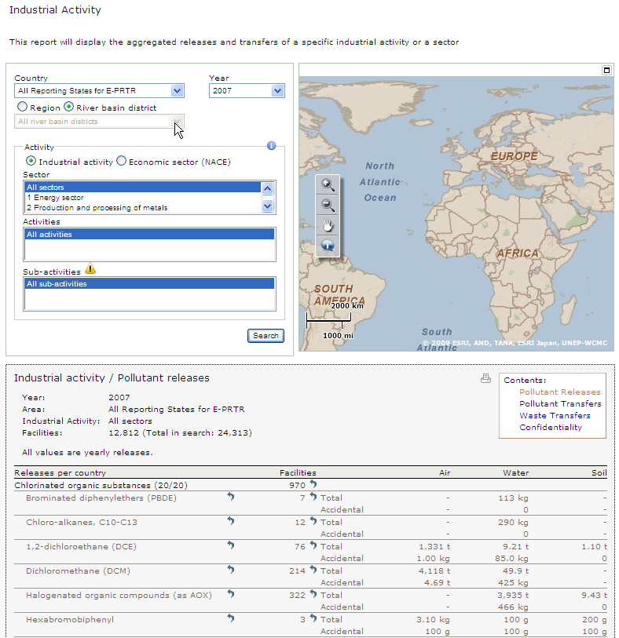
A new "Summary" sheet will be added to the contents box. This sheet will be the default sheet and will contain overall statistic data corresponding to the search criteria as show in the sketch below.
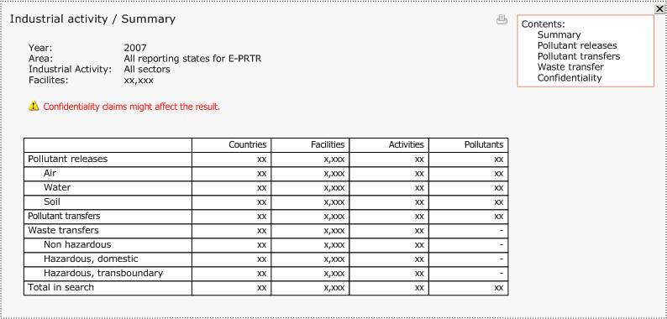
For each type of release/transfer the following information is presented:
- Countries:
The number of unique countries having reported the considered type.
- Facilities:
The number of unique facilities having reported the considered type.
- Activities:
The number of unique main activities (Annex I) having reported the considered type.
- Pollutants:
The number of unique pollutants being reported to the considered medium/ waste water- Not relevant for waste transfers.
A row with the total numbers fulfilling the search criteria. Notice that this will not correspond to the sum of the other rows, since some facilities reports both pollutants and waste.
Since the Industrial Activity search gives an overall picture of all data in the E-PRTR, it could be considered changing the name of this search, to something that reflects this.

Sheet headers
In all sheets, the total number of facilities fulfilling the search criteria is currently presented in the header. An example is shown below.
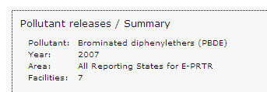
This information will be extended with a row presenting the number of main activities (Annex I) fulfilling the search criteria. In the example above, this would be:
Main activities: 2
The numbers shown will always correspond to the Annex I activities, independent of the search options. This will be consistent with the map, always showing Annex I sectors.
Notice that both the facilities as well as the activities correspond to the total numbers fulfilling the search criteria, even if the sheet it self only presents parts of the data.

