Kickstarting with Excel

Overview of Project: The overview of this project is to determine the successfulness of Kickstarter campaigns based on their launch dates and goals

Analysis and Challenges: I performed my analysis by compiling data of the successful, failed and canceled Kickstarter campaigns based off of what time of the year the campaigns were launched. I displayed this information in a line chart below
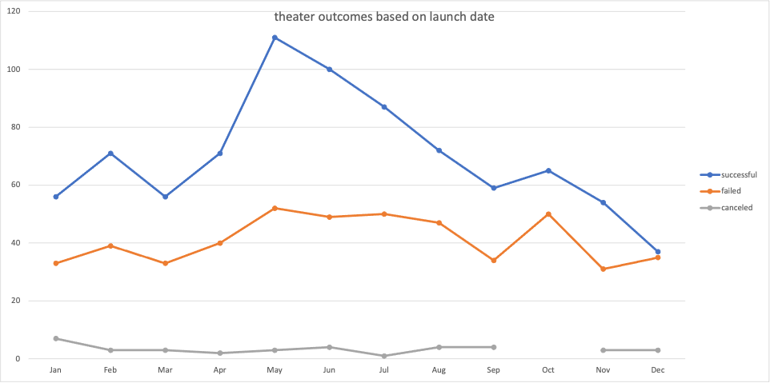

I also compiled the data the outcomes of theater Kickstarter campaigns based on the goals. I Displayed this information in a line chart below.

I encountered some difficulties while compiling the data for the outcomes based on goal because I didn’t have my ranges setup correctly, I was able to troubleshoot this problem through help with my TA.

Results

- The top three successful campaigns were launched in May, Jun and July and the top three least successful campaigns were launched in November, December and January based on the outcomes based on launch dates.

- The most successful Kickstarter campaigns had goals under $1000 with a 76% rate of success

- This dataset was limited by not including outcomes based on amounts pledged and outcomes based on dates ended by

