TeaServlet Architecture

February 5, 2002

Please send all comments to: opensource@dig.com

Copyright © 2000 by Walt Disney Internet Group

Document Revision and Evolution
Primary Author(s) | Description of Version | Date Completed
Michael Rathjen | Initial public release, based on interviews with Brian O’Neill. | June 30, 2000
Michael Rathjen | Minor update. | July 12, 2000
Jonathan Colwell | TeaServlet 1.5.0 changes added in section 4 | February 4, 2002

Preface
This document provides an overview of the TeaServlet Architecture for Java developers. It is not intended to be a user manual for TeaServlet.
There are a number of other documents complementary to this reference that cover topics associated with Tea and Tea-related tools. For additional Tea-related documentation, please visit http://opensource.go.com/.

Contents
1. Introduction 3
2. Functional Relationships 4
2.1 Applications and Contexts in TeaServlet 4
2.2 Function Priority in the Merged Context 5
3. TeaServlet Process Flows 6
3.1 Sequence of Initialization 6
3.1.1 Merged Application 6
3.1.2 Compiled Templates 6
3.2 Sequence of Execution 6
3.2.1 Servlet Request 7
3.2.2 Path Info Mapped to Template 7
3.2.3 Template Execution 8
3.2.4 Output Buffer 8
3.2.4.1 Output Capture 8
3.2.4.2 Character Conversion 9
3.2.4.3 Predetermined Content Length 9
3.2.5 Servlet Response 9
3.3 Sequence of Destruction 9
4. Changes for TeaServlet 1.5.0 10
4.1 com.go.tea.engine.* 10
4.2 Applications & ContextSources 10
4.3 DynamicContextSources 10
4.4 Template and Context Reloads 11

Introduction
The Tea Servlet architecture is a complete template environment that delivers web pages via the servlet API. Tea templates cannot directly acquire or modify information, but rely instead on their host to provide data returned from called functions. This is where the Tea Servlet plays an important part.
The role of the TeaServlet is to execute the Tea templates and their scripted data into a web page by taking the scripted data, executing Java internally, and sending the web page to an output buffer. The TeaServlet performs this conversion each time a page is requested, which provides the ability to serve dynamic content through defined templates.

Functional Relationships
In order to be more useful than standard HTML, Tea templates call upon special functions that are managed in contexts and returned by applications. The TeaServlet needs to support multiple contexts, so a merged context and a merged application are created. This saves the developer from having to merge the contexts manually beforehand.

Applications and Contexts in TeaServlet
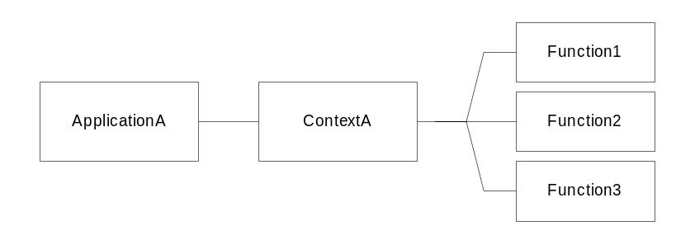
Figure 1 - The Role of a Context
Figure 1 illustrates the relationship between functions and an application. An application serves to return a context (a collection of functions) to a Tea template call, where each application can provide only one context. In a similar fashion, Tea templates can accept only one context. However, the TeaServlet can manage multiple contexts by merging the contexts and applications, as shown in Figure 2.

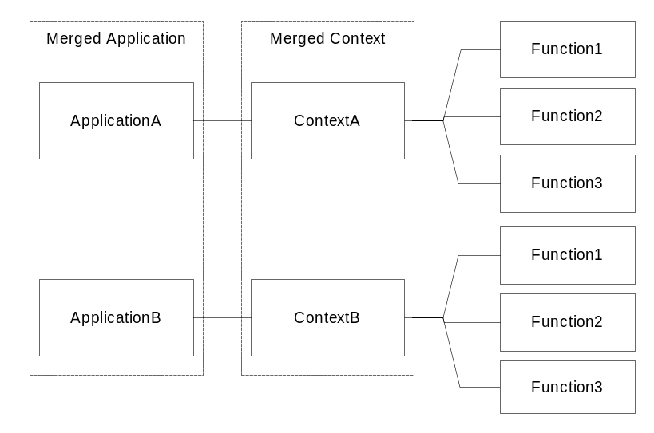
Figure 2 - The Relationship between Applications and the Merged Application
When the merged application is called to provide a context type, it gathers contexts from each individual application. The functions of each context are contained in the merged class. The merged application takes each context and passes it to the instance of the merged context class. This generated class is a wrapper; it delegates function calls to the appropriate applications. If any included context implements interfaces or is an interface, the merged class implements the interfaces.
TeaServlet 1.5.0 Update: with the addition of the com.go.tea.engine package, much of the context management functionality has been moved out of the TeaServlet. Due to these changes, the MergedApplication no longer exists, but a merged context is still created by the TeaServletEngine. Please see Section 4 for more details on changes for Teaservlet 1.5.0. -jc

Function Priority in the Merged Context
One or more contexts may have the same function, or different functions may have the same name. When contexts are merged containing conflicting function names, the first function added to the merged context will have preference. Any additional functions with the same name will not be added to the merged context using that name. Those functions can still be called by using a more complete name. An example follows:
Two applications, appA and appB, are contained in a merged application and they both have functions named foo. If function foo is called from a template, then the actual foo called is from appA, not appB. Either foo can be directly called by using complete addressing, such as appA.foo and appB.foo. Note that this order preference is not alphabetical. If appA and appB were reversed in the configuration order, function foo would be appB.foo.
There is also a default context built into the TeaServlet that provides a number of default functions. The functions in this context have the highest order preference and cannot be overridden with user-supplied contexts or their corresponding applications. The default context is not associated with any application.

TeaServlet Process Flows

Sequence of Initialization
When the TeaServlet is first started, it performs a series of tasks, including initializing applications, merging contexts, and loading and compiling templates.
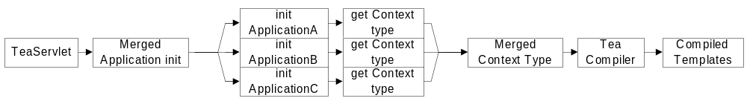Figure 3 - TeaServlet Sequence of Initialization

Merged Application
The TeaServlet begins by creating an empty merged application based upon an initial set of parameters. The TeaServlet then calls an init method on the merged application, resulting in the loading of each application. The merged application subsets the initial set of parameters to ensure that each individual application receives the correct parameters.
Each application’s init method is called, and the application is queried for what context it provides. If an application provides no context, it returns null to the query and during execution the merged application will not ask the application to create a context.
After querying applications and gathering the context types they provide, the merged application creates an auto-generated merged context.

Compiled Templates
The TeaServlet finishes initialization when the merged context class passes the templates to the Tea compiler. By option, the resulting compiled files can be saved to disk. During future initializations, the TeaServlet compares the dates of the source file to the class file. The TeaServlet then recompiles those source files that are newer than their class files. If the TeaServlet encounters template errors, it still loads as many templates as it can in an attempt to get into a usable state.
To ensure that user-defined classes don’t conflict with standard Java classes, a prefix is added during compilation. For example, if foo.java is compiled to foo.class, then foo.tea cannot also be compiled to foo.class. A package prefix is added to the class file, and it becomes com.go.teaservlet.template.foo.class.

Sequence of Execution
All Java servlets receive a request, process the request, and send a response. When the TeaServlet receives a servlet request, it performs a series of tasks that results in a web page sent as a servlet response. This series of tasks restarts for every hit, allowing the content to change from one hit to the next.
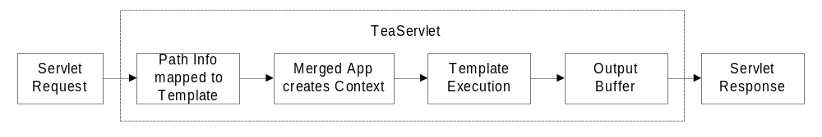Figure 4 - TeaServlet Sequence of Execution

Servlet Request
The servlet engine sends a request to the TeaServlet in the form of a doGet or doPost method. The TeaServlet treats both methods identically. This feature lets templates be created as receivers of form-posted data.

Path Info Mapped to Template
The URI is processed by the servlet engine, where it is broken down into components such as the servlet path, path info, and query string. The TeaServlet then maps the path info to the appropriate Tea template as shown in Figure 5.
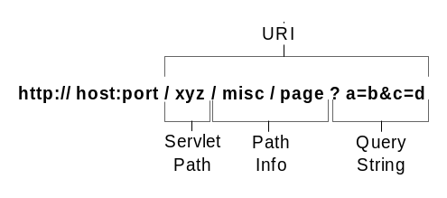
Figure 5 - URI Breakdown
Note that there is no .tea extension in the path info. The TeaServlet does not map the URI based upon file extensions. The path is translated to a fully qualified class name. In the example from Figure 5, the class name would be com.go.teaservlet.template.misc.page. If the servlet is mapped in using an extension, the extension is trimmed, the remaining portion of the servlet path is then used to determine the requested template.
If parameters from the query string are requested, they are passed to the template. Although many search engine spiders will not index URLs that contain a query string, TeaServlet supports custom separators. This lets developers use custom characters for query string separators.
The following configuration example, placed into the properties file, lets the TeaServlet to process additional patterns for the query string separator characters ‘?’, ‘=’ and ‘&’.

separator.query = .html/
separator.value = -
separator.parameter = /

Using the example setup above, a request for /path/directory?user=9999&show=address can also be requested as /path/directory.html/user-9999/show-address.

Template Execution
If the TeaServlet finds the template based upon the URI breakdown, it creates an application request object and a response object. The request object determines which template to use and the response object is the output buffer. The TeaServlet then calls the merged application for the merged context.
Each context object is passed into the merged application, and the output buffer is created. The content from the executing template is stored in the output buffer until complete.
If a redirect is executed, the template processing stops and the browser is told where to go. If there is an error in the content, the buffer is discarded entirely and the servlet engine error handler becomes responsible for a new response. The servlet engine error handler can write standard responses for standard errors. If any exception occurs, it is captured, logged, and an “HTTP 500 Internal Server Error” is passed to the user. Template aborts are not logged as errors.

Output Buffer
The TeaServlet includes a buffer that holds data while the template executes. The executing template may pull data from several different sources. Figure 6 shows an example of a web page constructed from an output buffer.
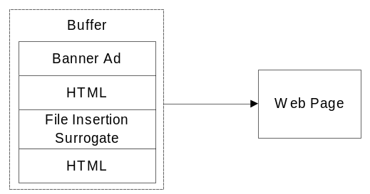
Figure 6 - TeaServlet Buffer
The output buffer is designed to provide several features, such as efficient capture of output, character conversion, and predetermined content length.

Output Capture
Unlike a string buffer, which doubles in size when it grows and must repetitively copy itself, the output buffer consists of a linked list of smaller buffers. The output buffer resizes itself as needed and captures the output stream efficiently.

Character Conversion
The output buffer provides character conversion from Java unicode to other character set encodings, such as ISO-8859-1 and UTF-8. Any constant strings are captures and the character conversion is cached, improving performance.

Predetermined Content Length
Having a predetermined content length allows the TeaServlet to use persistent connections, increasing transmission efficiency.

Servlet Response
If the template is executed without errors, it sets the content length (computed by the output buffer) and writes the buffer to the output stream, completing the servlet response. Once the servlet response is sent, the TeaServlet is finished for one hit.

Sequence of Destruction
After completing the hit, the TeaServlet calls the merged application’s destroy method, which in turn calls each application’s destroy method.
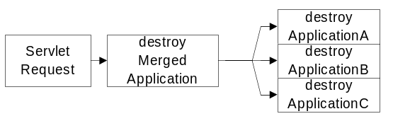
Figure 7 – Sequence of Destruction

Changes for TeaServlet 1.5.0
After moving to the function model and multiple contexts in late 1999, the core operation of the TeaServlet remained essentially the same for the next two years. Most changes during that time either occurred on top of the existing API or required the addition of hooks deep inside to expose useful information and management control. When the ability to reload contexts in a running instance was considered, it became clear that the internals should be rewritten from the ground up in a more modular fashion and that all functionality not related to servlets or the networks should be moved into the realm of pure Tea and made available to other applications interested in an easier Tea integration.

com.go.tea.engine.*
This package contains interfaces and utilities intended to simplify the integration of Tea into any user application (as is program, not and teaservlet Application). Two critical interfaces are ContextSource and TemplateSource. A ContextSource is very much like the Application interface that all TeaServlet users should be familiar with. While it isn’t a superinterface of Application to preserve backward compatibility, the two interfaces are interchangeable once initialized. TemplateSources allow the management and compilation of templates to be handled by smaller units thus allowing a program to operate without having to pay attention to the details of templates and can just execute them with the assumption that the right things will happen. Since the TemplateSources contain a reference to the ContextSource used to compile the templates, there should be a minimum of execution errors. The once daunting task of merging contexts is now trivial thanks to the MergedContextSource that in a sense takes the place of the MergedApplication but is no longer TeaServlet specific. There is a TeaExecutionEngine interface as well as a SimpleTeaEngine implementation but this isn’t all that useful yet and is primarily intended as an example.

Applications & ContextSources
Since the Application and the ContextSource interfaces are essentially interchangeable, the TeaServlet will initialize the Applications and then wrap them as ContextSources to take advantage of the classes in the com.go.tea.engine package mentioned above. When an application is asked to create a context, an object containing a request and a response is passed in to the wrapper which extracts the components to use as in earlier TeaServlet versions.

DynamicContextSources
Some Applications can expect that the context type returned may change over time. In earlier versions of the TeaServlet, the context type was expected to remain the same and no provisions were taken if this was not in fact the case. Now, if an application intends to change the returned context type, it may implement com.go.tea.engine.DynamicContextSource. This application must then be able to return instances of past context types since now the createContext method will specify an expected class to ensure that the templates receive the correct execution context.

Template and Context Reloads
When templates are reloaded, getContextType() is called on any DynamicContextSources to determine if the context type has in fact changed. If this is the case, the MergedContextSource is recreated and all templates are compiled against the new Merged Context. Once this is completed successfully, the new TemplateSource is swapped in to replace the old one and all templates are executed against the new context. As mentioned in the previous section, the DynamicContextSource must retain the ability to return instances of an older context type since Templates compiled against that type may still be executing.

Custom Template Sources
Templates may be loaded from files and from URLs in the same manner as before but additionally, custom template sources may provide the ability to load templates from other locations. The custom template source will be provided with a single context source to compile the templates against and will then be responsible for managing the templates as specified by the TemplateSource interface.

