4th DB Hand in

# Description of the solution

The solution is an extension to the 3rd DB handin amd it is build on the same Master page, CSS file and skin files. The menu item SPONSORS is added to the menu bar allowing coaches to maintain sponsor information.

The XML CRUD page (sponsorCRUD.aspx) is bulid on the CoachMaster page and only persons who are loged in as a coach can access the page. At the page, coaches can create new sponsors, delete existing sponsor and update a sponsor’s information. When the page loades all sponsors displayes at page using a repeater. Coaches can select sponsors from a dropdownlist.

The Sponsor pictures is stored in the Pictures – Sponsor folder in the project. The pictures displays at the welcome page using a Repeater. At the SponsorCRUD page, coaches also can upload pictures of type .jpg or .png to the folder.

The XML file used in the solution is stored in the XML file folder in the project.

# XML file

The file contain:

<root> tag: Sponsors

<child> tag: Sponsor

<subchild> tag: all the elements of a sponsor; id, companyname, website, picture.

<?xml version="1.0" standalone="yes"?>

<sponsors>

<sponsor>

<id>1</id>

<companyname>Nike</companyname>

<website>http://nike.com</website>

<picture>nike_logo.jpg</picture>

</sponsor>

<sponsor>

<id>2</id>

<companyname>High5</companyname>

<website>http://highfive.co.uk/</website>

<picture>high5_Logo.jpg</picture>

</sponsor>

<sponsor>

<id>3</id>

<companyname>TechnoGym</companyname>

<website>http://technogym.com</website>

<picture>technogym.jpg</picture>

</sponsor>

<sponsor>

<id>4</id>

<companyname>6 Directions</companyname>

<website>http://www.6-directions.com</website>

<picture>6-directions_logo.jpg</picture>

</sponsor>

</sponsors>

# Welcome page

The welcome page uses repeaters to display activity pictures and text.

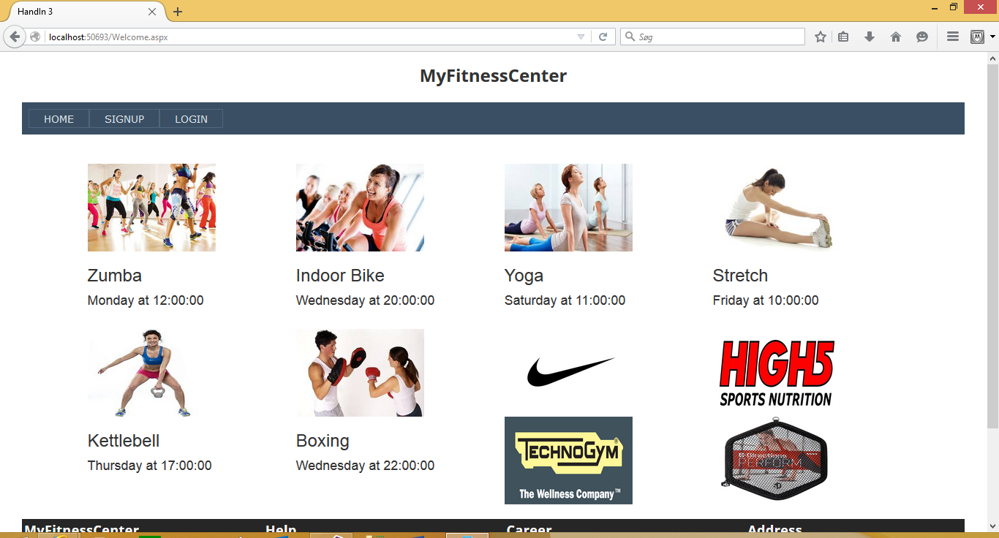

## Welcome.aspx

<%@ Page Title="" Language="C#" MasterPageFile="~/Member.Master" AutoEventWireup="true" CodeBehind="Welcome.aspx.cs" Inherits="HandIn3.Welcome" %>

<asp:Content ID="Content1" ContentPlaceHolderID="head" runat="server">

</asp:Content>

<asp:Content ID="Content2" ContentPlaceHolderID="ContentPlaceHolder1" runat="server">

<asp:Label ID="LabelMessage" runat="server"></asp:Label>

<br />

<div class="container">

<asp:Repeater ID="RepeaterWelcome" runat="server">

<ItemTemplate>

<div class="col-sm-6 col-md-3">

<img src="Pictures/<%# Eval("PictureLink") %>" alt="fitness" width="175" height="120" />

<h3 class="myitem"><%# Eval("Title") %></h3>

<h4 class="myitem"><%# Eval("Weekday") %> at <%# Eval("Time") %></h4>

<br />

</div>

</ItemTemplate>

</asp:Repeater>

<asp:Repeater ID="RepeaterSponsor" runat="server">

<ItemTemplate>

<div class="col-sm-6 col-md-3">

<img src="Pictures - sponsor/<%# Eval("Picture") %>" alt="logo" width="175" height="120" />

<br />

</div>

</ItemTemplate>

</asp:Repeater>

</div>

</asp:Content>

# Sponsor CRUD

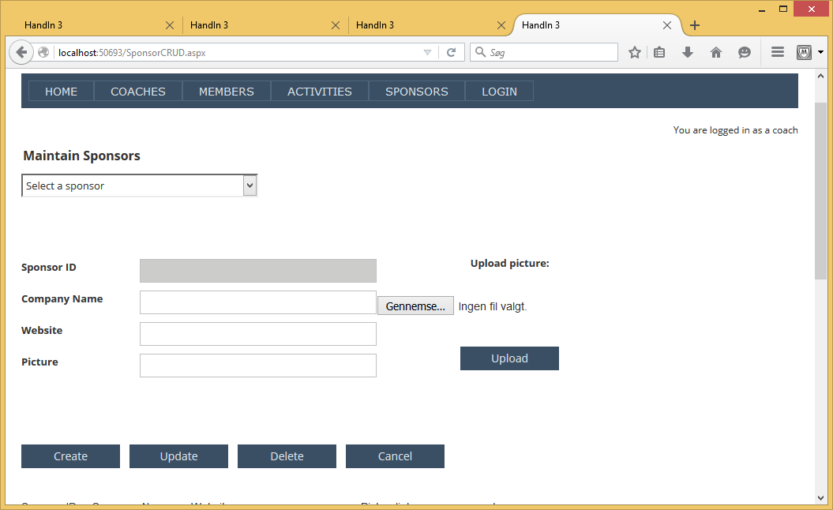

## Sponsor.aspx.cs

using System;

using System.Collections.Generic;

using System.Linq;

using System.Web;

using System.Web.UI;

using System.Web.UI.WebControls;

using System.Data;

using System.Data.SqlClient;

namespace HandIn3

{

public partial class SponsorCRUD : System.Web.UI.Page

{

DataSet ds;

DataTable dt;

int userlevel;

int membernumber;

protected void Page_Load(object sender, EventArgs e)

{

Response.Cache.SetNoStore();

try

{

userlevel = (int)Session["Level"];

membernumber = (int)Session["MemberNumber"];

}

catch (NullReferenceException nre)

{

userlevel = 0;

Session["Level"] = userlevel;

LabelMessage.Text = nre.Message;

}

finally

{

SetButtonAndText();

}

if (!Page.IsPostBack)

{

UpdatePage();

}

else

{

if (DropDownListSponsor.SelectedIndex != 0)

{

ds = new DataSet();

ds.ReadXml(Server.MapPath("~/XMLFile/XMLSponsors.xml"));

dt = ds.Tables["sponsor"];

foreach (DataRow dr in dt.Select("id = " + Convert.ToInt32(DropDownListSponsor.SelectedValue)))

{

TextBoxID.Text = dr["id"].ToString();

TextBoxCompanyName.Text = dr["companyname"].ToString();

TextBoxWebsite.Text = dr["website"].ToString();

TextBoxPicture.Text = dr["picture"].ToString();

}

LabelMessage.Text = TextBoxCompanyName.Text + " has been selected";

// selected index must be set back to 0 to avoid old data to be read back to the drop

DropDownListSponsor.SelectedIndex = 0;

ButtonCreate.Enabled = false;

ButtonUpdate.Enabled = true;

ButtonDelete.Enabled = true;

}

}

}

private void UpdatePage()

{

//populate dropdownlist

DropDownListSponsor.AutoPostBack = true;

DropDownListSponsor.Items.Clear();

try

{

ds = new DataSet();

ds.ReadXml(Server.MapPath("~/XMLFile/XMLSponsors.xml"));

dt = ds.Tables["sponsor"];

DropDownListSponsor.DataSource = dt;

DropDownListSponsor.DataTextField = dt.Columns[1].ToString();

DropDownListSponsor.DataValueField = dt.Columns[0].ToString();

DropDownListSponsor.DataBind();

}

catch

{

// XML file does not exist or empty

// dt made for display of repeater heading

MakeNewDataSetAndDataTable();

}

finally

{

RepeaterSponsor.DataSource = dt;

RepeaterSponsor.DataBind();

DropDownListSponsor.Items.Insert(0, "Select a sponsor");

}

TextBoxID.Text = "";

TextBoxCompanyName.Text = "";

TextBoxWebsite.Text = "";

TextBoxPicture.Text = "";

ButtonCreate.Enabled = true;

ButtonUpdate.Enabled = false;

ButtonDelete.Enabled = false;

}

private void MakeNewDataSetAndDataTable()

{

ds = new DataSet("sponsors"); //root tag

dt = ds.Tables.Add("sponsor");

dt.Columns.Add("id", typeof(Int32));

dt.Columns.Add("companyname", typeof(String));

dt.Columns.Add("website", typeof(String));

dt.Columns.Add("picture", typeof(String));

}

protected void ButtonCreate_Click(object sender, EventArgs e)

{

try

{

ds = new DataSet();

ds.ReadXml(Server.MapPath("~/XMLFile/XMLSponsors.xml"));

dt = ds.Tables["sponsor"];

}

catch

{

// XML file does not exits

MakeNewDataSetAndDataTable();

}

int maxsponsorid = 0;

if (dt == null)

{

// XML file exist but is empty

MakeNewDataSetAndDataTable();

}

else

{

foreach (DataRow dr in dt.Rows)

{

if (Convert.ToInt32(dr["id"].ToString()) > maxsponsorid) maxsponsorid = Convert.ToInt32(dr["id"].ToString());

}

}

DataRow newrow = dt.NewRow();

newrow["id"] = maxsponsorid + 1;

newrow["companyname"] = TextBoxCompanyName.Text;

newrow["website"] = TextBoxWebsite.Text;

newrow["picture"] = TextBoxPicture.Text;

dt.Rows.Add(newrow);

ds.WriteXml(Server.MapPath("~/XMLFile/XMLSponsors.xml"));

LabelMessage.Text = TextBoxCompanyName.Text + " has been created";

UpdatePage();

}

protected void ButtonUpdate_Click(object sender, EventArgs e)

{

ds = new DataSet();

ds.ReadXml(Server.MapPath("~/XMLFile/XMLSponsors.xml"));

dt = ds.Tables["sponsor"];

foreach (DataRow dr in dt.Select("id =" + Convert.ToInt32(TextBoxID.Text)))

{

dr["id"] = Convert.ToInt32(TextBoxID.Text);

dr["companyname"] = TextBoxCompanyName.Text;

dr["website"] = TextBoxWebsite.Text;

dr["picture"] = TextBoxPicture.Text;

}

ds.WriteXml(Server.MapPath("~/XMLFile/XMLSponsors.xml"));

LabelMessage.Text = TextBoxCompanyName.Text + " has been updated";

UpdatePage();

}

protected void ButtonDelete_Click(object sender, EventArgs e)

{

ds = new DataSet();

ds.ReadXml(Server.MapPath("~/XMLFile/XMLSponsors.xml"));

dt = ds.Tables["sponsor"];

foreach (DataRow dr in dt.Select("id =" + Convert.ToInt32(TextBoxID.Text)))

{

dr.Delete();

}

ds.WriteXml(Server.MapPath("~/XMLFile/XMLSponsors.xml"));

LabelMessage.Text = TextBoxCompanyName.Text + " has been deleted";

UpdatePage();

}

protected void ButtonCancel_Click(object sender, EventArgs e)

{

LabelMessage.Text = "Input values has been cleared";

UpdatePage();

}

protected void UploadButton_Click(object sender, EventArgs e)

{

// Specify the path

String savePath = @"C:\Users\Sorenbj\Documents\WEBSTUD - 1\Database\HandIn3\HandIn3\Pictures - sponsor\";

// Verify that the FileUpload control contains a file.

if (FileUploadPicture.HasFile)

{

// Get the name of the file to upload.

String fileName = FileUploadPicture.FileName;

// Get the extension of the uploaded file.

string extension = System.IO.Path.GetExtension(fileName);

if ((extension == ".jpg") || (extension == ".png"))

{

// Add the path to the name of the file to upload

savePath += fileName;

// Call the SaveAs method to save the uploaded file to the path.

FileUploadPicture.SaveAs(savePath);

LabelUpload.Text = "Your file was saved as " + fileName;

}

else

{

LabelUpload.Text = "Your file was not uploaded because " +

"it does not have a .jpg or .png extension.";

}

}

else

{

// Notify the user that a file was not uploaded.

LabelUpload.Text = "You did not specify a file to upload.";

}

}

private void SetButtonAndText()

{

if (userlevel == 2)

{

LabelUserLevel.Text = "You are logged in as a coach ";

}

else

{

Response.Redirect("ErrorPage.aspx");

}

}

}

}

# Screen dumps

Create sponsor

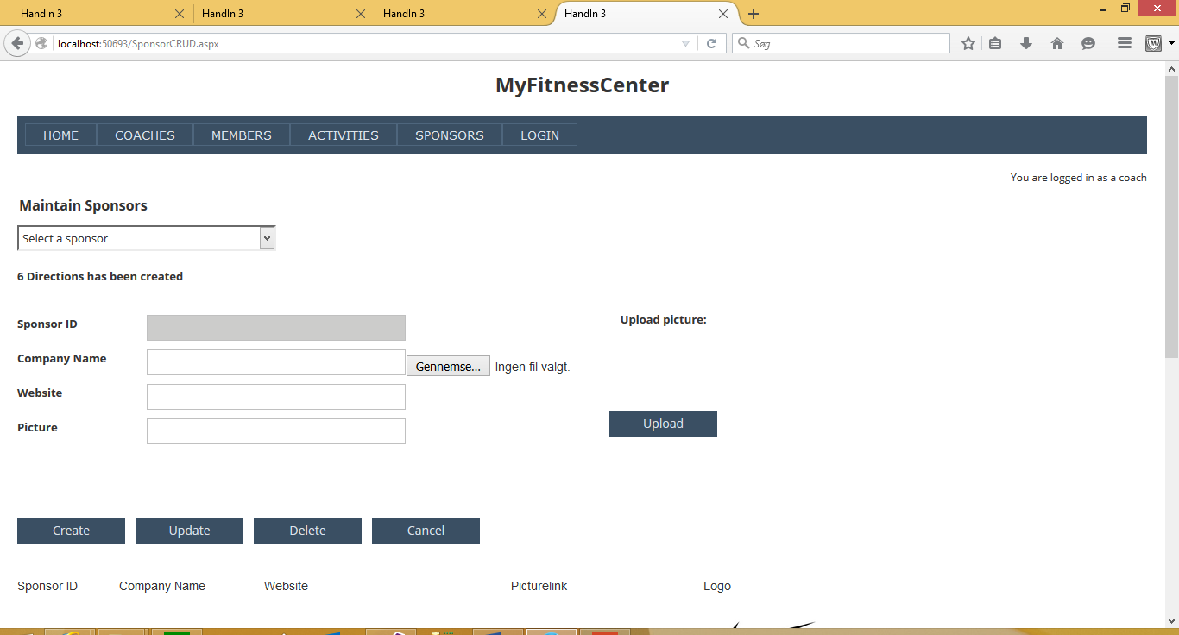

Select sponsor from dropdownlist

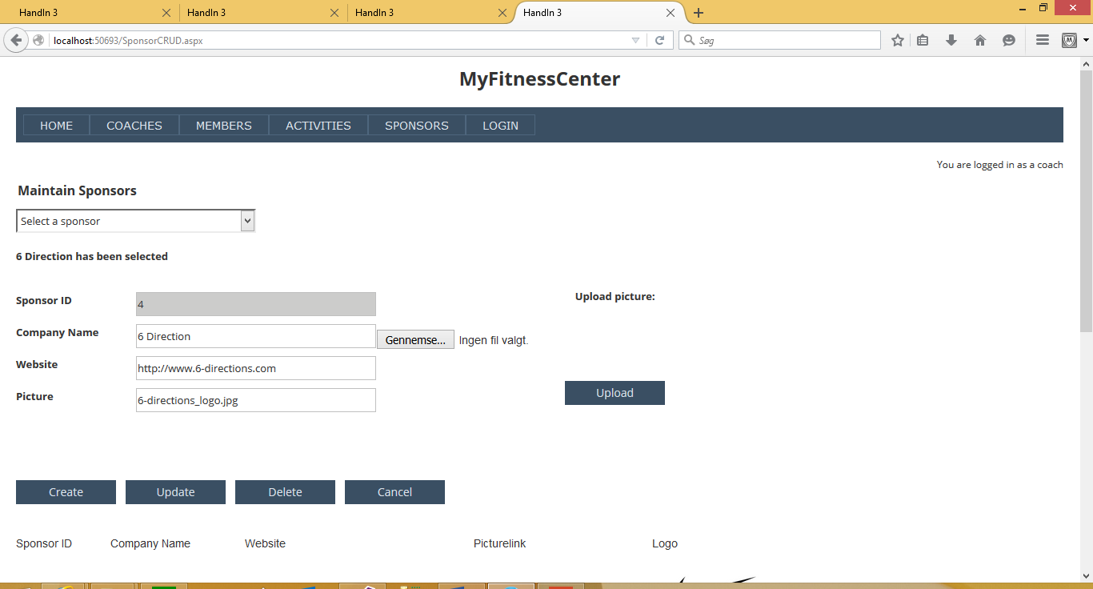

Update sponsor



Delete sponsor

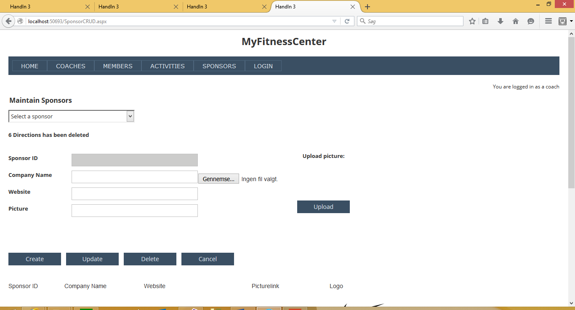

Sponsor list

