Title: | Study and development of focused JVM for low and mid range microcontrollers.
Description: | The aim of this project is to develop a Java Virtual Machine and design Java specific API to use common microcontroller resources using similar concept used in JavaCard for SmartCards.  The main idea is to implement an common JVM which could be executed in microcontrollers based on 1 kB RAM or more. This JVM is developed in C and provides a Java API to get access to microcontroller resources (ports, timers, serial port, etc.). It allows to implement microcontrollers Java applications object oriented and compatible with any microcontroller running this JVM on it.  Figures 1 and 2 represents the difference between native application and java based application for microcontroller.  This JVM should be a reduced version of standard JVM in order to successfully execute it on low and mid range microncontroller with limited resources. This project is based on JavaCard for SmartCards. An introduction and comparison to JavaCard and how it is currently used on real life using high range microcontrollers will be analyzed.  JVM will be initially developed to PIC18F4520 and PIC16F87X and will be adapted to some Atmel AVR microcontroller if possible.  Then, final goal is to make a comparison, in terms of performance and accuracy, between applications based on this JVM and native application. Regarding accuracy, resistive capture method by microcontroller PIC18F4520 will be analized. Regarding performance has to be defined.
Images | 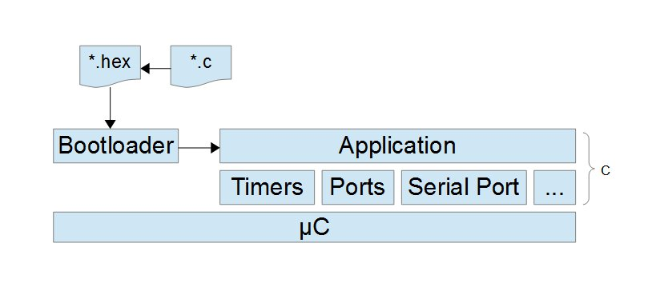Figure 1: Native application  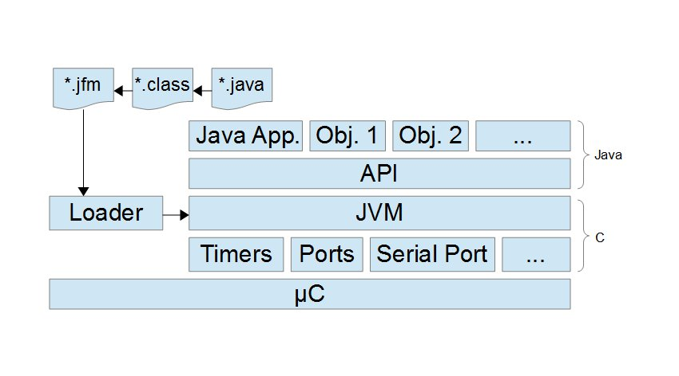Figure 2: Java based application
Project Parts | Following points are going to be analyzed in this project:  - Java for Microcontrollers, known issues.  - SmartCards and JavaCard introduction.  - Java for Microcontrollers focused on resources  - JVM Development  - Comparison between native and java based applications:  - Performance: To be defined  - Accuracy: Resistive sensors  - JVM Demo
References | NanoVM and uJava are similar projects which are based on Atmel AVR microcontrollers but they try to provide standard Java API. It is not focused on Java to allow access to different microcontroller resources.  NanoVM is based only on Atmel AVR microcontrollers and uJ includes a support of SD to store java class files.  Websites  NanoVM (http://www.harbaum.org/till/nanovm/index.shtml)  uJava (http://dmitry.gr/index.php?r=05.Projects&proj=12.%20uJ%20-%20a%20micro%20JVM)  Articles  S.A. Ito, L. Carro, and R.P. Jacobi. Making Java Work for Microcontroller Applications. IEEE Design & Test of Computers, 18(5):100–110, 2001.  N. Brouwers, P. Corke, and K. Langendoen, “Darjeeling, a Java compatible virtual machine for microcontrollers,” in Proceedings of the ACM/IFIP/USENIX Middleware Conference Companion, pp. 18–23, 2008

