HUMAN IBL LAB PROTOCOL 2.0
2025/26

Contact information
SOLO | +31 71 527 6763 | solo@fsw.leidenuniv.nl  labsupport@fsw.leidenuniv.nl
Maureen (lab manager) | +31 71 527 4082 | m.j.meekel@fsw.leidenuniv.nl  labmanager-ssh@leidenuniv.nl
Lab support office | Sylvius 2.5.01
Lab telephone 2.4.03 |  | 5684
Sylvius Reception | +31 71 527 5000  Emergency number (with landline number): 444
Anne Urai (PI) | +31 71 527 3371 | a.e.urai@fsw.leidenuniv.nl

Before you go to the lab
- Check your access permissions
Make sure your LU card allows entry to the following areas:
  - Lab 2.4.03
  - Equipment cleaning room (2.4.23)
  - Kitchens (right to the cleaning room)
  - Cupboard with towels
  - Hair washing room (2.4.22)
How to check/update:
  - Update your LU card at the box located at the entrance desks of FSW or Sylvius. The box should light up orange, then green.
  - If the box lights up red, contact the lab manager Maureen and/or visit the lab support office at Sylvius in person.
- Update lab bookings when participants sign up
  - Whenever a participant signs up (e.g., on SONA), also update the lab room booking system (https://leiden.roombookingsystem.co.uk) and indicate that you have a confirmed participant.
- Keep an eye out on the Teams channel
  - Always monitor proj-human-ibl-task to see if there are any important updates regarding testing, the lab, the equipment, etc.
  - If something is missing – make sure to replace it before testing
  - If something is not working – check the current state of it (ask Lucija, Isabelle, Anne, or whoever was last using the equipment for clarification)

Checklist of necessary materials

EEG materials
Always check if there are enough EEG materials for the number of scheduled participants.
- EEG caps with an additional FCz hole – make sure the labelling follows the 10-20 system
- EEG-electrode bundles:
  - EX1-EX5 face electrodes
  - CMS-DRL bundle
  - 32-electrode bundle (10-20 system)
- Electrode (signa) gel
- Syringes
- Tape for face electrodes
- Alcohol pads
- Cotton swab and NuPrep
- Stickers for face electrodes
- Measuring tape
- Tissues
- Shampoo (hair washing room / 2.4.22)
- Towels (hair washing room / 2.4.22 & towel cupboard)

Eye-tracking materials
- Alcohol wipes for facial make-up

General materials
Always check that there are enough printed:
- information letters
- consent forms
- debriefing documents
- set-up checklists
- payment by pin booklet (collected at SOLO desk)

Before the participant arrives

Document preparation
- Pick up USB stick and consent/debrief forms from the locker (see also pics below)
  - The lockers are located in the hallway left of the 2.4.03 lab.
  - Locker nr: 115
  - PIN: 5368
  - Open the locker
    - Tap “Open locker with PIN code” – do not tap your card or login with card!
    - Enter PIN
    - Enter locker number and tap the check icon
    - Tap “Open and Keep”
    - Press on the locker door to open
  - Close the locker
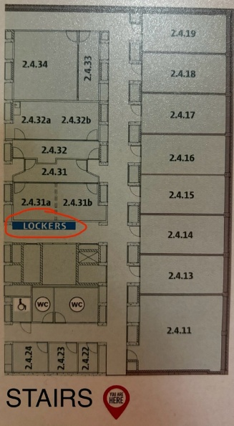
  - Just shut the door, it’ll lock automatically

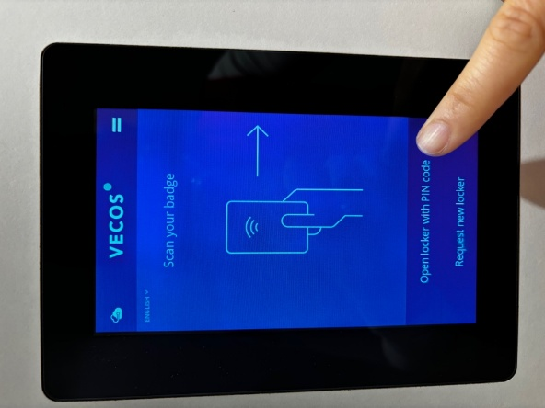
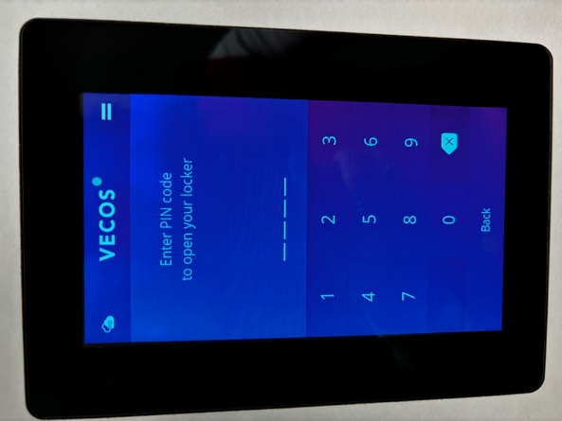
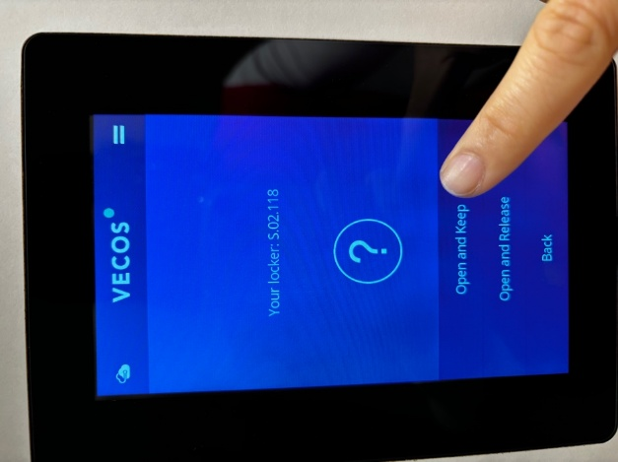
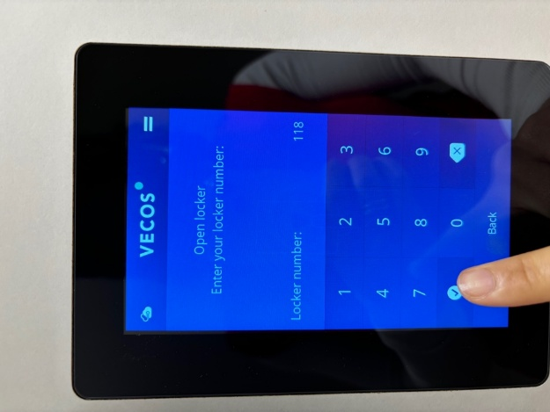

Experimenter room preparation
- Set the door slider to “Present”
- Turn on stimulus PC (left) – automatically logs in on lab user account
- Turn on J-drive PC (right) – login with your own Leiden account
(username: s0000000 [your student ID], password: your own account password)
  - If this username does not work – try s0000000@vuw.leidenuniv.nl
- J-drive path:
This PC/Public DFS on Network J:/Workgroups/FSW/VISUAL-DECISIONS
- Open lab notebook Excel file

Participant room preparation
- Turn on participant monitor if not already on
- Check that Tobii is connected – the EPU box (behind the computer) should be shining a have a blue light coming through the power button.
- Close window blinds
- Close blinds between experimenter and participant room
- Set light to 4
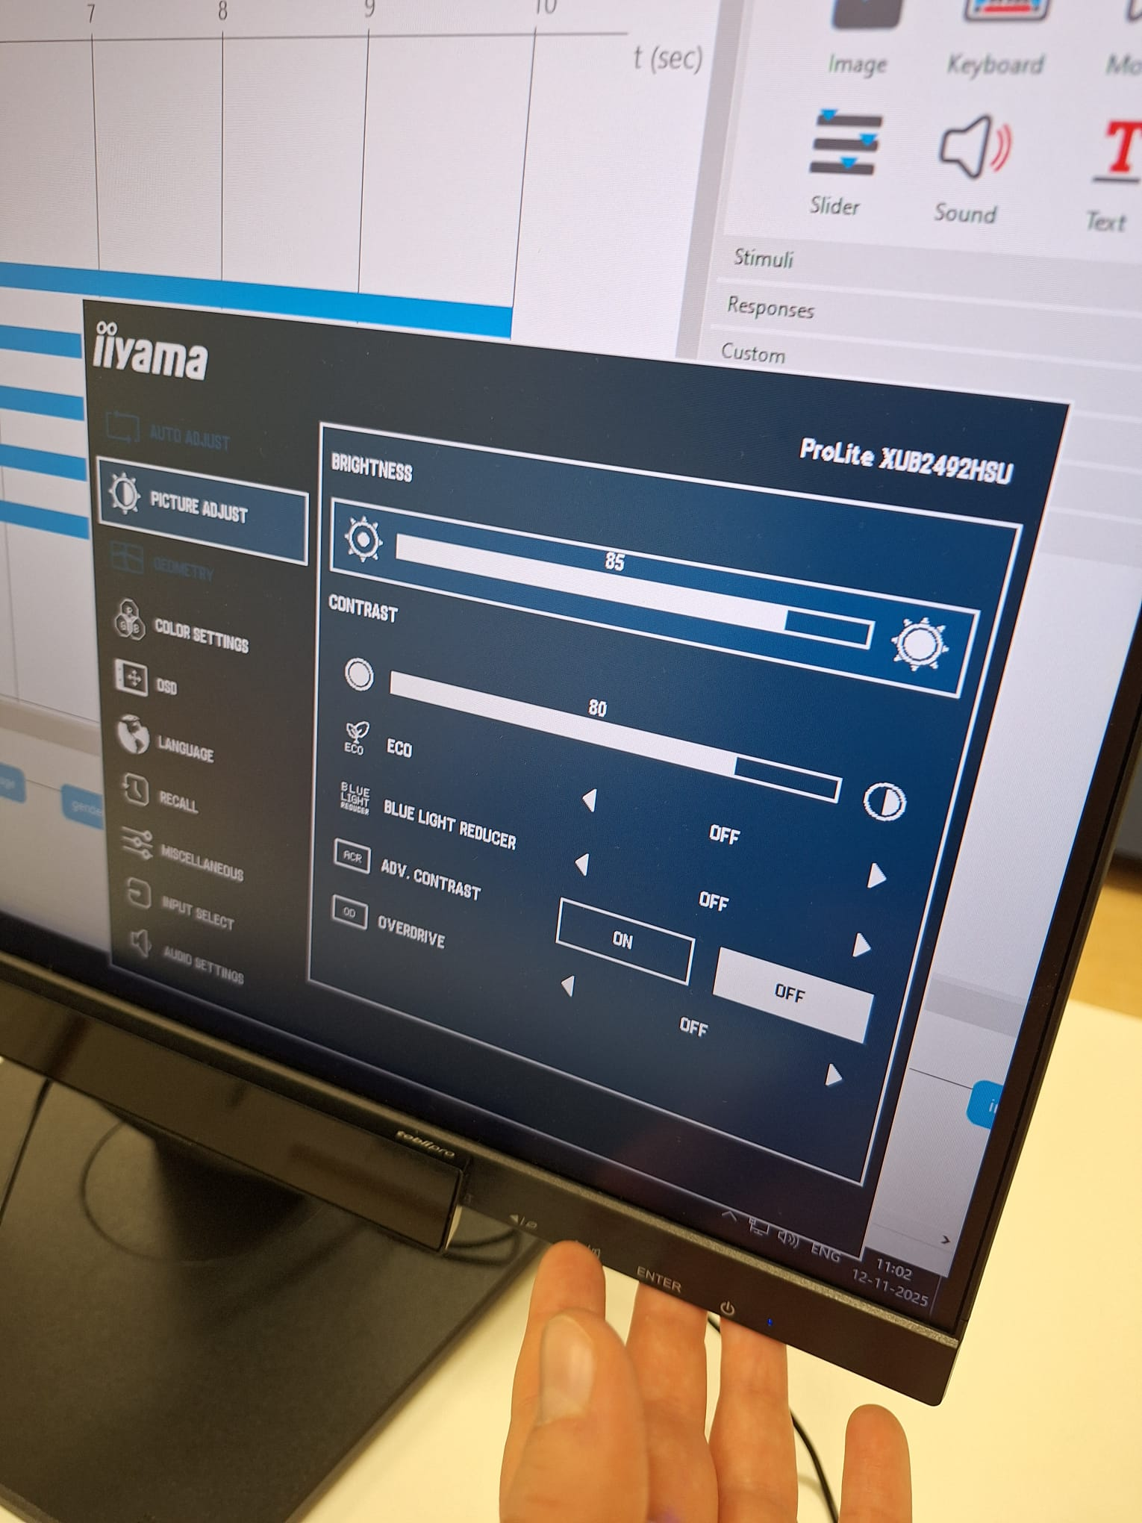
- Check the luminescence of the participant screen through the Enter button below the screen. All of the settings needs to be (picture below):
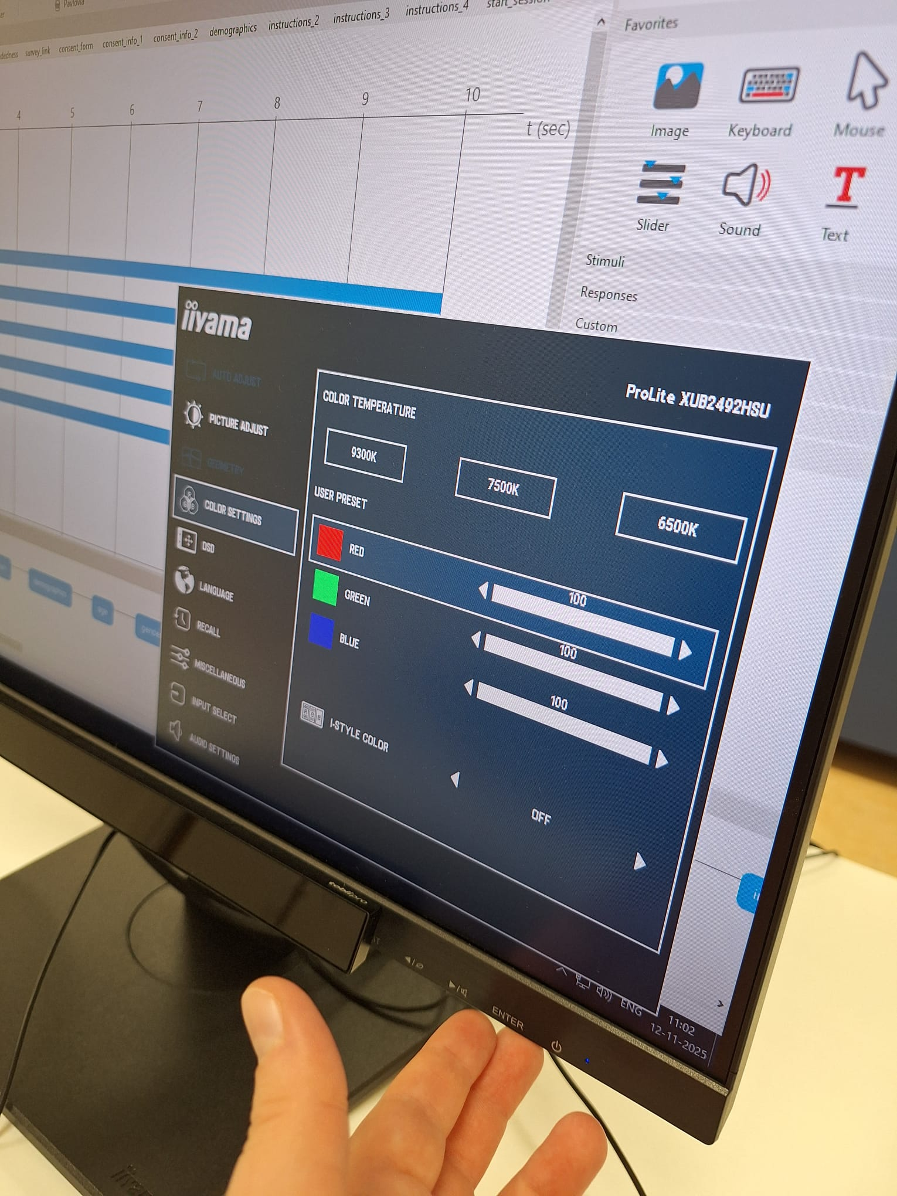
- Check if the sound works on the participant monitor.
- Check in PC settings that refresh rate is 60 Hz and mouse speed is set to 10

EEG preparation

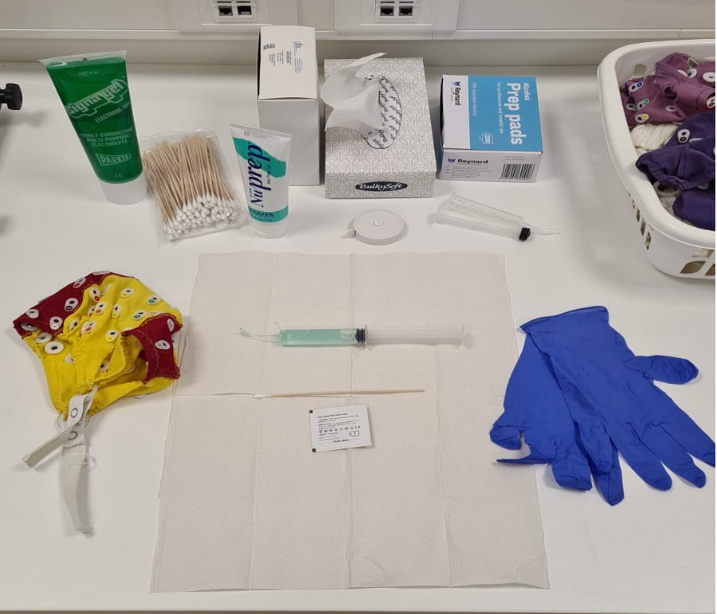
Equipment
- Fill two syringes with electrode gel (only one if you are testing by yourself).
- Prepare alcohol swaps
- Cotton tips and NuPrep
- Measuring tape
- Tissues and paper towels
- (Paper) tape (prepare pieces for external electrodes)
- Caps with two straps (our caps have 32 electrodes and an extra FCz hole). Make sure you have 3 caps available in the lab; small, medium and large.
- Gloves
- Place stickers on the external electrodes - do not remove the white piece of paper yet.

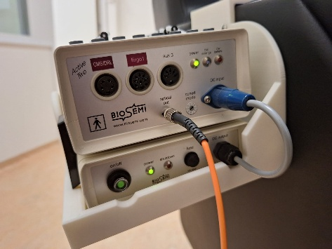
The EEG
- Take a bundle with 32 electrodes (10-20 system), 6 external electrodes (called EX1-EX6 – 4 around the eyes, 2 on the mastoids), and a CMS/DRL bundle.
- Place the EEG-box in its place, and turn on the battery (picture on the right). Make sure battery is not low. If necessary – change the battery, and place the old one to charge.
- Plug in the EX1-EX6 electrodes and separate them to the left (EX1, EX3, EX4, EX5) and right (EX2, EX6) sides of the chair. Place the stickers on the EX1-EX6 electrodes but do not remove the white part, yet.
- Note down the label of the EEG-bundle that you plan on using in the log file but do not plug in yet.

Acquisition PC – ActiView preparation
- Start ActiView on the acquisition computer.
  - Once open – click “Start” on the top left corner. This way you check the status of the battery plugged into the EEG. If needed – replace the battery.
  - After finishing the battery check – click “Stop”.
- Click on the ”About/Configure” tab on the top right corner.
  - Click on “Load CFG-file” on the left.
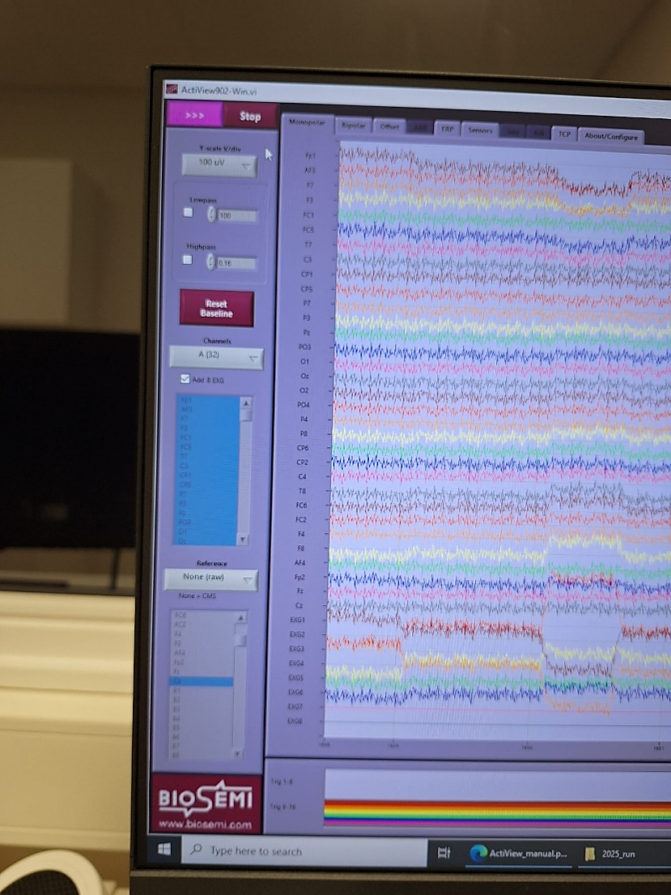
  - The file can be found at: This PC > OSDisk (C:) > Program Files (x86) > ActiView902 > Configuring > 10-20system32+8.cfg. Click the file named “10-20system32+8.cfg”. This will load the configuration file.
- Make sure the settings under the “Monopolar” tab look like this – picture on the right:

- Y-scale: 100 uV (or 50)
- Turn off lowpass and highpass
- Channels: A(32)
- Add 8 EXG
- Reference: None (raw)
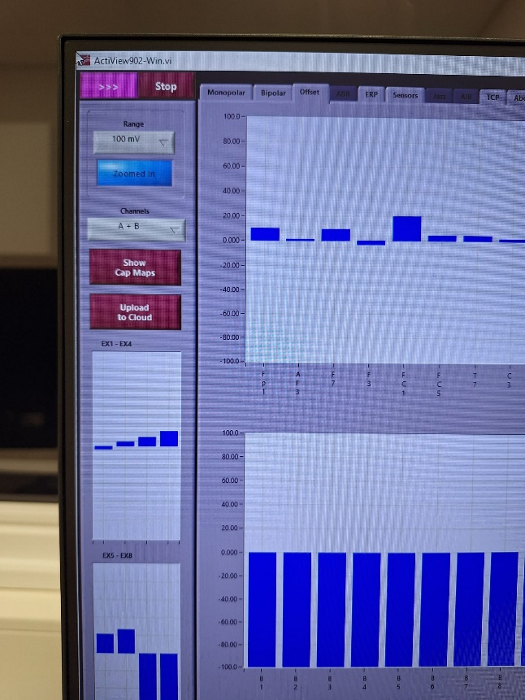
- Make sure the settings under the “Offset” tab look like this – picture on the left:
- Range: 100uV (or 50uV)
  - All values need to be around -20 to 20uV
- Channels (A+B)
- Open the log file Lab_Logbook.xlsx on the acquisition computer, which can be found at "J:\Workgroups\FSW\VISUAL-DECISIONS\2025_run\Lab_Logbook.xlsx" Always keep it open and up-to-date during the session, if there are any issues, note them down.
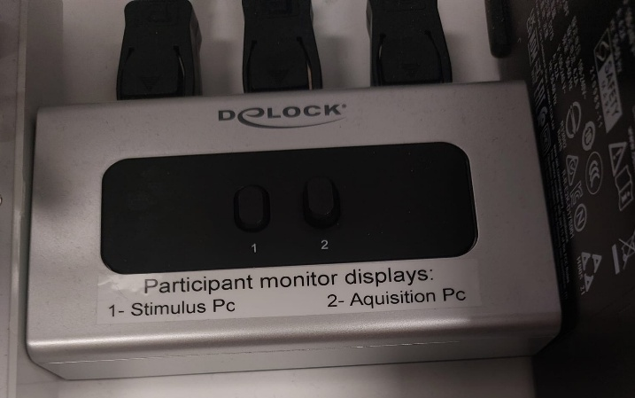
N.B. You can check which screen the participant is seeing with the buttons on the Delock (see picture on the right). Never change screens while running a task, it will cause the task to crash.

Upon participant arrival
- Greet the participant, ask them to leave their belongings in the experimenter room.
  - Ask them to put their phone on silent or turn it off completely
- Ask the participant to take a seat and provide them with the information letter and consent form to read and sign.
  - If the participant wears glasses, immediately ask whether they can see clearly without them. If not, the session cannot proceed, as this is part of the inclusion criteria. In that case, kindly inform them:
“Unfortunately, we cannot continue, as the eye-tracking equipment cannot be used with glasses. However, we can compensate you with 0.5 participation credits for your time today.”
- Ask the participant if they want to participate for credits or money. Note it down in the log book.
- Ask the participant if they are wearing make-up. If so, have them remove it from the areas around the eyes and any locations where external electrodes will be placed. Make-up wipes are available for this purpose.
- Make sure that the participant leaves all their belongings, especially their phone, in the experimenter room before entering the testing room. Always double check their phone is not in the testing room.
- Mention that they will be seated for about 1.5 hours, so if they need to use the restroom this is a good time.
- Take the checklist with you and go to the testing room with the participant.
- Let them know that throughout the experiment, you will always be able to hear them and talk to them even with the door closed, so they can speak up if they have any questions or issues – the intercom system
  - Turn on the microphone/speaker: (press On/Off button: it’s on if the LED turns green) you can hear participants at all time, but you need to press and hold “Talk” for them to hear you – this only works one way at a time: while you talk, you cannot hear them – make sure they know this

EEG Placement

Before placement
- Tell participant that you will now start with EEG set-up.
- Always wear gloves and clearly show/explain each step of the procedure to the participant as you go.
- Ask the participant if they have any piercings around their eyes (e.g., on their eyebrows) or ears. If so, request that they remove them. If removal is not possible, cover the piercing with a piece of tape to ensure it does not come into contact with the electrodes.
- Measure the participant’s head circumference to determine the correct cap size. Place the tip of the measuring tape at the center of the forehead and wrap it around the widest part of the head.
- Select a cap that matches the participant’s head circumference from the prepared set (32 electrodes + an extra hole for FCz). Use the size stickers inside the caps to identify the correct one. Do not put it on the participant yet.
  - Small: 50 – 54 cm (yellow)
  - Medium: 54 – 58 cm (red)
  - Large: 58 – 62 cm (blue)
  - In case of doubt – a tight cap is better – but only if the participant feels comfortable with it!

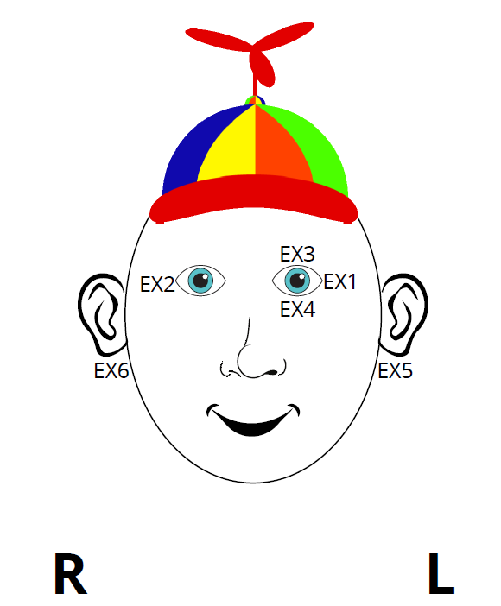
Placing external electrodes
- Always use the picture on the right as a reference. A printed copy should be available in the lab—make sure it is present and accessible at all times.
- Before starting placement – show the picture to the participant:
“First we will put some electrodes on your face, around your eyes and behind your ears (show picture). This is to correct for any facial movement that affects the brain signals.”

- Explain to the participant that you will first clean the skin before placing the electrodes. Using a cotton bud and the scrub gel, clean the area behind the ears. Show the gel to the participant and explain: “We use this mild scrubbing gel to clean up the area from dead skin cells. It might feel a bit cold, but if it burns let us know!” Scrub the gel behind the ears until the area gets a little bit red.
- Use an alcohol pad to clean up the remaining gel behind the ears. Show the pad to the participant and say “We use this alcohol pad to clean up the gel, if it burns let us know.”
- Use another alcohol pad to clean up the areas where you are going to place the rest of the external electrodes. Check the picture placed on the table inside the lab for the specific areas. Before applying the pads, show them to the participant and say: “We will use this alcohol pad to clean up the area around your face. You should close your eyes.” Then proceed with cleaning.
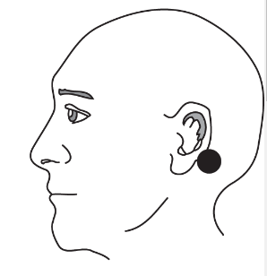
- Place some of the electrode gel directly on the electrodes. Then remove the sticker cover. “Now, I will attach the electrodes on your skin. I have to use some gel so the signal is transferred better to the electrode.”
- Place the electrodes on the mastoids. Feel the bone just behind the ear: that’s where you place the electrode. The picture shows where you have to place the mastoid electrode.
Say to the participant “I will feel the area behind your ears to find the bone called the mastoid, the electrode needs to be applied here specifically”.
Place the electrodes. If you are two people, you can do it simultaneously on both ears.
- Use tape to secure the placement of the electrodes.
- Proceed with placing the rest of the face electrodes by putting some gel directly on the electrode and then removing the sticker. Then secure with tape.
Note for placing EX3 & EX4: before placing these electrodes make sure to align them with the iris of the eye. Ask the participant to look in the middle of the screen and place the electrode accordingly.

Placing the cap
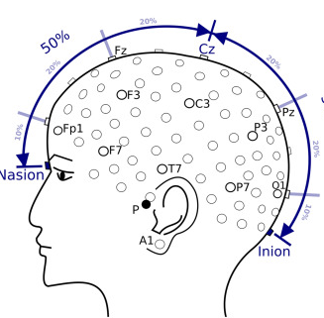
- Now you can put on the cap. Check if the cap is placed correctly (AF-electrodes at the front, O-electrode at the back).
- Make sure the cap is centred on the head: measure the distance between the inion (just under the “bulge” at the back of the head) and nasion (just above the nose) and the distance between the top of both ears. The Cz-electrode hole should be at the center of both distances (Inion-Nasion/2; ear-ear/2).
- Take out the label at the back of the cap.

Place the electrodes on the cap

- Show the syringe and let the participant touch the point – to show that it is not sharp.
“We will use this syringe to place gel on your head. It is an ultra-sound gel that helps us get better signal for the electrodes. The syringe is not pointy so it does not hurt. You can feel it if you want. We use the ends of the syringes to bring the gel as closely as possible to the skin, and remove some hair. This will not hurt. If you feel uncomfortable, please let us know so we can adjust and make you more comfortable! The gel will not damage your hair, but it might dry up. Afterwards, you will get the opportunity to wash out the gel before you go home. Do you have any questions?”
- Begin filling the holes in the cap with gel. Use the tip of the syringe to gently move hair aside, ensuring the gel reaches the skin. Avoid using too much; any excess can be removed with a cotton bud. Engage in light conversation with the participant to help them feel comfortable.
- First, connect the CMS/DRL electrodes.
  - Check the blue light on the cable box: a stable light indicates that the CMS/DRL and face electrodes are functioning correctly.
  - If the light flashes/blinks, there may be an issue with the CMS/DRL electrodes.
    - In that case, try adding more electrode gel or cleaning the electrodes with a paper towel. If the problem persists, switch to another CMS/DRL cable. Additionally, verify the signals in Actiview under the “Monopolar” tab: the face electrodes should show activity, while all other lines remain flat.
- Plug in the 32-A bundle and connect the rest of the electrodes. Always make sure the cable points to the back and does not pull the vires.
This is how everything needs to be connected:
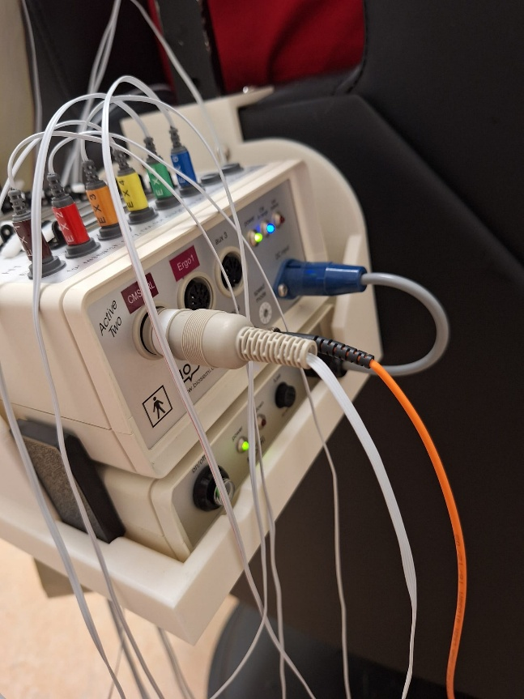
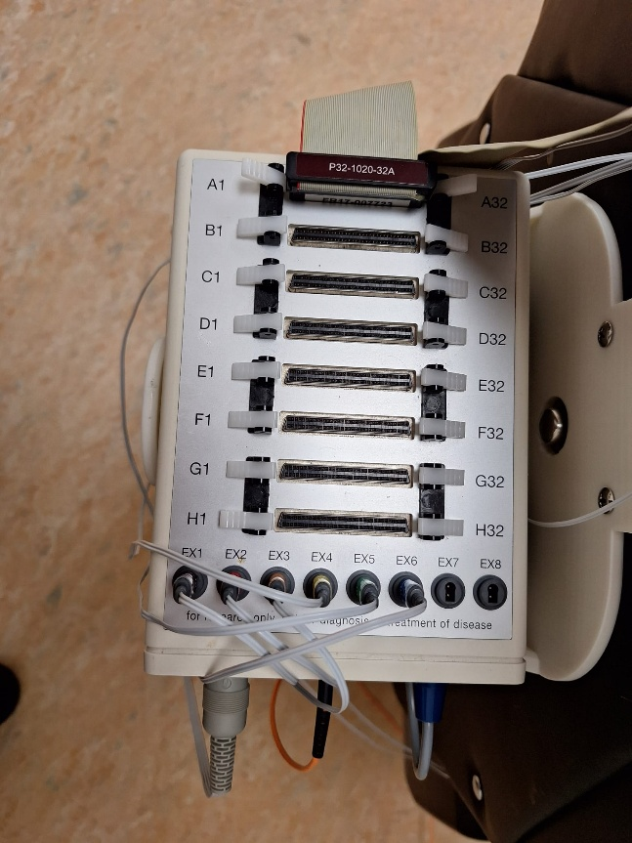
- Once all electrodes are attached, check the signal quality. First, open the “Offset” tab in Actiview. The blue bars should be within the acceptable range, remain stable (i.e., not fluctuate excessively), and be roughly equal in height (lower is generally better). If one bar differs significantly from the others, recheck that electrode (e.g., add gel, clean the tip, etc.). Next, open the “Monopolar” tab to ensure the horizontal lines are neither excessively noisy nor completely flat.
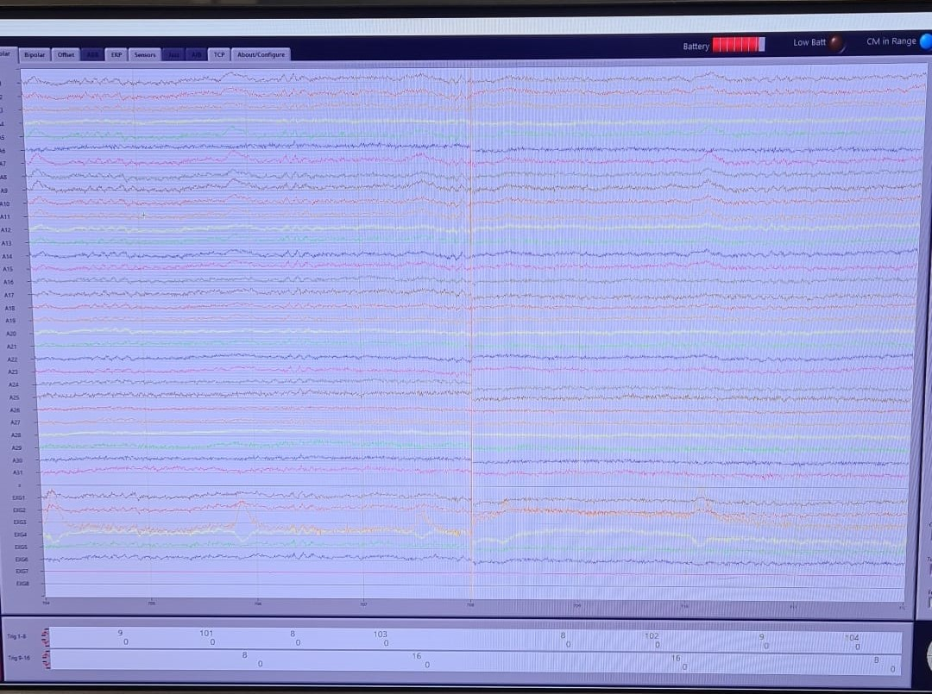
This picture shows a good signal:

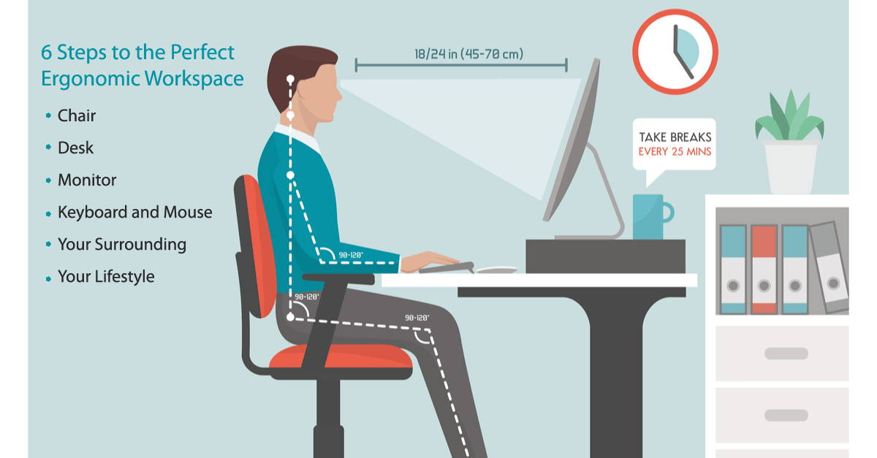
- Tape the cables to the chair so they will not pull on the cap.
- Check that the participant can comfortably reach and use the mouse. Ensure that their forearm rests fully on the table, forming approximately a 90-degree angle with the upper arm.
- Tell the participant:
“That was it! How are you doing? Are you comfortable?”
If not – check what you can do to make the participant more comfortable.
Before starting – ask the participant if they want to drink some water.

Tobii set-up

Calibration
- Open the Tobii Pro Eye Tracker Manager on the stimulus computer.
- There should be an eye-tracker called Tobii Pro X3-120 EPU
- Click on it and then click on calibrate

PsychoPy set-up

On stimulus PC
Open PsychoPy from taskbar
- Open experiment file (WIN_cursor_ibl.psyexp) from PsychoPy Builder. This can be found at this path: Desktop > psychopy code > WIN_cursor_ibl.psyexp
  - Make sure it is the file from the 2025 run!
- DO NOT OPEN THE FILE BY CLICKING ON IT IN THE FILE EXPLORER, it’ll start up with the wrong version! Only open files with the “Open…” button in PsychoPy at the top left.
- Ensure that the file runs in the correct version. - 2022.2.5
To do that:
- Find the “Experiment” section at the top
- Click on the settings (⚙️ - gear emoji, right next to the picture of a screen)
- Click “Use PsychoPy version”
- If it says 2022.2.5. just click “Ok” on bottom right. If not, change it to that, and then click “Ok”.
- In PsychoPy Builder, ensure that the “Run” button is green (if it’s orange, it’s in pilot mode)

Experiment

Starting the EEG recording
- Start recording (paused button)
- When saving turns green it means you are recording. Don’t forget this! – ONLY RECORDING IF YOU CAN SEE SAVING!
- The screen will ask you to put in a name for the file – please put 000 (where 000 is the participant number)
- Make sure that the file is saved in this folder: subjects_2025 (J drive > Workgroups > FSW > VISUAL-DECISIONS > subjects_2025)
- Make sure that the two available options are selected on the screen.

Starting the experiment
- In PsychoPy, click “Run”
- Enter participant number.
  - Use the 3-digit number from the log book (e.g. 101). Check which numbers have already been used so far, and pick the next unused one.
  - Do not reuse participant numbers even if a participant has unusable (e.g. corrupted) data
    - Start from the number after!
  - All numbers have to be three digit numbers starting from 101!

Calibration and validation
At the beginning of the experiment, you will need to calibrate and validate the Tobii eyetracker.
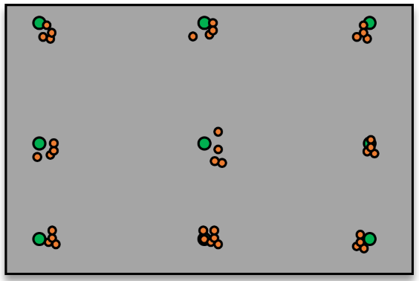
- Instruct participants that you will perform the calibration and that they should not use the computer during this step.
- If the validation does not look acceptable (e.g., the points are too scattered), abort the experiment and repeat the calibration.
  - An example of an acceptable scatter is shown on the right.
- If it is acceptable, confirm it
- Do not touch the stimulus PC anymore! – unless needed! – e.g., participant wants to stop, there are issues with equipment, there is an emergency, etc.

During the task
  - Note down the start of the task in the logbook!
  - Also note down any irregularities you notice!
- KEEP AN EYE OUT ON THE TASK and the EEG recording. If you notice movement/blinks remind them of the rules!
  - However, they should not be reminded too much.
- If you need to safely abort the task, press ESC
  - If problems happen very early on (practice trials, or very first few trials), safely abort the task, fix the problem, and start everything again.
  - If problems only occur later on, let the participant finish the task, but make a note of the problem in the lab logbook

Experiment end

PsychoPy
- Let PsychoPy finish loading – this will also take a long while, let it finish!
  - While loading at the end of an experiment, PsychoPy panics and freezes, and shows “Not Responding” at the top of one or more of its windows. Don’t worry, this is normal. Let it finish loading.
  - PsychoPy has 3 windows: Builder (where you open and start the task), Runner (where the script of the task is read by the computer and executed), and Coder (essentially just a terminal and script interface). Here we only care about the Builder and Runner. You can see which is which by their names at the top of the windows.
- On lab notebook, mark end time

EEG (BioSemi ActiView)
- Click pause (top right) and stop (top left)

Participant
- Remove all EEG equipment, be very careful!
- Give debrief to participant, answer any questions.
- Remind the participant about the hair washing area, and the possibility to clean up

If participant wants money compensation:
  - Take the Participant payment by pin booklet and follow these instructions:
  - Place the carton separator after the 3rd page before filling in, to prevent push through to the next set.
  - Fill in Researcher or project name, Sap number, Date, Amount and Participant number. All these fields are mandatory, without this information, SOLO can’t handle the payment.
  - Please also put a cross on the first amount field when the amount is less then €10,00.
  - Keep the white original for your own administration. Give the participant the 2nd and 3rd sheet, these are the green and yellow sheets and send the participant over to the SOLO desk at 2.5.01 for payment.
  - If you make a mistake, do not throw away the receipt but place a big cross on it and return all 3 copies to the SOLO desk. SOLO needs this to balance the books.
More information: https://researchwiki.solo.universiteitleiden.nl/xwiki/wiki/researchwiki.solo.universiteitleiden.nl/view/Participants/Participant%20Payment%20by%20Pin/

Equipment cleaning
Please follow the steps from the EEG_Equipment_Cleaning document.
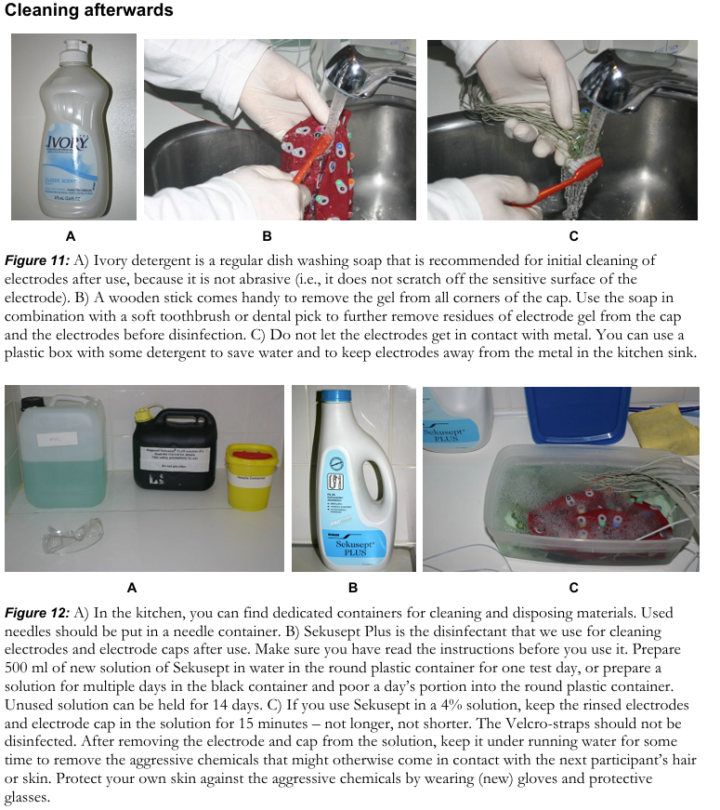
Do this immediately after participant leaves.


Cleaning the testing room
- Use disinfectant wipes to wipe all used surfaces – the mouse, the keyboard, the armchair arm rests, etc.

Data saving

Tobii and Behavior – stimulus PC
- Connect USB stick to stimulus PC
- The data will be saved in the folder named “data” in the folder “psychopy code”.
- Create a folder that corresponds to the participant number – e.g., 101
  - Copy the ALL data files from stimulus PC to USB stick in this folder if their file names start with the participant number
  - There should be 6 data files – COPY ALL OF THEM! Always check if you got all of them.
    - CSV file (.csv)
    - HDF5 file (.hdf5)
    - Text file (.log)
    - PSYDAT File (.psydat)
    - TSV File (.tsv)
    - Excel File (.xslx)
- Safely remove the USB stick using the “Safely remove hardware and eject media” command:
  - if unclear, you can read about it here: https://support.microsoft.com/en-us/windows/safely-remove-hardware-in-windows-1ee6677d-4e6c-4359-efca-fd44b9cec369
- Connect the USB stick to the acquisition PC

EEG – acquisition PC
- Move the entire “100”(example) folder from USB stick to J-drive in the ‘subjects_2025’ folder
  - To move the folder instead of just copy pasting it, do ‘cut and paste’ (right click – cut ; or Ctrl-X ; then paste in J drive)
- Move the EEG file from the subjects_2025 folder also to this folder. The EEG file is a .bdf file.
- On lab notebook, mark any additional comments, and mark whether data was saved correctly
- Safely remove the USB stick using the “Safely remove hardware and eject media” command.
This is what the folder should look like:
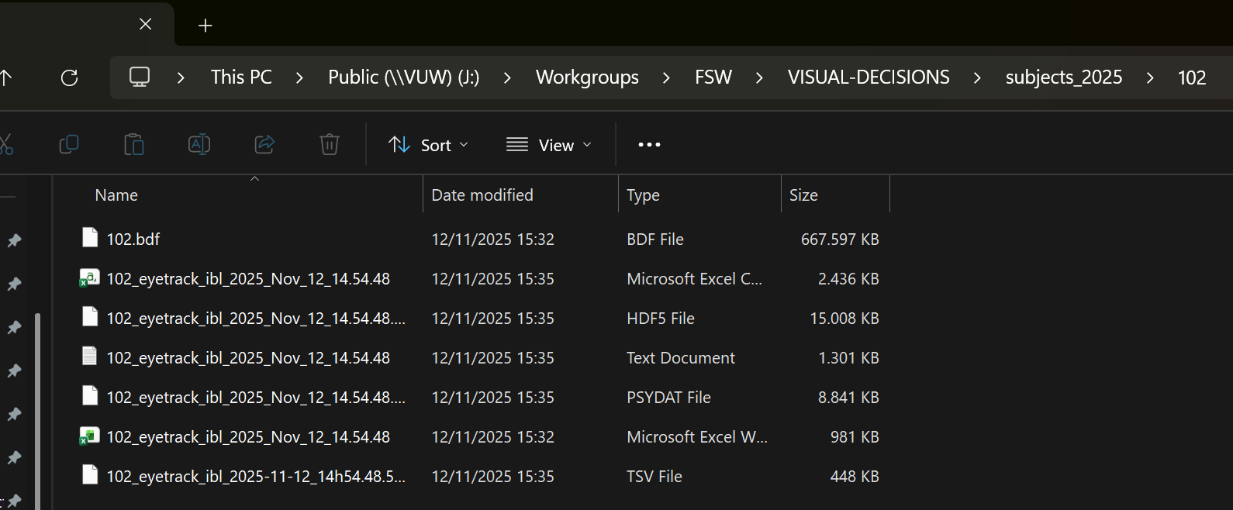

If you have another participant after
- In between participants, close the PsychoPy Runner window - only once it’s done loading!
  - PsychoPy loading delays pile up and grow exponentially with back to back participants. To avoid this, you can “refresh” PsychoPy’s memory by closing the Runner window only.
  - No need to reopen the Runner after you close it: PsychoPy will reopen it automatically once you start the task for the following participant.
  - If PsychoPy (Runner and/or Builder) are still loading or not responding after a very very long time, and this is preventing you from testing your next participant:
    - With PsychoPy windows still open (even if frozen), open data folder to see if PsychoPy files for that participant have been saved.
    - If all 3 PsychoPy files are there, then you can force quit PsychoPy entirely. Only do this if there is no other alternative – if you can wait, wait as long as you can to hopefully avoid doing this.
    - In any case, make a detailed note of everything you do on the Notebook

Leaving the lab
- Grant SONA credits to all participants from that day
Instructions on SONA manual (SONA Researcher Manual - XWiki (universiteitleiden.nl))
If for some reason a session took longer than 2 hours, give additional credits (0.5 credits per 15 minutes). Or if you dismissed someone early due to problems, grant them credits accordingly.
- Close all software on stimulus PC
The PsychoPy builder will ask you to save before quitting: click Yes
(it shouldn’t really matter anyways unless you edited the task in some way)
- Turn off all PCs
Stimulus PC: just turn it off normally
Acquisition PC: you can either log out and then turn off, or press the power button to turn off directly
- Turn Tobii off (click on the power button on the device behind the participant PC)
- Turn off all lights
- Lock the door with your card and set the slider to “Absent”
- Return the USB stick and consent/debrief forms to the locker (follow the same instructions as the beginning!)

