Software Requirement Specification

Document

Comparator de preturi intre dedeman.ro si bricodepot.ro

|  |  |
| --- | --- |
| Document ID | SOFTWARE REQUIREMENT SPECIFICATION-v0.2 |
| Version Number | 0.2 |
| Issue Date | Decembrie 07, 2022 |
| Classification | Public |

Copyright Notice

© PriceHunter, (original issue year – current issue year)

All Rights Reserved

The information contained in this document is the property of PriceHunter. No part of this document may be reproduced, stored in a retrieval system, or transmitted in any form, or by any means; mechanical, photocopying, recording, or otherwise, without the prior written consent of PriceHunter. Under the law, copying includes translating into another language or format. Legal action will be taken against any infringement.

The information contained in this document is subject to change without notice and does not carry any contractual obligation for PriceHunter. PriceHunter reserves the right to make changes to any products or services described in this document at any time without notice. PriceHunter shall not be held responsible for the direct or indirect consequences of the use of the information contained in this document.

**Revision History**

|  |  |  |  |
| --- | --- | --- | --- |
| **Date** | **Version** | **Description** | **Author (s)** |
| 04/11/2022 | 0.1 | Draft Version | Vieru Sorin-Cristian |
| 07/12/2022 | 0.2 | Final Version | Vieru Sorin-Cristian |
|  |  |  |  |

|  |  |  |
| --- | --- | --- |
| **Reviewed By (Customer)** | **Signature** | **Date** |
| TopProducts | TP | 21/12/2022 |
|  |  |  |
|  |  |  |
|  |  |  |
|  |  |  |

The reviewer signoff shall signify the recommendation for acceptance of this document.

**Table of Contents**

1 Introduction 5

1.1 Purpose 5

1.2 Document Overview 5

1.3 Intended Audience and Reading Suggestions 5

1.4 Project Scope 5

1.5 References 6

1.6 Acronyms and Abbreviations 6

2 Overall Description 6

2.1 Product Perspective 6

2.2 Product Features 6

2.3 The current situation 7

2.3.1 Purpose of the product 7

2.3.2 Product context 7

2.3.3 Benefits 7

2.4 Functional Requirements 8

2.4.1 Actors 8

2.4.2 System boundary 8

2.4.3 Use cases description 9

2.5 Non-Functional Requirements 9

# Introduction

## Purpose

The purpose of PriceHunter price scraper for shops is to automatically collect and store prices and other data from e-commerce websites.

## Document Overview

This document describes the software requirements for the PriceHunter scraper.

## Intended Audience and Reading Suggestions

PriceHunter is created for TopProducts and the final is the public, everyone can search for a specific category of products and see the prices between the products.

## Project Scope

This tool can be used for various purposes, such as:

* Market analysis: businesses can gather information about their competitors' prices and products to better understand the market and adjust their own pricing strategy accordingly.
* Price comparison: consumers can use price scrapers to compare prices across multiple online shops and find the best deal.
* Price monitoring: businesses can monitor their own prices and those of their competitors to ensure they stay competitive and make changes if necessary.

Overall, the purpose of an online price scraper is to automate the process of collecting and analyzing prices and other data from e-commerce websites to inform business and consumer decision-making.

## References

Software Design Description document (SDD)

## Acronyms and Abbreviations

|  |  |
| --- | --- |
| SDD | Software Design Description |

# Overall Description

## Product Perspective

An online price scraper is a software tool designed to extract and collect data from e-commerce websites, such as product prices, product descriptions, and availability information. This tool can be automated to run at regular intervals to continuously gather up-to-date information. The data collected by the price scraper can then be processed, analyzed, and stored for various purposes, such as price comparison, market analysis, or price monitoring. Online price scrapers can be used by both businesses and consumers and can be programmed to scrape specific websites or to search for products across multiple sites. The functionality of online price scrapers can vary, with some offering more advanced features such as price tracking, alerts, and reports.

## Product Features

Major features of PriceHunter:

* Gather products by category;
* Gather products names;
* Gather products prices;
* Gather products images (links to images);
* Save the informations into a CSV file.

All of the gathered informations are scraped from dedeman.ro and bricodepot.ro.

## The current situation

The current situation of PriceHunter refers to the details about the product being scraped, such as its price, description, availability, and any other relevant information. This information can be used to update a database or to compare prices across multiple e-commerce websites.

### Purpose of the product

The purpose of PriceHunter is to scrap between two different online stores – dedeman.ro and bricodepot.ro – and gather informations about the products such as name, price and picture of the products.

### Product context

Think about the internet, it is full of online stores that are selling a big majority of products but every single store has different prices. As a customer and a person that wants to buy a product, you are interested to find the best price. PriceHunter is a tool created with this scope.

### Benefits

Some of the beneftis provided by PriceHunter are:

* Reduce the money spending by searching all the products from a specific category by name and price so you can find the best product for you;
* You can create CSV files containing the current prices from a store and use it as a back-up or to update the database;
* Reduces the time for every user.

## Functional Requirements

### Actors

The actors for a web scraper such as PriceHunter are:

* Online Store (or stores);
* The administration team of the store;
* Public users;

Every signle online store that uses PriceHunter can use this tool to find the products prices from other stores and use the collected data to create a better promotion for their customers, or to update the price database with new prices after comparing their own prices with different prices from a veriety of online stores;

The administration team is helped by this tool to save time by creating a CSV file as a log with product names, prices and pictures of the products but not limited to that. The team can use PriceHunter as they find it usefull to them.

Public users are the ones that use this tool to find the best price of a product.

### System boundary

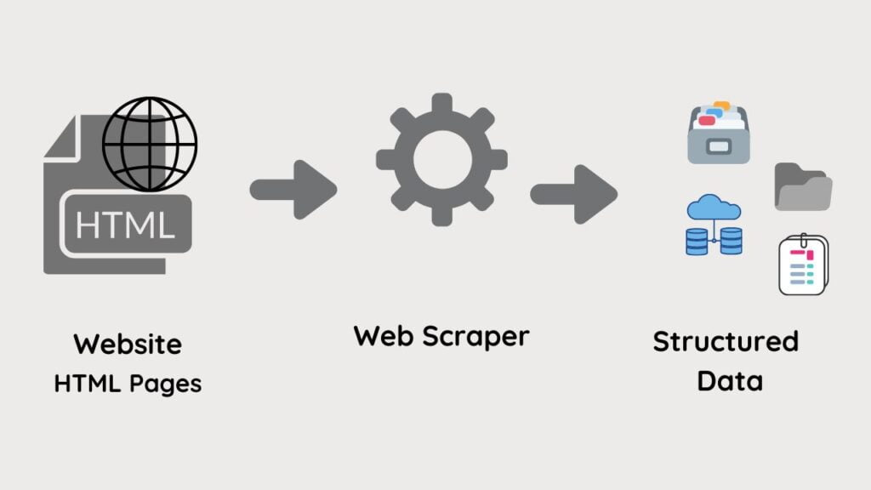

PriceHunter takes advantage of HTML tags to find the product details such as name, price and images. But it can be optimized to extract even more data such as product description, ratings and reviews and so on.

### Use cases description

* E-commerce Price Monitoring: A company can use the scraper to regularly collect prices of its competitors' products, to adjust its own prices and maintain a competitive edge.
* Market Research: Market research firms can use the scraper to gather prices of products and services from various websites to analyze market trends and consumer behavior.
* Dynamic Pricing: Online retailers can use the scraper to adjust prices dynamically based on real-time market data, to maximize revenue.
* Cost Management: Procurement departments of businesses can use the scraper to gather data on raw materials, suppliers, and other inputs to optimize costs and manage budgets effectively.
* Investment Analysis: Investors can use the scraper to gather financial data and stock prices.

## Non-Functional Requirements

* Performance

PriceHunter has a very good performance, it can scrap a store for product informations in no time and saves all the gathered informations in a CSV file.

* Security

PriceHunter uses html pages to search for product details. This offers a big level of security because no files or scripts are downloaded from the web.

* Reliability

The reliability of PriceHunter is well known by some of the following reasons:

* + Time and money saver, you have no longer to open a browser tab and go to a specific store and search for product prices;
  + Helps online stores to do the research of the market;
  + Can be used to create log files of the store;
  + Can be used to update the database;
* Usability

Every person or company that has a reason to use this tool.

* Maintainability

PriceHunter is ready to be maintained by the company that developed this tool, but it can be customized by everyone to do different operations.

* Portability

PriceHunter can be converted into an online app to be available for world wide users, also it can be used as a desktop/mobile app.