2014 Intel Cup Undergraduate Electronic Design Contest

- Embedded System Design Invitational Contest

**Final Report**

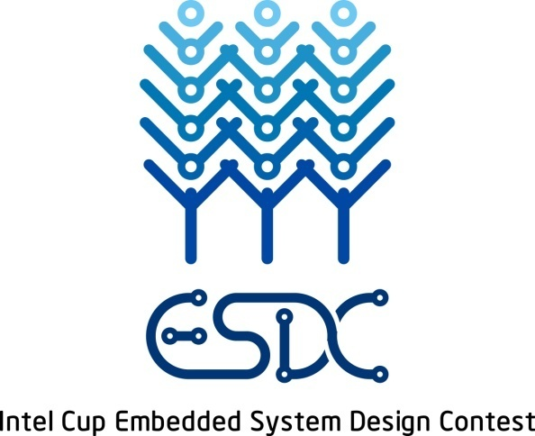

Project Name：Smart Hotel Room

Students: Marius Alexandru Neghina

Cristian Stefan Totolin

Ionut Marian Marcu

Faculty: Sorin Ilie, TA PhD Eng

University: University of Craiova, Romania

2014 Intel Cup Undergraduate Electronic Design Contest

- Embedded System Design Invitational Contest

**Declaration of Originality**

We hereby declare that this thesis and the work reported herein was composed and originated entirely by ourselves. Information derived from the published and unpublished work of others has been acknowledged in the text and a list of references is given in the references.

Team Members Signature: _____________________________________

Name (in Block Letters):

Date:

**SMART HOTEL ROOM**

**ABSTRACT**

All functionality runs on the contest platform in the form of web services. Users with different levels of access will be managed using a database. High level users like hotel employees, will be able to grant users access to a room for a given amount of time. Low level users like hotel guests and maintenance staff, will be able to open the door using their mobile device, change lighting options, turn power plugs on and off. High level users will be able to monitor room access, presence and power consumption of the room plugs.

The contest platform communicates via wired ethernet with Galileo module which controls an electric door, lights, plugs but also measures power consumption and determines human presence in the room using a motion sensor.

To accomplish this four distributed software applications will interact: the Galileo ethernet server, the web server on the platform, the database server and the android mobile application client.

**Key words:** Domotics, Smart house, Access Control, Light Control, Smarplugs

**Content**

**Chapter 1 Introduction**

Hotels and accommodation-based business are increasingly relying on technology for their day to day operations. Computing devices are now cheap and small enough to allow rooms to have a local embedded controller reporting to/ commanded by a hotel server.

Furthermore the personal smart mobile device boom offers new opportunities for improvement. Presuming that every employee and guest has a personal device we can create a virtual alter-ego of that person. Their device can communicate with the hotel server and thusly be given access to room controllers.

This project envisions a new way of interacting with hotel rooms. User experience will simply be that a mobile app can control door locks, lighting, plugs etc in rooms where they have access. Hotel reception can give access to guests and maintenance staff to a room for a given amount of time, even at predefined intervals. At all times the server can log all door accesses, presence, power consumption and so on for inspection.

**Chapter 2 Design**

# **2.1. Architecture**

The system we propose is composed of a central hotel server, one embedded controller per hotel room, one smart device per staff member or guest and interconnecting Ethernet and WiFi networks.

The embedded hotel room controller implements all interactions with the physical elements of the room: power plugs, lighting, door lock, motion sensor. The hotel server communicates via Ethernet with all controllers using basic socket communication but also waits for requests from mobile devices and reports from room controllers. Mobile devices offer user-friendly GUIs and depending on user interactions invokes functionality from the server via WiFi.

Server

Web Server

http

WebApp

http

Room Management Module

REST

Web Services

r/w

DB

TCP/IP

Lights

Door

Plug

Room Controller

Motion Sensors

# Android mobile device

consumes web services offered by brain module

user friendly interface

brain module

commands intel galileo using ethernet cable

connected to internet via WIFI

intel galileo

controls door

controls light color

controls smart plug

reads motion sensor output

# **Brain module**

<gif / movie of it running specs on side>

- hosts a Tomcat web server for webservices

- authentication module with local DB access

- admin functionality

- communicates with Intel Galileo (Arduino compatible) board via Ethernet cable (fixed IP)

- specs:

Intel Atom Processor E38xx

4 G RAM

64G SSD

Win 8

connectivity: ethernet, wifi,

12V 3A power supply

use case diagram (the types of users and the functionality they can access)

database table structure

UML class diagram

sequence diagram

- interaction protocols between brain and galileo

- between brain and android mobile device

# **Intel Galileo**

<gif / movie of it running specs on side>

- hosts an ethernet server

- communicates with the brain via ethernet cable (fixed IP)

- controls door, lights, smartplugs, motion sensor

Arduino:

1 digital port for access   port 7

1 digital port for security  port 2

Rx for input  current intensity

1 digital output for smartplug control   port 13

1 digital output  for smartplug manual switch enabler port 12

3 analog output ports for rgb lighting ports 9 10 11

1 analog port for light sensor  port A5

1 analog input port for current intensity port A0

2 digital input for door open sensor

External commands for Galileo sent as String:

Sending 1-    Opens door

Sending 2-    Asks Door Status

Sending 3-    Sends Light Control

Sending 4-    Turns on the Smart Plug

Sending 5-    Turns of the Smart Plug

Sending 6-    Checks Smart Plug Status

Sending 7-    Reads Current Sensor

Driver class API (quick overview)

**Door**

<1) gif / movie of it running specs on site 2) gif/movie of it running tablet on side>

- spring loaded mechanical opener

- opens by button from inside

- opens by key from outside

- 12V 2A power source electromagnet opener

- 5v relay activates electromagnet

- when door closed contact is made in a 5v circuit

schematic for door

**Lights**

<1) gif / movie of it running specs on site 2) gif/movie of it running tablet on side>

- 3 meters of RGB light strip

- 3X analog 12V 3A power

- 3X 5v analog command module

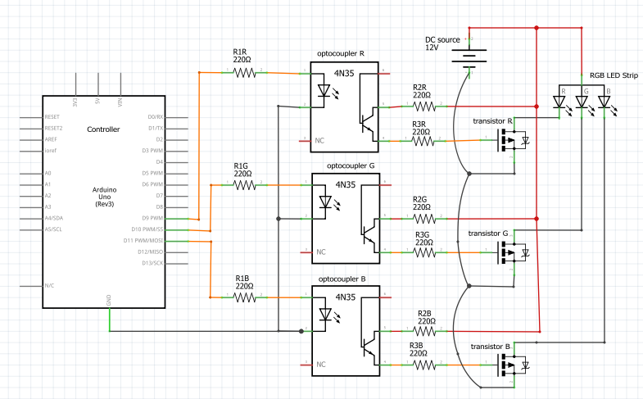

**Plug**

<1) gif / movie of it running specs on site 2) gif/movie of it running tablet on side>

- 5V relay that closes 220V 5A plug

- in line Amp meter with 0-5V output

schematic for plug

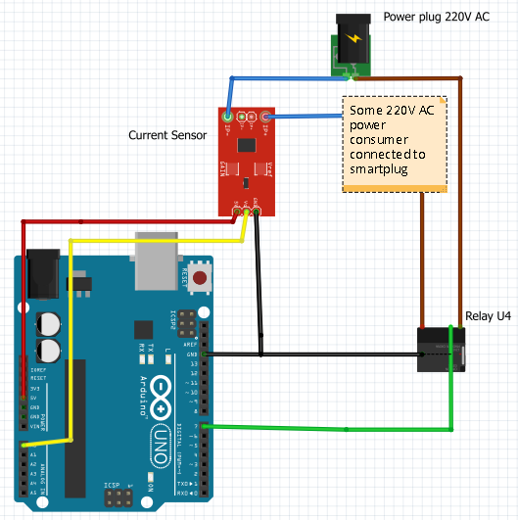

**Motion Sensor**

<1) gif / movie of it running specs on site 2) gif/movie of it running server notiffication on side>

- 12V power

- normally outputs 5V

- outputs 0V when motion detected

schematic for motion sensor

**1.1 Introduction**

HCCI (Homogenous Charge Compression Ignition) combustion has advantages in terms of efficiency and reduced emission. HCCI combustion can not only ensure both the high economic and dynamic quality of the engine, but also efficiently reduce the NOx and smoke emission.

**1.1.1 Introduction**

HCCI (Homogenous Charge Compression Ignition) combustion has advantages in terms of efficiency and reduced emission. HCCI combustion can not only ensure both the high economic and dynamic quality of the engine, but also efficiently reduce the NOx and smoke emission.：

1. Introduction

…………………………………………………………………

(2)Introduction

…………………………………………………………………

(3)Introduction

…………………………………………………………………

**Chapter 2 Introduction**

**2.1Introduction**

…

2.1.1 Introduction

…



（2-1）

http://www.heyunfeng.com/ssn/2004/01/102-2.gif （2-2）

Table 2-1 Table

|  |  |  |  |
| --- | --- | --- | --- |
| Item | Hf(kcal/mol) | Sf(kcal/mol) | Cp(kcal/mol) |
| A1  A2  A3 | 100 | 100 | 100 |

Continue table 2-1

|  |  |  |  |
| --- | --- | --- | --- |
| Item | Hf(kcal/mol) | Sf(kcal/mol) | Cp(kcal/mol) |
| A4  A5  A6  A7  A8 | 100 | 100 | 100 |

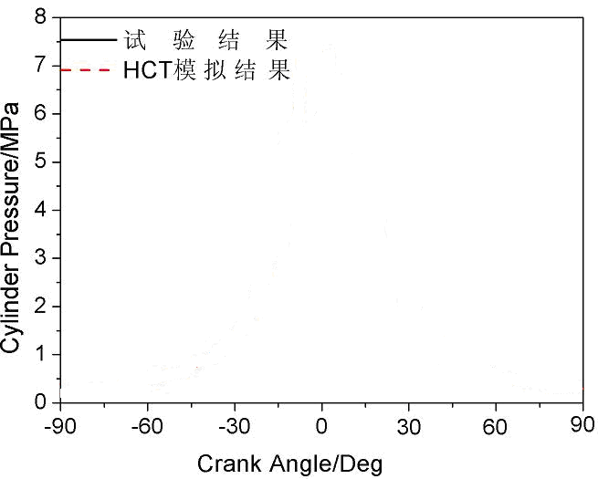

**Figure 2-1 caption**

**Chapter 5 Conclusion**

…

**References**

[1] World Health Organization. Factors regulating the immune response:report of WHO Scientific Group[R].Geneva:WHO,1970.

[2] CHRISTINE M. Plant physiology:plant biology in the Genome Era[J/OL].Science,1998,281: 331-332[1998-09-23].http://www.sciencemag.org/cgi/collection/anatmorp.