**ReactJs Hands-On – 1**

**Reactjs Setup**

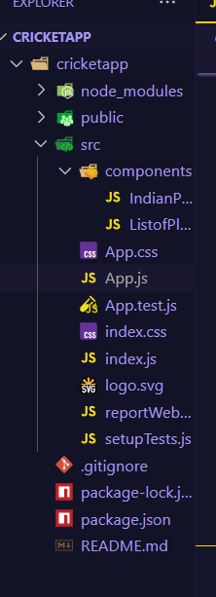**App.js**

import React from 'react';

import ListofPlayers from './components/ListofPlayers';

import { OddEvenPlayers, MergedPlayersList } from './components/IndianPlayers';

function App() {

  const flag = false;

  const players = [

    { name: 'Mr. Jack', score: 50 },

    { name: 'Mr. Michael', score: 70 },

    { name: 'Mr. John', score: 40 },

    { name: 'Mr. Ann', score: 61 },

    { name: 'Mr. Elisabeth', score: 61 },

    { name: 'Mr. Sachin', score: 95 },

    { name: 'Mr. Dhoni', score: 100 },

    { name: 'Mr. Virat', score: 84 },

    { name: 'Mr. Jadeja', score: 64 },

    { name: 'Mr. Raina', score: 75 },

    { name: 'Mr. Rohit', score: 80 },

  ];

  const IndianTeam = ['Sachin1', 'Dhoni2', 'Virat3', 'Rohit4', 'Yuvaraj5', 'Raina6'];

  const T20Players = ['Mr. First Player', 'Mr. Second Player', 'Mr. Third Player'];

  const RanjiTrophyPlayers = ['Mr. Fourth Player', 'Mr. Fifth Player', 'Mr. Sixth Player'];

  const IndianPlayersList = [...T20Players, ...RanjiTrophyPlayers];

  return (

    <div style={{ padding: '20px', fontFamily: 'Arial, sans-serif' }}>

      {flag ? (

        <ListofPlayers players={players} />

      ) : (

        <>

  <OddEvenPlayers team={IndianTeam} />

  <hr />

  <MergedPlayersList players={IndianPlayersList} />

</>

      )}

    </div>

  );

}

export default App;

**ListofPlayers.js**

import React from 'react';

const ListofPlayers = ({ players }) => {

  const players70 = [];

  players.map((item) => {

    if (item.score <= 70) {

      players70.push(item);

    }

    return null;

  });

  return (

    <div>

      <h2>List of Players</h2>

      <ul>

        {players.map((item, index) => (

          <div key={index}>

            <li>

              Mr. {item.name} <span>{item.score}</span>

            </li>

          </div>

        ))}

      </ul>

      <hr />

      <h2>List of Players having Scores Less than 70</h2>

      <ul>

        {players70.map((item, index) => (

          <li key={index}>

            Mr. {item.name} <span>{item.score}</span>

          </li>

        ))}

      </ul>

    </div>

  );

};

export default ListofPlayers;

**IndianPlayers.js**

import React from 'react';

export function OddEvenPlayers({ team }) {

  const [first, second, third, fourth, fifth, sixth] = team;

  return (

    <div>

      <h2>Odd Players</h2>

      <ul>

        <li>First : {first}</li>

        <li>Third : {third}</li>

        <li>Fifth : {fifth}</li>

      </ul>

      <hr />

      <h2>Even Players</h2>

      <ul>

        <li>Second : {second}</li>

        <li>Fourth : {fourth}</li>

        <li>Sixth : {sixth}</li>

      </ul>

    </div>

  );

}

export function MergedPlayersList() {

  const T20Players = ['Mr. First Player', 'Mr. Second Player', 'Mr. Third Player'];

  const RanjiTrophyPlayers = ['Mr. Fourth Player', 'Mr. Fifth Player', 'Mr. Sixth Player'];

  const IndianPlayers = [...T20Players, ...RanjiTrophyPlayers];

  return (

    <div>

      <h2>List of Indian Players Merged:</h2>

      <ul>

        {IndianPlayers.map((player, index) => (

          <li key={index}>{player}</li>

        ))}

      </ul>

    </div>

  );

}

**Output (When Flag = true)**

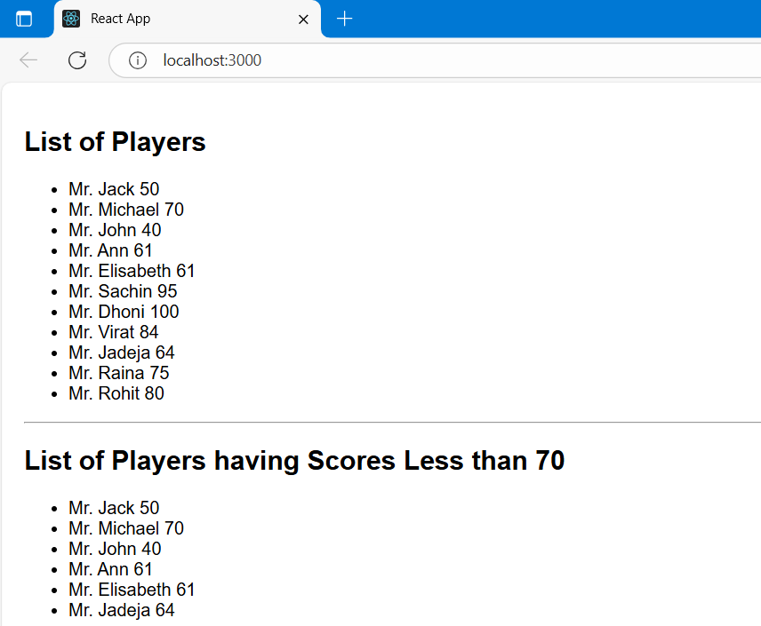

**Output (When Flag = false)**

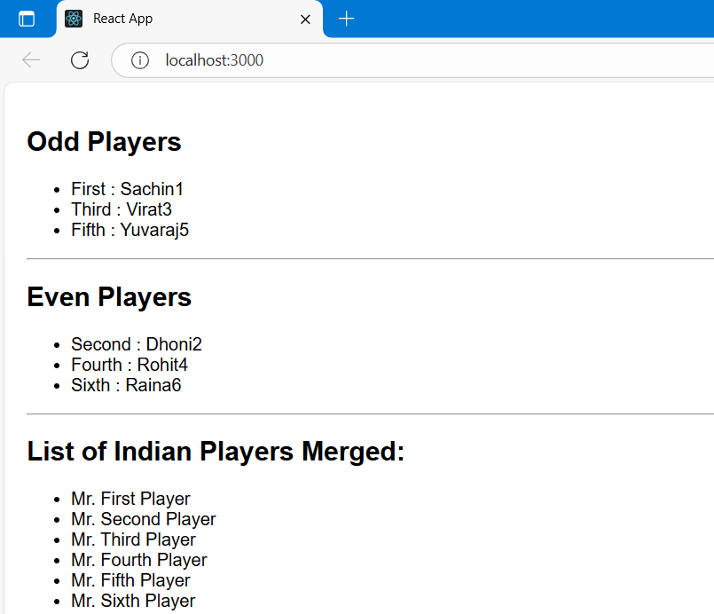

**ReactJs Hands-On – 2**

**App.js**

import React from 'react';

import './App.css';

function App() {

  const heading = "Office Space";

  const office = {

    Name: "DBS",

    Rent: 50000,

    Address: "Chennai"

  };

  return (

    <div className="container">

      <h1>{heading} , at Affordable Range</h1>

      <img src="/office.jpeg" width="300" height="200" alt="Office Space" />

      <h2>Name: {office.Name}</h2>

      <h3 className={office.Rent <= 60000 ? 'textRed' : 'textGreen'}>

        Rent: Rs. {office.Rent}

      </h3>

      <h3>Address: {office.Address}</h3>

    </div>

  );

}

export default App;

**App.css**

.container {

  padding: 30px;

  font-family: Arial, sans-serif;

}

.textRed {

  color: red;

}

.textGreen {

  color: green;

}

**Index.js**

import React *from* 'react';

import ReactDOM *from* 'react-dom/client';

import App *from* './App';

const root = ReactDOM.createRoot(document.getElementById('root'));

root.render(<App />);

**Output**

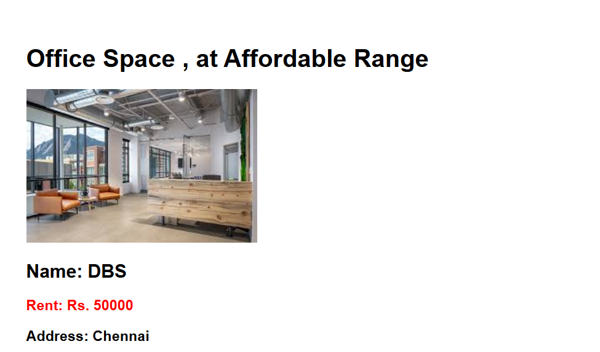

**ReactJs Hands-On – 3**

**ReactJS Setup**

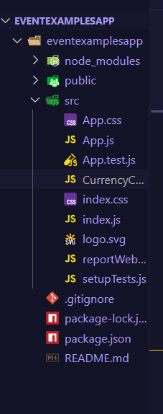

**App.js**

import React, { useState } from 'react';

import CurrencyConvertor from './CurrencyConvertor';

import './App.css';

function App() {

  const [count, setCount] = useState(5);

  const increment = () => {

    setCount(prev => prev + 1);

    alert("Hello! Member1");

  };

  const decrement = () => {

    setCount(prev => prev - 1);

  };

  const sayWelcome = () => {

    alert("welcome");

  };

  const handleClick = () => {

    alert("I was clicked");

  };

  return (

    <div className="app-container">

      <h1>{count}</h1>

      <div className="vertical-controls">

        <button onClick={increment}>Increment</button>

        <button onClick={decrement}>Decrement</button>

        <button onClick={sayWelcome}>Say welcome</button>

        <button onClick={handleClick}>Click on me</button>

      </div>

      <hr />

      <CurrencyConvertor />

    </div>

  );

}

export default App;

**CurrencyConvertor.js**

import React, { useState } from 'react';

function CurrencyConvertor() {

  const [amount, setAmount] = useState('');

  const [currency, setCurrency] = useState('');

  const handleSubmit = (e) => {

    e.preventDefault();

    const rate = 80;

    if (currency.trim().toLowerCase() === 'euro') {

      const converted = parseFloat(amount) * rate;

      alert(`Converting to Euro Amount is ${converted.toFixed(2)}`);

      setCurrency(`€${converted.toFixed(2)}`);

    } else {

      alert("Please enter 'Euro' as the currency to convert.");

    }

  };

  return (

    <div className="converter">

      <h2>Currency Convertor!!!</h2>

      <form onSubmit={handleSubmit}>

        <label>

          Amount:

          <input

            type="number"

            value={amount}

            onChange={(e) => setAmount(e.target.value)}

          />

        </label>

        <label>

          Currency:

          <input

            type="text"

            value={currency}

            onChange={(e) => setCurrency(e.target.value)}

          />

        </label>

        <button type="submit" className="submit-button">Submit</button>

      </form>

    </div>

  );

}

export default CurrencyConvertor;

**App.css**

body {

  font-family: Arial, sans-serif;

  background-color: #f8f8f8;

}

.app-container {

  padding: 20px;

}

h1 {

  font-size: 36px;

  margin-bottom: 15px;

  color: #333;

}

.vertical-controls {

  display: flex;

  flex-direction: column;

  align-items: flex-start;

  gap:10px;

  margin-bottom: 20px;

}

.vertical-controls button {

  padding: 10px 20px;

  font-size: 16px;

}

.converter {

  background-color: #fff;

  padding: 20px;

  border-radius: 6px;

  box-shadow: 0 0 8px rgba(0, 0, 0, 0.1);

}

.converter h2 {

  color: green;

  font-size: 24px;

  margin-bottom: 20px;

}

label {

  display: block;

  margin-bottom: 10px;

  font-weight: bold;

}

input[type="number"],

input[type="text"] {

  width: 100%;

  padding: 8px;

  font-size: 16px;

  margin-bottom: 15px;

  border: 1px solid #ccc;

  border-radius: 4px;

}

.submit-button {

  background-color: white;

  color: black;

  font-size: 16px;

  padding: 10px 20px;

  border: 2px solid black;

  cursor: pointer;

}

**Output**

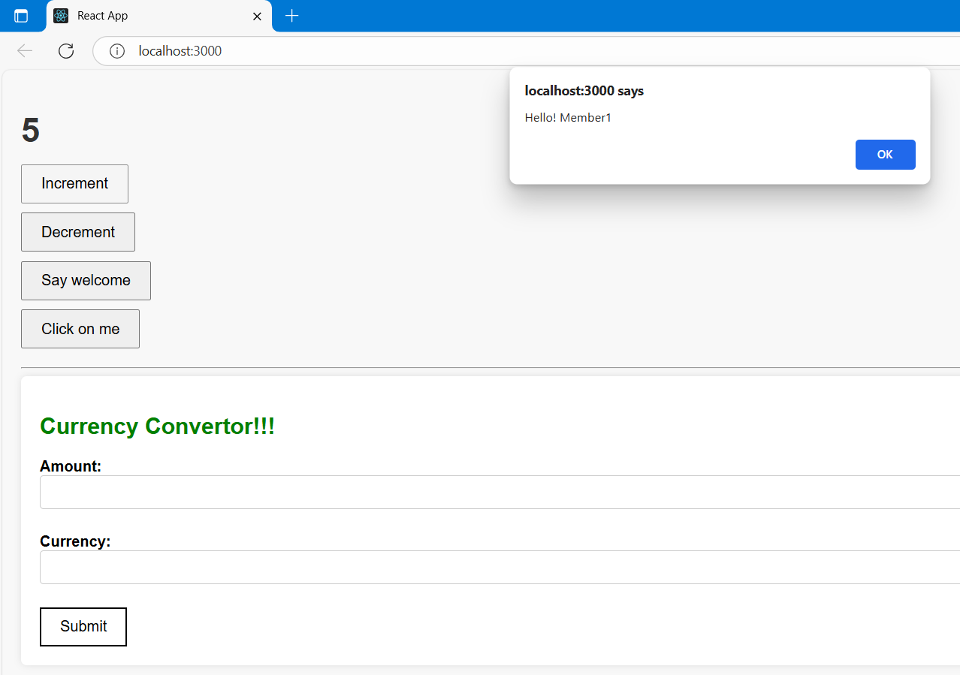**Increment**

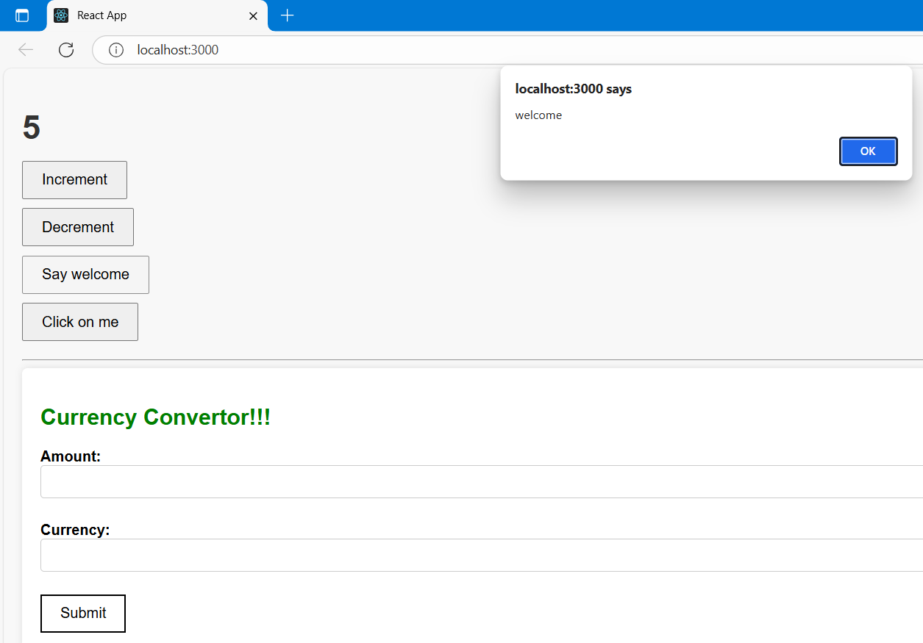**Say Welcome**

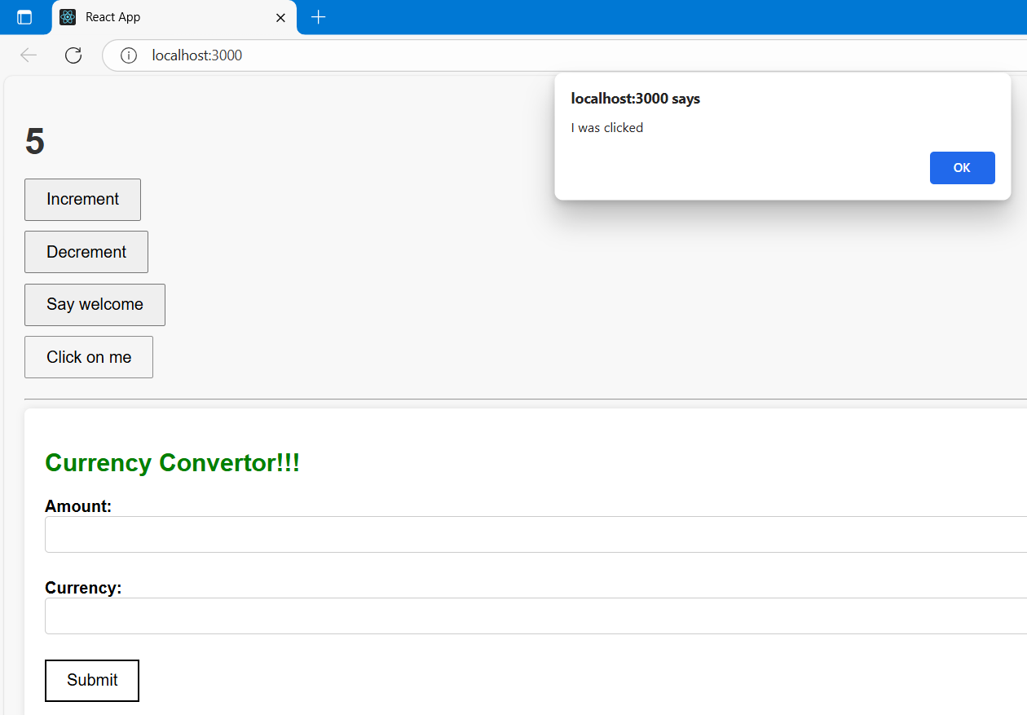**OnPress**

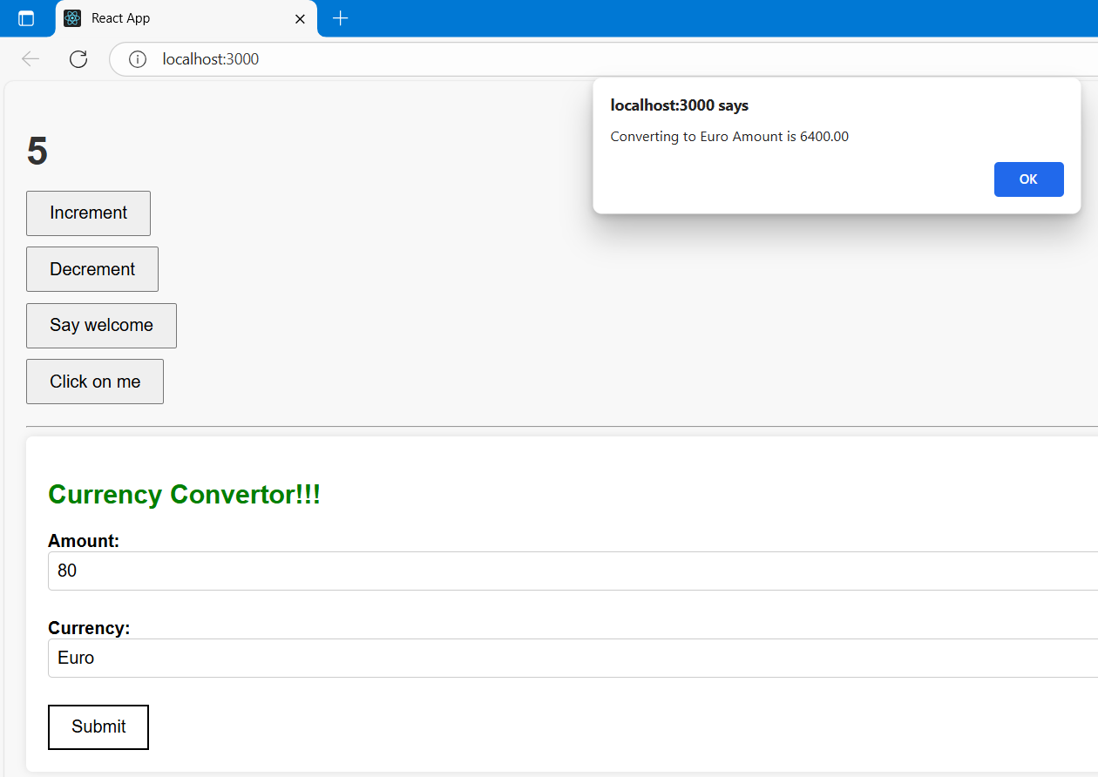**CurrencyConvertor**

**ReactJs Hands-On – 4**

**ReactJS Setup**

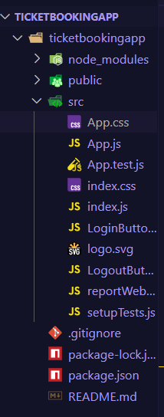

**App.js**

import React, { useState } from "react";

import LoginButton from "./LoginButton";

import LogoutButton from "./LogoutButton";

import "./App.css";

function App() {

  const [isLoggedIn, setIsLoggedIn] = useState(false);

  const handleClick = () => {

    setIsLoggedIn(prev => !prev);

  };

  return (

    <div className="container">

      <p>{isLoggedIn ? "Welcome back" : "Please sign up."}</p>

      {isLoggedIn ? (

        <LogoutButton onClick={handleClick} />

      ) : (

        <LoginButton onClick={handleClick} />

      )}

    </div>

  );

}

export default App;

**LoginButton.js**

function LoginButton({ onClick }) {

  return (

    <button *onClick*={onClick}>Login</button>

  );

}

export default LoginButton;

**LogoutButton.js**

function LoginButton({ onClick }) {

  return (

    <button onClick={onClick}>Login</button>

  );

}

export default LoginButton;

**App.css**

body {

  margin: 0;

  padding: 0;

  font-family: Arial, sans-serif;

  display: flex;

  justify-content: center;

  align-items: center;

  height: 50vh;

}

.container {

  text-align: left;

}

h1 {

  font-size: 24px;

  margin-bottom: 10px;

}

p {

  font-size: 32px;

  font-weight: bold;

  margin-bottom: 20px;

  font-family: Arial, sans-serif;

}

**Output**

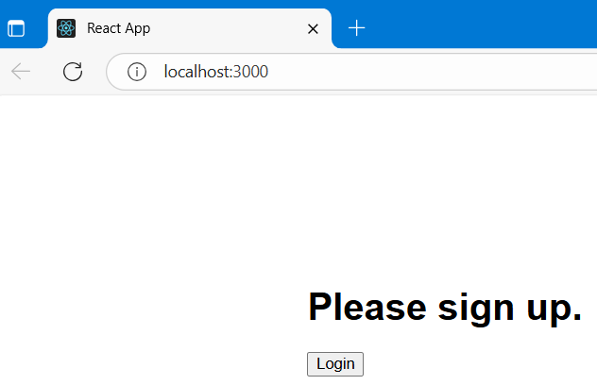

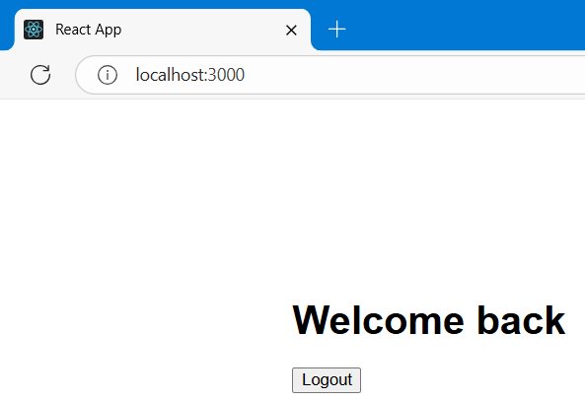

**ReactJs Hands-On – 5**

**ReactJS Setup**

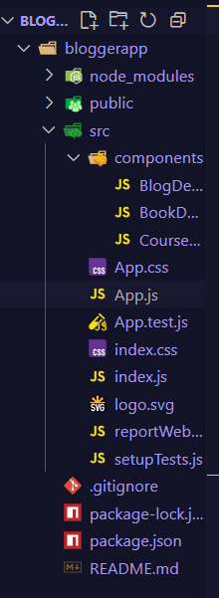

**App.js**

import React from 'react';

import './App.css';

import BookDetails from './components/BookDetails';

import BlogDetails from './components/BlogDetails';

import CourseDetails from './components/CourseDetails';

const books = [

  { id: 101, bname: 'Master React', price: 670 },

  { id: 102, bname: 'Deep Dive into Angular 11', price: 800 },

  { id: 103, bname: 'Mongo Essentials', price: 450 },

];

const blogs = [

  { id: 1, title: 'React Learning by Stephen Biz', content: 'Welcome to learning React!' },

  { id: 2, title: 'Installation by Schewzdenier', content: 'You can install React from npm.' },

];

const courses = {

  angular: '4/5/2021',

  react: '6/3/2021',

};

function App() {

  return (

    <div>

      <div>

        <div className="mystyle1">

          <h1>Course Details</h1>

          <CourseDetails courses={courses} />

        </div>

        <div className="st2">

          <h1>Book Details</h1>

          <BookDetails books={books} />

        </div>

        <div className="v1">

          <h1>Blog Details</h1>

          <BlogDetails blogs={blogs} />

        </div>

      </div>

    </div>

  );

}

export default App;

**BookDetails.js**

import React from 'react';

function BookDetails(props) {

  const bookdet = (

    <ul>

      {props.books && props.books.length > 0 ? (

        props.books.map((book) => (

          <div key={book.id}>

            <h3>{book.bname}</h3>

            <h4>{book.price}</h4>

          </div>

        ))

      ) : (

        <p>No Books Available</p>

      )}

    </ul>

  );

  return bookdet;

}

export default BookDetails;

**BlogDetails.js**

import React from 'react';

function BlogDetails(props) {

  return (

    <>

      {props.blogs && props.blogs.length > 0 ? (

        props.blogs.map((blog) => {

          const [mainTitle, author] = blog.title.split(' by ');

          return (

            <div key={blog.id}>

              <strong>{mainTitle}</strong>

              <p><b>{author}</b></p>

              <p>{blog.content}</p>

            </div>

          );

        })

      ) : (

        <p>No Blogs Available</p>

      )}

    </>

  );

}

export default BlogDetails;

**CourseDetails.js**

import React from 'react';

function CourseDetails(props) {

  const { courses } = props;

  return (

    <>

      {'angular' in courses && (

        <>

          <h3>Angular</h3>

          <p>{courses.angular}</p>

        </>

      )}

      {'react' in courses && (

        <>

          <h3>React</h3>

          <p>{courses.react}</p>

        </>

      )}

    </>

  );

}

export default CourseDetails;

**App.css**

.st2, .v1, .mystyle1 {

  display: inline-block;

  vertical-align: top;

  width: 30%;

  padding-left: 30px;

  border-left: 4px solid green;

  min-height: 300px;

  margin-top: 40px;

}

h1 {

  font-size: 24px;

  font-weight: bold;

}

h3, strong {

  font-size: 20px;

  font-weight: bold;

}

**Output**

