mysql> use sorni;

Database changed

mysql> show tables;

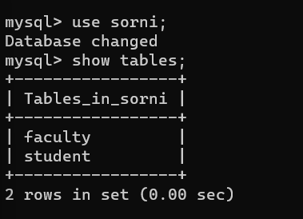

mysql> select*from student;

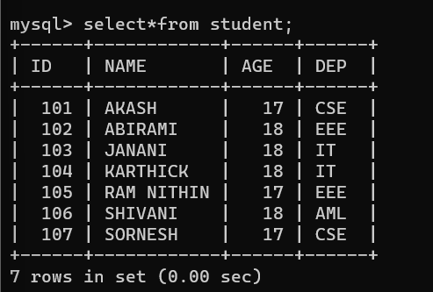

mysql> select*from faculty;

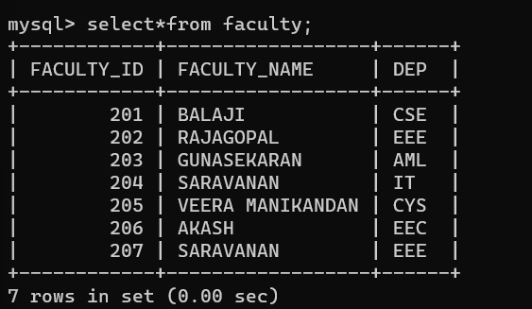

mysql> select student.name,faculty.faculty_name,student.age from student inner join faculty on student.dep=faculty.dep;

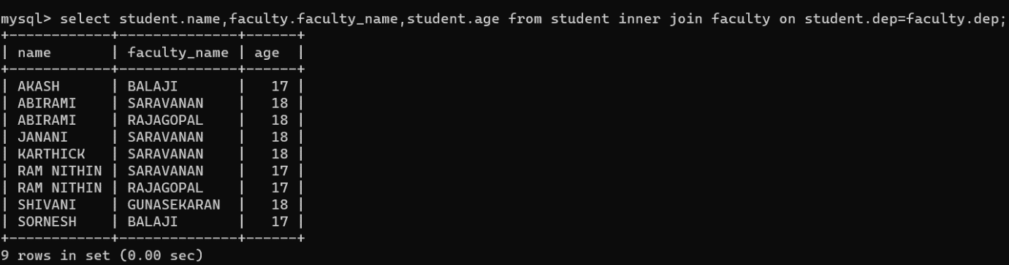

mysql> select student.name,faculty.faculty_name from student left join faculty on student.dep=faculty.dep;

