mysql> use sorni;

Database changed

mysql> create table coustomers(ID int,NAME char(50),AGE int,CITY char(20),SALARY int);

Query OK, 0 rows affected (0.08 sec)

mysql> insert into coustomers values(1,"ramesh",32,"delhi",20000);

Query OK, 1 row affected (0.01 sec)

mysql> insert into coustomers values(2,"pluffy",30,"mumbai",30000);

Query OK, 1 row affected (0.01 sec)

mysql> insert into coustomers values(3,"tommy",31,"chennai",32000);

Query OK, 1 row affected (0.01 sec)

mysql> insert into coustomers values(4,"dhoni",45,"chennai",90000);

Query OK, 1 row affected (0.01 sec)

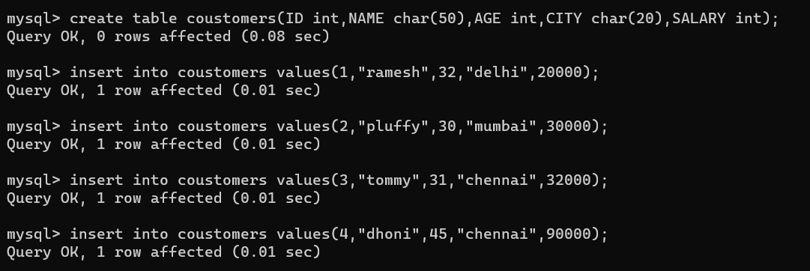

mysql> select*from coustomers;

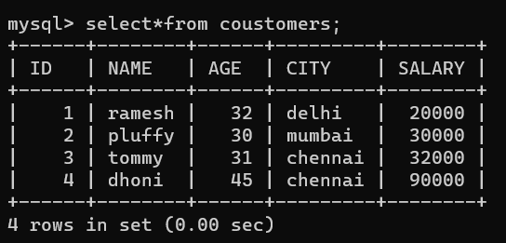

mysql> create view coustomers_view as select name , age from coustomers;

Query OK, 0 rows affected (0.01 sec)

mysql> select*from coustomers_view;

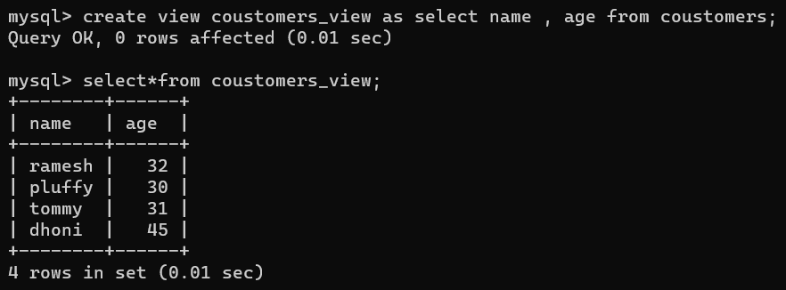

mysql> create index coustomers_index on coustomers (name,city);

