Raport

a. Intructiunile alese suplimentar:
i) XOR (SAU-EXCLUSIV logic intre 2 registre)
-xor $d,$s,$t
-$d<=$s^$t
-000 sss ttt ddd 0 110
ii) SLT (Set on less then)
-slt $d,$s,$t
-if $s < $t
$d <= 1
else
$d <= 0
-000 sss ttt ddd 0 111

iii) SUBI (SUB immediate)
-subi $t ,$s,i
-$t <= $s + i
-101 sss ttt iiiiiii
iv) BNE (Branch on not equal)
-bne $s,$t,offset
-if $s != $t then PC<=PC + 4 + (offset<<2)
-110 sss ttt iiiiiii

b. Tabel valori semnale control:
Semnale control MIPS16
<?> ϵ {_gez, _ne, _gtz}
Tipuri de operații care se pun în paranteză la ALUOp si ALUCtrl: {(+), (-), (&), (|), (^), (<<l), (<<lv), (>>l), (>>a), (<)}, & - AND, | - OR, ^ - XOR, l - logic, a - aritmetic, v - cu variabilă
Instrucțiune | Opcode Instr(15-13) | RegDst | ExtOp | ALUSrc | Branch | Bne | Jump | JmpR (opțional) | MemWrite | MemtoReg | Reg Write | ALUOp (1:0) | func Instr(2-0) | ALUCtrl (2:0)
ADD | 000 | 1 | X | 0 | 0 | 0 | 0 |  | 0 | 0 | 1 | 00(func) | 000 | 000(+)
SUB | 000 | 1 | X | 0 | 0 | 0 | 0 |  | 0 | 0 | 1 | 00(func) | 001 | 001(-)
SLL | 000 | 1 | X | 0 | 0 | 0 | 0 |  | 0 | 0 | 1 | 00(func) | 010 | 010(<<)
SRL | 000 | 1 | X | 0 | 0 | 0 | 0 |  | 0 | 0 | 1 | 00(func) | 011 | 011(>>)
AND | 000 | 1 | X | 0 | 0 | 0 | 0 |  | 0 | 0 | 1 | 00(func) | 100 | 100(&)
OR | 000 | 1 | X | 0 | 0 | 0 | 0 |  | 0 | 0 | 1 | 00(func) | 101 | 101(||)
XOR | 000 | 1 | X | 0 | 0 | 0 | 0 |  | 0 | 0 | 1 | 00(func) | 110 | 110(^)
SLT | 000 | 1 | X | 0 | 0 | 0 | 0 |  | 0 | 0 | 1 | 00(func) | 111 | 111
ADDI | 001 | 0 | 1 | 1 | 0 | 0 | 0 |  | 0 | 0 | 1 | 10(+) | XXX | 000
LW | 010 | 0 | 1 | 1 | 0 | 0 | 0 |  | 0 | 1 | 1 | 10(+) | XXX | 000
SW | 011 | x | 1 | 1 | 0 | 0 | 0 |  | 1 | x | 0 | 10(+) | XXX | 000
BEQ | 100 | x | 1 | 0 | 1 | 0 | 0 |  | 0 | x | 0 | 01(-) | XXX | 001
SUBI | 101 | 0 | 1 | 1 | 0 | 0 | 0 |  | 0 | 0 | 1 | 01(-) | XXX | 001
BNE | 110 | x | 1 | 0 | 0 | 1 | 0 |  | 0 | x | 0 | 01(-) | XXX | 001
J | 111 | x | x | x | x | x | 1 |  | 0 | x | 0 | XX | XXX | XXX

c. Program C: int A[10]={1,2,3,4,5,6,7,8,9,10};
int sum=0;
for(i=0;i<10;i++){
A[i]=A[i]-2;
sum=sum+A[i]; }
d. Trasarea executiei programului:
add $1,$0,$0 => RD1=0; RD2=0; ALURes=0; WD=0
addi $2,$0,8 => RD1=0; Ext_Imm=8; ALURes=8; WD=8
add $3,$0,$0 => RD1=0; RD2=0; ALURes=0; WD=0
add $4,$0,$0 => RD1=0; RD2=0; ALURes=0; WD=0
beq $1,$2,7 => RD1=0; RD2=8; Ext_Imm=7; ALURes=-8;
lw $5,0($3) => RD1=0; RD2=0; Ext_Imm=0; ALURes=0; MemData=0; WD=0
addi $5,$5,-2 => RD1=0; RD2=0; Ext_Imm=-2; ALURes=-2; WD=-2
sw $5,0($3) => RD1=0; RD2=-2; Ext_Imm=0; MemData=-2
add $4,$4,$5 => RD1=0; RD2=-2; ALURes=-2; WD=-2
addi $3,$3,1 => RD1=0; RD2=0; Ext_Imm=1; ALURes=1; MemData=; WD=1
addi $1,$1,1 => RD1=0; Ext_Imm1=; ALURes=1; WD=1
j 4 => JumpAdress=4
sw $4,9($0) => RD1=-2; RD2=0; Ext_Imm=9; MemData=-2
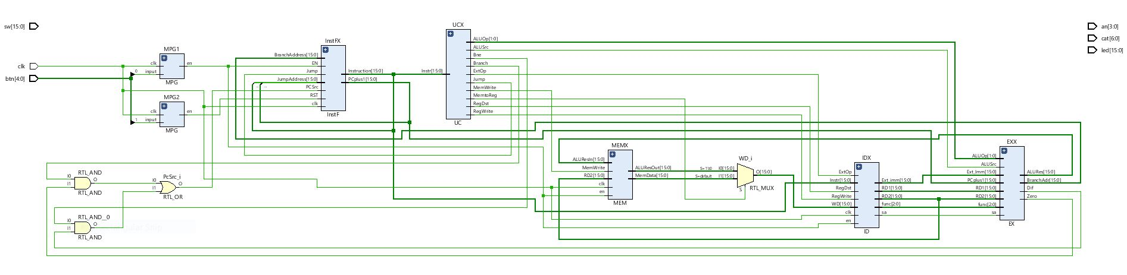
e. RTL Schematic

