**-Exe 2.9**

In this problem we want to calculate (autocorrelation) and (cross correlation)

 

By using eq.3 we can calculate correlation between two sequences

Eq.3  For DT;

But from eq.3 we can rotate one of sequence against amplitude vector and then convolve two sequence. 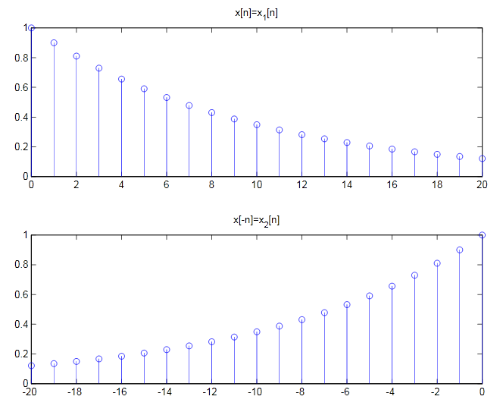

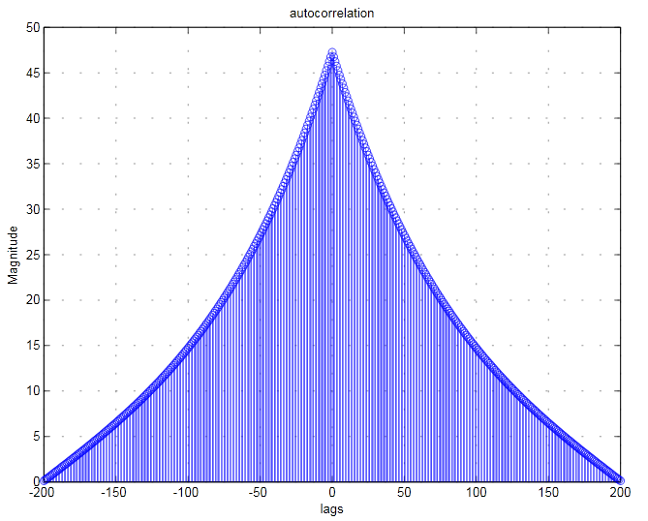

And for calculating the correlation between y[n] and x[n] we use same technique like former problem

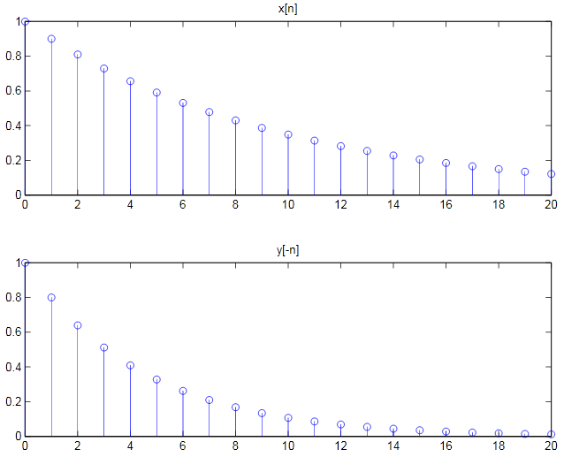

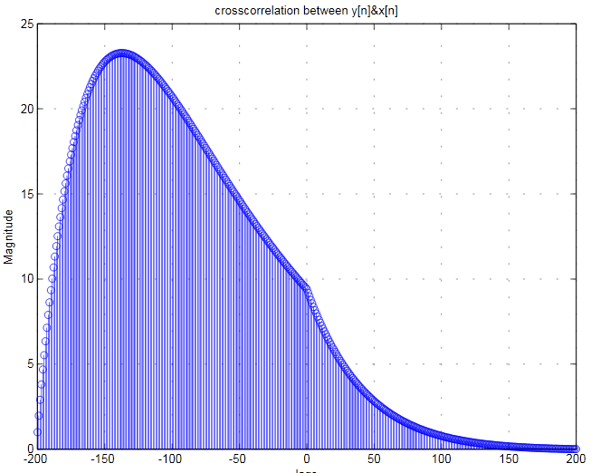

Note: correlation is a measure of how similar signals are.

If  y[n] , x[n] are uncorrelated and the power of can be calculate by superposition .



And also



When  have the highest amount two sequence have the most similarity