**-Exe 3.21**

In this problem we want to change CT signal to DT signal.

First we want to sampling CT signal by several rates (0.01 0.05 0.1)for sampling we multiply x(t) by impulse train (s(t)).

Let



Introduction the “modulated” signal



Since 



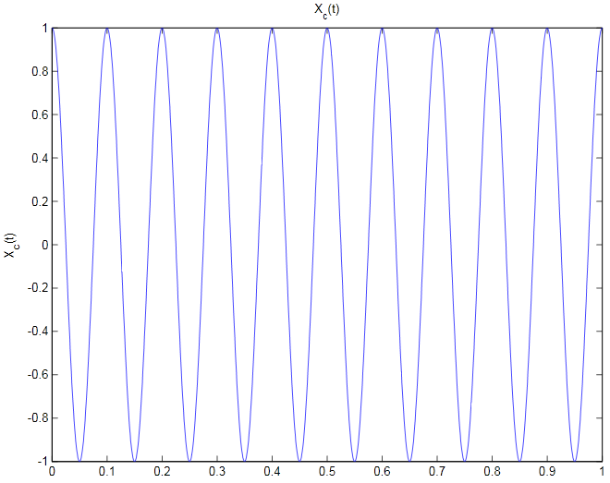

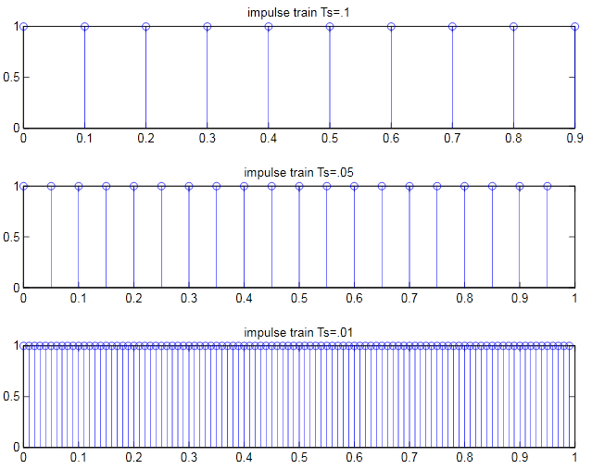

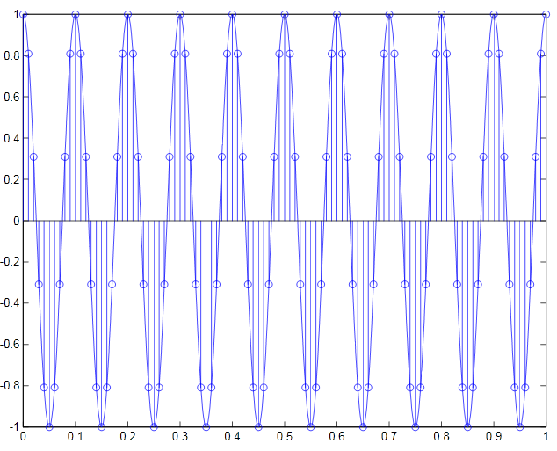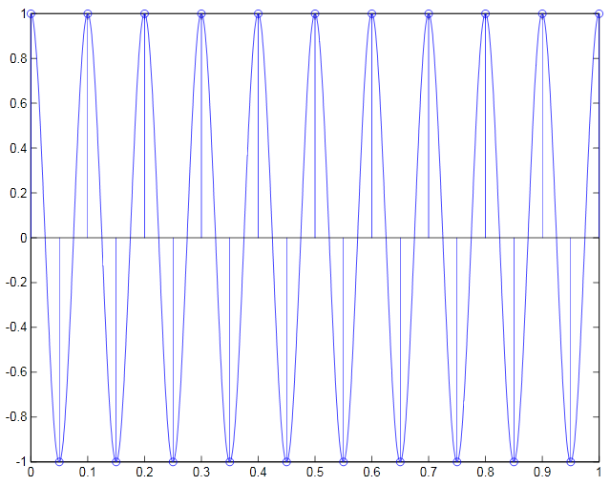

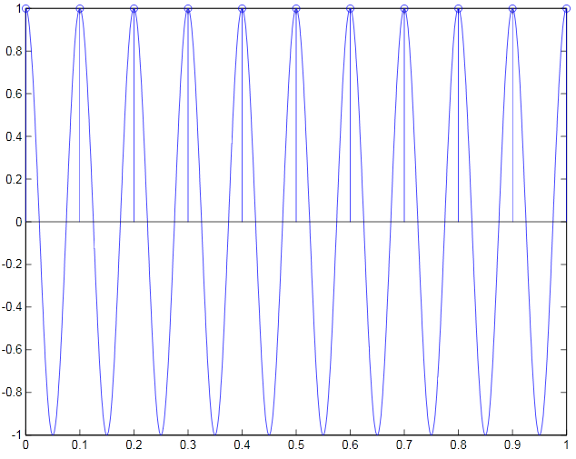

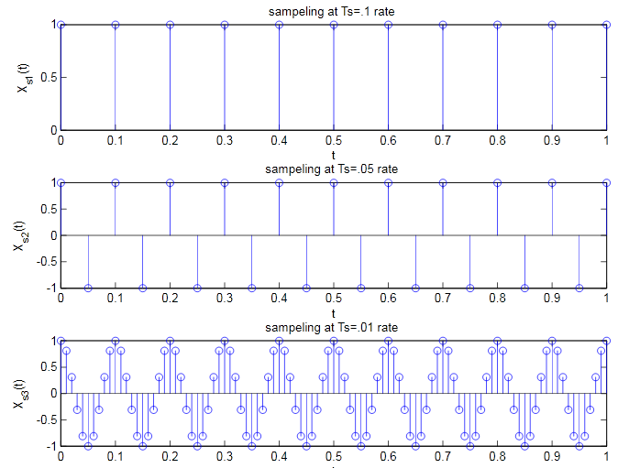

If sampling is done frequently enough () Xc (t) can be recovered from Xs(t) with as ideal lowpass filter Hr(jΩ)

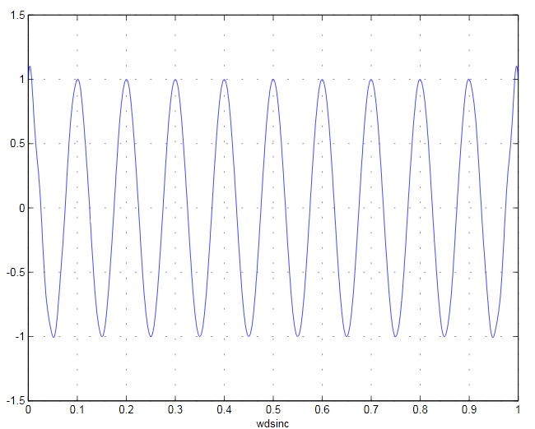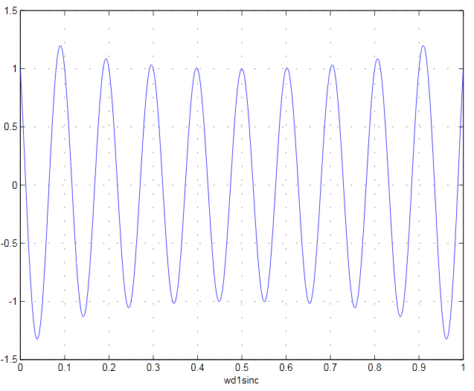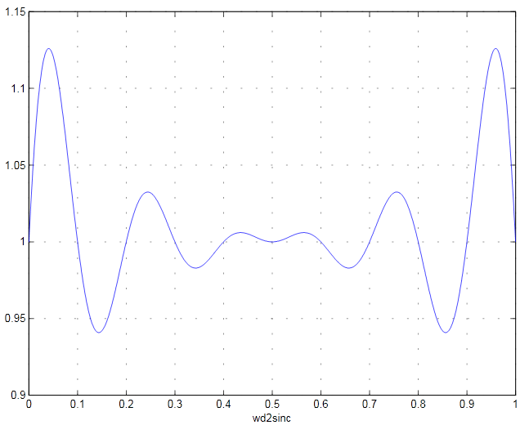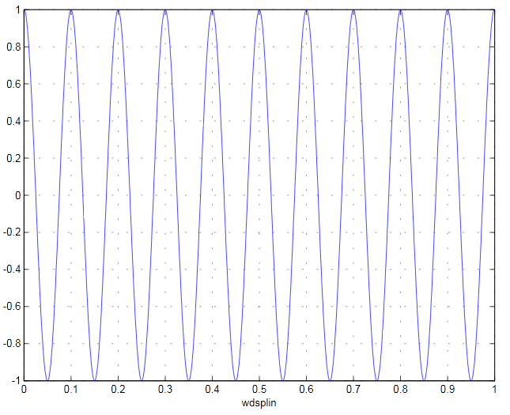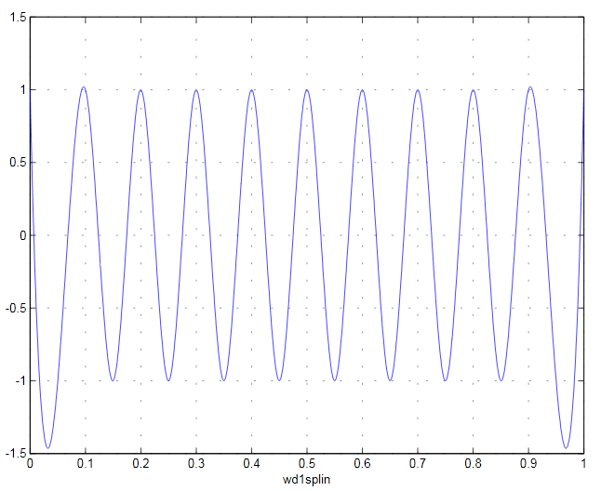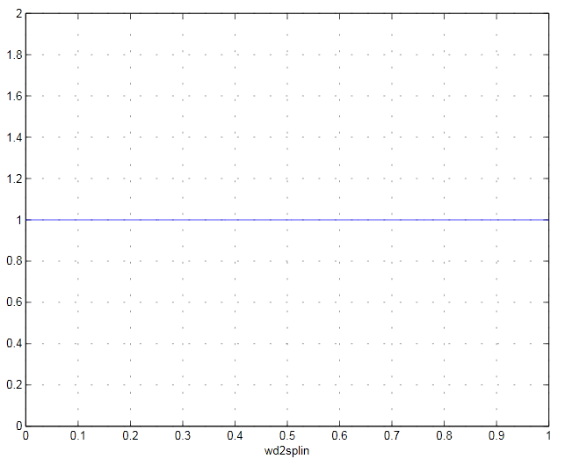

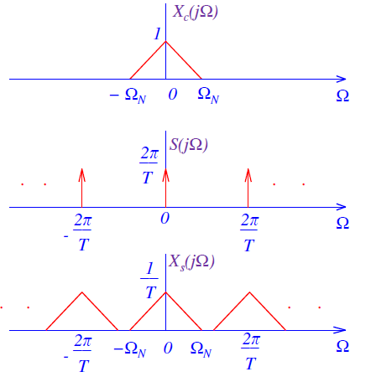

In MATLAB we using *sinc* function and spline when the nyquist rate is satisfied reconstructed sequence will be more accurate than the bigger rates.

By using sinc function it actually multiply *sinc* with samples and by using spline function it actually interpolates between impulse of Xs(t) to construct a CT signal Xr(t) that is an exact reconstruction of Xc(t)

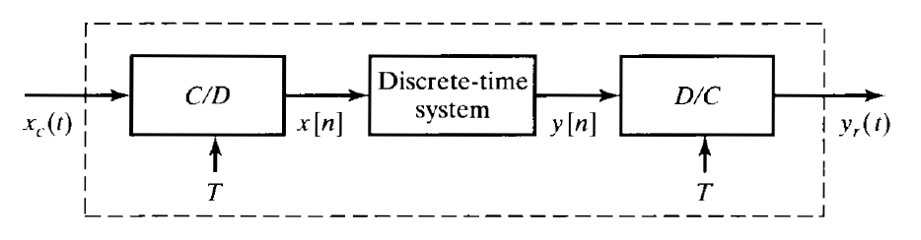We assume that the C/D and the D/C converters have same sampling of T