AIM : Blink LED using Bluetooth.

APPRATUS : LED, breadboard, wires, arduino, Bluetooth.

CIRCUIT DIAGRAM :

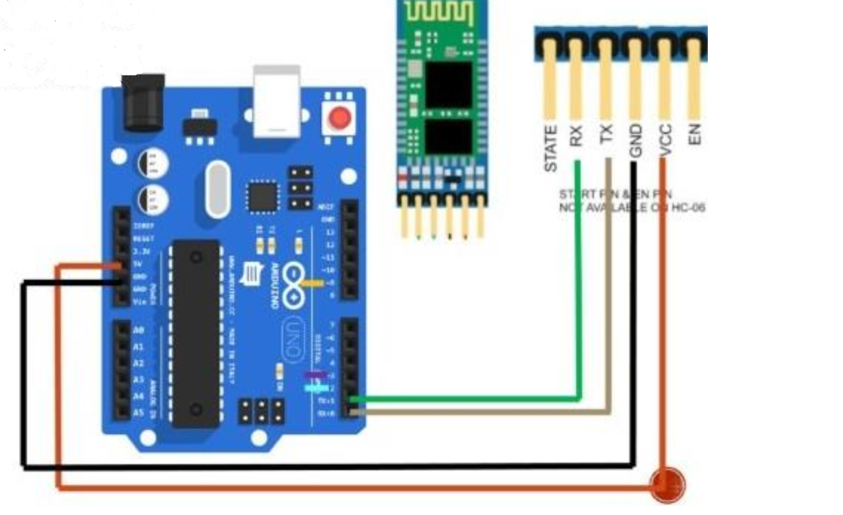

THEORY : The LED has one p junction and n junction inside it, p is longer while p is shorter. Breadbord have network of connection inside it. Bluetooth has two pins in it one is RX and other one is TX.RX means receiving signal and TX means transmitting signal. And same as arduino.

CODE : Char data=0 Void Setup() {

Serial.begin(9600); pinMode(1,OUTPUT); } Void loop() { If(Serial.available()>0) { data=Serial.read(); Serial.print(data ); Serial.print(“\n”); If (data==’1’) digitalWrite(13,HIGH); else if(data==’0’) digitalWrite(13,LOW); } }

LERNING & OBSERVATION : 1. We have to connect Bluetooth always with TX because it transmit the signal to arduino. 2. Aurdino receives the signal from RX pin. 3. We have to connect three pin one with RX, other with TX and 5V.

PROBLEM & TROUBLESHOOTING: 1. Arduino was not working properly and cable were also not working. 2. Mistake in code uploading.

LEARNING OUTCOMES: 1. Bluetooth always with TX because it transmit the signal to arduino. 2. Coding on arduino using bluetooth . 3. Speed of Bluetooth and inventions of new Bluetooth which works on higher speed and have less accuracy.