Assalamu 'ala manit taba'al huda



presents

**Welcome Contest for Batch-54,**

**Male & Female**

*(Hosted by-* ***Cholo Programming Shikhi*** *(****CPS****))*

**Problem’s Solution Book**

You are warmly invited to visit our site, [চলো, Programming শিখি](https://cps-22.netlify.app/).

**For any query**, **Cell:** 01961537181 (***WhatsApp only***).

Stay Connected with us for amazing upcoming events!

Your Well Wisher-

[**Md. Sorowar Mahabub Rabby**](https://github.com/sorowar-cse)

***CEO, Founder & Head Instructor***, [চলো, Programming শিখি](https://cps-22.netlify.app/)

***Teaching Assistant (TA)*,**

Dept. of CSE, International Islamic University Chittagong

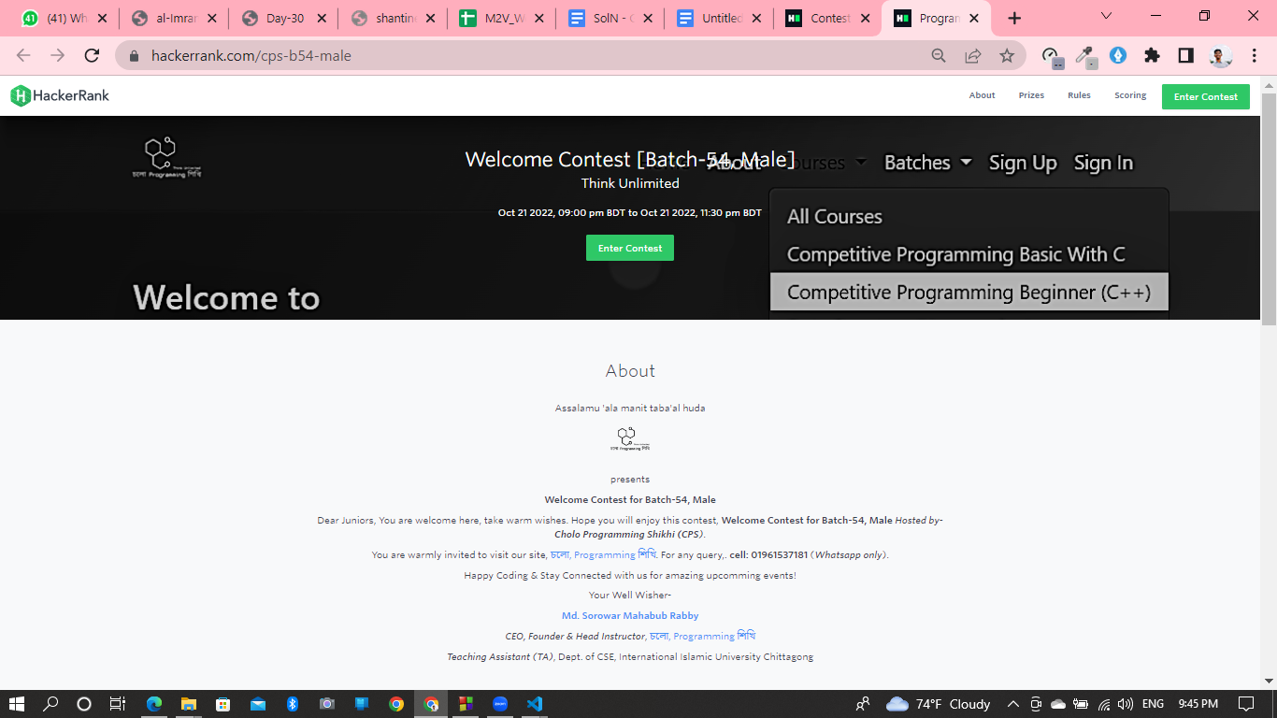

**Male**

**Contest Link:** [**https://www.hackerrank.com/cps-b54-male**](https://www.hackerrank.com/cps-b54-male)

**Female**

**Contest Link:** [**https://www.hackerrank.com/cps-b54-female**](https://www.hackerrank.com/cps-b54-female)

**Problem Name: What is the total cost?**

**Solution Link:** <https://pastebin.ubuntu.com/p/Q9d5c38tnr/>

**Problem Name: Who Will Pay the Bill?**

**Solution Link:** <https://pastebin.ubuntu.com/p/6qRZMyG7fn/>

**Problem Name: Age Gap**

**Solution-1 Link:** <https://pastebin.ubuntu.com/p/hDZFj2fZNT/>

**Solution-2 Link:** <https://pastebin.ubuntu.com/p/rHrtfjrrRV/>

**Problem Name: Can we fit the circle**

**Solution Link:** <https://pastebin.ubuntu.com/p/CY8cMpXQYP/>

**Problem Name: Visit the patient**

**Solution Link:** <https://pastebin.ubuntu.com/p/NbNC8sbdgn/>

**Problem Name: Get the minimum [Easy Version]**

**Solution Link:** <https://pastebin.ubuntu.com/p/sB3r667yY2/>

**Problem Name: Get the minimum [Hard Version]**

**Solution Link:** <https://pastebin.ubuntu.com/p/d439wkHG7J/>

-The End-