|  |  |
| --- | --- |
| pROJECT rEPORT  Of MSMR Company Ltd. | **project name**  **MSMR Land Mark Website by MSMR Group**  **Sorowar Mahabub**  **Author, ID: WB220135** |

Bismillahhir Rahmanir Rahim

**Objective:** My project **MSMR Land Mark Website by MSMR Group** is developed for our own company. Our main objective of developing this project is to maintain our business and keep a track of our customer with updated project of residential houses. As you know, we build houses for our client according to their needs. There are several design for our customers. Those design we can showcase by our website to our customer in details. To reach more customer easily, the development of the project will help us more.

**Technology:** To develop this project, I used the following technology-

**Languages:**

1. HTML *to define the content of webpages*
2. CSS *to specify the layout of webpages*

**Software:**

1. VS Code *for coding*
2. Canva *for making related design*
3. Color Zilla *for picking color*

**Browsers:** *for running and testing*

1. Chrome
2. Edge

**Developers Guideline:**

**I use the following portion of code for whole documents-**

* {

  margin: 0;

  padding: 0;

  box-sizing: border-box;

}

**The Media query for 1200px code-**

@media screen and (max-width: 1200px) {

*.header* {

    padding: 20px 20px;

  }

*.container* {

    margin: 0 80px;

  }

*.ceo* {

    margin: 0;

  }

*.about* {

    flex-direction: column;

  }

*.services* {

    grid-template-columns: 1fr;

  }

*.testimonial* {

    flex-direction: column;

  }

*.list* {

    flex-direction: column;

  }

*.list* p {

    width: 100%;

  }

*.contact-info*,

*.form-group* {

    flex-direction: column;

  }

*.contact-info* {

    margin-bottom: 30px;

  }

*.contact-info* input,

  textarea {

    width: 100%;

  }

*.footer* {

    display: flex;

    flex-direction: column;

    align-items: center;

  }

*.footer* img {

    margin-bottom: 20px;

  }

*.footer* ul {

    display: flex;

    flex-direction: column;

    align-items: center;

  }

}

**The Media query for 1200px code-**

@media screen and (max-width: 768px) {

*.container* {

    margin: 0;

    padding: 0 40px;

  }

*.header* {

    flex-direction: column;

    justify-content: center;

    align-items: center;

    text-align: center;

    position: relative;

  }

  nav ul {

    flex-direction: column;

    align-items: center;

  }

  nav ul li {

    margin: 10px 0;

  }

*.hero* {

    flex-direction: column;

    justify-content: center;

    align-items: center;

    padding: 30px 0;

  }

*.hero* *.left* {

    width: 100%;

    text-align: center;

  }

*.hero* *.left* h2 {

    font-size: 2rem;

    padding: 20px 0;

  }

*.ceo* {

    width: 100%;

    margin: 0;

  }

*.hero* *.right* {

    width: 100%;

    padding: 0;

    margin-top: 35px;

  }

*.about* {

    flex-direction: column;

    justify-content: center;

    align-items: center;

  }

  /* .about img {

    width: 700px;

  } */

*.list* p*:hover::after* {

    width: 100%;

  }

*#team* {

    display: grid;

    grid-template-columns: 1fr 1fr;

  }

*.contact-info*,

*.form-group* {

    flex-direction: column;

    justify-content: center;

  }

*.contact-info* input,

  textarea {

    width: 100%;

  }

*.contact-info* {

    margin-bottom: 30px;

  }

*.form* {

    width: 100%;

    padding: 10px;

  }

*.footer* {

    grid-template-columns: 1fr;

    gap: 20px;

  }

*.footer* p {

    margin-bottom: 20px;

  }

}

**The Contact section code-**

*.contact-info*,

*.form-group* {

  display: flex;

  justify-content: space-between;

  gap: 30px;

  padding: 30px 0;

}

*.contact-info* h2 {

  font-size: 2rem;

  font-weight: 400;

}

*.contact-info* p {

  font-size: 1rem;

}

*.form* {

  width: 80vw;

  border: 1px solid #69798c;

  padding: 40px;

}

*.contact-info* input,

textarea {

  width: 380px;

  height: 45px;

  background-color: #020a14;

  color: #fff;

  border: 1px solid #69798c;

  padding: 10px;

  outline: none;

  margin-bottom: 20px;

}

textarea {

  height: 180px;

}

input*:hover*,

textarea*:hover* {

  border: 1px solid #f66d1d;

}

input*:focus*,

textarea*:focus* {

  border: 1px solid #fff;

}

**Some Screenshots:**

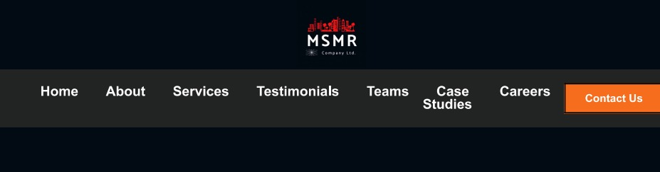

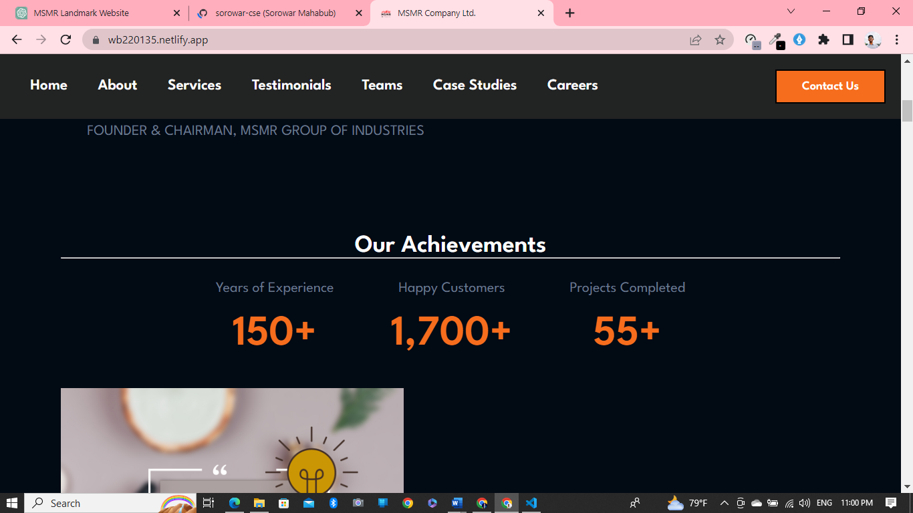

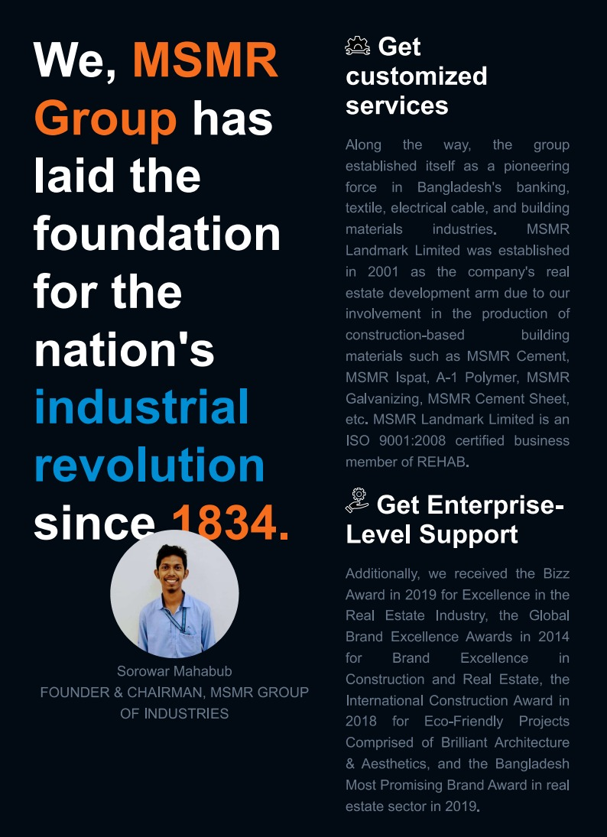

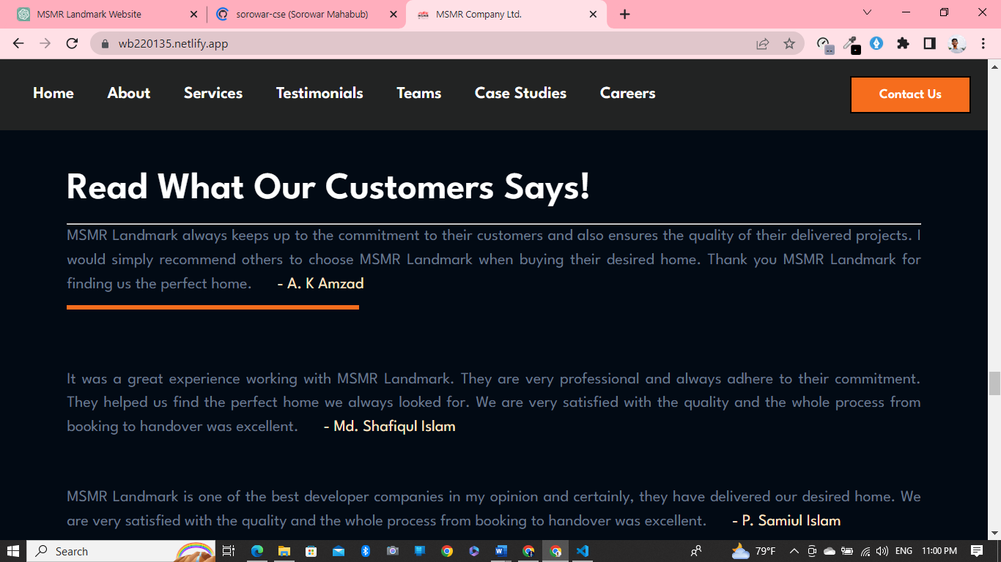

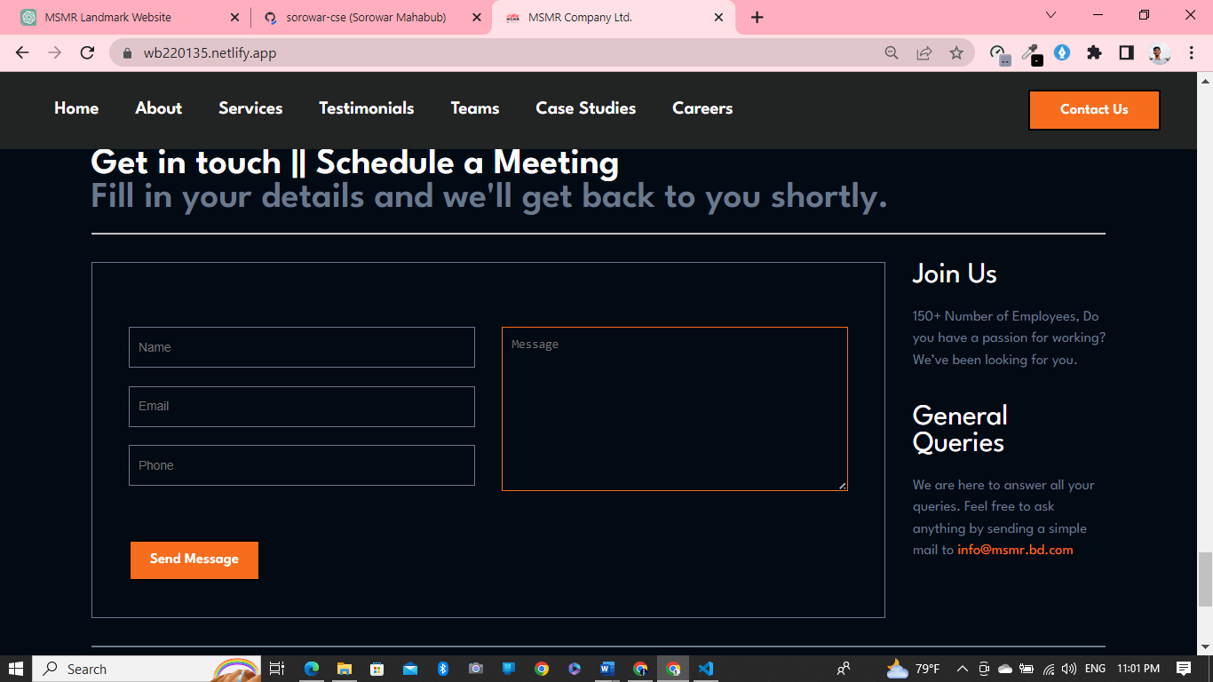

**Live Project Link:** <https://wb220135.netlify.app/>

**Source Code [GitHub Link]:** <https://github.com/sorowar-cse/Project_of_WB220135>

**Conclusion:** In conclusion, the MSMR Land Mark Website by MSMR Group is an exceptional project that provides users with an immersive experience of the iconic landmarks designed by the MSMR Group. **MSMR Land Mark Website by MSMR Group** is a perfect example of how technology can be used to showcase the beauty of architecture and design and inspire people to appreciate the artistry of the built environment. Congratulations to the MSMR Group on an exceptional project.