[ Tales of Titans ]

Software Requirements Specification

September 7, 2016

[ Teen Titans ]

[ ]

Revisions

|  |  |  |  |
| --- | --- | --- | --- |
| Version | Primary Author(s) | Description of Version | Date Completed |
| Draft Type I | JT  Waylon  Neal  Afeefa | This is the initial draft. | 09/19/2016 |

Contents

1 Introduction. 4

1.1 Purpose. 4

1.2 Scope. 4

1.3 Definitions, Acronyms, and Abbreviations. 4

1.4 References. 5

1.5 Overview. 5

2 Overall Description. 5

2.1 Product Perspective. 5

2.2 Product Functions. 5

2.3 User Characteristics. 6

2.4 Constraints. 6

2.5 Assumptions and Dependencies. 6

2.6 Apportioning of Requirements. 6

3 Specific Requirements. 6

3.1 Overall game description. 6

3.1.1 Rooms. 8

3.1.2 monsters. 14

3.1.3 Puzzles. 16

3.1.4 User Interface Interfaces. 20

3.2 Software Product Features. 20

3.3 Performance Requirements. 26

3.4 Design Constraints. 26

3.5 Software System Attributes. 26

3.5.1 Reliability. 26

3.5.2 Availability. 26

3.5.4 Maintainability. 27

3.6 Logical Database Requirements. 27

3.7 Other Requirements. 27

# 

# 

# 

# 

# 

# 

# 

# 

# 

# 

# 

# **1 Introduction**

This document provides an overview of the scope and specifications that will be included in this document. The document will include, the terminology, definitions, and functions for the software.

## **1.1 Purpose**

The purpose of this document is to give a description for the game called “Tales of Titans”. It declares the development and requirements of the system. It also gives an idea on how the interface looks and how it will interact with with applications. Overall, this document is a proposal and reference for the development team.

## **1.2 Scope**

The Teen Titans Game “Tales of Titans” is a Windows based text adventure game that will include an array of rooms, monsters, and puzzles that the player will explore and interact with via a command line interface.

## **1.3 Definitions, Acronyms, and Abbreviations**

Define all terms, acronyms, and abbreviations used in this document.

|  |  |
| --- | --- |
| **Term** | **Definition** |
| Player | The primary user that interacts with the system |
| Administrator | The actor that will have access to storage files and will be permitted to modify them. |
| MON | An mobile obstacle that often attacks the player |
| INV | Inventory where a player can collect and save items |
| ID | Identification number |
| TITLE | Name of item |
| DESC | Description of item |
| DEP | Dependency of item on another item |

|  |  |
| --- | --- |
| AREA | The name of the area |
| PUZ | Name of the puzzle |
| ITEM | The name of an item |
| SOL | Solution to a puzzle |
| STR | Strength rating for monster out of 10 |

## **1.4 References**

List all the documents and other materials referenced in this document. This section is like the bibliography in a published book.

1. <http://teentitans.wikia.com/wiki/Category:Characters>

## **1.5 Overview**

The rest of this document includes two more sections: Overall Description and Specific Requirements. Section two will include system functionality as well as system interactions. Section three will include specific interactions between the system and users.

# **2 Overall Description**

## **2.1 Product Perspective**

The product will run as an executable file on a Windows operating system and should be able to accept textual inputs from the user. The game will use text-based backend to store and retrieve information about the player.

## **2.2 Product Functions**

The software should display text for the user as well as take the user’s input and respond accordingly. It also needs to initiate/save/load the game.

## **2.3 User Characteristics**

Describe the general characteristics of the intended users and how would they use the system differently.

|  |  |
| --- | --- |
| Administrator | Administrator will monitor the system for possible bugs. |
| Player | Player will interact with game with the goal of completing it. |

## **2.4 Constraints**

The game application should be played on an interface that has windows. The game should also be able to save player information as the player interacts with the system.

## **2.5 Assumptions and Dependencies**

An assumption we must make is that the game will work on Windows OS and will be a stand alone executable. The user is also assumed to speak english with the ability to either type or click.

## **2.6 Apportioning of Requirements**

Altering storylines based on the player’s inventory and decisions

# **3 Specific Requirements**

# **3.1 Overall Game Description**

This game is a medieval fantasy theme text based adventure game that has a heavy rpg aspect to it. The player is humanity’s last hope in saving the world from Briarios and his Evil Republic. It is told from a narrator’s perspective who is also the hero in this game. It is a dramatic retelling of his adventure:

“The Republic is spreading across these lands like a disease. Briarios, leader of the republic, sends his minions of darkness to do his dirty work while he sits in his Tower of Babel and gets fat. Well, I was going to be the one to do something about it. Briarios won’t know even know what’s going to happen.

The Republic has taken every city except the city of Athena which is humanity’s last standing fortress. I was on my way to Athena when I fell into a trap. I had become a victim to goblin treachery and fell into a mine. That is where my journey began..”

The game should start with a main menu where the player can decide to start a new game, load or change options. When the player starts a new game, they should be prompted with a character attribute allocation system where they can allocate ten attribute points to their base attribute of 10. These attributes determine the path that the player can take throughout the game.

The player will start off in the bottom of the mine and progress forward into a forest and then into Athena and then through another small forest on the way to Briarios and his Tower of Babel.

**3.1.1 Rooms**

|  |  |  |  |  |  |  |  |  |  |  |  |  |  |  |  |  |  |  |  |
| --- | --- | --- | --- | --- | --- | --- | --- | --- | --- | --- | --- | --- | --- | --- | --- | --- | --- | --- | --- |
|  |  |  |  |  |  |  |  |  |  |  |  |  |  |  | T10 |  |  |  |  |
|  |  |  |  |  |  |  |  |  |  |  |  |  |  | T8 | T7 | T9 |  |  |  |
|  |  |  |  |  |  |  |  |  |  |  |  |  |  |  |  |  |  |  |
|  |  |  |  |  |  |  |  |  |  |  |  |  |  | T5 | T4 | T6 |  |  |  |
|  |  |  |  |  | F1 | F2 | F3 | F4 |  |  | C3 |  |  |  |  |  |  |  |
|  |  |  | M3 | M4 | M5 |  |  | F5 | F6 | C1 | C2 | F7 | F8 | T1 | T2 | T3 |  |  |  |
|  |  | M1 | M2 |  | M6 |  |  |  |  |  |  |  |  |  |  |  |  |  |  |
|  |  |  |  |  | M7 |  |  |  |  |  |  |  |  |  |  |  |  |  |  |
|  |  |  |  |  | M8 | M9 |  |  |  |  |  |  |  |  |  |  |  |  |  |

5 Major Areas

AREA: Goblin Mine (9 Rooms)

DESC : The player will start at the bottom of this mine with only a stick. There will be a weapon cache in the beginning allowing the player to decide which weapon they will want to use throughout the game because this will determine their combat for the rest of the game.

ID: M1

TITLE: Mine end

DESC: You are at the end of a damp cave. Small shimmers of light creep in from high above. A passage leads to the east.

MON: N/A

PUZ: N/A

ITEM: Sword, Spear, Bow

ID: M2

TITLE: Mine 2

DESC: You are a dark and cramped tunnel. Piles of soot covered earth and block your path, but you can make out a crawlspace to the north.

MON: MON2

PUZ: N/A

ITEM: Gold Coin

ID: M3

TITLE: Mine 3

DESC: You are in the channel of a mine shaft. The torches lining the walls are just bright enough to illuminate the area. The channel continues to the west. A crawl space lies to the south.

MON: N/A

PUZ: P4

ITEM: Torch

ID: M4

TITLE: You are surrounded with the veins of excavated minerals. A light shimmers further to the east. The channel continues to the west.

DESC:

MON: MON3

PUZ: N/A

ITEM: Gold Coin

ID: M5

TITLE: Mine 5

DESC: You are at the entrance of a mine shaft. A wooden door overgrown with Ivy and brambles lies to the north. The shaft forks into southern and western corridors

MON: MON2

PUZ: N/A

ITEM: N/A

ID: M6

TITLE: Mine 6

DESC: The shaft continues to the south. The mine’s entrance can be seen to the north.

MON: MON4

PUZ: N/A

ITEM: Gold Coin

ID: M7

TITLE: Mine 7

DESC: You stumble in the darkness. It is too dark to continue without a light.

MON: MON3

PUZ: P7

ITEM: Human Skull

ID: M8

TITLE: Mine 8

DESC: The shaft makes a sharp turn to the east.

MON: N/A

PUZ: N/A

ITEM: N/A

ID: M9

TITLE: Mine 9

DESC: The shaft comes to a stop. The air is stagnant and hot.

MON: MON7

PUZ: P5

ITEM: N/A

AREA: Athena (3 Rooms)

DESC:

ID: C1

TITLE: Inn

DESC: The Inn should allow the player to take a rest for the night for a small number of gold coins.The Inn should also sell cheap food that can be eaten to recover health. The Inn should be run with an Innkeeper that the player has to interact with the Innkeeper in order to buy food or a night at the Inn.

MON: N/A

PUZ: P2

ITEM: Gold Coins

ID: C2

TITLE: Potion Shop

DESC: This shop is run by an old alchemist who spends his free time creating magic potions with different attributes.

MON: N/A

PUZ: N/A

ITEM: Shop

ID: C3

TITLE: Blacksmith

DESC: The Forge is run by a master blacksmith(Siegfried) and his apprentice(Roots). The blacksmith is a master at his work so he does not deal with customers because he is too busy making the finest swords in Athena. Roots does all of the business as he has a silver tongue that can barter up any trader.

MON: N/A

PUZ: P3

ITEM: Shop/I2

AREA: Forest (9 Rooms)

DESC: A huge forest with trees standing 50 feet tall lies ahead of you.

ID: F1

TITLE:Mine Entrance

DESC: You are in a wooded area surrounding a mine. A dusty path continues to the east. To the south lies the mine entrance.

MON: MON6

PUZ: N/A

ITEM: N/A

ID: F2

TITLE:Dusty Trail

DESC: You are on a footpath in a dense forest. You can hear the sound of rushing water to the east.

MON: MON3

PUZ: N/A

ITEM: Gold Coin

ID: F3

TITLE: River

DESC: A River flows eastbound alongside the trail.

MON: MON2

PUZ: N/A

ITEM: N/A

ID: F4

TITLE: Lake

DESC: A great lake lies at the end of the trail. A clearing in the forest lies to the south.

MON: MON5

PUZ: N/A

ITEM: Gold Coin

ID: F5

TITLE: Road

DESC: An ornate stone roadway cuts eastward through the forest. A nearby sign reads “NORTH: Lake Durnam. EAST: Athena”

MON: MON4

PUZ: N/A

ITEM: N/A

ID: F6

TITLE:Forest 6

DESC: You are on the outskirts of a great city. A guard stands at his post, preventing all from entering.

MON: N/A

PUZ: P6

ITEM: N/A

ID: F7

TITLE:Forest 7

DESC: A great tower can be seen rising from the western horizon.

MON: MON6

PUZ: N/A

ITEM: N/A

ID: F8

TITLE:Forest 8

DESC: There is a small clearing in the forest towards the Tower of Babel with a pitch black statue in the middle.

MON: N/A

PUZ: P1

ITEM: N/A

ID: F9

TITLE:Forest 9

DESC: As you approach the Tower of Babel, a Wraith appears holding a shining key. It does not speak but it shrieks as it approaches you slowly.

MON: MON1

PUZ: N/A

ITEM: I1

AREA: Tower of Babel (9 Rooms)

DESC: A massive tower stands before you. This is Briarios’ lair. He waits for you at the top of the tower.

ID: T1

TITLE:Tower 1

DESC: You stand at the bottom floor of the tower. Behind you to the west lies the exit. A staircase can be seen past an awning to the east.

MON: N/A

PUZ: N/A

ITEM: N/A

ID: T2

TITLE: Bottom Staircase

DESC: An enormous spiral staircase extends upwards. The entrance chamber lies to the west. A holding cell lies to the east.

MON: MON2

PUZ: N/A

ITEM: N/A

ID: T3

TITLE: Holding Cell

DESC: You stand in a decrepit holding cell. The walls are lined with claw marks and other incomprehensible inscriptions. Behind you to the west is the staircase.

MON: MON4

PUZ: N/A

ITEM: N/A

ID: T4

TITLE: Staircase Second Floor

DESC: You are halfway up the staircase. Chamber rooms lie to the east and west.

MON: MON2

PUZ: N/A

ITEM: N/A

ID: T5

TITLE: Western Chamber, Second Floor

DESC: You find yourself in a what appears to be an observatory west of the central staircase.

MON: MON3

PUZ: N/A

ITEM: N/A

ID: T6

TITLE: Eastern Chamber, Second Floor

DESC: You enter the eastern chamber. Shelves of ancient tomes line the walls. Each book is written in a strange language completely foreign to you. The central staircase lies to the west.

MON: MON5

PUZ: N/A

ITEM: N/A

ID: T7

TITLE: Staircase Third Floor.

DESC: You have reached the top of the tower. A massive door of granite lies directly to the north. You’re sure you can see shadows dancing from under the cracks of the door.

MON:

PUZ: N/A

ITEM: N/A

ID: T8

TITLE: Observatory

DESC: You find yourself in what appears to be an observatory overlooking the city. A map of the surrounding area is pinned to the far wall. Several markings are etched onto the map, mysteriously coinciding with the places you have been. The central staircase lies to the east.

MON:

PUZ: N/A

ITEM: N/A

ID: T9

TITLE: Armoury

DESC: You enter an expansive armoury crowded with row upon row of weapons and armors. The dust-coated armors, though neglected, shows no sign of deterioration.Unfortunately, these armaments were clearly designed for someone much larger than yourself. The central staircase lies to the east.

MON:

PUZ: N/A

ITEM: N/A

ID: T10

TITLE: Briarios’ Throneroom

DESC: You cautiously proceed onward through the massive doorway and find yourself in what is likely the final room in the tower. An array of banners, weathered by time, encompass an ornate throne in the center of the chamber. Atop the throne sits Briarios, King of Darkness. Sparing no time, he rises from his throne and prepares for battle.

MON: MON9

PUZ: N/A

ITEM: N/A

### **3.1.2 Monsters**

ID: MON1

NAME: Wraith

DESC: A Wraith will be one of the strongest and unstoppable monsters in the game. It can only be killed with a silver weapon(sword, arrow, spear). If the Wraith can not be defeated then the player will either die or have the choice to escape without gaining the reward for killing the wraith which should be something very valuable but not essential to beating the game.

STR: 10

HP: 9999

ID: MON2

NAME: Slime

DESC: The weakest of all the monsters.

STR: 1

HP: 5

ID: MON3

NAME: Goblin

DESC: A lowly creature that only fiends for gold and shiny things. They are easily distracted and not very intelligent. They cannot use bows but can throw knives and use very primitive weapons.

STR: 4

HP: 10

ID: MON4

NAME: Orc

DESC: A foul creature that oozes bodily fluid with sharp ears and body piercings. They can use any weapon from daggers to swords and even bows. They are the most feared enemies of the elves.

STR: 5

HP: 15

ID: MON5

NAME: Giant

DESC: A brute that stands 20 feet tall. He is a worthy adversary and only attacks when provoked. He has high health and high defense. He also wields a tree as a club.

STR: 9

HP: 50

ID: MON6

NAME: Ent

DESC: Defender of the forest. The Ent comes to harm those who ruin his home. He stands 10 feet tall with branches as arms.

STR: 7

HP:45

ID: MON7

NAME: Mercenary

DESC: A mercenary from the east who has a contract to kill you. He may be of use to you later if you let him live.

STR: 6

HP: 30

ID: MON8

NAME: Briarios

DESC: Briarios awaits the player at the end of the game at the top of the tower. He wields a giant greatsword and has the strength to cut through entire buildings with one blow. Briarios wears thick armor that protects him but makes his movements very slow.

STR: 9

HP: 100

### **3.1.3 Puzzles**

ID: P1

NAME: Daedric Prince Statue

DESC: A pitch black statue stands before you with a shape of a dark prince of Daedric descent. The eyes glow red as you look into its face. The statue is holding its hand out in your direction above a fountain of water. A description under the prince says: “A prince of safe passage if you give the right offering”

SOL: The prince requires a stone of sunlight that you obtain from a merchant in the city.

ID: P2

NAME: Gambler

DESC: The player can gamble against Grodd, a local at the Inn who likes to hustle new patrons. You must guess how many rocks he has in his right hand. If you win, he doubles your money and if you lose, you lose your bet. The game may be played up to five times.

SOL: Grodd is an ocular based creature that has incredible eyesight. He always has the same number of rocks in his hand as the player has gold coins.

ID: P3

NAME: Silver’s the Name

DESC: Roots is a jokester and likes to make jokes and riddles. If the player guesses the answer to Roots’ riddle, then the player will receive a silver dagger that is needed to kill a wraith.

“The King has an army of soldiers

That hiss and fly

They wear masks of feathers

And blood that ____”

The player must guess the last word to get the dagger. They are given four choices:

1. Clots

2. Dries

3. Bleeds

4. Freezes

SOL: Roots’ riddle is a joke and his riddle simply rhymes. Dries is the correct answer.

ID: P4

NAME: Cypher

DESC: There is an odd drawing on the wall in the shape of a triangle. It appears to be hollowed out like there was something that used to go in the crevice.

SOL: Reach into the triangle and unlock a hatch that will open the door to the next room

ID: P5

NAME: Mercy

DESC: After you defeat the mercenary in the mines, you can either kill him or spare him.

SOL: Sparing the mercenary will make him your friend and he will assist you in the city to obtain a sun stone.

ID: P6

NAME: City Guard

DESC: The guard watches the road diligently, denying entry to passerby.

HINT: Hours at this post have made this guard weary. He can’t keep his guard up forever...

SOL: Player enters “wait” into the command line. The guard will doze off, allowing the player to pass.

ID: P7

NAME: Darkness

DESC: You can’t see a thing in this darkness. Continuing in these conditions would be far too dangerous.

HINT: Perhaps there is a light source nearby.

SOL: The player must have a Torch in their inventory in order to continue.

**3.1.4 Items**

ID: I1

NAME: Shining Key

DESC: There is a Shining Key that a wraith holds. The key is very unique; it has a detailed bow that has inscriptions of a forgotten language.

ID: I2

NAME: Silver Dagger

DESC: The Silver Dagger is found once you have defeated the Jokester riddle. Its handle is long with geometric designs that accompany it. The blade is made of pure silver, made to defeat the wraith.

ID: I3

NAME: Human Skull

DESC: While wandering around the dark mines, you find a Human Skull. Its cracked on the top, and the lower jaw of the skull is missing. The skull is covered in soot but beneath that you see that it’s of a white color.

ID: I4

NAME: Torch

DESC: You wander around the lightly lit mine and finally stumble upon a torch that is within reach. The Torch has a fire that is as bright as the moon and its handle is made of a bamboo wood.

ID: I5

NAME: Sunstone

DESC: The Sun Stone is of the shape of a near-perfect sphere. It’s made of smooth marble with a color of a light copper.

ID: I6

NAME: Potion

DESC: Heals 50 health

ID: I7

NAME: Gold Coin

DESC: Trade for items and equipment or a nights rest

**3.1.5 Equipment**

ID: E1

NAME: Sword

DESC: The Sword is a two handed weapon that has a handle of wood with a single edged aluminum blade.

STR: 5

ID: E2

NAME: Spear

DESC: The Spear is a two handed weapon made of wood with a sharp pointed blade made of steel.

STR:5

ID: E3

NAME: Bow

DESC: The Bow is made of a flexible wood that is held together by a strand of the a horse's mane. It has arrows that are made of wood and its tip is made of a sharp metal.

STR:5

ID: E1

NAME: Sword +

DESC: The Swords’ handle is made of gold while its blade is a long double edge made of copper that was made by a long forgotten civilization.

STR:10

ID: E1

NAME: Spear +

DESC: The Spear is a two handed weapon which can be thrown or stabbed with. Its handle is made with an ancient oak tree with a blade that was stolen from the dragons.

STR:10

ID: E1

NAME: Bow +

DESC: The bow is made of a strong bamboo that is held together by a unicorn's mane. Its arrows are made of steel and the points made of crystals.

STR:10

### **3.1.5 User Interfaces**

Briefly provide a description to standard menus you have in your game such as navigation menus buttons, directions etc.…

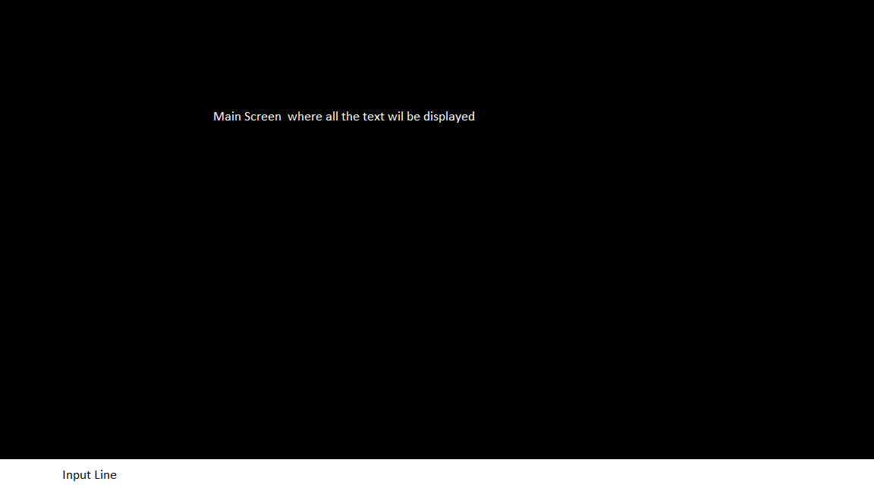

## **3.2 Software Product Features**

The game will be an executable. Users will need to download or obtain a copy of the .exe to be able to play the game

### **3.2.1 Feature 1 - Menu (Waylon)**

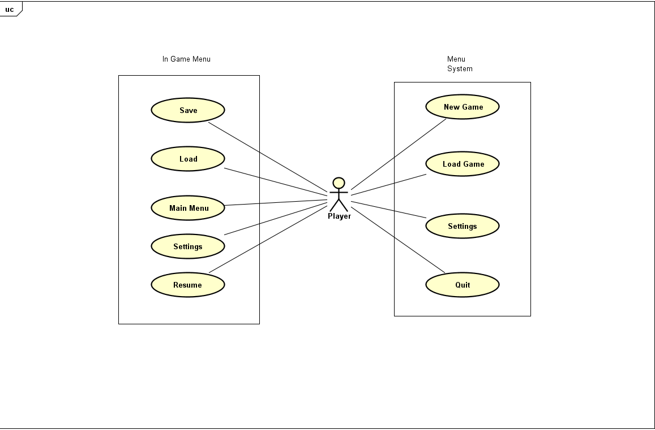

* **Purpose**
  + The ‘Main Menu’ allows users to start a ‘New Game’, ‘Load Game’, or ‘Quit’.
  + An ‘In-game Menu’ will let users ‘Save’ and ‘Load’. It will also let users ‘Return to Main Menu’
* **Stimulus and Response Sequence**
  + **Saving**
    - Users will type in ‘save’
    - The system will then create a .txt file to save the user’s progress
  + **Load**
    - Users will type in ‘load’
    - System will open the saved .txt file so that players can resume their game
  + **Quit**
    - Users type in ‘quit’
    - The application closes
  + **New Game**
    - Users will type in ‘new game’
    - System will create a new instance of the game with the player starting in room 1 in the Mines
  + **Return to Main Menu**
    - Users will input ‘main menu’
    - System will bring the user back to the ‘Main Menu’ with just the ‘load’, ‘save’, and ‘quit’ options
* **Associated Functional Requirements**

**3.2.2 ID: FR2**

* **Title: Fighting (Neal)**
* **Use Case Diagram**

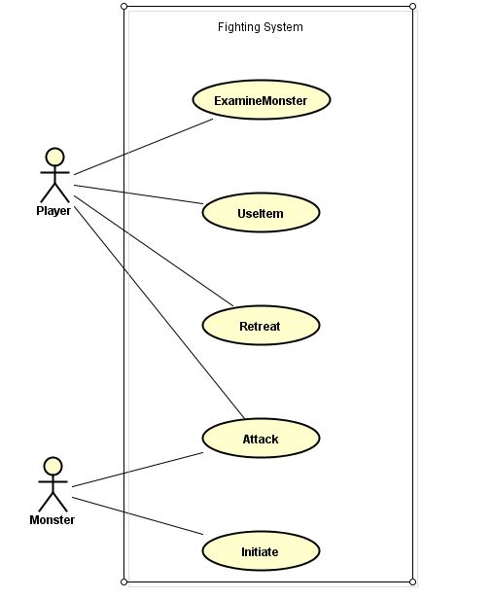

* **Purpose**
  + The Fighting Feature is intended to display the functions, inputs and outputs given when the player encounters and fights a monster.
  + When fighting with a monster, the system must be able to read the statistics of both the player and the monster as well as the artifacts that are being used by both.
  + The system must define a condition in which the player defeats or is defeated by a monster and be able to identify when that condition is met.
  + The player must have the option to flee to an adjacent room that the monster cannot travel to.
  + The System must be able to poll stats from the character and monster in order to determine the amount of damage dealt and received.
* Stimulus / Response Sequence
  + Scenario 1
    - The player enters a room and is attacked by a goblin.
    - The player receives x amount of damage
    - The player chooses to attack
    - The player deals y amount of damage
  + Examine Monster
    - The player enters the command examine monster
    - A textual description of the monster is displayed to the player
  + Retreat
    - The player enters the command retreat
    - The player is moved to the previous room
    - A textual description describing the players retreat will be displayed.
  + Attack
    - The actor enters the command attack [monster name]
    - The total damage is computed as a function of player strength and monster strength
    - The computed total is deducted from the monster strength
    - A textual description of the damage dealt is displayed to the player
  + Initiate
    - After entering a room, the monster uses ‘initiate’
    - The chance of attacking is computed based on the monsters aggressiveness statistic
    - If true, the monster will use ATTACK
  + Use Item
    - The player enters the command use [Item Name]
    - The item’s function is used based on its item type
    - The item is removed from the player’s inventory.
* Associated functional requirements
  + Inventory Management

**3.2.3 Feature 3 - Inventory Management (Afeefa)**

* **Use Case Diagram**

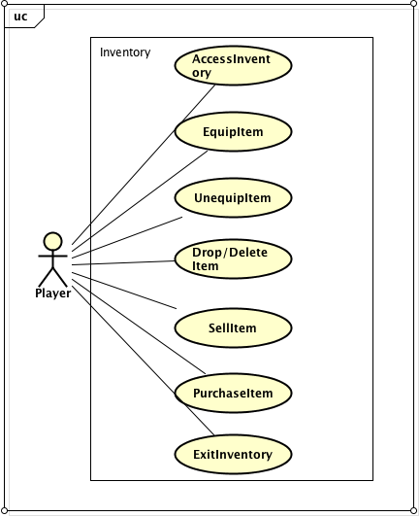

* **Purpose**
  + The Inventory is there for the players to store items such as ‘artifacts’ and ‘potions.’
  + The player can access inventory at any time during the game.
  + The player should also be able to purchase and sell items to any vendor in the city.
* **Stimulus /Response Sequence**

EquipItem

* + Player accesses inventory by using the command line to type INV.
  + Player can ‘EquipItem’ for immediate use then the item (if multiple in quantity) should be reduced by 1.

UnequipItem

* + Player accesses inventory by using the command line to type INV.
  + Player “UnequipItem” that may not be needed at that particular time.
  + It is stored away for later use.

Drop/DeleteItem

* + Player accesses inventory by using the command line to type INV.
  + Player can ‘DropItem’ that may not be needed.
  + The item is destroyed.

SellItem

* + Player accesses inventory by using the command line to type INV.
  + Player may sell item in order to increase his coin wealth.

Puchase

* + Player accesses inventory by using the command line to type INV.
  + Player can purchase different forms of items from NPCs.
  + The item(s) purchased is then added into the inventory or if multiple in quantity is added to previous quantity.
* **Associated Functional Requirements**
  + None

**3.2.4 Feature 4 - Rooms**

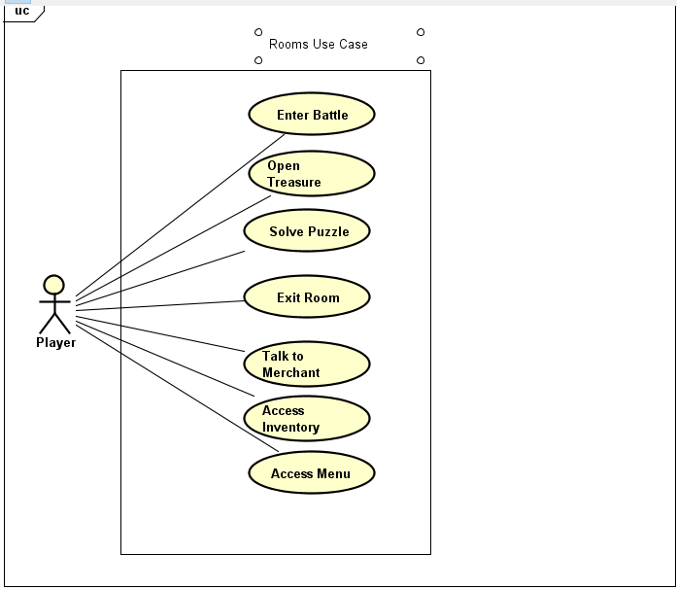

* **Purpose** 
  + **Rooms will house either monsters, puzzles, other characters throughout the game and items.**
  + **Rooms will be the main way that players progress through the game**
* **Stimulus/Response Sequence**
  + **Player selects direction and enters the room**
  + **The room will enter into a battle if there is a monster present**
  + **The room will have a puzzle in it if there is no way out visible at first**
  + **The room will have loot if there is a treasure chest present**
  + **If there isn’t a monster, puzzle or treasure in the room then the player will be asked if they want to leave the room or if there is a merchant then the player can purchase items from the merchant**
* **Associated Functional Requirements**
  + **There must be way to allow the player to choose which path they can take**
  + **At least two exits per room**
  + **Be able to initiate a puzzle after a battle or before if necessary**

**3.2.5 Feature 5 - Puzzles**

* **Use Case Diagram**

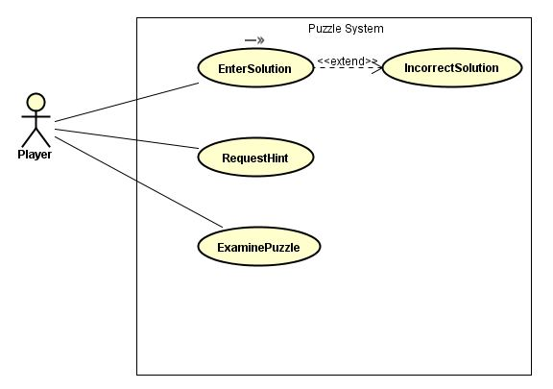

* **Purpose**
  + **To give the player a challenging puzzle in order to allow them to move on or give them an item.**
* **Stimulus/Response Sequence**
  + EnterSolution
    - The player enters the correct text field to solve the puzzle
    - A textual description is displayed to the user describing the puzzle’s outcome
  + RequestHint
    - The player enters the hint command
    - A textual hint describing the function of the puzzle is displayed to the player
  + ExaminePuzzle
    - The player enters the command examine [Puzzle Name]
    - A textual description of the puzzle is displayed to the player.
* **Associated Functional Requirements**
  + **Access to rooms**
  + **Access to inventory**

###### 

## **3.3 Performance Requirements**

The player should be able to seamlessly choose actions within rooms that allow the player to do things to progress further in the game. The game should not use up too much power from a computer.

## **3.4 Design Constraints**

The game should be written in Java using Windows OS. The hardware limitations will be that it should be able to run on any modern Windows-based computer.

## **3.5 Software System Attributes**

The following items provide a partial list of system attributes that can serve as requirements that should be objectively verified.

Other possible options include scalability, portability, robustness, recoverability, etc.

### **3.5.1 Reliability**

The game should start up every time with no errors. It should run without any crashes.

### **3.5.2 Availability**

The game does not rely on any databases or servers, therefore it should be readily available to the customer/player.

### **3.5.3 Maintainability**

The game should be open to adding modules or more rooms. In the case that the game becomes more popular, then players should be able to enjoy part II or part III and so on. If the interface of the game becomes old then it should be easily changed to work with the customer.

## **3.6 Logical Database Requirements**

The system will not rely on a database but will instead use a text file to store game information.