**Course Assignment (Mini Project I-2)**

█ 谭诚 10215101460

1. Draw system sequence diagram for UC-1(Unlock) and UC-4(RetireUser)

**Sequence diagram for UC-1(Unlock)：**

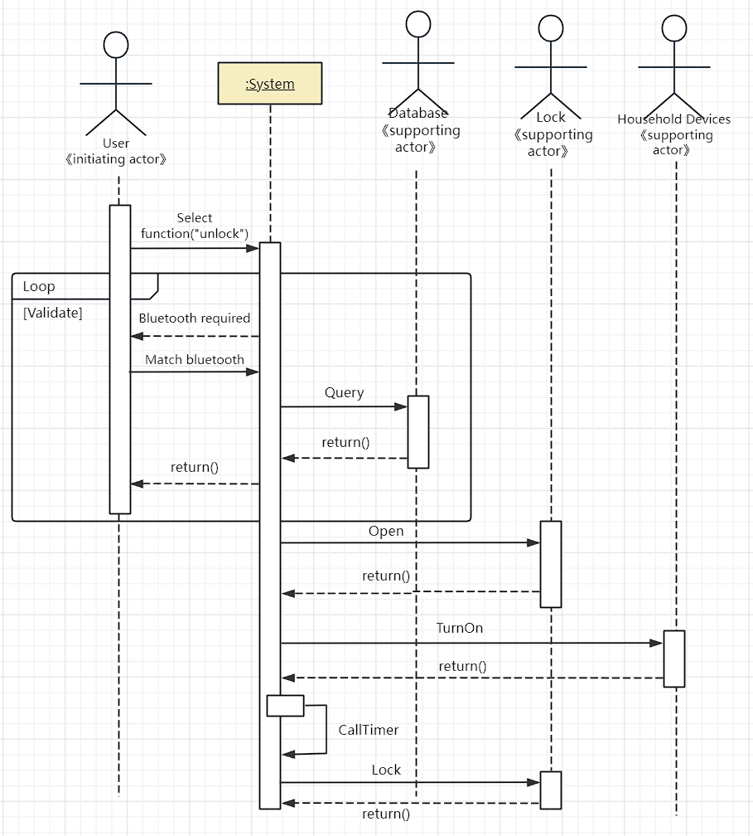

**Sequence diagram for UC-4(RetireUser)：**

*See it in the next page.*

**Sequence diagram for UC-4(RetireUser)：**

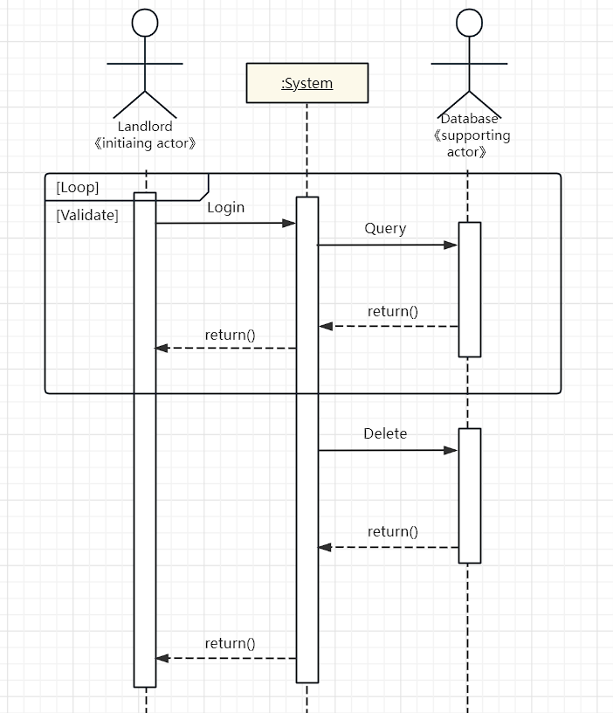

1. Draw activity diagram for UC-1(Unlock) and UC-4(RetireUser)

**Activity diagram for UC-1(Unlock)：**

*See it in the next page.*

**Activity diagram for UC-4(RetireUser)：**

*See it in the next page.*

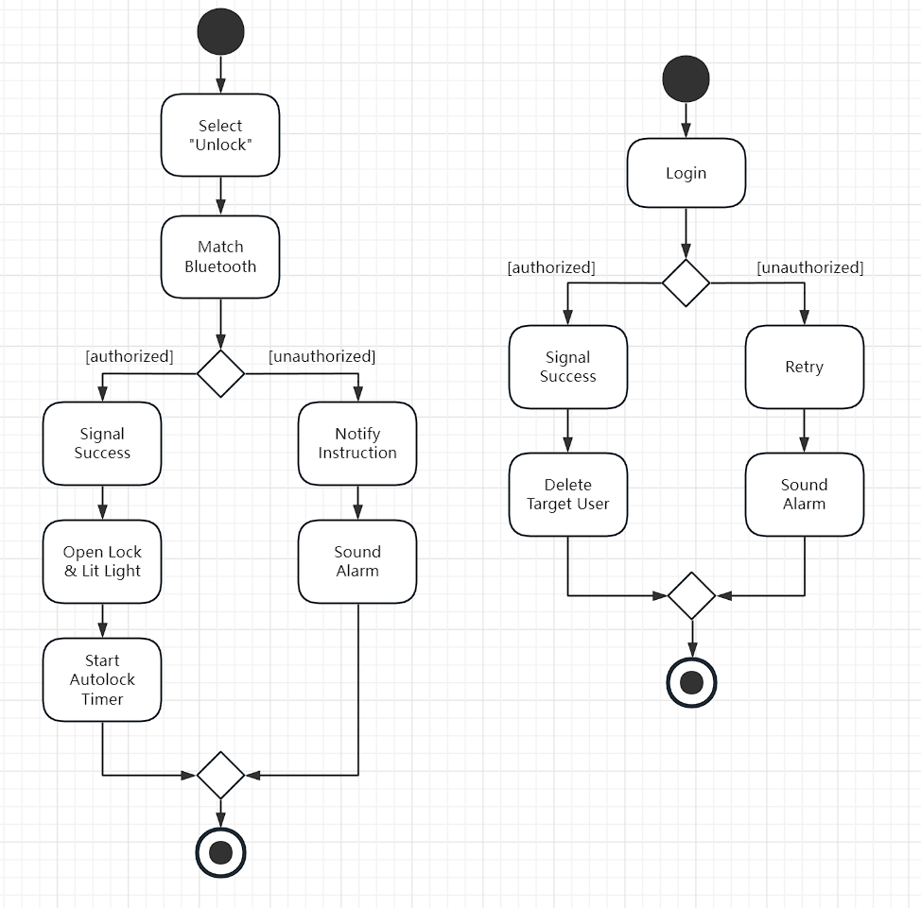

1. Domain model for UC-4(RetireUser): CRC分析

