**電腦視覺**

**Homework 2**

**Contents:**

1. Description
2. Methodology
3. Code fragments
4. Images

Description

This is the report for the second homework for Computer Vision 2019. It is completed in full.

The environment is Windows, with the code (for both parts) being written in Python 3 with the cv2 module. The graphing is done using matplotlib.

Methodology

1. Binary image
   1. Every (i,j) pixel of greyscale value less than 128 sets a corresponding binary image’s (i,j) to white (0).
   2. Every (i,j) pixel of greyscale value more than or equal to 128 sets the binary image’s (i,j) pixel to black (255).
   3. The resulting image is saved as “**binarized.bmp**”.
2. Histogram
   1. Each greyscale value is collected and its frequencies are visualized as a graph using matplotlib.
   2. The resulting graph is saved as “**histogram.png**”.
3. Connected components, centroid, bounding box
   1. The iterative algorithm is used to determine the connected components (regions).
   2. Regions with more than or equal to 500 pixels are shown, with such regions each having a bounding box and centroid.
   3. The resulting image is saved as “**boxed.bmp**”.

Code Fragments

1. Binary image
2. **for** i **in** range(shape[0]):
3. **for** j **in** range(shape[1]):
4. **if** image[i, j][0] < 128:
5. binary_image[i, j] = [0, 0, 0]
6. **else**:
7. binary_image[i, j] = [255, 255, 255]
8. Histogram
9. **for** i **in** range(shape[0]):
10. **for** j **in** range(shape[1]):
11. y[int(image[i, j][0])] += 1
12. Connected components, centroid, bounding box
13. change = True
14. **while** change == True:
15. """Top down pass"""
16. change = False
17. **for** i **in** range(rows):
18. **for** j **in** range(cols):
19. **if** Labels[i, j] != 0:
20. M = get_min_neighbours(Labels, i, j)
21. **if** M != Labels[i, j]: change = True
22. Labels[i, j] = M
23. """Bottom up pass"""
24. **for** i **in** range(rows-1, -1, -1):
25. **for** j **in** range(cols-1, -1, -1):
26. **if** Labels[i, j] != 0:
27. M = get_min_neighbours(Labels, i, j)
28. **if** M != Labels[i, j]: change = True
29. Labels[i, j] = M

Images

1. Binary image (scaled for convenience)

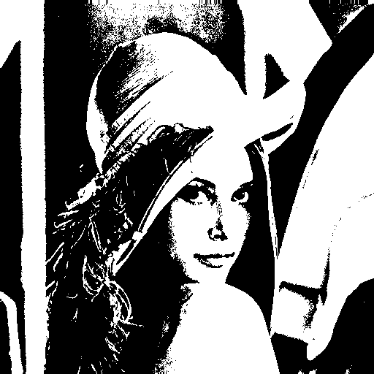

1. Histogram

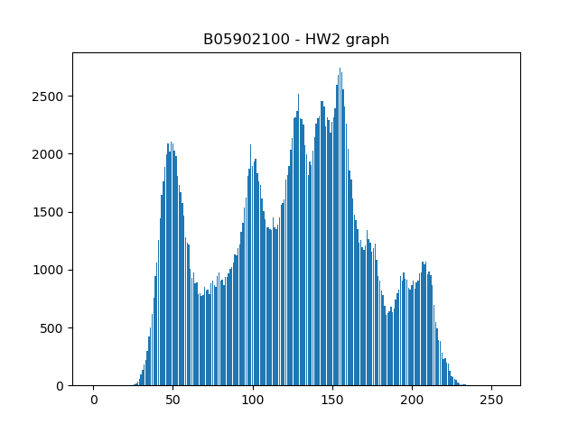

( c ) Connected components, centroid, bounding box

