Delivus FrontEnd Assignment #1

Assignment
Recreate web browser(chrome) using reactjs.
- Estimated hours : 3~6hours

Requirement
- UI Elements - we recommend you to use existing component library
  - Single tab
  - URL input
  - Buttons
    - back
    - forward
    - refresh
  - Webview
  - Loading icon
- Function Specification
  - Navigation function
    - back, forward, refresh
  - Load WebView according to submitted URL
  - First page of the browser should display list of last visited websites
    - example (UI element does not need to be the same )
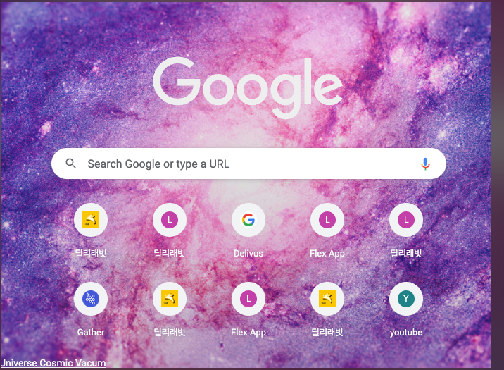
- What we are looking for:
  - State management
  - React hook usage
  - Familiarity existing UI component
- Extra credit
  - Tab management

