|  |  |  |
| --- | --- | --- |
| Enze Luo | **Mobile**: +86 17199920471 |  |
| **Address**: Guangdong, China | **Email**: luo_850184312@163.com |

**Education**

|  |  |
| --- | --- |
| **Northeastern University**, China | 09/2022 – Now |
| *Bachelor* Computer Science and Technology (GPA 81.22/100) | |

**Research Experience**

|  |  |
| --- | --- |
| **Hybrid Control System Design for a Five-Axis Servo Motor Robotic Arm Based on Optical**  **Flow and One-to-One Encoder Integration** | 1. *– present* |

1. 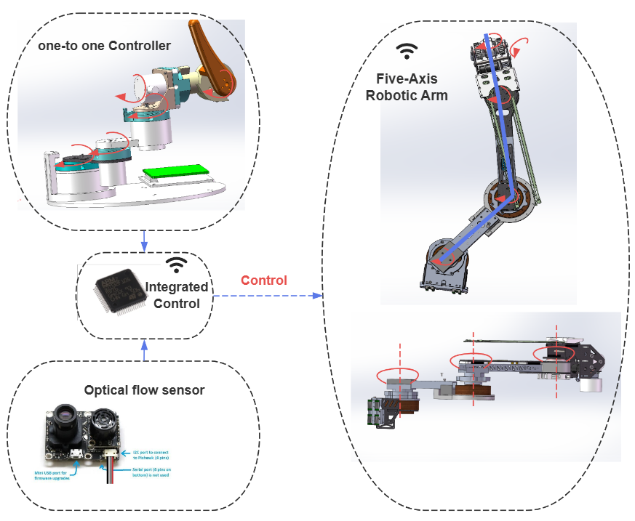Responsible for developing an embedded control system for a five-axis robotic arm, utilizing servo motors for the first three axes (resembling a SCARA structure) and enabling pitch and roll degrees of freedom for the last two axes.
2. Designed and implemented a hybrid control strategy that integrates optical flow data and one-to-one encoder controller data. This approach leverages the precision of optical flow measurements and the flexibility of encoder-based control, ensuring enhanced motion control performance.
3. Developed an advanced motion control algorithm using PID control combined with a dynamic feedforward strategy to achieve precise trajectory tracking and fast response. Successfully achieved a robotic arm repeatable positioning accuracy of 0.1 radians across all joints.
4. Integrated torque feedback derived from servo motor current to implement force control, enabling the robotic arm to sense and adapt to external forces during operation. This improved the system's ability to handle delicate manipulation tasks and ensured safety in human-robot interactions.
5. Designed and executed comprehensive experiments to validate the control system’s stability, precision, and adaptability under various load and operational conditions. Collaborated on hardware-software integration to implement the hybrid control solution on the physical robotic arm.
6. Responsible for data acquisition, analysis, and optimization of the hybrid control system. Combined extensive performance testing with iterative improvements to achieve a balance of precision, speed, and robustness in control.

|  |  |
| --- | --- |
| **Edge Computing-Based Visual Guidance System** | *2024 – Present* |

1. 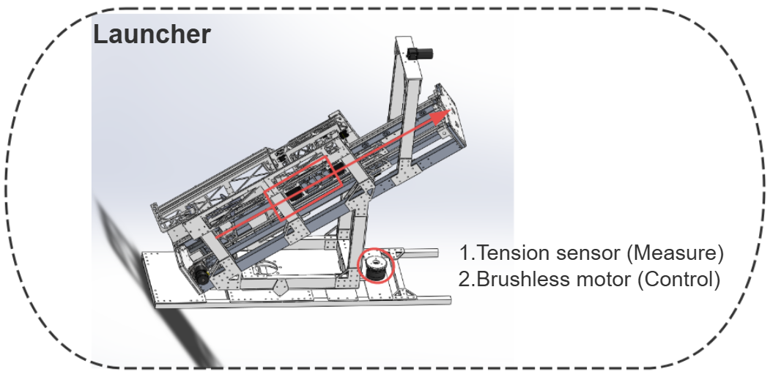System Design: Designed a system comprising a launcher and a flying vehicle. The flying vehicle is capable of recognizing and precisely striking ground targets. It relies on initial velocity for flight, adjusts its attitude via a tail wing, and achieves target accuracy through visual guidance. The launcher provides initial velocity, controls thrust using a tension sensor, and adjusts the vehicle’s yaw angle during launch with a motor.
2. 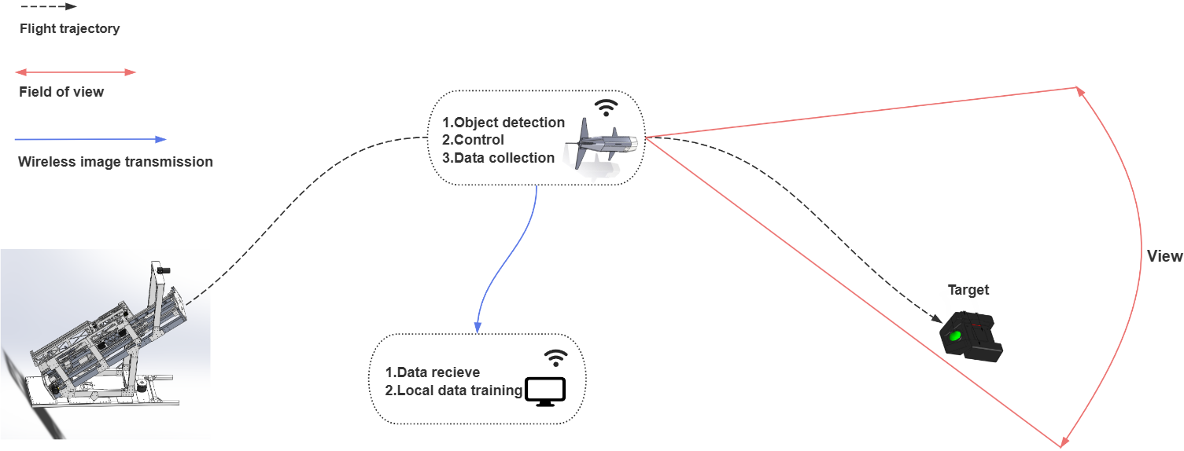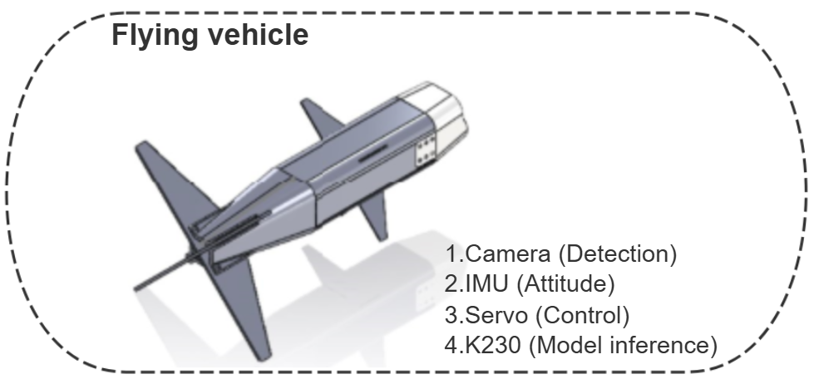Control Methodology: Leveraged edge computing for real-time target detection and vehicle attitude control. The visual guidance system integrates precise target recognition with adaptive attitude adjustment to ensure high-accuracy strikes.
3. Hardware Implementation:

* Integrated an embedded NPU (K230) for real-time inference of the target detection model.
* Used an embedded CPU (K230) to control servo motors that adjust the vehicle’s tail wing for attitude regulation.
* Incorporated an IMU to acquire real-time attitude data of the flying vehicle.
* Implemented an embedded Free-RTOS system to manage the launcher’s thrust control and yaw angle adjustment during operation.

1. Software Development: Developed and trained the target detection model, optimized it for deployment on the embedded NPU, and implemented robust control algorithms for vehicle attitude and launcher operations.
2. Experimental Validation: Conducted comprehensive tests to validate the system’s performance under various conditions, ensuring its ability to recognize targets, adjust flight dynamics, and achieve precise strikes.

|  |  |
| --- | --- |
| **Series-Wheeled Legged Control System Design and Implementation** | *2023 – 2024* |

1. 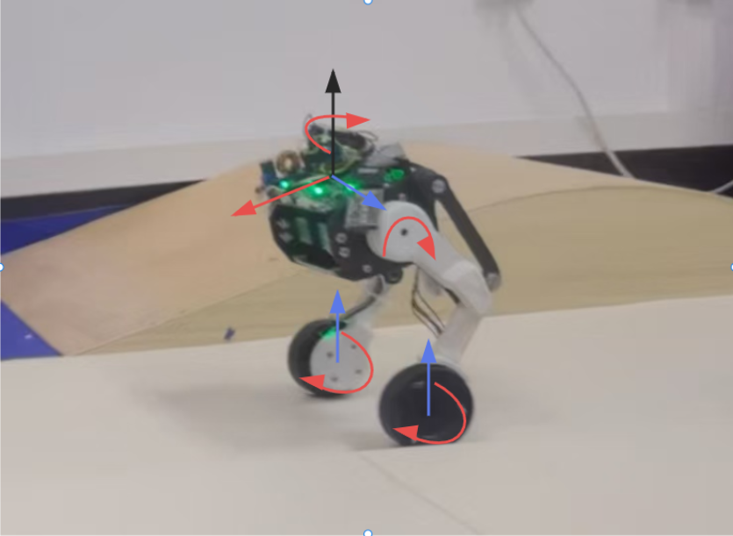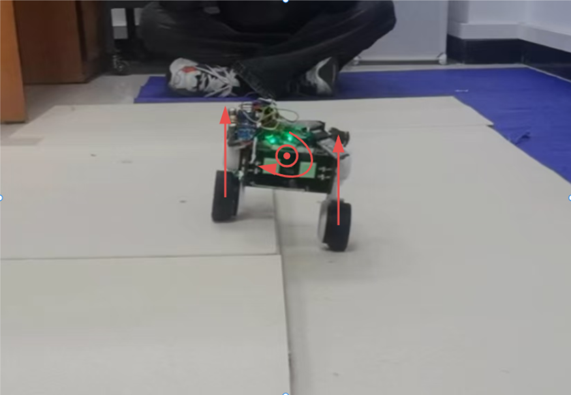System Design: Designed a 3-DOF wheeled-leg robot chassis, integrating wheeled locomotion with legged movement to enhance mobility and adaptability across diverse terrains.
2. Control Algorithm:

* Implemented a high-stability control algorithm leveraging a Kalman fusion observer for real-time state estimation and sensor data integration.
* Adopted a hybrid control approach combining Linear Quadratic Regulator (LQR) for optimal trajectory control and Proportional-Integral-Derivative (PID) controllers for precise motion adjustments.

1. Embedded System Development: Developed an embedded system to execute the control algorithm, enabling seamless coordination between the robot’s wheels and legs.
2. Experimental Validation: Conducted tests to validate the stability, precision, and adaptability of the control system under various operational scenarios, ensuring optimal performance across complex environments.

|  |  |
| --- | --- |
| **Wheeled Robot Software Control System Design and Implementation** | *2022 – 2023* |

1. 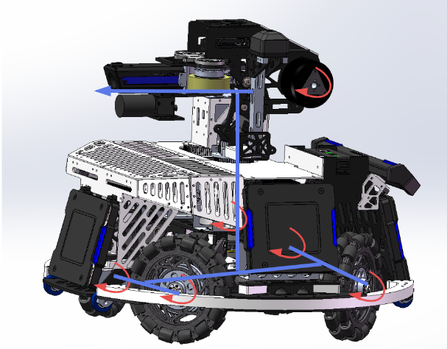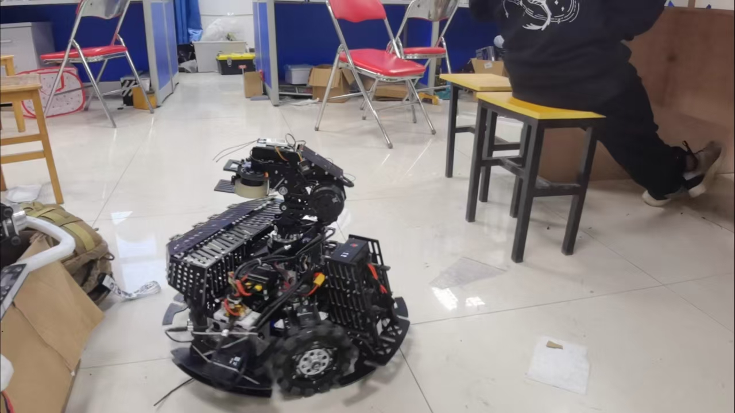System Development: Developed an embedded software control system to enable precise motion control for an omni-wheel chassis and a 2-DOF gimbal, ensuring high maneuverability and stability.
2. Algorithm Implementation:

* Designed and implemented algorithms tailored for specific motion tasks, optimizing the system's performance under diverse operational conditions.
* Integrated human-computer interaction features, allowing intuitive and seamless control of the system.

1. Performance Validation: Conducted extensive testing to validate the efficiency and responsiveness of the control system, ensuring reliable and accurate operation in real-world scenarios.

**Skills**

* **Software:** MATLAB, Keil, Code Composer Studio
* **Programming:** C, Rust, C++ for Embedded Linux and MCU real-time Operating Systems(Free-RTOS)
* **Engineering:** Easy Circuit/PCB Design and Debug

**Awards & Honors**

* National College Robot Competition ROBOMASTER(2023, First Prize)
* Huawei Embedded Software Competition(2024, Second Prize in the Northeast)
* School Science and Technology Innovation Scholarship