Thomas Moh

tjm8339

Project B: A Spaceship Overlooking Bird, Dog, House, and Alien in Habitat

**User’s Guide**

**Goals**

In creating this project, I sought out to create an interactive 3D world that portrayed a spaceship overlooking some habitat of creatures and objects. To be more specific, I hoped that my project would have the following elements:

* Rotatable, interactive 3d part
* Animated assemblies
* One assembly with joints that could be altered by the user
* Controls that allow the user to easily navigate through the world
* Instructions and controls that are easy to follow
* Ground plane and world axes
* Resizable canvas with viewports displaying a perspective and orthographic view

I also wanted to create a project that had interesting colors that really popped on-screen for the user, since I found that my last project lacked in that regard. Additionally, I wanted to find a way to experiment with html a bit more, and create an interesting html component.

**User Instructions**

Firstly, and importantly, the user accesses all of the instructions and controls simply by clicking the “Open Instructions and Controls” button.

From there, the user should see the following popup:

which they can click outside of, or click the ‘X’ to exit. The user should be able to just read through the prompts, but I will go into more detail here.

Under the default or ‘Normal Mode’, users can use the ‘W’ and ‘S’ keys to move forward and back in the gaze direction, ‘A’ and ‘D’ keys to strafe left and right, Left and Right arrow keys to rotate the camera along the x-y plane, and the Up and Down arrow keys to tilt the camera up and down. This should allow for simple and easy navigation.

Under the ‘Flying Mode,’ which can be activated by clicking the ‘Flying Mode’ button at the bottom of the page, users can use ‘W’ and ‘S’ keys to adjust throttle, ‘A’ and ‘D’ keys to adjust roll, Up and Down arrow keys to adjust pitch, and Left and Right arrow keys to adjust yaw. To revert to the normal navigation mode, click ‘Normal Mode’ at the bottom of the page.

For the alien object assembly that has multiple cube sets, the user can enter an angle into one of the designated boxes and hit submit. For whatever set of cubes specified before the submit button and enter box, the range that the joint rotates between will update to the entered value.

Finally, users can specify parameters for the perspective view function, frustum. By entering values into the corresponding boxes, and hitting submit, the view on the left of the screen will update. Hitting the revert changes button will revert changes.

**Results**

In general, I met all of my major goals with this project, and I’m proud of how it turned out. I’ll go through a few instances wherein I met those goals with some figures.

Figure 1: Perspective and Orthographic View

Figure 1 demonstrates that there is a working perspective view on the left and an orthographic view on the right. This can be seen by the fact that the objects on the right all seem similar sizes because the depth-to-camera is not registered by the orthographic view, since the camera is just gathering data in parallel lines to the view.

Figure 2: A Before and After of using the 'W' key in normal mode

Figure 2 demonstrates that the ‘W’ key moves the user in the gaze direction.

Figure 3: Before and after dragging mouse in the downward direction

Figure 3 demonstrates that the quaternion rotation is working since dragging the mouse down rotates the object on an axis perpendicular to the direction of the mouse direction. This figure does not demonstrate the problem that exists in the project that the rotation does not update based on the camera.

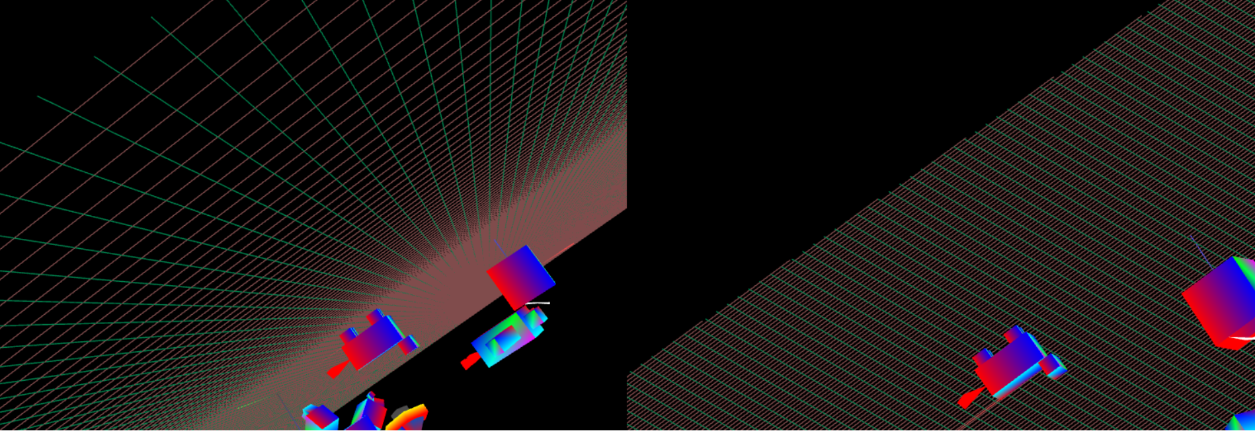

Figure 4: Before and after using the 'A' key in 'Flying Mode'

Figure 4 demonstrates that the ‘A’ key affects the roll in ‘Flying Mode’. This was implemented by adjusting the up vector of the camera.