Random dna
# Batch ORF Analysis Summary

- **Input directory**: mock_fasta
- **FASTA files processed**: 500
- **Total bases across all files**: 865,244 bp
- **Total ORFs found (> 80 aa)**: 355
- **Files with zero qualifying ORFs**: 269

## Descriptive Statistics

- **ORFs per file**: n=500, mean=0.71, median=0.00, stdev=0.96, min=0.00, max=5.00
- **ORF density (ORFs per kb)**: n=500, mean=0.356, median=0.000, stdev=0.496, min=0.000, max=4.213
- **CAI codon match (%), across all 355 ORFs**: n=355, mean=53.0, median=53.0, stdev=3.7, min=44.4, max=65.4

Random dna with misleaders
# Batch ORF Analysis Summary

- **Input directory**: mock_fasta
- **FASTA files processed**: 500
- **Total bases across all files**: 850,644 bp
- **Total ORFs found (> 80 aa)**: 844
- **Files with zero qualifying ORFs**: 124

## Descriptive Statistics

- **ORFs per file**: n=500, mean=1.69, median=2.00, stdev=1.32, min=0.00, max=6.00
- **ORF density (ORFs per kb)**: n=500, mean=0.941, median=0.900, stdev=0.765, min=0.000, max=4.517
- **CAI codon match (%), across all 844 ORFs**: n=844, mean=62.5, median=61.7, stdev=9.6, min=44.3, max=82.5

Random 1000 from addgene
# Batch ORF Analysis Summary

- **Input directory**: addgene_fasta
- **FASTA files processed**: 997
- **Total bases across all files**: 6,730,803 bp
- **Total ORFs found (> 80 aa)**: 8041
- **Files with zero qualifying ORFs**: 0
- **ESM-2 model**: facebook/esm2_t6_8M_UR50D

## Descriptive Statistics

- **ORFs per file**: n=997, mean=8.07, median=8.00, stdev=3.94, min=2.00, max=26.00
- **ORF density (ORFs per kb)**: n=997, mean=1.191, median=1.138, stdev=0.301, min=0.451, max=2.185
- **CAI codon match (%), across all 8041 ORFs**: n=8041, mean=56.3, median=56.6, stdev=6.4, min=38.2, max=90.7
Random 500 addgene accurate perplexity

# Batch ORF Analysis Summary

- **Input directory**: addgene_fasta
- **FASTA files processed**: 484
- **Total bases across all files**: 3,203,992 bp
- **Total ORFs found (> 80 aa)**: 4064
- **Files with zero qualifying ORFs**: 20
- **ESM-2 model**: facebook/esm2_t6_8M_UR50D

## Descriptive Statistics

- **ORFs per file**: n=484, mean=8.40, median=8.00, stdev=5.60, min=0.00, max=61.00
- **ORF density (ORFs per kb)**: n=484, mean=1.247, median=1.249, stdev=0.467, min=0.000, max=3.501
- **CAI codon match (%), across all 4064 ORFs**: n=4064, mean=56.9, median=56.6, stdev=6.6, min=22.2, max=100.0
- **ESM-2 perplexity, across all 4064 ORFs**: n=4064, mean=13.99, median=14.45, stdev=3.05, min=1.17, max=19.91

Random Wikipedia to dna
# Batch ORF Analysis Summary

- **Input directory**: wiki_dna_fasta
- **FASTA files processed**: 500
- **Total bases across all files**: 1,293,094 bp
- **Total ORFs found (> 80 aa)**: 210
- **Files with zero qualifying ORFs**: 356
- **ESM-2 model**: facebook/esm2_t6_8M_UR50D

## Descriptive Statistics

- **ORFs per file**: n=500, mean=0.42, median=0.00, stdev=0.78, min=0.00, max=4.00
- **ORF density (ORFs per kb)**: n=500, mean=0.154, median=0.000, stdev=0.310, min=0.000, max=2.639
- **CAI codon match (%), across all 210 ORFs**: n=210, mean=51.7, median=51.2, stdev=4.2, min=40.6, max=64.1
- **ESM-2 perplexity, across all 210 ORFs**: n=210, mean=9.43, median=9.19, stdev=3.84, min=1.26, max=17.39

Methods:
Randomly sampled 500 plasmids with sequences from Addgene using the Addgene Developer API from the available ~175,000. Removed those without a sequence leaving 484 sequences with a minimum sequence length of 136 bp and maximum sequence length of 35681 bp. Wrote sequences to FASTA files.
Randomly sampled 500 wikipedia articles from the English Simple Text Wikipedia API, excluding stubs, converted them to binary and then converted the binary to nucleotides using the mapping A=00/C=01/G=10/T=11, truncated the sequences randomly between 300 and 5000 bp and wrote the sequences as FASTA files.
Examined FASTA files in all 6 reading frames and identified ORFsbeginging with ATG encoding for proteins with >80 aa. Measured ORFs per plasmid and ORF density per kb. For each ORF, calculated the CAI against the preferred E coli codons and the pseudo-perplexity using ESM2.
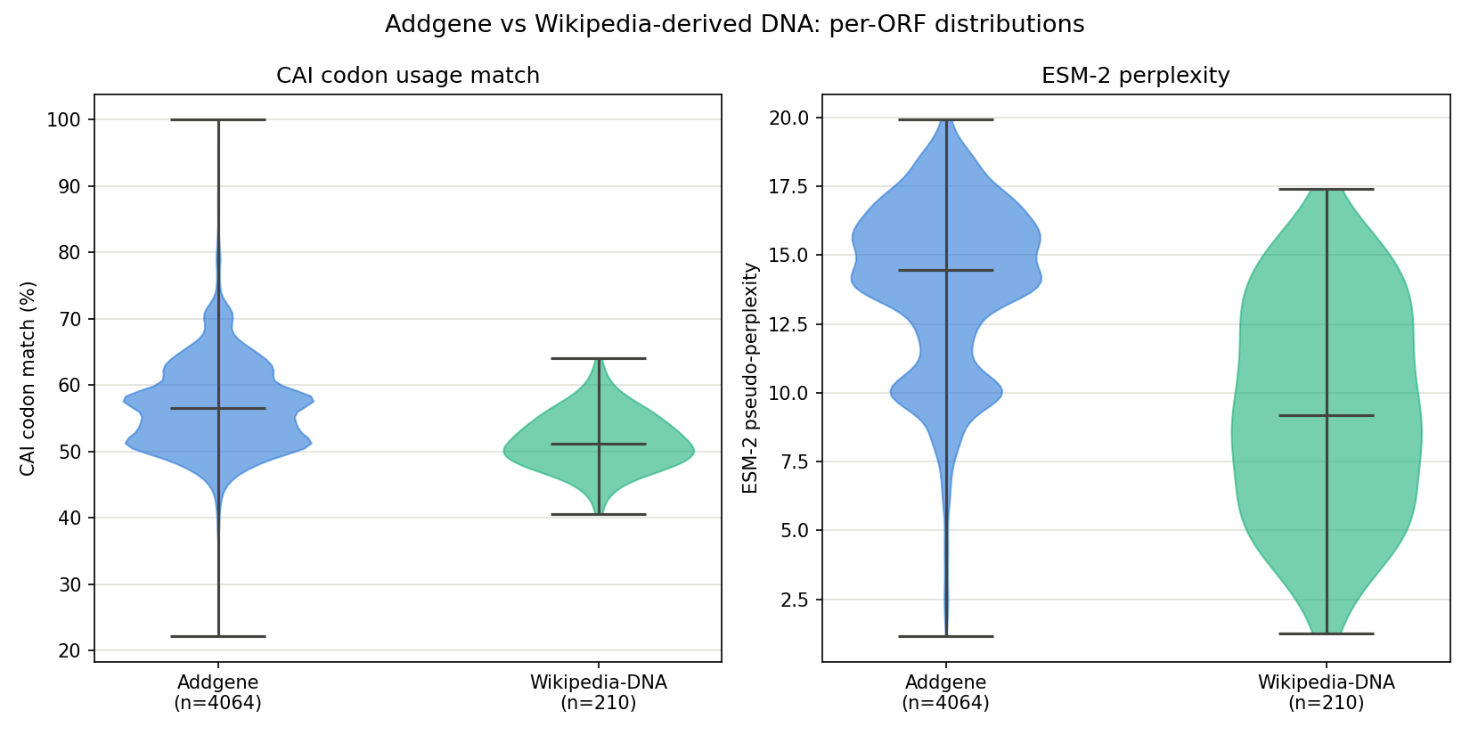
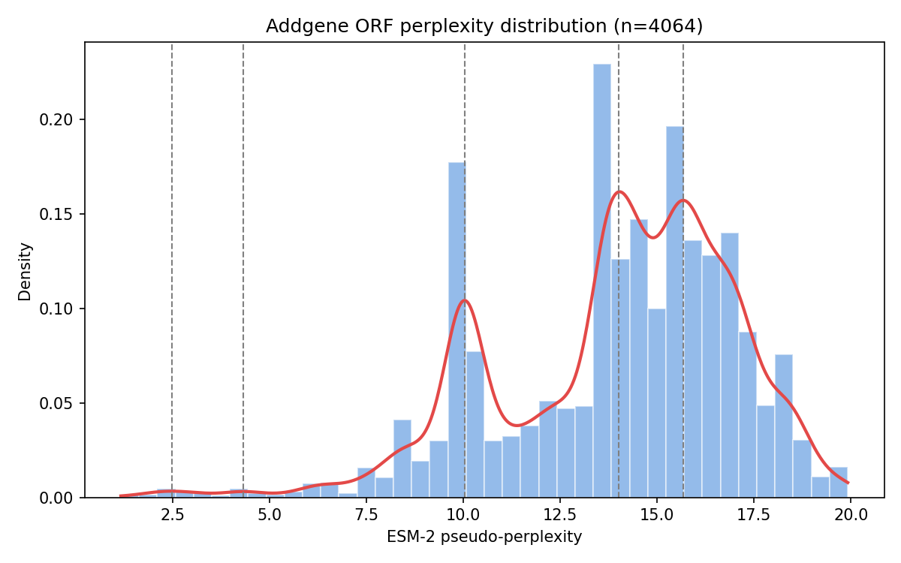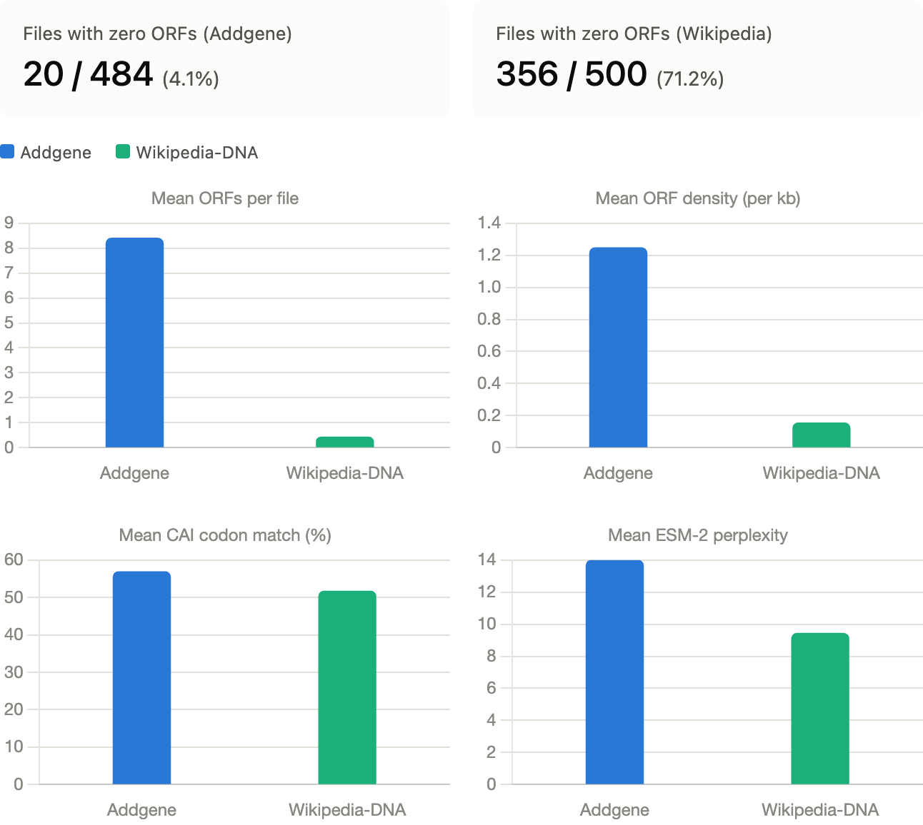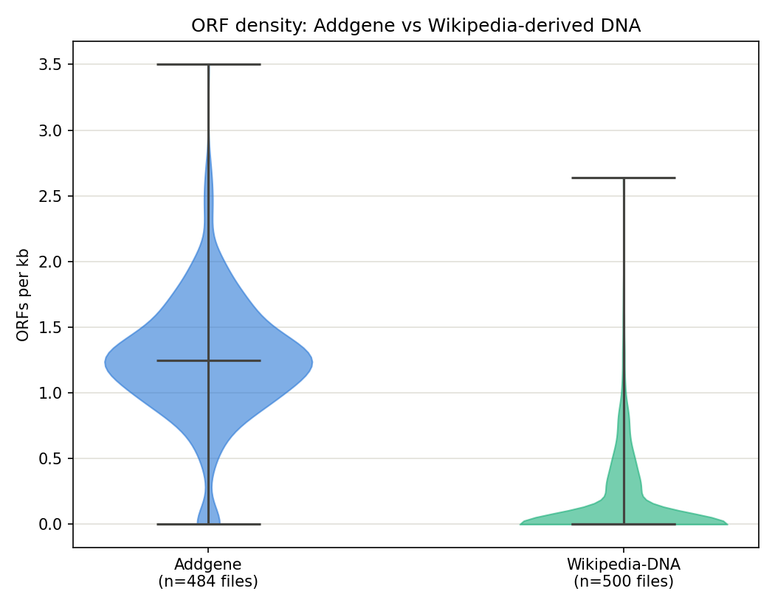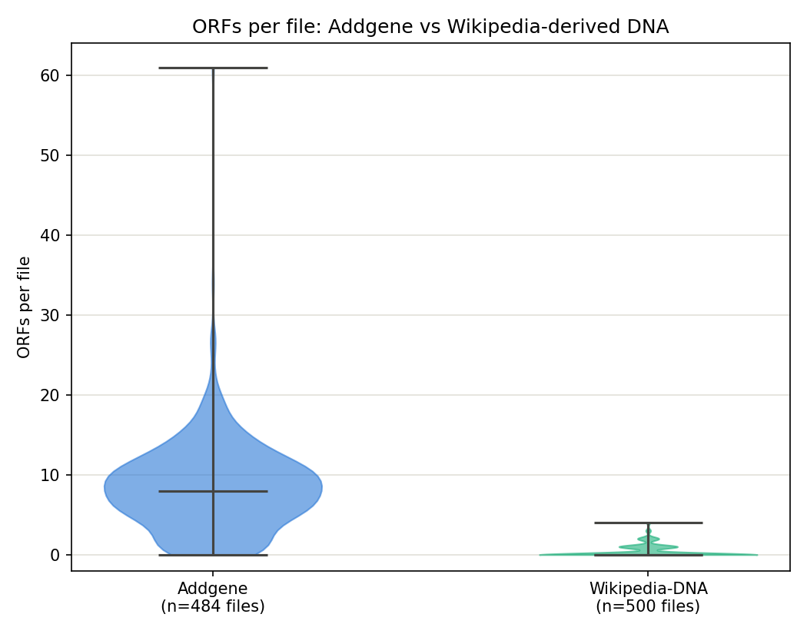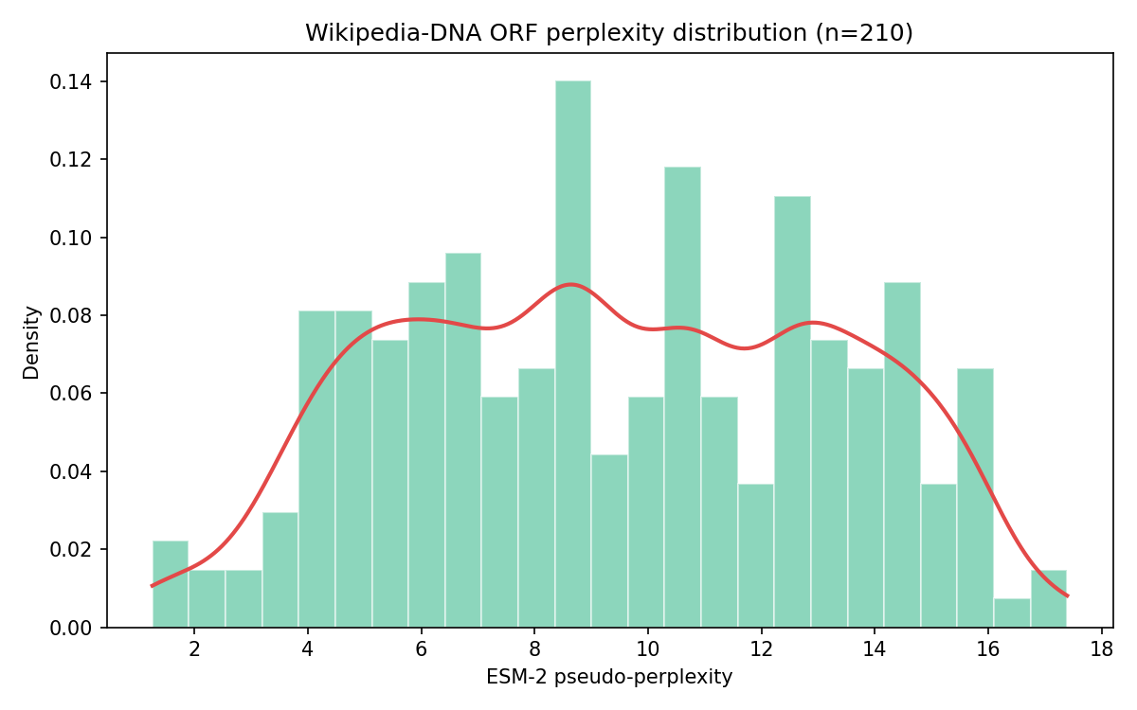
Set 2
Methods:
Added Shannon entropy and k-mer (k=6) analysis. Began searching for noncanonical start codons. Removed computationally intensive ESM2.
