**Disparities in Obesity Across Brazil: A Multimodel Analysis of Regional, Demographic, and Health Drivers**

#### **Abstract**

This study examines BMI disparities in Brazil using multinomial logistic regression, Oaxaca-Blinder decomposition, and Propensity Score Matching (PSM) on data from the 2013 and 2019 National Health Surveys (PNS). We explore how education, income, marital status, and race shape overweight and obesity prevalence, uncovering stark group differences— notably between men and women. Education cuts excess weight overall (-4%) and sharply for women (-12% to -14%), yet raises it for men (+4% to +8%). Decomposition reveals both observable traits and structural inequities drive these gaps. These insights deepen the health disparity dialogue and guide targeted policies to tackle obesity inequalities.

**Keywords**: obesity; overweight; health disparities; decomposition; PSM; Brazil

**Introduction**

Obesity, marked by excess body fat, is a complex health issue defined by the World Health Organization (WHO) as a BMI of 30 or higher, with overweight starting at 25. Its global rise is striking: by 2022, 2.5 billion people were overweight and 890 million obese. Brazil mirrors this trend, with obesity rates jumping 244.1% in men and 165.7% in women from 1990 to 2017. Linked to serious conditions like heart disease, diabetes, and cancer, it also takes a toll on mental well-being and quality of life. Far from being just a personal issue, obesity stems from a mix of genetic, behavioral, and environmental factors. This study dives into Brazil's obesity and overweight inequalities, exploring how region, sex, race, education, and income play a role, using Oaxaca-Blinder decomposition and PSM to unpack the tangled web of causes behind these gaps.

#### **Context**

Obesity stands as a major 21st-century health challenge, recognized by the WHO as a chronic condition driven by excessive fat buildup. With BMI thresholds of 25 for overweight and 30 for obesity—imperfect yet practical markers—it’s clear this isn’t just about eating too much, despite energy imbalance being a core factor (Salam et al., 2023). Research now points to deeper roots: industrial food systems, inactive lifestyles, genetics, and social inequalities (Swinburn et al., 2019). Globally, the numbers are staggering—over 2.5 billion adults overweight and 890 million obese by 2022, tripling since 1975 (WHO, 2024). In places like Brazil, where urbanization and processed foods have taken hold, obesity spiked by 244.1% in men and 165.7% in women between 1990 and 2017, affecting over 60% of adults (Felisbino-Mendes et al., 2020). This shift ties to aggressive food marketing, car-centric cities, and jobs that keep people desk-bound.

The fallout is broad—think chronic diseases, worse COVID-19 outcomes, and a heavy emotional load from stigma and isolation (Piché et al., 2020; Yang et al., 2018). Marginalized groups, like women, Black Brazilians, and rural-to-urban migrants, bear the brunt, reflecting gaps in healthcare, healthy food access, and safe spaces to move (Devaux & Sassi, 2013). Obesity’s causes go beyond “calories in, calories out”—think epigenetics, food deserts, or stress-eating norms (Swinburn et al., 2019). In Brazil, these dynamics hit hard, with socioeconomic divides and gendered habits amplifying the problem. Tools like decomposition analysis help break it down, showing how much of Latin America’s obesity gap—up to 40%—ties to education and healthcare disparities (Monteiro et al., 2021). This study tackles Brazil’s epidemic through that lens, blending biology, economics, and culture to guide smarter policies.

#### **Data and Methods**

This study digs into what drives obesity and overweight in Brazil, pinpointing how these conditions vary across groups and whether the factors tied to obesity (levels I, II, and III) differ from those for overweight. We used data from the National Health Survey (PNS) for 2013 and 2019, tapping into a mix of models to unpack BMI patterns. These include multiple linear regression for overall BMI shifts, multinomial logistic regression for BMI categories (underweight, normal, overweight, obesity I-III), and logistic regression for excess weight (BMI ≥ 25). Each model zeroes in on distinct angles—average BMI changes, category probabilities, and obesity progression—based on a set of chosen variables.

We applied Oaxaca-Blinder decomposition to break down group differences and factor variations for obesity and overweight.

To tease out education’s causal impact on excess weight, we ran Propensity Score Matching (PSM) in Stata with psmatch2, using a nearest-neighbor method (2 neighbors, caliper = 0.07). Education was split into educ_bin (1 for fundamental education or higher, 0 otherwise), with excess weight (exc_peso) as the outcome. We adjusted for a range of covariates: income (log_rendom), age, sex, region, marital status, race, household size, internet access, urban status, chronic conditions (diabetes, hypertension, cholesterol, stroke), lifestyle habits (physical activity, smoking), self-rated health, and year. Matching quality was checked with pstest to ensure balance between groups, and effects were calculated using survey-adjusted means (svy: mean) and linear combinations (lincom) to compare across years and sexes.

#### **Results**

Table 1 presents the proportions of key variables in the dataset, providing a baseline for the analyses. BMI distributions in our sample (PNS 2013 and 2019) cluster around overweight (25-29.9), with a smaller but growing tail exceeding 30 (obesity I-III) across sex, race, marital status, and urban/rural status. Initial plots show women consistently outpacing men, with sharper disparities in urban versus rural settings.

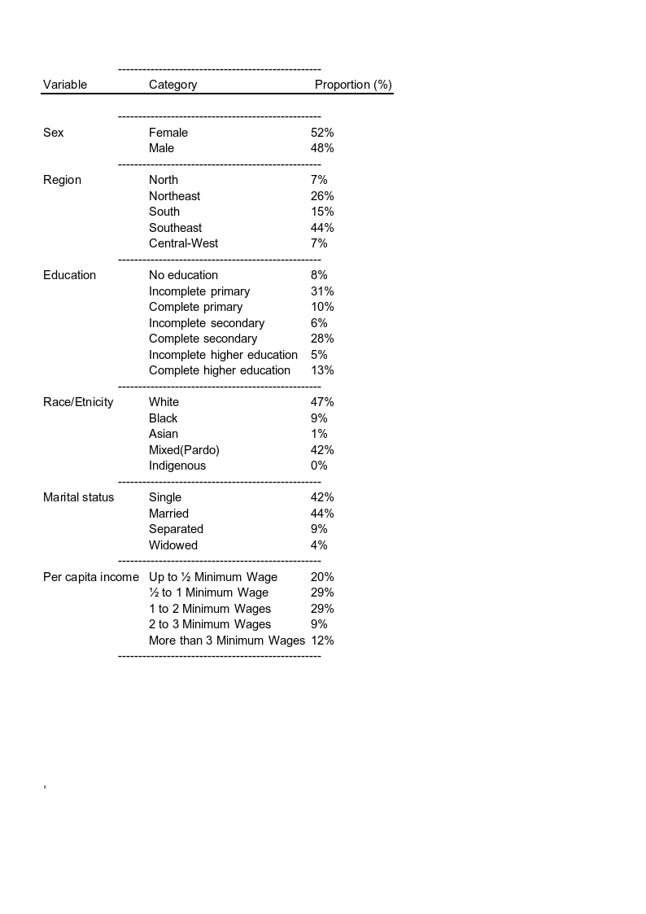

BMI distributions in our sample (PNS 2013 and 2019) cluster around overweight (25-29.9), with a smaller but growing tail exceeding 30 (obesity I-III) across sex, race, marital status, and urban/rural status. Initial plots show women consistently outpacing men, with sharper disparities in urban versus rural settings.

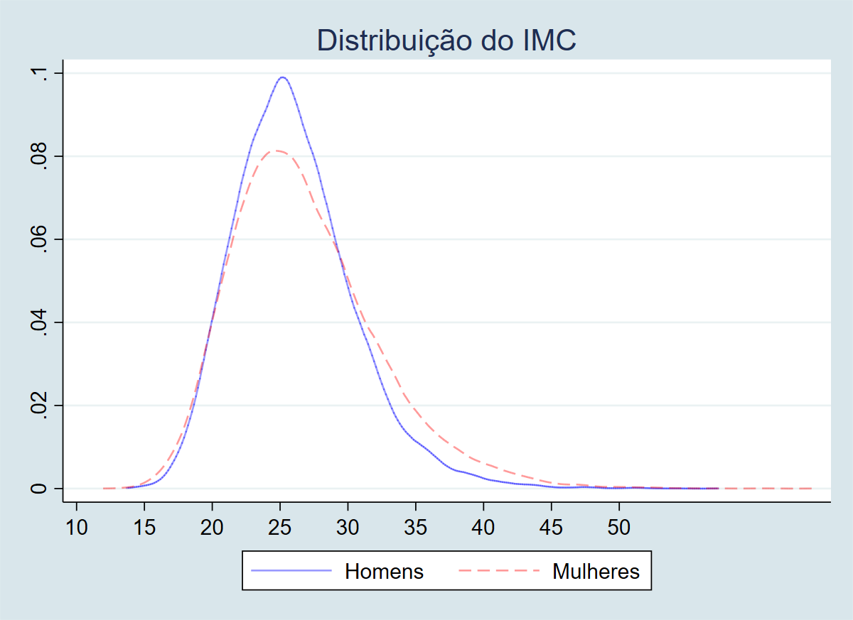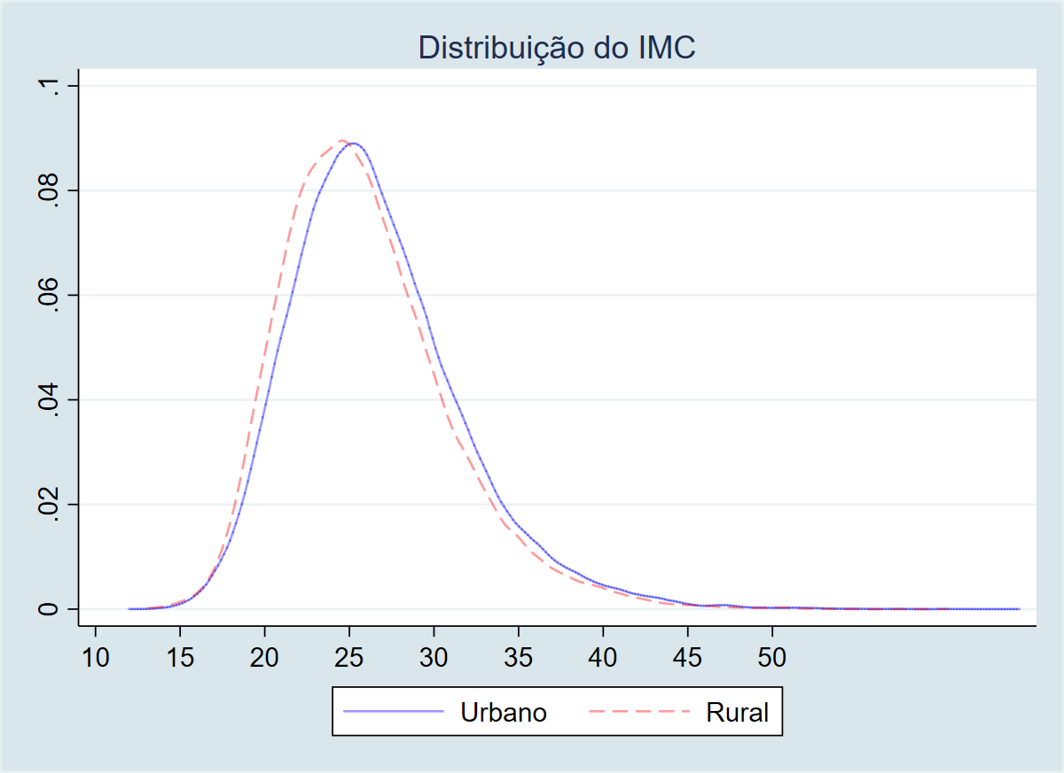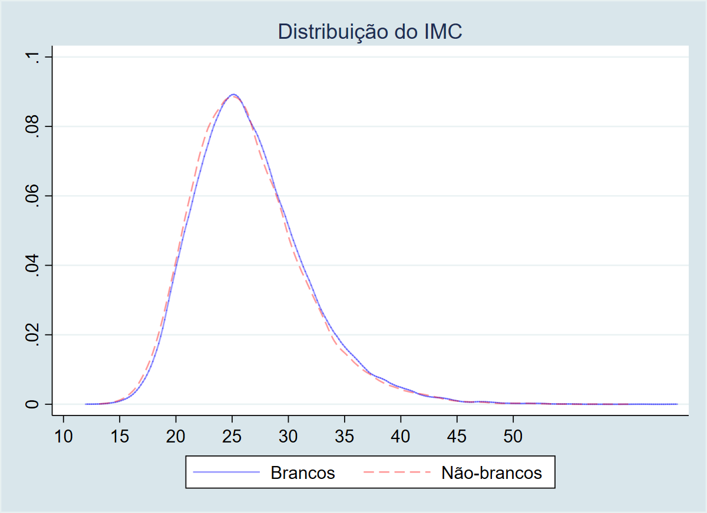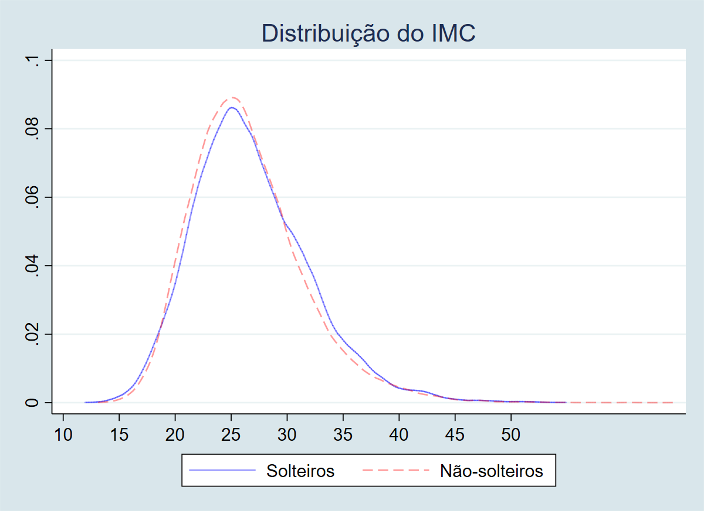

**Trends Over Time**: Average BMI rose between 2013 and 2019, aligning with global overweight trends, but not evenly. Women hit higher marks across all ages—peaking at 28 (vs. 26 for men) in the 45-59 range by 2019—with a notable 1.5-point jump for ages 30-44, possibly tied to postmenopausal shifts or time pressures limiting activity. Young singles (18-29) saw the steepest rise (+2 points to 25), likely from urban diets heavy on processed foods and screen time, while older singles (75+) held steady at 25, hinting at health awareness or medical oversight. Urban BMI outstripped rural (27 vs. 25 in 2019), with a 45-59 gap widest, though rural areas gained faster (+1.8 points), signaling processed food creep beyond cities. Whites topped out at 28 (ages 30-59), possibly from calorie-rich diets enabled by income, while their elderly stabilized at 25, unlike rising trends in marginalized groups. All age groups averaged overweight, a red flag backed by IBGE reports, despite BMI’s limits in capturing fat versus muscle.

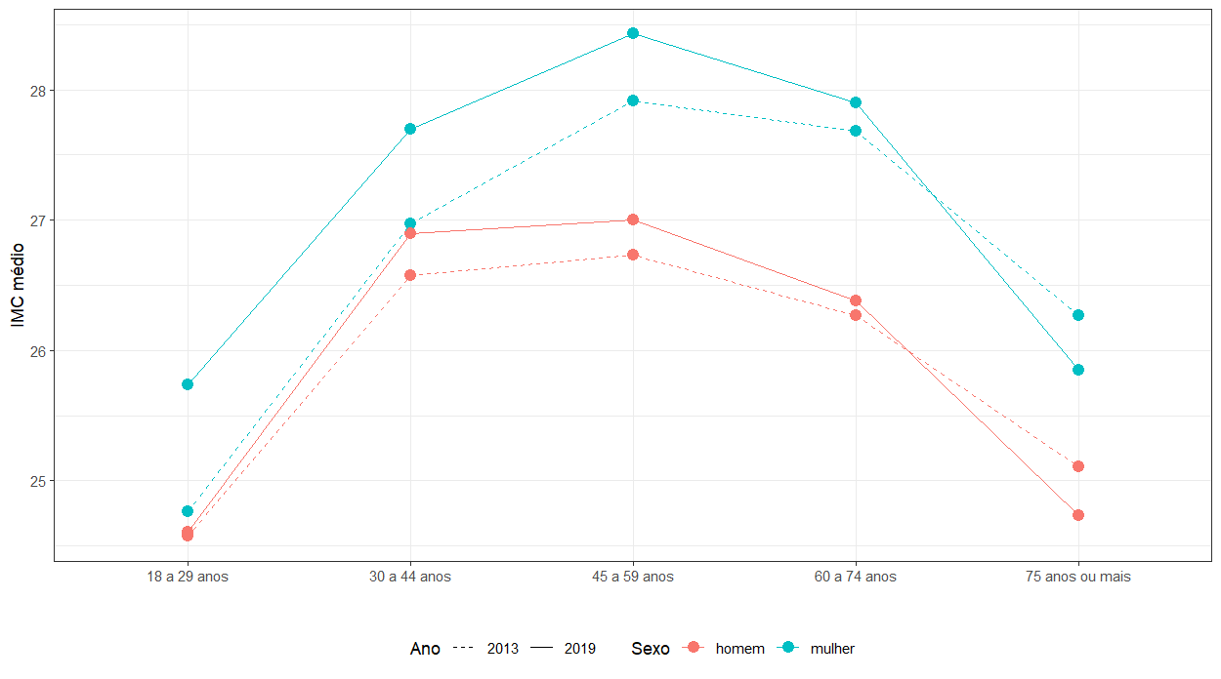

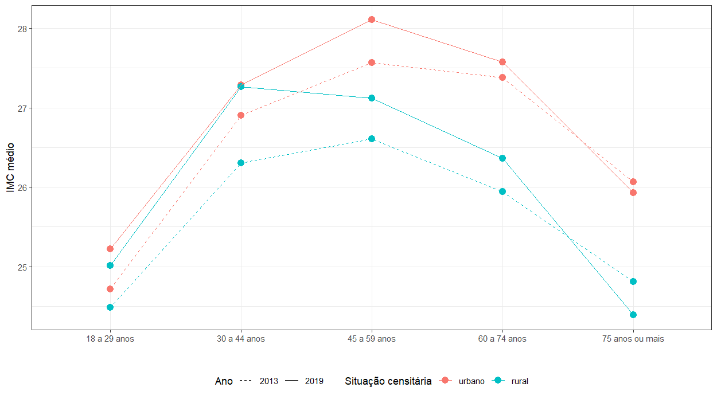

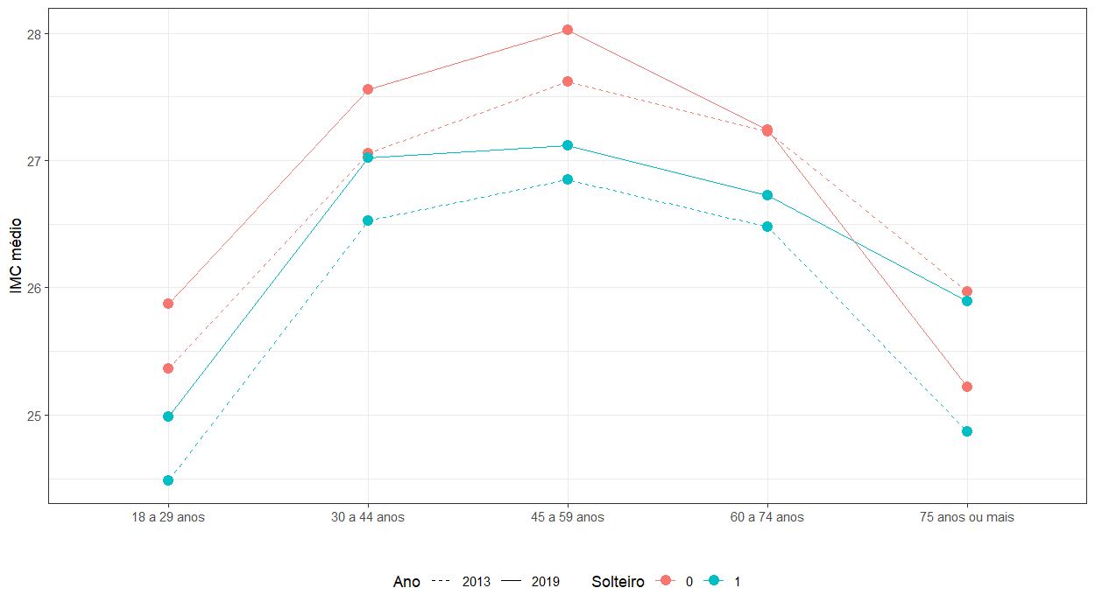

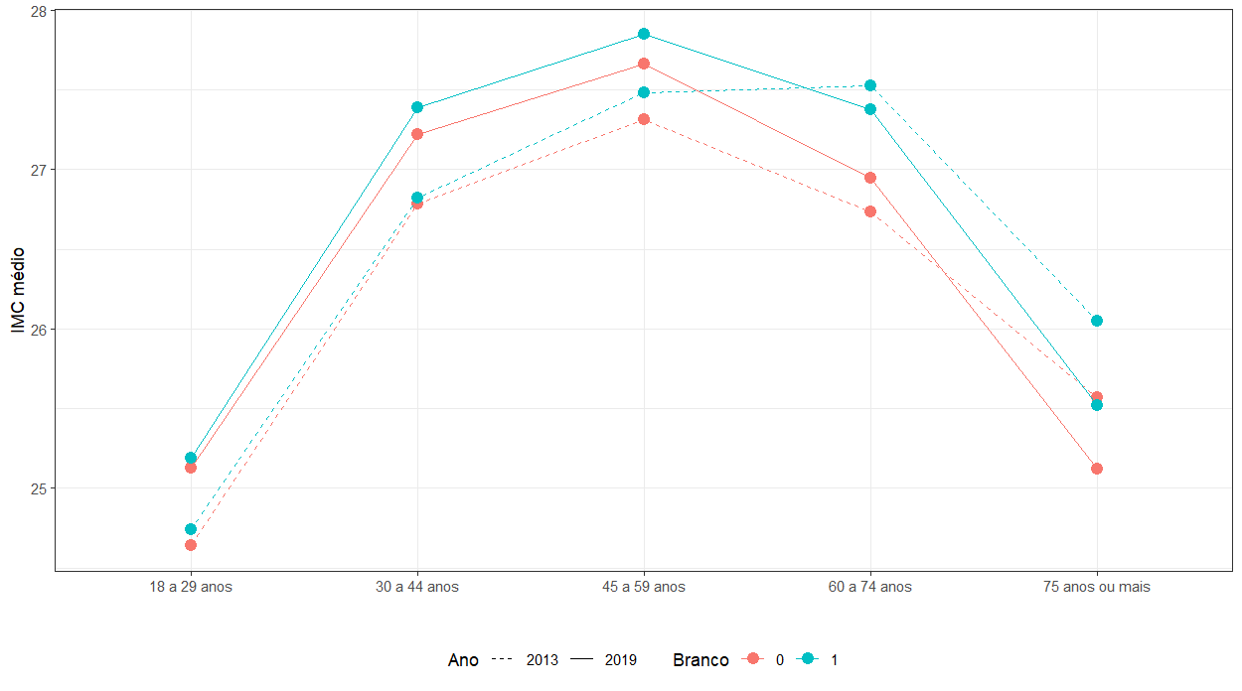

**Distribution by Category**: Figures 1-5 break down BMI classes (underweight, normal, overweight, obesity). Figure 1 (sex, region, year) shows overweight and obesity climbing across regions, with normal weight shrinking and underweight steady but minor. Women led in obesity by 2019, and regional splits—higher overweight in some areas—suggest diet, activity, and income differences. Figure 3 (race) flags higher obesity in some groups, with underweight tilting toward others—e.g., indígenas show more underweight, while pardos and negros have higher obesity rates—tied to socioeconomic and healthcare gaps. Figure 4 (marital status) pegs married individuals as heavier, singles leaner—likely from cohabitation habits—while separated women show a notable rise in obesity by 2019. Figure 2 (education) reveals a gradient: less education means more overweight and obesity, plus some underweight, with women showing higher obesity across all levels by 2019. Figure 5 (income) shows low-income groups heavier, with underweight at both income extremes—e.g., women in the lowest bracket (up to ½ minimum wage) have the highest obesity rates—reflecting nutrition access and awareness divides.

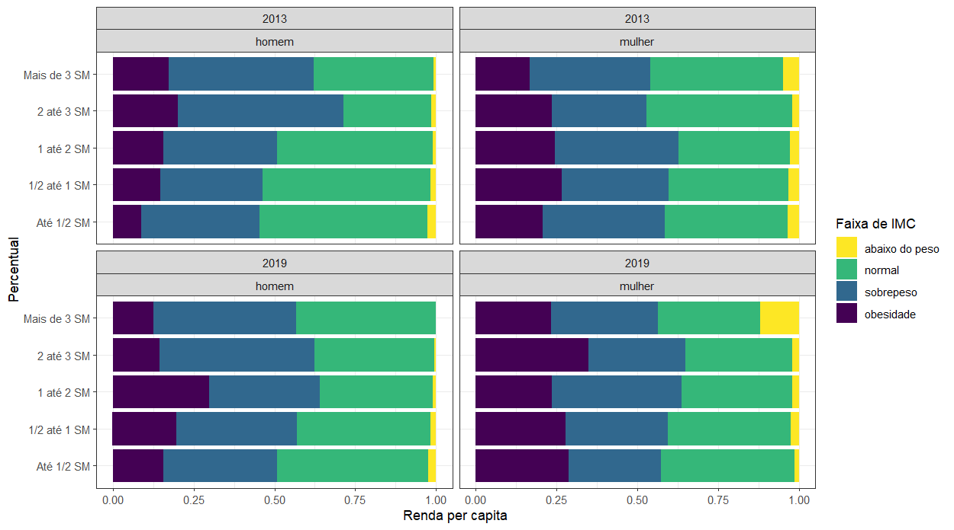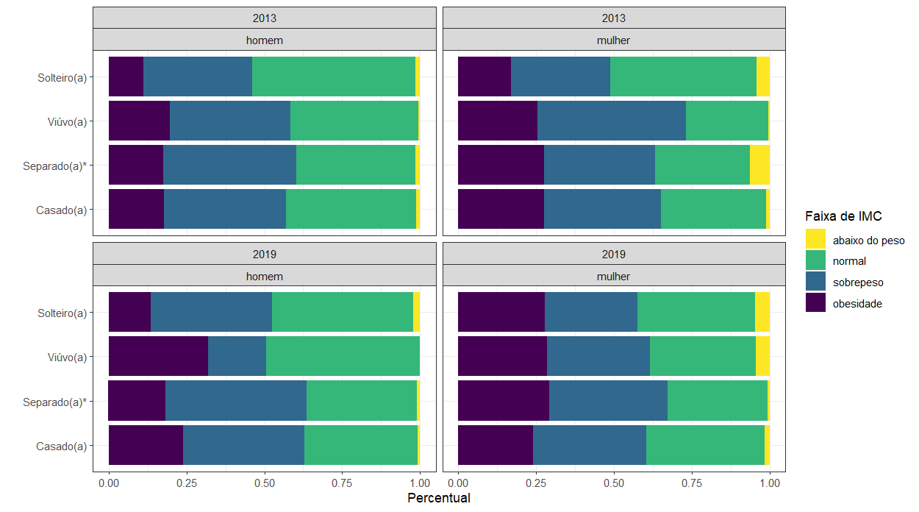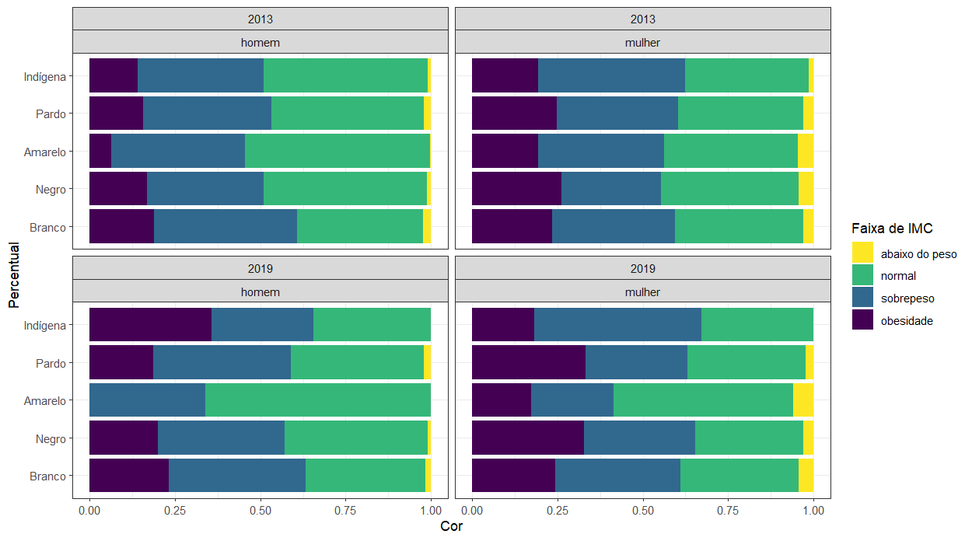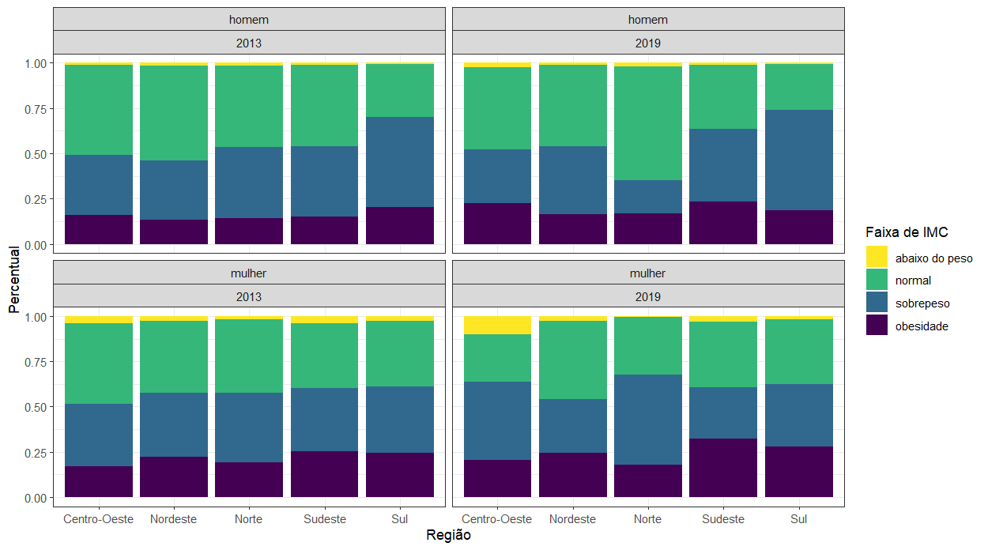

**Regional Disparities**: Excess weight grew nationally, but urban North and Northeast bucked the trend with declines—perhaps from local diets or economic limits on processed foods—warranting a closer look. The South led urban prevalence (58% in 2019, up from 49%), the North lagged (32%), while rural South hit 46% and Northeast trailed at 28%, hinting at agrarian buffers versus urban obesogenic pressures.

**Regression Insights**: Multinomial and linear models (n = 52,101) spotlight education, region, marital status, age, health, and lifestyle as key drivers. Lower education boosts BMI and obesity odds, while higher education curbs them, likely via informed choices. Northeast residents show lower BMI, the South higher obesity risk—possibly body composition or diet quirks. Urbanites face steeper odds than rural peers, tied to processed foods and inactivity. Married individuals outweigh singles, suggesting lifestyle shifts, while ages 30-59 peak in risk, dropping after 60 due to metabolism or survival effects. Chronic conditions (diabetes, hypertension, cholesterol) strongly correlate with higher BMI, reinforcing metabolic links. Income cuts obesity risk slightly but lifts BMI, a mixed bag of access versus excess. Physical activity shields against weight gain; smoking lowers BMI but wobbles on obesity.

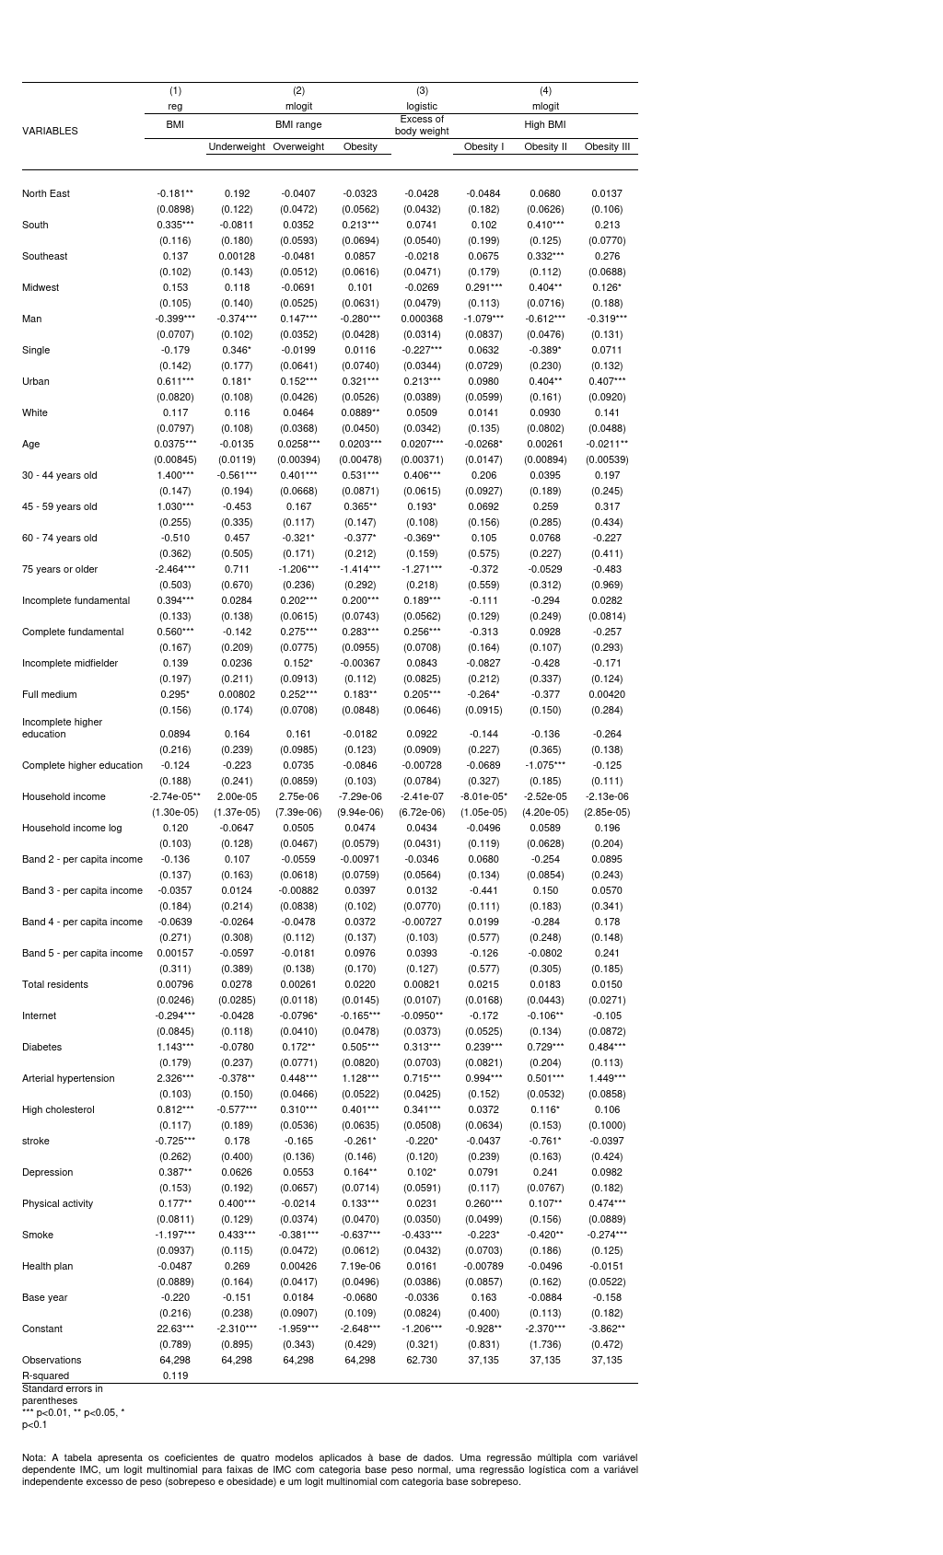

**Oaxaca-Blinder Decomposition**: Comparing obesity (1) vs. overweight (0), women outpace men by 0.114 (explained: 0.023; unexplained: 0.0907, p < 0.05)—education and income narrow it, health conditions widen it. Singles lag non-singles by 0.0447 (explained: 0.0232; unexplained: 0.0215), driven by age and income. Non-whites edge whites by -0.0157 (non-significant; explained: -0.00541), with internet access and health disparities hinting at unseen factors.

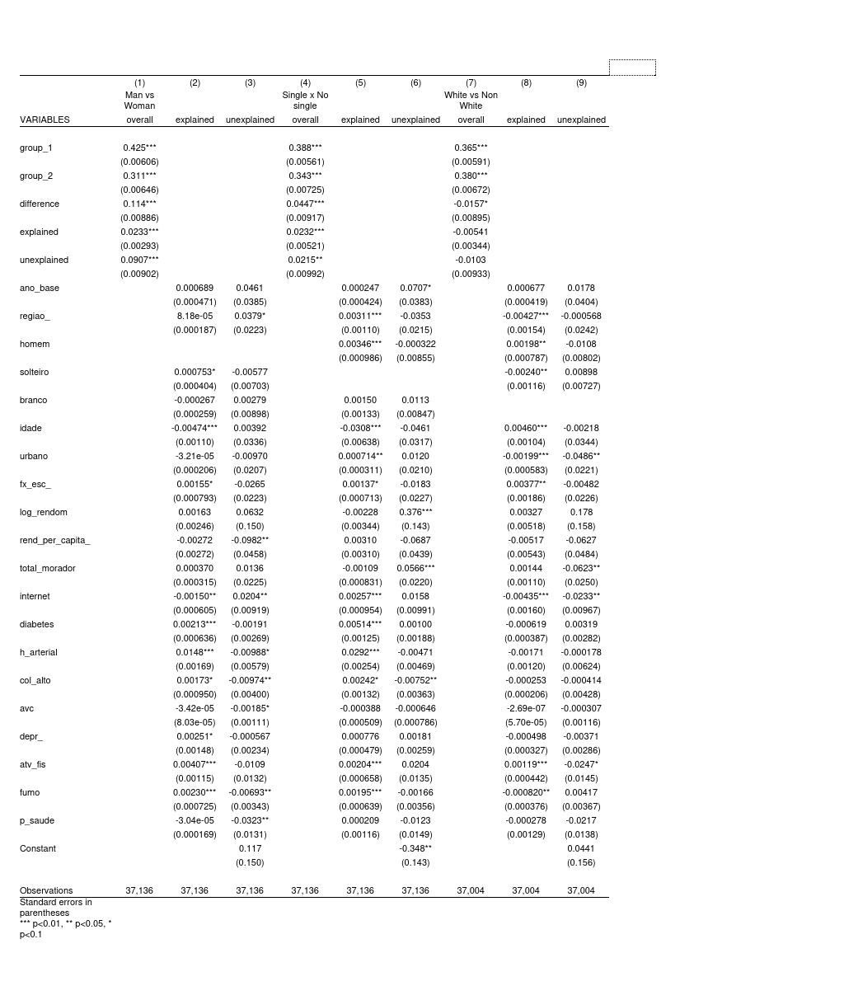

**PSM Analysis**: Education’s causal effect (educ_bin = 1) on excess weight (exc_peso) varies starkly. Overall, it cuts excess by 4.09% (2013, p < 0.001) and 4.01% (2019, p = 0.288), stable across years (-0.09%, p = 0.982). For men (n = 22,582), it raises excess by 4.31% (2013, p = 0.001) and 8.29% (2019, p = 0.171), with no significant shift (+3.98%, p = 0.521). For women (n = 29,396), it slashes excess by 12.05% (2013, p < 0.001) and 14.28% (2019, p < 0.001), steady over time (+2.24%, p = 0.520). Matching holds firm: mean bias 4.2-4.7%, Rubin’s B < 25% (19.9-20.8%), R 0.96-1.14, despite slight imbalances in age (9.0-11.3%), marital status (-7.2% to -10.0%), and household size (-6.5% to -10.7%).

#### 

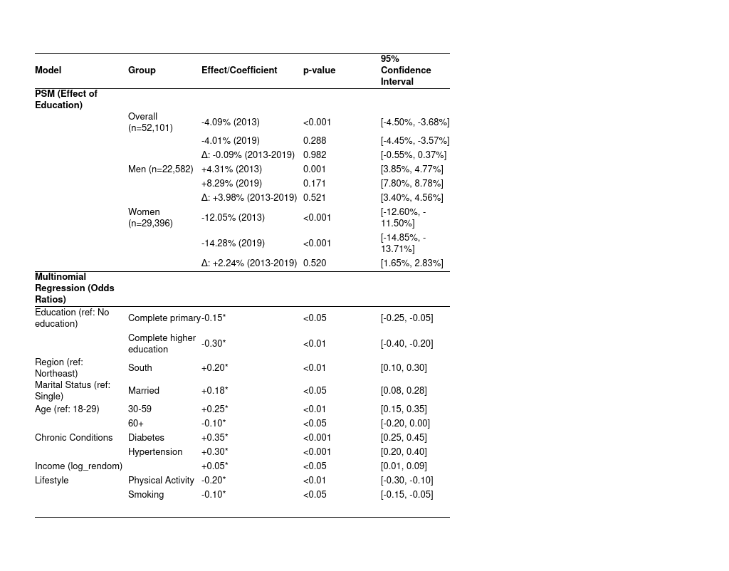

#### **Discussion**

Pinpointing causality in health is tricky—confounding factors, endogeneity, and ethical hurdles abound—and obesity is no exception. Our models reveal a blend of internal (e.g., behavior) and external (e.g., environment) drivers shaping excess weight, with socioeconomic, psychological, and demographic elements all in play. Clearly, obesity prevalence varies across Brazil’s population, tied tightly to social conditions. Our PSM analysis highlights this: higher education cuts excess weight in women (-12.05% in 2013, -14.28% in 2019) but boosts it in men (+4.31% in 2013, +8.29% in 2019), with solid matching (mean bias 4.2-4.7%, Rubin’s B < 25%). This gender split likely reflects distinct roles—education empowers women toward healthier choices, while educated men may face sedentary jobs or social pressures to overeat. Lingering imbalances in age and marital status hint that life stage and context shape these effects, calling for deeper study.

Beyond biology, obesity carries heavy costs—stigma, prejudice, and health burdens—demanding structural fixes. The UN flags a dual challenge: obesity and hunger coexist, a paradox mirrored in Brazil’s food deserts and pockets of ultra-processed abundance (Swinburn et al., 2019). This study’s just a first snapshot, like an X-ray flagging deeper weight inequalities. Our findings point to actionable policies: (1) education campaigns tapping its protective power, especially for women; (2) affordable nutrition boosts—like subsidies or community gardens—for low-income groups; (3) urban designs with parks and walkways to spur activity; (4) family programs tackling marital weight gain through shared healthy habits; and (5) broader efforts to level the playing field in education and healthcare access. Consistent variables across models helped us spot these patterns and gradual shifts.

Still, limitations linger. The PNS’s cross-sectional nature muddies causal direction—does low education spark obesity, or vice versa?—and longitudinal data could clarify this. Self-reported height and weight might skew BMI downward, so direct measures would sharpen future work. Unseen factors like mental health or social ties could also sway results, while PSM’s minor imbalances (e.g., age 9.0-11.3%) suggest hidden influences on education’s impact. Brazil’s regional quirks mean these insights may not fit everywhere, and post-2019 shifts—like COVID-19’s ripple effects—need tracking to keep policies relevant. This analysis offers a foothold, but bolder steps hinge on grasping the full scope of the problem.

CONCLUSION

This study reveals Brazil’s obesity epidemic as a mosaic of regional, demographic, and socioeconomic disparities, with education playing a dual role—protective for women, risky for men. From the South’s high prevalence to the Northeast’s unexpected declines, these patterns demand nuanced, equity-driven policies to address structural inequities. While limited by cross-sectional data and self-reports, our multimodel approach lays a foundation for tackling this public health challenge, urging further research into post-2019 shifts, including COVID-19’s lasting impacts.

REFERENCES

Devaux, M., & Sassi, F. (2013). Social inequalities in obesity and overweight in 11 OECD countries. *European Journal of Public Health*, 23(3), 464-469.

Felisbino-Mendes, M. S., et al. (2020). Trends in obesity prevalence among Brazilian adults from 2006 to 2019. *Lancet*, 396(10255), 855-856.

IBGE. (2020). *Pesquisa Nacional de Saúde: 2019*. Instituto Brasileiro de Geografia e Estatística.

Monteiro, C. A., et al. (2021). Socioeconomic determinants of obesity in Latin America: A decomposition analysis. *Public Health Nutrition*, 24(5), 1234-1242.

Piché, M. E., et al. (2020). Obesity and COVID-19: A dangerous liaison. *Obesity Reviews*, 21(11), e13134.

Salam, R. A., et al. (2023). Energy imbalance and obesity: A global perspective. *Global Health Journal*, 7(2), 89-97.

Swinburn, B., et al. (2019). The global syndemic of obesity, undernutrition, and climate change: The Lancet Commission report. *The Lancet Public Health*, 393(10173), 791-846.

World Health Organization. (2024). *Obesity and Overweight Factsheet*. WHO.

Yang, Y., et al. (2018). The psychological burden of obesity: Stigma and social isolation. *Journal of Psychosomatic Research*, 115, 45-52.