MEGADAPT

Agent-based modeling

This document was generated by the team of ASU and UNAM researchers, for the project MEGADAPT.

**Introduction**

There is a growing concern among scientists and urban planners regarding the increasing vulnerability of megacities to hydrological- and climate-related hazards around the world (Chelleri et al., 2015; Ernstson et al., 2010; Henderson et al., 2016). In the context of adaptation to climate change, there is a persuasive tendency to focus on the exogenous biophysical drivers of vulnerability, such as precipitation extremes and storm surges, when considering investment in hard infrastructure (Hunt et al., 2017; Pelling, 2011). Nevertheless, we also know that vulnerability is affected by political decisions, motivated by influential actors such as resource managers and elected officials. Such decisions are not made on the basis of a technical cost-benefit type of calculation alone; rather, they are grounded in the social, cultural, political, and economic priorities of management authorities, infrastructure providers, resources users, social organizations, and other stakeholders (Pahl-Wostl, 2007). Large-scale public and private investments are thus influenced by contextual cues, local social networks, political pressure, social norms, and the legacy of prior decisions on the landscape (Sivapalan et al., 2012; Smith et al., 2010; Wise et al., 2014; World Bank, 2015). The priorities and preferences of these institutional actors can shape actions and investment in the urban landscape, resulting in material changes in the biophysical world that then, in turn, shape risk, risk perceptions, and decision priorities. The embedded nature of these priorities and their feedback within the biophysical landscape is what we refer to as socio-political infrastructure (Eakin et al., 2017).

A critical task for sustainability is therefore to provide tools that can help decision-makers, stakeholders and society at large navigate the complexities of decision-making to evaluate the interwoven dynamics of socio-hydrological vulnerability –the hard and soft infrastructure– in urban landscapes and stimulate reflection on current practices and the consequences of the decisions over long-term spatial and temporal scales. . Developing these tools can provide a more pluralistic perspective about the causes and consequences of hydrological risk in order to illustrate and stimulate discussion about new solution possibilities to address MC’s current challenges (Brugnach and Pahl-Wostl 2008).

This document describes the implementation of the agent-based model of the MEGADAPT project (adaptation in a megacity). The objective of the model is to develop a computational tool that can help to convey stakeholders and researchers to discuss the role decision-making and socio-political factors into the dynamics of the socio-hydrological vulnerability of CDMX. Specific objectives of the model are: to use is as a place for discussion with stakeholders and residents about the current strategies for adaptation, and 2) to identify how their actions influence the vulnerability of the city. The full MEGADAPT model simulates the coupling between the biophysical processes that influence water-related hazards and the decisions of residents and the water authority of Mexico City (CDMX here on) to adapt to these conditions. In other words, the MEGADAPT model is a participatory model.

Due to its location on an ancient lakebed, CDMX has suffered from water-related hazards for more than 600 years. As the city grew, authorities invested heavily in grey infrastructure to reduce its vulnerability to flooding and to provide potable water (Tellman et al., 2018). While these investments have been pivotal in developing the megalopolis, they have made the city dependent on the proper functioning of the system of pipes, canals, and pumps and the institutions that manage them (Romero Lankao, 2010). Over the years, the grey infrastructure has deteriorated due to age and over-use, causing it to perform at insufficient capacity, thus increasing the risk of infrastructure-related flooding events. The combined sewage and stormwater system, designed to drain the city of floodwaters, now chronically exposes residents to contaminated water. Consequently, when heavy rainfall causes the city to experience ponding, the increased risk of technological and infrastructural failures threaten the safety of the built environment and the resident's health and wellbeing (Ezcurra et al., 1999; Romero Lankao, 2010).

The current implementation of the model incorporates a set of procedures to simulate the decisions of the institution responsible for the management of water and water-related infrastructure in CDMX, The Servicio de Agua de la Ciudad de Mexico (SACMEX here on), and the actions of residents within neighborhoods of CDMX. The models incorporate procedures to simulate events of flooding, water distribution problems, and the associated burden of waterborne diseases spatially in CDMX based on statistical association found between hazard production and infrastructure condition. The megadapt approach is to couple the biophysical models with the decisions of the residents and the managers that with their actions change the biophysical conditions and the attributes of the landscape, changing thus the risk of those neighborhoods to hazards (Figure 1).

The outcome of the model is a set of indicators of urban vulnerability in time and space. The level of exposure of the different neighborhoods of the city, the frequency of interventions by SACMEX and the residents, the level of adaptation of residents, the inequality in the distribution of resources, and the vulnerability of the residents to flooding and water scarcity.

In the next section, we show the theoretical principles behind the modeling approach and its implementation to run a simulation in super-computing infrastructure, based on the implementation on the open source for statistical analysis R (R Core Team, 2013).

**Definitions and Theoretical principles**

**Spatial unit**: Spatial units refer to delimited areas that are recognized by the institutional agents to invest in infrastructure. Each spatial unit, indexed by the symbol, with , can be exposed to environmental hazards over time, . In this implementation our spatial unit is the census block.

**Urban landscape**: An urban landscape is a group of spatial units that are delimitated by a large area than the spatial unit according to the limit of the actor's mandate. An urban landscape can be composed of multiple other urban landscapes. For instance, a municipality or a group of municipalities can be considered an urban landscape. For SACMEX, the urban landscape corresponds to all census blocks (spatial units) that are associated with the CDMX.

**Exposure**: Is the risk of harmful events in a spatial unit. The risk of events in each spatial unit is characterized by the condition of a set of attributes of the unit, with influence in the hydrological and social vulnerability of the population, for instance the number of houses connected to the water system in a census block is an attribute that influences the average days without water. Based on the actions of the residents, the values of the attributes change over time, and a risk prediction of exposure would change as well as influencing the vulnerability of the residents.

The frequency of exposure to a hazard is associated with characteristics of the landscape based on the attributes that influence risk:

where is the state at time of a set of attributes of the landscape within a spatial unit that are influenced by the actions of the different agents. The symbol represents the set of geographic, climatic, and other external variables exogenous to the attributes associated with the agents’ actions, which may be expressed at a local or regional scale, and whose influence is correlated in time and/or space. In the current version, the exposure is simulated using statistical regressions and dynamic simulation.

The attributes of the landscape that influence risk by the action of the agents must be represented dynamically in the spatial simulation. Key to the objective of the model, which is the operationalization of a decision tool for vulnerability assessment, is to connect these attributes’ changes with the decisions of the manager and resident agents (actions of the MCDA model). Representing risk and exposure according to the heterogeneity of the landscape is critical for. Operationalization includes defining the minimal spatial unit of analysis, the extension of the area of governance, and the attributes of the landscape that the socio-institutional agents will use as criteria to select alternatives for investment.

**Institutional decisions**: Institutional decisions are the investments in infrastructure associated with the management of waste and potable water. The procedures that simulate institutional decision-making processes are built using multi-criteria decision principles and tools. In the MEGADAPT approach, this involves connecting multi-criteria modeling outputs to a set of geospatial layers associated with the attributes of the urban landscape. From this connection, the agents can calculate a metric of vulnerability according to the agent and can evaluate the urban landscape to define spatial units with priorities for investments. The current implementation reads, as input, a list of criteria and actions and the parameter values associated with the priorities of the criteria and actions. This information was obtained after a consultation with SACMEX (Shelton et al., 2018), and transformed into an analytic network using the software SuperDecision (Bojorquez-Tapia et al., 2018).

**The residents**: The residents are groups of people living in a neighborhood and taking actions within neighborhoods. Neighborhoods are represented by the spatial units. Similar to the institutional agents, residents evaluate a set of possible actions based on a set of criteria they consider important to confronting water-related hazards. The current implementation of the model includes the action of residents to adapt and cope with water scarcity and flooding. Based on a set of workshops with different residents (Eakin et al., 2016), a generic multi-criteria model was defined (Shelton et al., 2018). The model includes three actions: House modifications, protests, buy water and collective actions. The current implementation of the ABM includes the decision to modify their house and to protest. House modifications imply adaptation. In the model thus house modifications influence the resident's sensitivity to hazards events. For instance, modifying the house to store water is an action that can reduce the need of people to rely on public sources, and thus reduce the sensitivity of residents to water supply disruptions (Eakin et al., 2016). The action “protest” on the other hand implies a respond from the residents to the authority. Currently, protests from residents can influence criteria in the decision of SACMEX.

**Approach**

In this paper, we present a formal approach that considers multi-scale feedback among institutional decisions, social responses, and climatic risk modeling. The approach is based on combining agent-based modeling with multi-criteria decision analysis (MCDA) and geospatial simulation (Bojórquez-Tapia et al., 2001). By combining these three techniques, the model simulates biophysical data-driven infrastructure-related risk, social responses to exposure, and the feedback of those responses with decision-makers actions.

**Multi criteria decision analysis**

Multi-criteria decision analysis (MCDA) provides an ensemble of analytical tools to characterize choices among alternatives based on preferences of the actors. MCDA bases its utility on building a decision framework that makes explicit the linkages between criteria and decision. Building this decision framework implies identifying objectives, alternatives, criteria, weighting stakeholder criteria and score the alternatives using a quantitative approach. There are many techniques to develop a MCDA decision framework. Our method relay on using Analytic network process (ANP), to elicit a set of criteria and action and the preferences. The ANP model is a method that allows to derive an overall measure of priority for the criteria and actions. This is done by pairwise comparison between criteria, actions and both. The critical information needed to develop an ANP model is to obtain, from the different stakeholders represented as agents in the model, the importance the stakeholder gives to each criteria and alternative relative to the others. These questions are of the form: relative to action A, is criteria B more important than criteria C? The answers to these questions are codified in an intensity scale, from 0 to 9 scores, centered in cero. From these comparisons, a weight matrix is constructed. From this matrix a set of absolute criteria and actions weights can be derived by computing the eigenvector associate with the maximum eigenvalue using linear algebra (Saaty 2004) We use here an approximation to this method by computing the limit matrix . The weighted matrix from the resident was obtained from the workshop conducted with SACMEX. Each group was divided between potable water managers and sewer system managers and together each group answered the questions to make the pair comparisons and to define the matrices .

**Agent Based modeling**

Agent-based modeling is a technique employed to simulate the decisions and actions of multiple agents by incorporating the influence of other agents and the environment into a spatially-explicit framework (An, 2012; Railsback and Grimm, 2012). The agents are independent entities that make decisions based on a set of simple rules and the environmental context, which includes the decisions of other actors. From these interactions, patterns emerge that differ from the simple rules that determine individual decisions. We use agent-based models to represent the socio-political dynamics in a geographical context, connecting attributes of the landscape with the actions of other agents. ABMs can include geospatial information and thus can represent realistic responses of actors to changes in biophysical and socio-political landscapes.

**Model Formalism**

The model operationalizes the connection between the range of criteria and decisions elicit using the multi-criteria decision analyses, and the consequences of the actions in the landscape are simulated for the different socio-institutional agents (in our case, SACMEX). Here, the institutional agent must be defined, and the decision criteria and decision options associated with these agents are specified. The agents evaluate a set of possible actions based on a set of criteria valuation obtained from multi-criteria decision analyses. The multi-criteria model is constructed as a direct network of criteria and actions. The valuation of each criterion and action was elicited in consultation with SACMEX.

Definition: Let defined the set of criteria, , as a group of concepts associated to the decision of the agent to act on infrastructure system . Each criterion is associated to an attribute of the landscape that can be represented spatially (a map) and whose values can vary by spatial unit , such that for site . In each site, there is a transformation of the attribute value to a normalized scale between 0 and 1 using a value function of the form =.

Criteria weights: For each set criteria associated to an agent *G*, ,, there is a set of criteria weights that represent the importance the agents give to each criteria associated to the attributes of the landscape. These values are obtained from the Multi-criteria model output computed from the limit of the weighted matrix that in turn was obtained after consultation with SACMEX, using the procedure described in (Saaty, 2004), and are an input to the model from the calculation of the limit matrix (Bojorquez-Tapia 2019 In review).

**Site selection and site suitability**

The decisions of SACMEX is to select a subset of spatial units that maximized the satisfaction of the agent according to the goal of reducing the vulnerability of the city to water-related crisis. The investment decisions by the socio-institutional agents are accomplished in the model by two sub-routines: **site suitability** and **site selection**. Site suitability informs the socio-institutional agent as to the best spatial units for investment, based on the criteria and alternatives of the MCDA model. The site selection procedure then evaluates the different alternatives of spatial units in order to identify the set of spatial units that minimized the dissatisfaction after the investment. These investments involve a set of possible actions taken by the socio-institutional agents, . Formally, an investment is defined as a Boolean variable, , where the value represents that an investment associated with action and related to infrastructure system has been made in the spatial unit at time . SACMEX decides in which spatial units to allocate investments associated with infrastructure systems, to reduce the risk of exposure to hazards at time in spatial unit , , that is managed by a socio-institutional decision-maker agent.

Depending on the type of socio-institutional agent represented in a model and their actions, the decision-process dictated by these two sub-routines can be triggered over different periods. We call each period a **decision cycle**.

**Site Suitability**

An assessment of the census blocks that are prioritized for actions is obtained through multicriteria evaluation of the distance of each census block from an “ideal point,” or utopian state, defined as a set of decision-making criteria and the relative importance of each criterion for the decision makers (Bojórquez-Tapia et al., 2011). Formally, we calculate a distance , such that:

(1)

where is the distance to the ideal point of census block with respect to decision and system ; is the criterion weight of criterion related to system , is the alternative weight of action with respect to system (Fig. 2); is the normalized value in a census block of the attribute corresponding to criterion , with respect to infrastructure system and decision ; is the departure of an alternative from the ideal point for a criterion. This variable is the standardized score , which represents a judgment about the importance of an observable stimulus (census block attribute value) in the water authority’s decision; , , , , and are indices for criteria, census blocks, action, time, and infrastructure system, respectively. Finally, In Equation 1 is the compensatory parameter that define the metric to compute the distance. With , the metric is Euclidian. Given that the variables representing the criteria are continuous and interval- and ratio-scaled, these scores are obtained by means of value functions (Beinat, 1997), which transform the natural scale of a criterion to a [0, 1] value scale (1 represents the most undesirable state and 0 the most desirable state).

**Site selection**

Every year site selection is invoked by the manager for choosing investments , in action in system ,in a specific number of census blocks, established by budgetary constraints . Formally, this involves using a 0-1 (or binary) programming model (Dykstra 1984) in which the objective function maximizes . In this way, the model simulates a preference for investing in the census blocks where investment in infrastructure system is most needed. Formally:

(2)

Subject to

where is the number of census-blocks where investment related to action can take place; is the 0-1 decision variable for action for system in census block at time (, if census block is selected for investment, or 0 otherwise). An implementation of other forms of maximization with a more complete set of constrains is underway.

Budget represents a total capital or resources divided among census blocks. Thus when there is a limited among of resources to be divided in the city. The budget can be aggregated or disaggregated according to institutional rules. For instance, in CDMX the budget for drainage is separated from the budget for potable water system, and within each system, the budget is divided in actions. The optimization of the objective functions were done using a non-dominant sorting assessment (NDSA) that find solutions near the Pareto frontier. The results from the NDSA was then used to constrain a genetic algorithm that find the best alternative in for investments each spatial unit (See Apendix optimization).

**Value Functions**

This procedure standardizes each criterion using normalization functions needed to evaluate the distance to the ideal point of each census block related to each action and system . This procedure is called in every decision cycle to update in a standardized scale the value of the criteria.

##### Different procedures are implemented to capture different functional forms. Generally, the procedures take the following notation:

(3)

where is the perceived magnitude of stimulus defined by the value of attribute in census block at time , and a set of control parameters to ensure that , given the scale of the attributes and it relevance to each agent.

In the R version, the code also includes a procedure to compute using step-functions that take as argument the value of the attribute and a set of cut-off values, such that

(4)

where are cut-off values that follow a progression for increasing and decreasing functions. Parameter represents the maximum value of the attribute , which will set the range of the value function. From a second consultation with SACMEX a set of empirical functions and its parameter values where obtained, and included in the model. For those criteria without empirical information to derive value functions, expert knowledge was used.

**Water authority actions and changes to census block attributes**

Once the model computes the distance metric for each census block and the selection procedure is activated, a set of actions are invoked. These actions change specific attributes of the landscape. Here we explain the actions and their consequences on the census block attributes. Table 2 summarizes the actions described in consultation with SACMEX and included in the model.

Maintenance of current infrastructure

When the Maintenance reduces the age of infrastructure system , at a rate proportional to its effectiveness:

Where is the age of infrastructure system in spatial unit at time , and is the effectiveness of maintenance.

**Build new infrastructure**

The provision of new infrastructure influences the proportion of the population in census block covered with infrastructure system , such that:

where is the effectiveness of the action “new-infrastructure” in providing system to the proportion of houses that lack coverage, .

Residents can invoke actions that either influence the local infrastructure of the census block or change the socio-political landscape via protesting.

**House modification**

The action “House modification” influences the sensitivity of the residents to hazard events. We define the sensitivity of the house as a change of the perception of the magnitude of a hazard. Formally, we assume that sensitivity is defined by

where

is the accumulated number of times that the action “house modification” was invoked by the residents of census block . This formalization assumes therefore that modifications are cumulative and the change in the sensitivity of the residents depends on the rate of adaptation, .

**Protests**

The procedure “protest” in a census block, defined by the symbol , is triggered when the action “protest” is perceived as a priority compared to “house modification” to adapt to scarcity. Accordingly:

where is the distance to the ideal point related to the protest action .

**Models of exposure**

**Exposure to water supply disruption**

According to a government survey, in CDMX a large proportion of households experience weekly disruptions in water supply. These disruptions are assumed to be caused by a failure in the condition and the provisions of the potable water infrastructure,, in addition to the risk associated with the location of the census block.

Accordingly, the risk of exposure to water supply disruption is assumed to be a failure from a binomial alternative space, where 1 implies not having water distributed in a single day from the supply network, and 0 otherwise. We simulate the number of days with water per week per census block, , using a negative binomial process:

Where is the expected number of days without water. is simulated using regression of the form

The model is composed of two part. First is the binomial part that simulated the changes of a site to have or not water in a week. This is based on the proportion of people disconnected from the distribution network . In the case of having water the negative binomial part of the regression () is used to estimate the number of failures per week, Assuming a number of days until a failure occur in a week. The parameters of the model were estimated using data from a household survey regularly by Mexico survey institution (webpage/path to/ survey data/?).[Illiana please check]

In the model we implement the results from this statistical model with an algorithm that determines the days without water per week and update a set of water scarcity related variables. The algorithm works as follow:

1. Predict new probability of failure using the negative binomial model the data for the external predictors (, , and ,). The output of the prediction includes probabilities for each from 0 to 7 days without water (number of successes until you see the a number of failures in the negative binomial). Each spatial unit has these 7 probabilities.
2. Generate a lottery to estimate the number of spatial units that have 7,6,5..,etc., days without water. The lottery has 7 steps. In step 1, all the spatial units with 7 days with not water are selected by chance. First, a random number with uniform distribution is obtained, then if this number is larger than the probability for 7 days without water, and obtained in 1), the variable water-in-a-week is updated to 7 [days]. Finally, all these spatial units with 7 days without water are removed from the list. Next step repeats step 1 of the lottery, but using the probability “6 days without water”, and those spatial units not selected in the previous step (7 days without water). The procedure continues for all the other spatial units until the probability 0 days without water is reached (step 7).
3. Update variables:
   1. days-in-a-week-without-water
   2. days-in-2weeks-without-water
   3. days-a-month-without-water
   4. days-a-year-without-water

**Exposure to Flooding**

The model also includes procedures for simulating flooding events based on the frequency of yearly events recorded in the different census blocks. For a definition of the flooding per site see ().

To simulate the expected number of flooding, we use a zero-inflated negative binomial model that considers both over-dispersion to extreme events and the high presence of sites without problems associated with flooding. Using this model the expected number of event in a year T is simulated as:

(13)

where is the expected number of flood events in census block at year . ,, and are the regressor parameters associated with the independent variables age , capasity , and hydraulic cost of the sewer system , respectively, all of them evaluated at week .

**Exposure to Gastrointestinal diseases**

The health model is implemented as two separate regression models that simulate the expected number of incidences of gastrointestinal diseases in the lowlands and in the highlands of CDMX.

For the lowlands, a regression model of the form

(14)

was used to incorporate the full set of predictors and the spatial dependency observed in the data. is a vector of observations of the dependent variable, with one observation for every census block, is the number of flooding events in census block , and is a parameter that relates the number of flooding events to the risk of gastrointestinal diseases. is a vector of disturbance terms, where is assumed to be independently and identically distributed for all , with zero mean and variance of . In order to capture the spatial dependency observed in the incidence data, the model incorporates an additional regressor in the form of a spatially-lagged variable,(Anselin, 2001). This variable captures cross-section dependencies, in which a covariance structure exists in different locations derived from the geographic space (Anselin, 1998; Anselin, 2001). The term is the unknown spatial lag coefficient, and *W* is the contiguity matrix. This equation was estimated empirically prior to study (Baeza et al., 2018).

**Infrastructure decay**

We assumed that over time infrastructure ages and decays over time. This decay in turns influences the performance of the infrastructure. Exposure of census blocks to infrastructure hazards is related to the average condition of infrastructure systems. First, we assumed that the capacity of the sewer infrastructure decays at a rate such that

.

In addition, we assumed that the infrastructure system in census block , , ages over the years, such that:

**Governance scenarios**

A governance scenario in this framework is defined as the set of criteria , priorities , and actions of a socio-institutional agent, and defined for each infrastructure system, . Thus, a governance scenario of agent is formally defined as: where, , and are the set of criteria, criteria weights, and actions associated to systems . To calculate the suitability assessment, , and for each agent and system .

**Indicators of Vulnerability**

The indicators obtained at the end of the simulation period are described in the sections below.

**City average age of infrastructure system**

This indicator corresponds to the average age of the infrastructure in the city over the last years of the simulation. Formally,

where is the average age of infrastructure system , and the total number of census blocks in the urban landscape.

**City average exposure to flooding and scarcity**

These indicators are calculated using

for scarcity, and

for flooding, where and are the annual number of water disruption and flooding events, respectively, in census block at year . is the final time-step of the simulation and . is the total number of census blocks.

Census block average exposure was measured using

The total number of events in the 10 years of simulation in each census block was represented as

**City average level of socio-political pressure**

This index is calculated using the number of accumulated protests over the last time-steps of the simulation, divided by the total number of census blocks :

**Vulnerability index**

The vulnerability of a census block is calculated using the “surface of vulnerability” definition by (Luers 2005). In this framework, the vulnerability index is summarized as the ration between the product of exposure *E* and sensitivity *S*, and the adaptive capacity of the census block. Formally:

where is the vulnerability in census block at time . is the exposure, defined as the level of flooding or scarcity of water. represents the sensitivity of census block to hazard events . We measure this by keeping track of the number of decisions that involve house modifications and water storage. The more these actions accumulate in a census block, the less sensitive it would be to the exposure. Parameter represents the adaptive capacity of the census block. We assume that

(48)

where is the income index of census block . Thus, we explicitly assumed that census blocks with more resources have higher adaptive capacity than poor census blocks. That is, wealthy areas are less vulnerable because they have more access to resources to take action. We use purchase power as an indicator of adaptive capacity.

**Application**

The model is currently implemented in R (R Core Team, 2013) a free open-source software for statistical computing. The user needs to install R and Rstudio, and needs to clone, from GitHub, the following directory: [add SHV path here]. Once the user installs the folder, she or he needs to open the project file “ABM_Rversion.prj”. The model to run will need the following dependencies packages: “glmmADMB”. “maptools”, “ecr”, “pscl” “plyr”, “gramEvol”. These packages can be installed into the R library using the function install.packages(). The function will install the packages in the “library” folder, located in the folder where the R source was installed.

The model is composed of several sub-routines and groups in two main procedures: “setup.R” and “cycle.R”. In Setup the model will read the empirical information to define the criteria, the actions and the priorities of SACMEX and the residents, and the geospatial information and the biophysical models that will be used to simulate the hazards events. The setup subroutine, reads the empirical parameters to define the shape of the values functions and the parameters that will define the metric of distance to the ideal point use to select sites (site selection). This information was obtained in consultation with SACMEX and a group of residents from different neighborhoods. The model can be run by using the function “source()” to run a single instance of the model source(“setup.R”) and (“cycle.R”) in the console. Before the model can run however the user needs to define first some initial parameters and store them in the global environment of RStudio. To help the user, a file named “Intial_parameter_values.R” was created and can be sourced to define the values. In this file, the user need to change the variable “path_to_source” to the current directory with the gitHub repository “/SHV/ABM_Rversion/MEGADAPT_APP/”. A future version of the model will be docked and archived with all its dependencies.

In “cycle.R”, the files for simulating the decision of the agents, the modification of the attributes of the landscape, and the simulation of events are loaded previous the simulation of the cycles. The cycle will run for the number of years the users defined in the parameters of the simulation. For details about the processes and the sequence of the processes, see Pseudocode_MEGADAPT.docx.

To run the model in the terminal the user with the “ABM_Rversion.prj” project file opened, will see the R-file “run_MEGADAP_Cluster.R”. This file will read arguments (parameter values) from the command line and will invoke files “setup.R” and “cycle.R”. The arguments passed through the command line are the 1) effectiveness of the interventions from SACMEX (parameters and ), the rate of rate of infrastructure decay , the time of the simulation in years, , and the budget for investment and climate scenario . In the terminal tab (Figure 3) the user must type the following instruction:

Rscript --vanilla run_MEGADAPT_Cluster.R

To run the model. Where , , , , and are the values of the input parameters. Figure 4 shows an example with specific parameter values.

After the simulation is completed, the model will return a x (* data frame, where is the number of years of the simulation is the number of output variables saved and is the number of spatial units or sites. Thus, for each spatial unit , and variable , a time series of length can be generated. Alternative a spatial map of extension and resolution can be compute for each variable .

**Visualization of indicators of vulnerability**

Currently the model contains a file called “Indicators_of_Vulnerability.R” that by sourcing it will open a viewer window with an application to manipulate the outcome layers associated to the indicators of vulnerability (Fig. 5). The user can select particular indicators to visualize, and obtain the value of the indicator for each spatial unit.

**Tables**

Table 1: Attributes of the census blocks of CDMX.

|  |  |  |  |
| --- | --- | --- | --- |
| Variable | Description | Symbol | name variable in netlogo |
| Census block ID | Numerical key to identify each census block |  | ID |
| CVEGEO | Unique national identifier | - | CVEGEO |
| Estate | Administrative units |  | CV_estado |
| Municipality | Units |  | CV_mu |
| Group cluster ID | A classification of the census blocks of MC based on socio-economic and environmental similarities (appendix) |  | group_kmean |
| Weekly water supply | Days in a week water was supplied by system |  | scarcity |
| Flooding | Number of flooding events per year |  | flooding |
| Protests | 1 if a protest occurs in a given week; 0 if otherwise |  | protests |
| Health | Annual incidences of gastrointestinal diseases |  | salud |
| Social pressure | Number of protests per year |  | Presion_social |
| Media pressure |  |  |  |
| Infrastructure coverage | % houses connected to infrastructure system |  | Houses_with_D  Houses_with_Ab |
| Age infrastructure | Age of infrastructure system |  | Antiguedad-infra_D  Antiguedad-infra_Ab |
| Hydraulic load | Average volume of water per unit of time received by the sewer system in census block in a year |  | Gasto |
| Capacity | Index of the capacity of the pipes of system |  | Capasidad_D  Capasidad_Ab |
| Rainfall | Total annual rainfall in census block |  | precipitation |
| Subsidence | The rate of subsidence per year |  | hundimientos |
| Income index | The purchasing power by census block |  | Income-index |
| Potable water | The volume of water supplied to the census block by system at time |  | Water-in |
| Garbage | Garbage produced in each census block |  | garbage |
| Water quality | Index of the quality of potable water |  | water_quality |
| Urban growth | Percentage of census blocks considered to be urbanized |  | urban_growth |
| Water deviated | Number of wells multiplied by the days without water in census blocks with indigenous communities |  | desviacion_agua |

Table 2: Actions and their changes in landscape attributes.

|  |  |  |  |  |
| --- | --- | --- | --- | --- |
|  | Actions | Symbol | Attribute changed | Decision cycle |
| SACMEX | Maintenance |  | * Average age of Infrastructure * Increase capacity of sewer system | Year |
| New infrastructure |  | * Increase capacity of sewer system * Connections of houses to water supply and drainage * Pumping capacity | Year |
| Residents | House modification |  | * Sensitivity of neighborhoods to flooding or potable water scarcity | Year |
| Protest |  | * Social pressure | Week |

Table 3: Criteria used in residents’ decision-making.

|  |  |  |
| --- | --- | --- |
|  | |  |
| Criteria | Definition | Symbol Attribute associated |
| Urbanization | Percentage of area urbanized  (driver of change from simulations of urban growth model) |  |
| Waste of water | Dummy |  |
| Water deviación | The perception of local people that live close to wells that water is being distributed to other census-blocks |  |
| Service efficiency | related to the efficiency of infrastructure system |  |
| Insufficient infrastructure | Represented by the percentage of the population in each census-block not connected to the sewer system |  |
| Contaminación de agua/water quality |  |  |
| Drainage system clogged | Garbage produced by census block |  |
| Water scarcity | Number of days of water disruption |  |
| Flooding | Number of flooding events per year |  |
| Health risk | Number of incidences per pear |  |

Table 4: Criteria used in water supply operators’ decision-making.

|  |  |  |  |
| --- | --- | --- | --- |
| Criteria for calculating THE decision metric OF THE water supply operator | | | |
|  |  | Definition | unit |
| Infrastructure | Age of infrastructure | The average age of infrastructure per census block | years |
| Capacity | Capacity [in length of pipes] of the infrastructure to supply water or to discharge | Mts/area |
| Failure | An index of the number of infrastructure-related hazards per year (e.g., pipes break) | [events/year] |
| Lack of infrastructure | The lack of connection to potable water and sewer systems | % houses not connected to the infrastructure system |
| Hydraulic pressure | Pressure in pipes TBD | ? |
| Risks to the population | Water quality | TBD | ? |
| Water scarcity | Number of weeks in a year without water supply by system or | [weeks/year] |
| Flooding | Represented by the number of flooding events per year | [events/year] |
|  | Health | Represented by the number of gastrointestinal incidences per year | [events/year] |
| Socio-institutional | Supply | Represented by the requirements of the population on the infrastructure system | [pop * need/pop.] |
| Petitions from residents | The demand of population funneled by politicians at the level of the municipality, representing the collective level of response from each municipality. |  |
| Social pressure | Represented by the number of protests per year | [pop * need/person] |

|  |  |
| --- | --- |
| Indicator | Name in output data-frame |
| Id of census block | "AGEB_ID" |
| Municipality of each census block | "municipio" |
| Age of the infrastructure | "antiguedad_D" |
| Age of the infrastructure | "antiguedad_Ab" |
| Frequency of ponding. This variable was used to estimate the ponding model | "f_en", |
| Number of ponding events predicted by the ponding model | "encharca" |
| Number of flooding events predicted by the flooding model | “Inunda” |
| Proportion of houses not connected to the potable water system | "FALTA_IN" |
| Capacity of the sewer/storm water system | "capac_w" |
| Proportion of houses not connected to the drainage system | "falta_dren" |
| Average number of days without piped water in a week. This variable was used to estimate the water-scarcity model | "lambdas" |
| Number of days without water in a week predicted by the water scarcity model | "NOWater_week_pois" |
| Number of days during two weeks without piped water | "NOWater_twoweeks" |
| Number of days during a month without piped water | "days_wn_water_month" |
| Number of days in a year without water | "days_wn_water_year" |
| Number of protests in a year | "social_pressure" |
| Sensitivity of residents to potable water scarcity. It reflects the number of interventions by the residents to modify their neighborhood | "sensitivity_Ab" |
| Sensitivity of residents to flooding. It reflects the number of interventions by the residents to modify their neighborhood | "sensitivity_D" |
| Indicator that combines the sensitivity to potable water scarcity, the exposure to water scarcity and the income | "vulnerability_Ab" |
| Indicator that combines the sensitivity to flooding, the exposure to flooding and the income | "vulnerability_D" |
| Indicator of the number interventions from sacmex associated to potable water infrastructure | "Interventions_Ab" |
| Indicator of the number interventions from sacmex associated to sewer and storm water infrastructure | "Interventions_D" |

**Figures**

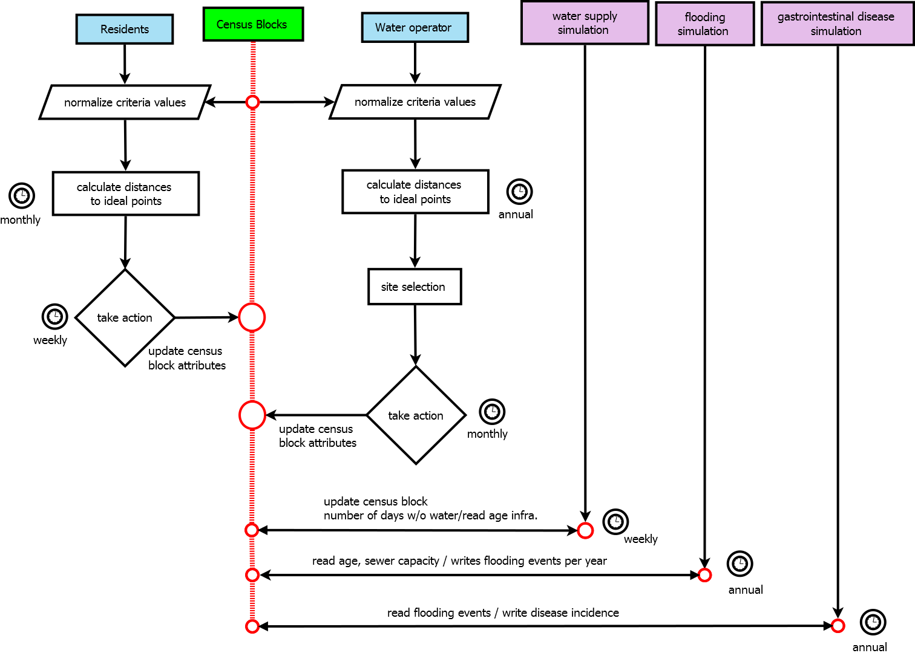

Figure 1: A Flow diagram of the processes and sub-models included in the current agent-based model. The figure summarizes the processes implemented the sequences of events and the scales in time that connect the sub-routines.

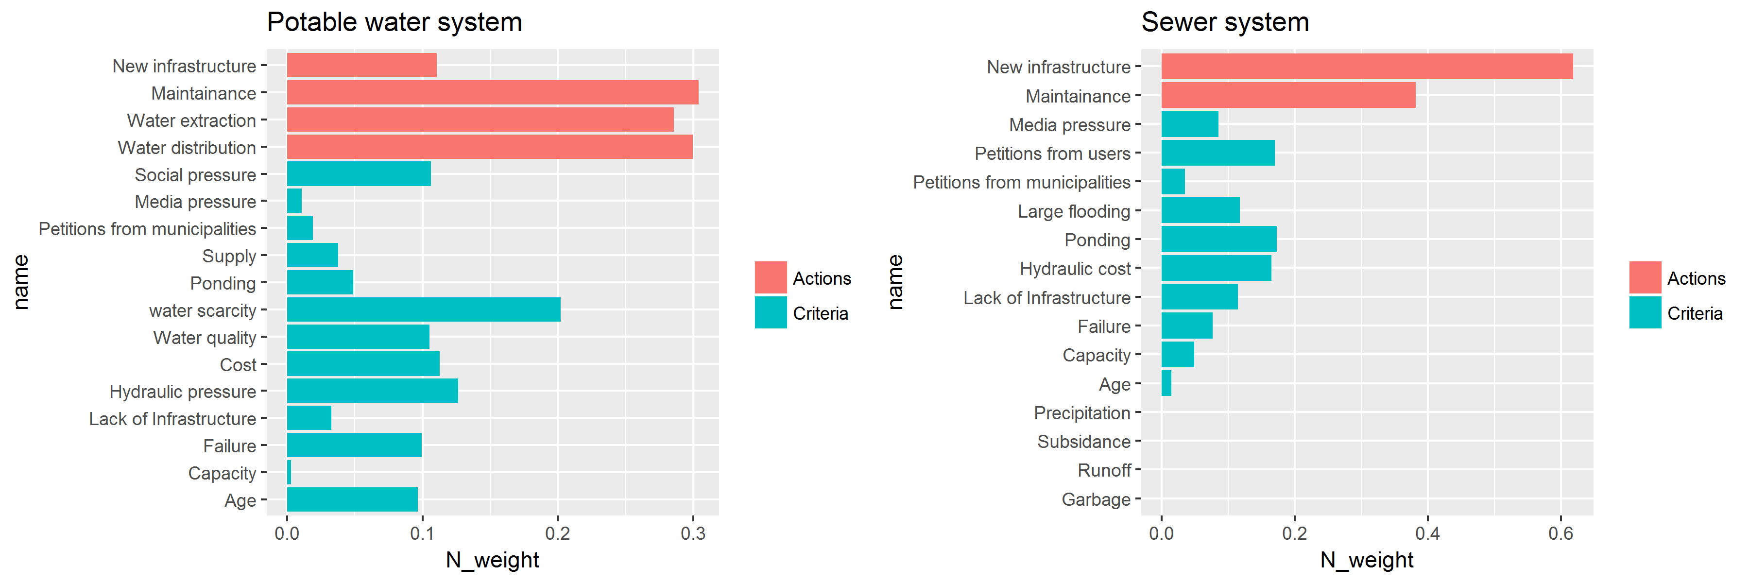

Figure 2: Criteria, actions, and criteria and action weights. The figures show the input data to define the decision-making process of SACMEX. This input data correspond to the criteria weights and action weights using the limit of a weighted matrix T obtained from an analytic network process (ANP), and elicited in consultation with managers of SACMEX. In red the actions and in blue the criteria. The bars indicate the priorities of each criteria and action.

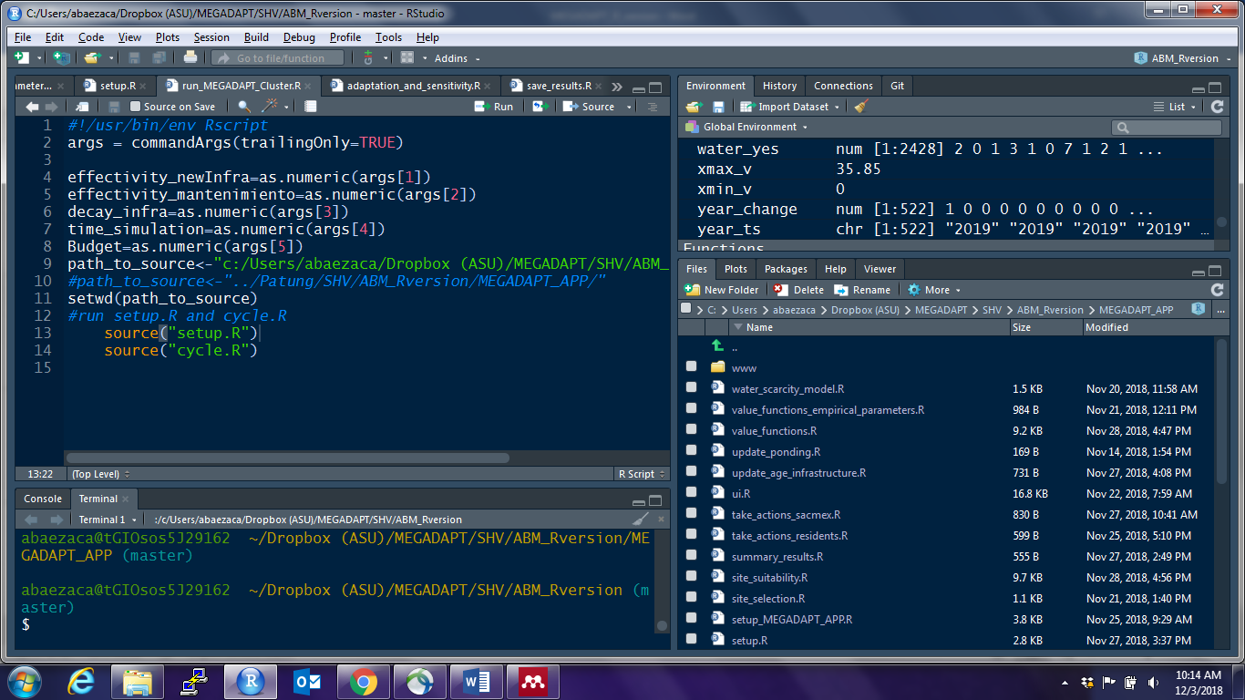

Figure 3: Screenshot of the MEGADAP model in R.

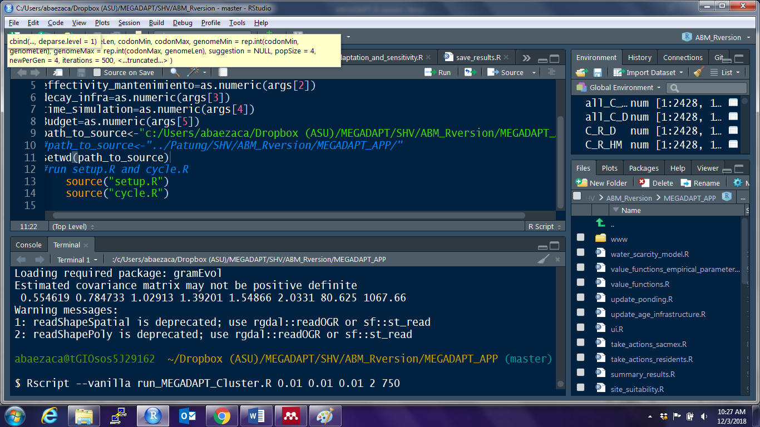

Figure 4: Screenshot of a run of the model in the terminal using specific parameter values. , , [years], and [spatial units per year].

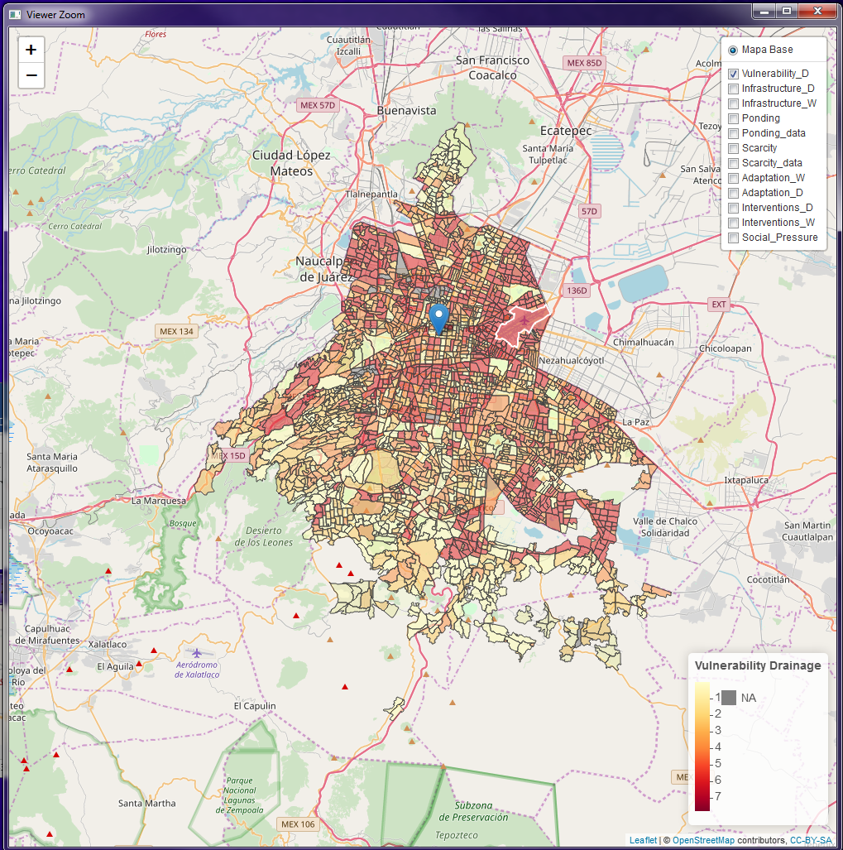

Figure 5: Map view showing a geo-visualization of the indicators of vulnerability at the end of a simulation.

**References**

Baeza, A., Estrada-Baron, A., Serrano-Candela, F., Bojorquez-Tapia, L.A., Eakin, H., Escalante, A.E., 2018. Biophysical, infrastructural and social heterogeneities explain spatial distribution of waterborne gastrointestinal disease burden in Mexico City. Environ. Res. Lett. 13. https://doi.org/`

Beinat, E., 1997. Conclusions, in: Value Functions for Environmental Management. Springer Netherlands, Dordrecht, pp. 213–226. https://doi.org/10.1007/978-94-015-8885-0_9

Bojorquez-Tapia, L.A., Eakin, H., Baeza, A., Gómez-Priego, P., Janssen, M.A., Miquelajauregui, Y., Serrano-Candela, F., 2018. Spatially explicit simulation of two-way coupling of complex socio-ecological systems: Socio-hydrological risk and decision making in Mexico City. Socio-Environmental Syst. Model.

Bojórquez-Tapia, L.A., Luna-González, L., Cruz-Bello, G.M., Gómez-Priego, P., Juárez-Marusich, L., Rosas-Pérez, I., 2011. Regional Environmental Assessment for Multiagency Policy Making: Implementing an Environmental Ontology through GIS-MCDA. Environ. Plan. B Plan. Des. 38, 539–563. https://doi.org/10.1068/b36129

Eakin, H., Lerner, A.M., Manuel-Navarrete, D., Hernández Aguilar, B., Martínez-Canedo, A., Tellman, B., Charli-Joseph, L., Fernández Álvarez, R., Bojórquez-Tapia, L., 2016. Adapting to risk and perpetuating poverty: Household’s strategies for managing flood risk and water scarcity in Mexico City. Environ. Sci. Policy 66, 324–333. https://doi.org/10.1016/j.envsci.2016.06.006

Ezcurra, E., Mazari-Hiriart, M., Pisanty, I., Aguilar, A.G., 1999. The Basin of Mexico: Critical Environmental Issues and Sustainability, 1st ed. United Nations University Press, Tokio, Japan.

R Core Team, 2013. R: A Language and Environment for Statistical Computing.

Romero Lankao, P., 2010. Water in Mexico City: what will climate change bring to its history of water-related hazards and vulnerabilities? Environ. Urban. 22, 157–178. https://doi.org/10.1177/0956247809362636

Saaty, T.L., 2004. Fundamentals of the analytic network process -Dependence and feedback in decision-making with a single network. J. Syst. Sci. Syst. Eng. 13, 129–157.

Shelton, R.E., Baeza, A., Janssen, M.A., Eakin, H., 2018. Managing household socio-hydrological risk in Mexico City: A game to communicate and validate computational modeling with stakeholders. J. Environ. Manage. 227, 200–208. https://doi.org/10.1016/J.JENVMAN.2018.08.094

Tellman, B., Bausch, J., Eakin, H., Anderies, J., Mazari-Hiriart, M., Manuel-Navarrete, D., Redman, C., 2018. Adaptive pathways and coupled infrastructure: seven centuries of adaptation to water risk and the production of vulnerability in Mexico City. Ecol. Soc. 23.