**MEGADAPT**

**Define baseline simulation year based on observed meteorological data**

The baseline simulation year -**2013**- was selected based on monthly data availability provided by the Servicio Meterológico Nacional (SMN), and the percentage of missing values within a given year (Table 1). Once the baseline year was selected, a linear interpolation was performed to replace missing values. Observational data were recorded with a temporal frequency of 10 min. Temperature (°C) records were averaged to represent a single hourly value (Figure 1). As with temperature, the cumulative rainfall (mm) was calculated on an hourly basis (Figure 2) to guarantee temporal correspondence with WRF outputs.

Table 1. Meteorological station name, geographic location, altitude and percentage of missing values over the 12-month period of record (January-December) for the three years evaluated (2012-2014).

|  |  |  |  |  |  |  |  |
| --- | --- | --- | --- | --- | --- | --- | --- |
| Meteorological Station | Location | Latitude  (°N) | Longitude  (°W) | Altitude  (m) | % missing values (2012) | % missing values (2013) | % missing values (2014) |
| Atlacomulco | Estado de México | 19.475 | -99.523 | 2600 | 2.20 | 0.33 | 0.04 |
| Cerro Catedral | Estado de México | 19.323 | -99.318 | 3754 | 12.9 | 2.70 | 7.89 |
| Ecoguardas | CDMX | 19.161 | -99.121 | 2200 | 11.9 | 0.94 | 4.62 |
| El Chico | Hidalgo | 20.118 | -98.425 | 3004 | - | 1.10 | - |
| Huamantla | Tlaxcala | 19.239 | -97.575 | 2222 | 6.19 | 1.75 | 0.06 |
| Huejutla | Hidalgo | 21.917 | -98.226 | 115 | 4.67 | 2.17 | 0.11 |
| Huichapan | Hidalgo | 20.231 | -99.395 | 2189 | 3.46 | 0.24 | 0.05 |
| Itza-Popo | Estado de México | 19.543 | -98.383 | 3682 | 0.86 | 0.51 | 11.3 |
| Nevado Toluca | Estado de México | 19.732 | -99.461 | 4139 | 3.04 | 0.46 | 0.13 |
| Presa Madín | Estado de México | 19.312 | -99.164 | 2364 | 0.78 | 0.26 | 0.02 |
| Valle de Bravo | Estado de México | 19.223 | -100.54 | 2476 | - | 1.35 | 3.37 |
| Zimapán | Hidalgo | 20.442 | -99.232 | 1788 | 0.87 | 3.37 | 0.72 |

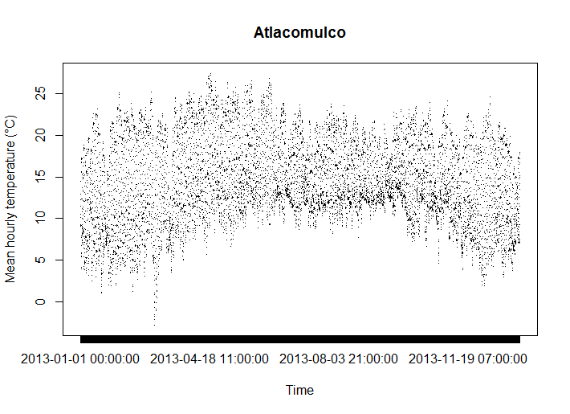

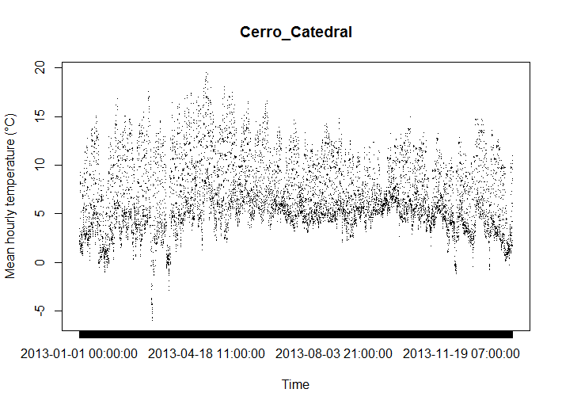

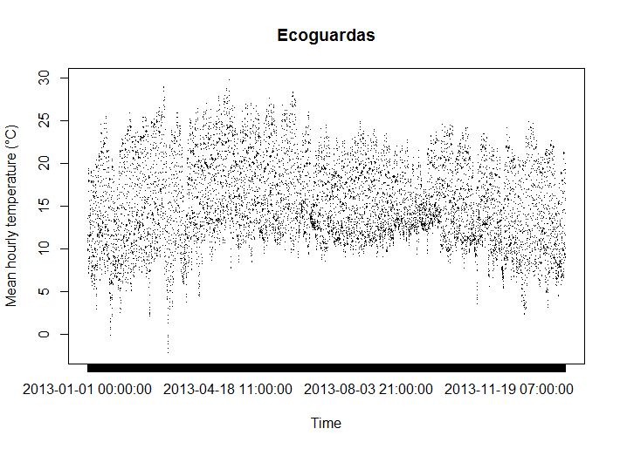

Figure 1. Observed mean hourly temperatures for the baseline simulation year (2013) for three meteorological stations. Averages were obtained after replacing missing values using a linear interpolation.

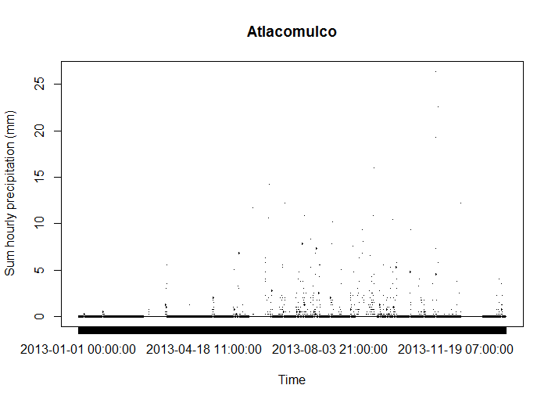

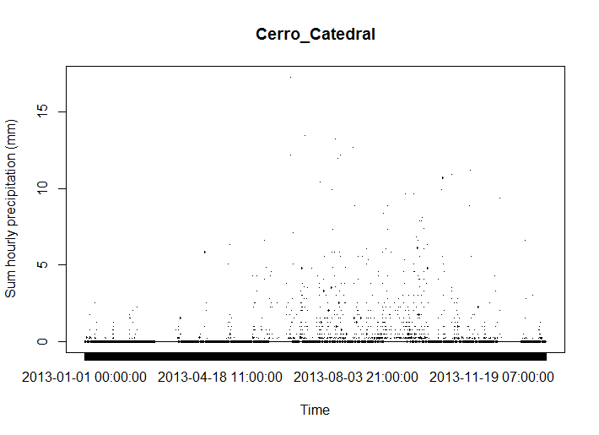

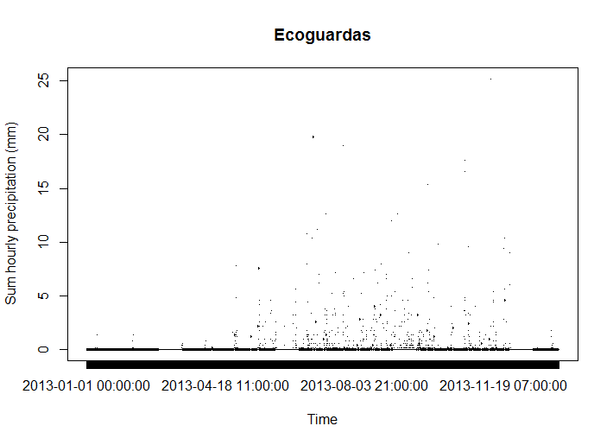

Figure 2. Observed cumulative hourly rainfall (mm) for the baseline simulation year (2013) for three meteorological stations obtained after replacing missing values using a linear interpolation.