Table of Contents

ADW Specification — Philosophy, Architecture, Contracts
English | Deutsch
Audience: contributors to the ADW orchestrator — people who change adw/, review changes to it, or need to know why it is built the way it is. As of: version 0.26.1 (2026-10-11). Companion documents: ADW Workflow (the seven phases in depth, for users and contributors) · ADW Handbook (operating ADW as a developer).

How this document relates to the others
Document | Role | Status
docs/SPEC.md | The original target specification with the Definition of Done (§8) that the acceptance tests (tests/test_e2e_dry_run.py) map. It defines what ADW must do. | Normative. Changes to target behaviour land there first.
docs/PLAN.md | The implementation plan of the 0.1.0 core (Tasks 0–13). | Historical — the plan was executed; it is not maintained as the code evolves.
docs/GUI-SPEC.md | Normative specification of the event log, snapshots, retention and the Run Inspector GUI. | Normative for everything under adw/gui/, events.py, snapshots.py, retention.py.
This document | The as-built specification: the philosophy behind the design, the architecture as it stands at 0.26.1, the data contracts, invariants and extension points. | Descriptive, verified against the code. Where it and SPEC.md disagree, the code is the fact and SPEC.md is the intent — file the gap.
CHANGELOG.md | What changed, per release. | Maintained with every push.
docs/FOLLOWUPS.md | Register of open follow-up findings from ADW runs. | Maintained by hand.
docs/briefs/ | Issue briefs that ran through ADW without escalation — a template for writing new ones. | Reference.

Part I — Philosophy
ADW exists because agentic coding fails in two predictable ways: the agent decides the control flow (and loops, skips checks, or declares victory), and the agent grades its own work. Every principle below closes one of those doors. Each one is stated as a rule, followed by the reason and the place in the code that enforces it — a principle that no code enforces is only a wish.
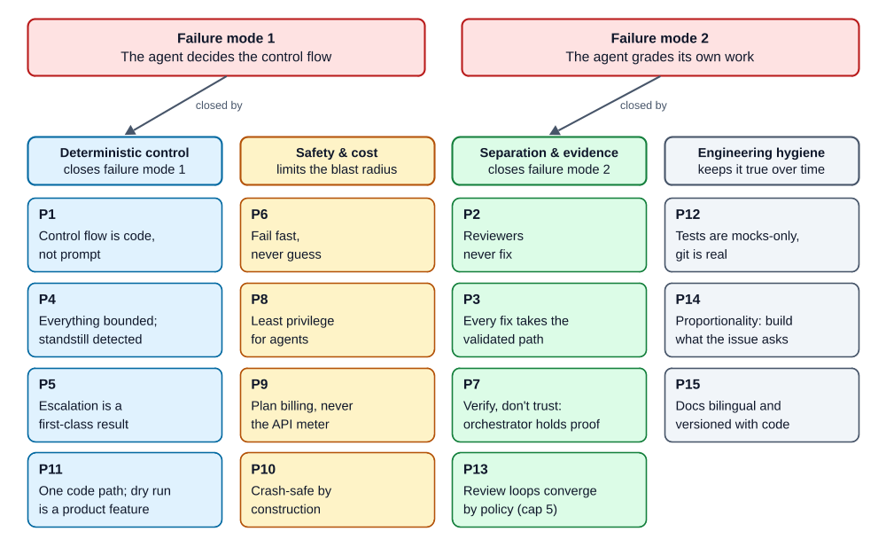
The fifteen principles, grouped by the failure mode they close (HTML: hover a tile for rule and reason)

P1 — Control flow is code, not prompt
Rule. Loops, gates, merges, dispatch, triage, limits, approval pauses and CI polling are deterministic Python. Agents are called only where judgment is needed: writing a spec or plan, writing code, assessing a review, assigning a failure to a lane.
Why. Repeatable work in a prompt costs tokens, behaves differently every time and cannot be tested. The same work in Python costs nothing, behaves identically and is covered by tests. An agent that is told "repeat until the tests pass" can stop early, loop forever or redefine "pass"; a while loop with a counter cannot.
Enforced by. adw/phases.py owns every loop; agents receive a single task string and return text. No agent is ever told "now call the next phase".

P2 — Reviewers never fix
Rule. Every reviewer — Codex in phases 1, 2 and 5, the final reviewer in phase 6, the E2E triage agent, the CI log analyst — is read-only and answers only with Findings. Fixes are always done by the build agent of the affected lane.
Why. A reviewer that fixes "just the trivial thing" bypasses exactly the checks that should have caught its mistake, and it marks its own homework. Keeping the roles apart also keeps the reviewer honest: it has no stake in the code being fine.
Enforced by. The agent registry (adw/agents.py) gives every reviewer READ_ONLY_TOOLS (Read/Grep/Glob) and no write rule; Codex runs with --sandbox read-only.

P3 — Every fix takes the validated path
Rule. A fix from any source (gate failure, E2E, Codex review, final review, CI) goes through the build agent, then through all gates of the lane — and in parallel mode again through merge + E2E. There is no shortcut for small fixes.
Why. "Small" is the agent's opinion, not a measurement. The cost of re-running the gates is seconds to minutes; the cost of an unchecked fix reaching the push is a red pipeline or worse.
Enforced by. _dispatch_lane_fixes is the single fix-routing function; it always ends in _run_lane (the gate loop). The review phases obtain their worktree through _integration_loop, so a review fix re-enters merge + E2E.
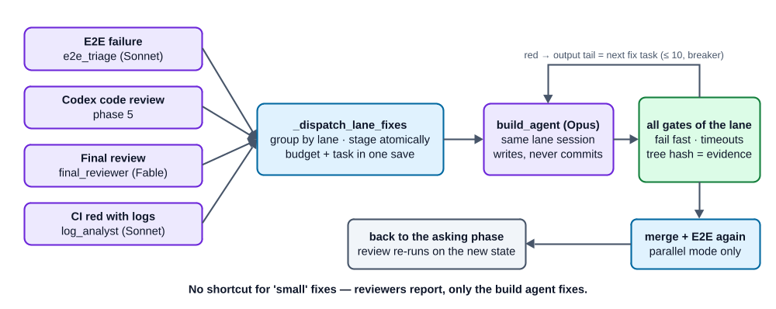
P3 — every source of findings ends in the same validated path

P4 — Everything is bounded, and standstill is detected
Rule. Every loop has a hard, persisted limit. In addition a circuit breaker stops a loop as soon as a round produces exactly the same failure set as the round before.
Why. An unbounded agent loop is the most expensive failure mode there is. Limits that live only in memory are reset by a crash, so they must be persisted with the work they guard. The circuit breaker catches the cheaper-to-detect case — "nothing changed" — long before the limit is spent.
Enforced by. adw/triage.py (check_gate_iterations, check_fix_cycles, check_progress) and the round counters in RunState/LaneState. Limit checks run before the expensive work, never after.

P5 — Escalation is a first-class result
Rule. An exhausted limit, a merge conflict, an unparseable reviewer answer or a broken invariant ends the run in a controlled way: escalation.md + phase=escalated + exit 1. Escalated runs are final.
Why. An orchestrator that "somehow keeps going" produces expensive garbage. A human gets the state reached and the concrete reason and decides.
Enforced by. escalate() in phases.py; adw resume refuses escalated runs.

P6 — Fail fast, never guess
Rule. A missing or invalid config aborts before anything starts; there are no guessed defaults for project knowledge (gates, branches, lanes). Parsers accept exactly one well-defined shape and reject everything else.
Why. Silent defaults produce silent misbehaviour, and a tolerant parser accepts a stale or fabricated ok when in doubt. A parse error is safe (escalation); a false ok ships broken code.
Enforced by. AdwConfig.load (strict YAML loader rejecting duplicate keys, pydantic with extra="forbid"); extract_review_result (whole-object JSON or the last ```json fence, nothing else).

P7 — Verify, don't trust: the orchestrator holds the evidence
Rule. Every claim an agent could make about its own work is instead proven by the orchestrator and persisted in orchestrator-owned state: gates green (gates_passed + gates_tree hash), RED proven (red_confirmed + red_test_paths), HEAD unchanged (expected_head), branch unchanged. Only the orchestrator commits.
Why. An agent-written commit message, flag or report is agent-falsifiable. A tree hash computed by the orchestrator binds "the gates were green" to exactly the content that was checked. The same reasoning rejects per-task self-reporting in the trace (docs/SPEC.md §6).
Enforced by. _worktree_tree_hash, _require_no_agent_commit, _require_lane_branch, _require_expected_head, _commit_lane in phases.py.

P8 — Least privilege for agents
Rule. Each agent gets the smallest tool set and the narrowest path rules that let it do its job. Secret stores are deny-listed for everyone, run state is unwritable for everyone, neighbouring lanes are unreadable, Bash is sandboxed. Subprocesses inherit only a whitelisted environment.
Why. Agents read untrusted content (issue text, repository files, CI logs). Whatever an injected instruction could make them do, the tool boundary limits the damage.
Enforced by. AgentSpec.tools (restricts what is offered) + allowed_tools (artifact-exact path rules), SECRET_STORE_DENY_RULES, sandbox_bash, deny_read_paths per lane, safe_env(); protected artifacts are restored byte-exactly after every agent run.

P9 — Plan billing, never the API meter
Rule. ADW talks to Claude only through the Claude Code CLI (spawned headless by the Agent SDK) with the stored login. API-key environment variables are actively blanked. An agent call that fails — typically an exhausted plan window — leaves the run at its checkpoint without escalating; adw resume continues after the reset.
Why. Cost control by construction instead of by discipline: an accidental token-by-token API drain is technically impossible. The price is an availability risk, which the crash-resume design covers anyway.
Enforced by. _require_stored_login() and the env overrides in adw/agents.py; the AgentRunError branch in cli._execute.

P10 — Crash-safe by construction
Rule. Every transition and every open piece of feedback is checkpointed atomically. Budget increments are persisted in the same save as the work that justifies them. State that is cheap to rebuild (the integration branch, review worktrees) is thrown away and rebuilt instead of interpreted.
Why. Real runs take hours, hit plan limits and get killed. Interpreting a half-merged or half-written state correctly is error-prone; rebuilding it deterministically is cheap and provably correct.
Enforced by. RunState.save/update (tmp + os.replace, flock), the mutate_staged hook in _dispatch_lane_fixes, _fresh_integration_worktree, _resume_pending_lanes.

P11 — One code path; the dry run is a product feature
Rule. Single-lane mode is parallel mode with one lane — there is one code path and one CLI. --dry-run injects mocks into the production code path, including canonical failure fixtures (a gate that only turns green on the second attempt, an E2E failure resolved by a triaged lane fix).
Why. Two code paths drift apart. A dry run that exercises the real control flow lets a user accept a config and the whole flow at 0 tokens, and gives the acceptance tests something real to test.
Enforced by. RunContext as the dependency-injection root (all contact with the outside world goes through it); cli._dry_run_runners/_dry_run_glab/_dry_run_gh.

P12 — Tests are mocks-only, git is real
Rule. No test needs the network or tokens. Agents, Codex, glab and gh are mocked at their interfaces; git is real (throwaway repos in tmp_path). Development is test-first: a red test before every behaviour change, and a regression test for every bugfix.
Why. The orchestrator's hardest guarantees are about git state, crash windows and worktrees — mocking git would test the mock. The external services are where the cost and the flakiness are.
Enforced by. adw/mock.py (MockAgentRunner, MockCodexRunner); the injectable run_glab/run_gh/sleep seams; a JS harness that drives the served app.js in plain node for the GUI.

P13 — Review loops converge by policy: descending severity, findings memory, cap 5
Rule. Every Codex review loop — authoring (spec/plan) and code review — follows the same policy:
Round | Findings acted on | Others
1 | P1, P2, P3 | —
2 | P1, P2 | P3 → known limitations / follow-ups
≥ 3 | P1 only | P2, P3 → known limitations / follow-ups
cap 5 | open P1 → escalation | everything else accepted and documented
From round 2 on, Codex receives the previous rounds' findings with their disposition (fixed / rejected + reason / below threshold) so settled points are not re-reported.
Why. Without this policy the loop does not converge on orchestration code: a deterministic reviewer finds an unbounded supply of edge cases at the lowest severity, and without memory it oscillates between "too strict" and "too lenient". The same policy is the contributor's own per-commit review rule — ADW and its developers deliberately run the same loop.
Enforced by. _actionable_severities, _split_by_severity, _severity_context, AUTHORING_MAX_ROUNDS = 5, MAX_REVIEW_ROUNDS = 5 in phases.py; dispositions persisted in authoring_prior_context / review_prior_context.

P14 — Proportionality: build what the issue asks for
Rule. The spec and plan authors are bound by a proportionality rule: every acceptance criterion must trace back to the issue; process requirements (commit messages, branch topology, git history) do not belong in a spec. Scope gaps found at the end become follow-ups, not new work.
Why. Two strong authors plus a strict reviewer naturally inflate scope. The counterweight has to be written into the prompts of both authors and the synthesis, or the synthesis undoes it.
Enforced by. _SPEC_CONTENT_RULES / _PLAN_CONTENT_RULES — one shared constant each, used by the Claude author, the synthesis agent and the Codex author prompts; scope_gap triage into followups.md.

P15 — Documentation is bilingual and versioned with the code
Rule. All docs exist in English (default, no suffix) and German (.de. before the extension), kept in sync, with a language switcher under the H1. Every push to main is a release with a version bump, a changelog entry in both languages and a tag (see §18).
Why. The users and contributors work in both languages; a doc that exists in only one silently goes stale in the other. Releases per push keep "which version introduced this?" answerable.

Part II — Technical specification (as built, 0.26.1)

1. Architecture and module map
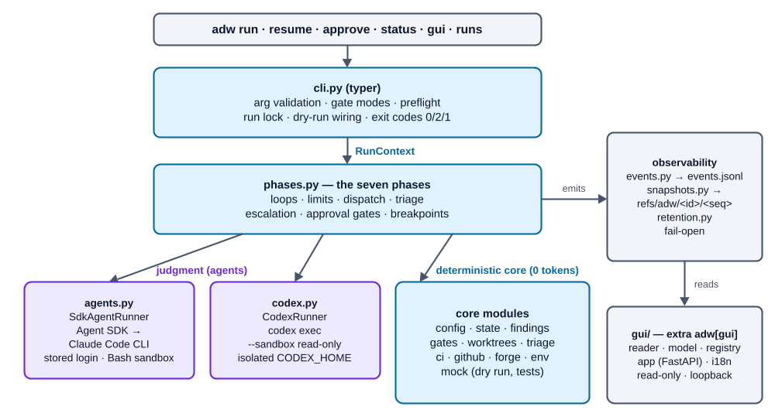
Architecture of the adw package: entry point, phase engine, judgment, deterministic core, fail-open observability and the read-only GUI
Module | Lines | Responsibility
adw/cli.py | 1235 | typer entry point: run, resume, approve, status, gui, runs list, runs prune. Gate-mode resolution (--gates vs. legacy flags), issue intake (text, glab, gh), forge preflight, working-tree preflight with self-heal, per-run execution lock, run span, dry-run wiring, auto-prune.
adw/phases.py | 2674 | The seven phases over a RunContext: draft stage, synthesis, authoring loop, approval and breakpoint gates, lane gate loop incl. RED stage, integration + E2E, Codex review, final review + triage, push + CI. All limits, dispatch and escalation.
adw/agents.py | 595 | Agent registry (REGISTRY, AgentSpec), shared content rules, deny rules, SdkAgentRunner (stored-login enforcement, env sanitizing, sandbox, stream mirroring into the event log), RunTotals.
adw/codex.py | 473 | CodexRunner: review() and author() via codex exec -m gpt-6-astra --sandbox read-only, isolated CODEX_HOME, marker-block protocol with per-call nonce, process-group kill, token back-sync.
adw/findings.py | 223 | Finding, ReviewResult, SCHEMA_INSTRUCTION (one shared constant), strict parser extract_review_result.
adw/config.py | 154 | .adw/config.yaml schema and loader (AdwConfig, Gate, LaneConfig, E2eConfig, CiConfig, CodexConfig, TraceConfig, BreakpointName).
adw/state.py | 289 | RunState, LaneState, Phase; atomic persistence, transactions, monotonic sequence, find_latest.
adw/gates.py | 187 | Gate runner: subprocess per gate with real timeout, process-group kill, bounded output tail (200 lines × max. 4 KiB), gate spans.
adw/worktrees.py | 219 | Lane worktrees (idempotent, ready marker, recovery from partial adds, serialized mutations), lane branches adw/<run_id>/<lane>, deterministic ports with bind check, self-ignoring .adw/runs/.gitignore.
adw/triage.py | 95 | Pure functions: final-review triage (scope_gap → follow-up, rest → lane fixes), limit checks, circuit breaker.
adw/ci.py | 207 | GitLab: SHA-bound pipeline polling via glab api, failed-job log retrieval.
adw/github.py | 172 | GitHub Actions: SHA-bound workflow-run polling via gh api, --log-failed excerpts. Same CiResult and error classes as ci.py.
adw/forge.py | 82 | GitLab vs. GitHub: ci.provider override, otherwise hostname of the origin URL; unknown host → ForgeError: the CLI forge preflight refuses the command; phase 7 escalates only if origin/config changed mid-run (dry run: falls back to GitLab).
adw/env.py | 39 | safe_env(): environment whitelist for every subprocess.
adw/events.py | 371 | EventEmitter/NoOpEmitter: append-only JSON Lines event log with spans, per-run seq, flock, file mode 0600, fail-open.
adw/snapshots.py | 133 | Per-step worktree snapshots as git refs refs/adw/<run_id>/<seq> (temporary index, commit-tree, update-ref), fail-open.
adw/retention.py | 477 | Run enumeration, canonical dating, pruning (worktrees → refs → directory), --gzip compression of event logs.
adw/models.py | 165 | Model freshness check: newest model per role (Claude aliases, codex catalog), 24 h cache, refusal message.
adw/mock.py | 209 | MockAgentRunner, MockCodexRunner: scriptable response queues, simulated file writes, call recording.
adw/gui/reader.py | 131 | Incremental, fault-tolerant event-log reader (also .jsonl.gz), reports seq_gap/bad_line.
adw/gui/model.py | 224 | Span tree from event records; orphans from worker threads re-homed by time containment.
adw/gui/registry.py | 203 | ~/.adw/repos.json: canonical repo path → stable slug; adw run registers automatically (fail-open).
adw/gui/app.py | 3073 | Read-only FastAPI app: run list, run detail (Trace/Timeline/Artifacts/Raw), JSON API, SSE live tail, diff endpoint with ref allowlist.
adw/gui/i18n.py | 353 | Dictionary-based EN/DE chrome translation; content is never translated.
adw/gui/templates/, static/ | — | Jinja2 templates, app.css (token system, dark mode), app.js (no framework).
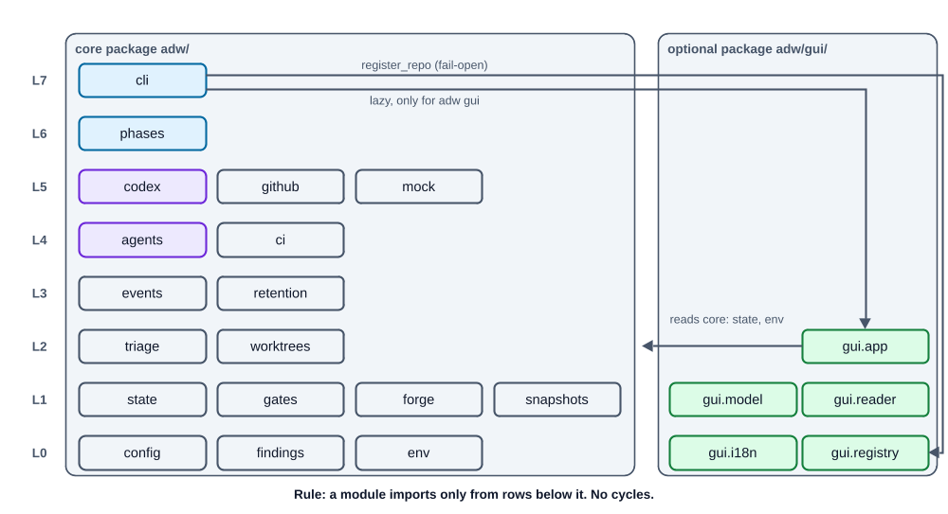
Import layers of adw/ — every import points to a lower row (HTML: hover a module for its exact imports)

1.1 RunContext — the dependency-injection root
RunContext (dataclass in phases.py) carries everything a phase needs: repo, config, state, the two runner interfaces (agents: AgentRunner, codex: CodexClient), the seams run_glab, run_gh, sleep, the run's single emitter, the pinned flags skip_approval, spec_approval, dry_run, a git_env, and a threading.RLock (state_lock) that serializes state mutations across parallel lane threads. ctx.save() persists the state and mirrors a state.saved event after the write succeeded.
Because every contact with the outside world goes through this object, the same production code runs against mocks in --dry-run and in the test suite.

1.2 The two judgment interfaces
class AgentRunner(Protocol):
def run(self, agent: AgentSpec, task: str, cwd: Path, resume: str | None = None,
deny_read_paths: list[str] | None = None, emitter=None, span=None,
on_session_id=None) -> AgentResult: ... # AgentResult(text, session_id)
class CodexClient(Protocol):
def review(self, kind, content_refs, cwd, context=None, emitter=None, span=None) -> ReviewResult: ...
def author(self, kind, task, cwd, marker_id=None, emitter=None, span=None) -> dict[str, str]: ...
# file name → content; kind: spec | plan
on_session_id lets the runner report the SDK session id the moment it appears in the stream, so a crash mid-run still leaves a resumable session in the state.

2. State machine
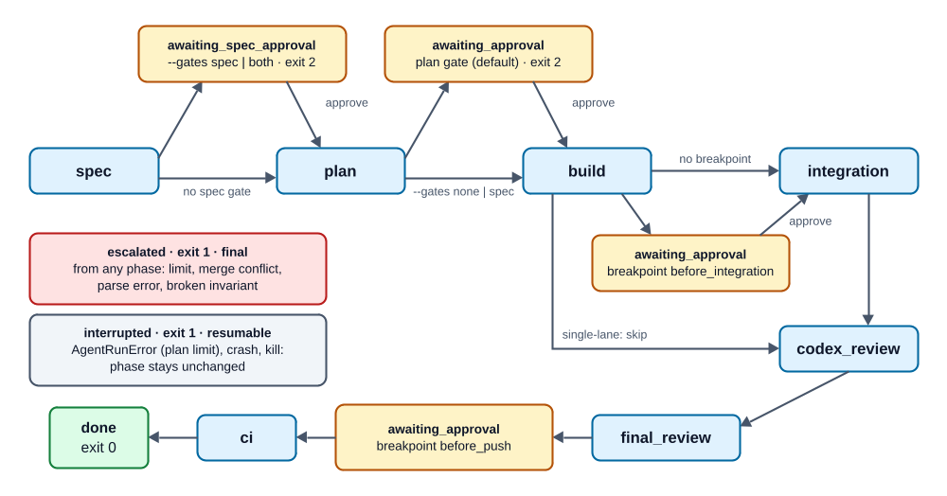
Run state machine with approval holds, breakpoints and exit codes
- Phase is a closed Literal in state.py: spec, awaiting_spec_approval, plan, awaiting_approval, build, integration, codex_review, final_review, ci, done, escalated.
- Breakpoints (before_integration, before_push) reuse awaiting_approval; which one waits is recorded in pending_breakpoint — not a new phase value. They pause only when enabled in the config and approval is not skipped (--gates none skips them too).
- cli._execute always calls the complete phase chain; each phase function checks ctx.state.phase itself and returns immediately when it is not its turn. A resume therefore starts in the right phase without a dispatcher.
- Exit codes: 0 done · 2 awaiting approval (gate or breakpoint) · 1 escalation, refusal, or interrupted agent call (the message distinguishes them).

3. Phase control flow (summary)
The phases are explained step by step in ADW Workflow. The contracts a contributor must preserve:
Phase | Function | Contract
1–2 Spec, Plan | run_spec_and_plan → _draft_stage, _reviewed_authoring_loop | Claude author (Opus) and Codex author write drafts in parallel to .adw/runs/<id>/drafts/; idempotent over the files; a Codex failure degrades (marker <kind>.codex.FAILED), a missing Claude draft escalates. The synthesis agent (Fable) is round 1 of the authoring loop and also writes the gate summary. Loop: Codex review → findings to the same session → P13 policy, cap 5. Protected files restored after every run; artifacts archived to the run dir, the checkout reset.
Gates | cli._execute / cli.approve | Spec gate (optional), plan gate (default), persisted in state; awaited / granted approval events.
3 Build | run_build_phase → _run_lane | Per lane: worktree, seed artifacts + orchestrator commit, optional RED stage (_confirm_red), gate loop (limit → checkpoint → agent → invariants → restore → gates), evidence with tree hash, orchestrator commit. Lanes run in a thread pool under --parallel.
Breakpoint | _breakpoint_gate("before_integration") | Hold after all lanes are green.
4 Integration | run_integration_phase → _integration_loop | Integration branch rebuilt fresh every round from the base branch; merge conflict → abort + escalation; E2E gate with both lanes' ports; red → triage agent → lane fixes → re-integrate. Parallel mode only.
5 Codex review | run_codex_review_phase | _resume_pending_lanes first (no ungated state reaches a review); limit check before dispatch; circuit breaker on the actionable finding set; P13 policy; dropped findings → followups.md.
6 Final review | run_final_review_phase | Fable, read-only, mandatory category; triage_final_review routes scope_gap → follow-ups, others → fix cycles (max. 3 per lane); cycle increment persisted with the staged fix.
Breakpoint | _breakpoint_gate("before_push") | Hold before any push/CI work.
7 CI | run_ci_phase | git push --force-with-lease -u origin <branch> (integration branch in parallel mode, lane branch otherwise; skipped in dry run); SHA-bound polling; red with logs → log analyst → exactly one re-entry; red without logs → escalation.

4. Data model

4.1 Target-repo config — .adw/config.yaml
Loaded by AdwConfig.load(repo). Strict: duplicate YAML keys, unknown keys (extra="forbid"), blank strings, non-positive timeouts and non-boolean tdd values are a ConfigError before anything runs.
Key | Type / default | Meaning
base_branch | str, required | Branch lanes fork from; diffs run against it.
lanes | `{backend | frontend: {gates: [...]}}`, ≥ 1 lane
lanes.<l>.gates[] | name, cmd, timeout (s), tdd (bool, false) | Run in order, fail fast. tdd: true marks a gate for the RED proof.
e2e | cmd, timeout | E2E command, used in parallel mode.
ci | poll_interval 60, timeout 2700, staging_job null, provider null | Polling; provider overrides origin-URL detection.
codex | timeout 900 | Limit of every codex exec subprocess (author and review).
trace | enabled true, keep_runs 20 | Event log on/off; auto-prune after a successful run (0 = never).
breakpoints | list of before_integration/before_push, empty | Additional human holds. Pinned at run start.

4.2 RunState and LaneState
Persisted as .adw/runs/<run_id>/state.json. run_id is 8 hex characters.
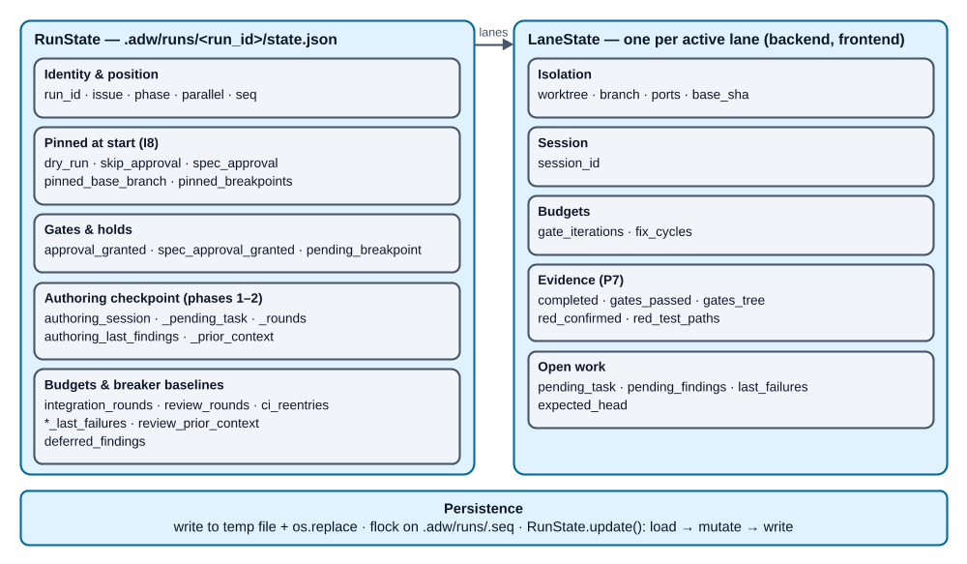
RunState and LaneState field groups and the atomic write path
Field | Level | Purpose
run_id, issue, phase, parallel | run | Identity and position.
dry_run, skip_approval, spec_approval | run | CLI decisions the resume invocation no longer knows.
approval_granted, spec_approval_granted | run | Gate grants.
pending_breakpoint, pinned_breakpoints | run | Which breakpoint waits; the breakpoint set pinned at start (None = legacy state, follows config).
pinned_base_branch | run | Effective base branch pinned at start; cannot change once lanes exist.
authoring_session, authoring_pending_task, authoring_last_findings, authoring_rounds, authoring_prior_context | run | Checkpoint of the spec/plan authoring loop.
integration_rounds, integration_last_failures | run | E2E budget and circuit-breaker baseline.
review_rounds, review_last_failures, review_prior_context | run | Codex code-review budget, baseline, findings memory.
final_review_last_failures | run | Circuit-breaker baseline of phase 6.
deferred_findings | run | Finding keys a fix run proved unactionable (pure P3); never trigger another fix or the breaker.
ci_reentries | run | CI re-entry budget.
seq | run | Monotonic save sequence used by find_latest.
lanes.<l>.worktree, branch, ports, base_sha | lane | Isolation; base_sha is the pinned fork point.
session_id | lane | SDK session for session resume.
gate_iterations, fix_cycles | lane | Budgets.
completed, gates_passed, gates_tree | lane | Evidence; gates_tree binds green gates to a tree hash.
red_confirmed, red_test_paths | lane | RED proof and the tests that delivered it.
pending_task, last_failures, pending_findings | lane | Open fix task, breaker baseline, findings of the staged fix.
expected_head | lane | HEAD at the last checkpoint — detects foreign commits across a crash window.
Persistence mechanics. Snapshot to a temp file + os.replace (no half-written state ever exists); exclusive flock on .adw/runs/.seq around every write; parallel lane threads mutate the shared in-memory state under RunContext.state_lock and persist with ctx.save(); a corrupt .seq is reconstructed from the persisted states.

4.3 Findings — the one reviewer contract
Every reviewer (Codex, final reviewer, E2E triage, log analyst) answers in the same schema, embedded via the shared constant SCHEMA_INSTRUCTION:
{
"verdict": "ok | needs_fixes",
"findings": [{
"severity": "P1 | P2 | P3",
"lane": "frontend | backend | unknown",
"file": "path/relative/to/repo",
"issue": "description",
"remediation_plan": ["step 1", "step 2"],
"category": "scope_gap | implementation | trivial"
}]
}
- extra="forbid"; ok only with an empty list, needs_fixes with ≥ 1 finding.
- category is mandatory for the final reviewer (missing → escalation, no silent default), optional elsewhere.
- The parser accepts only a whole-JSON answer or the content of the last ```json fence. Duplicate keys, nesting > 100 and integers > 100 digits fail closed in linear time. Schema violations (ValidationError) escalate like parse errors.
- A finding's identity for the circuit breaker, deferral and dispositions is the key "<file>|<issue>".
- A lane value that is unknown or not active in this run is dispatched to all active lanes — better checked twice than lost.

4.4 Run artifacts and directory layout
<target-repo>/
.adw/
config.yaml project config (protected, restored after agent runs)
issue.md spec.md plan.md contract.yaml spec-summary.md plan-summary.md
authoring artifacts in the checkout during phases 1–2;
reset afterwards; the only files the preflight self-heals
runs/
.gitignore "*" — run data never shows in git status
.seq save-sequence lock/counter
.lock-<run_id> per-run execution lock (resume/approve)
<run_id>/
state.json RunState
events.jsonl[.gz] event log (mode 0600)
drafts/ <artifact>.claude.<ext>, <artifact>.codex.<ext>, *.codex.FAILED
spec.md plan.md contract.yaml spec-summary.md plan-summary.md archived artifacts
authoring-<kind>-known-findings.md findings accepted at threshold/cap
followups.md scope gaps, below-threshold and deferred findings
escalation.md only when escalated
trees/<lane>/ lane worktrees (+ trees/integration in parallel mode)
refs/adw/<run_id>/<seq> snapshot refs (in the git object store)
branches adw/<run_id>/<lane> lane and integration branches
contract.yaml is the interface contract between lanes (OpenAPI/types/events). Its top-level x-adw-* blocks (e.g. a declared scope) are shown by the GUI next to the actual change scope — without any automatic verdict.

4.5 Event log
.adw/runs/<run_id>/events.jsonl, one JSON object per line:
{"seq": 17, "ts": "2026-09-13T10:02:03.123Z", "type": "gate", "kind": "start|end|point",
"span": "<id>", "parent": "<id|null>", "phase": "build", "lane": "backend",
"round": null, "payload": {...}}
- Span types: run, phase, lane, round, agent.run, gate, codex.review, codex.author, ci.wait.
- Point types: agent.message, agent.tool.call, agent.tool.result, snapshot, red.check, commit, merge, ci.poll, ci.reentry, triage.decision, limit.hit, circuit_breaker, escalation, approval, artifact, followup, state.saved, log.
- Payloads are specified in GUI-SPEC.md §4.4. agent.run start carries the full prompt; the log therefore contains unredacted agent input and output and is created with mode 0600.
- Fail-open is the defining invariant: no emitter error (disk full, permissions, unserializable payload) ever reaches the caller. On the first internal error the emitter warns once and disables itself for that run. state.json — not the event log — is the resume authority, so fsync is deliberately not issued.
- seq is assigned under flock across processes; a crash-truncated tail line is healed by starting the next record on a fresh line.
- Spans opened in worker threads (parallel lanes, the draft pool) carry parent: null; the GUI model re-homes them by time containment.

4.6 Snapshots
At every step boundary of a lane (before_agent, after_agent, after_gates, red) snapshots.capture() builds a tree over a temporary index, creates a commit object with commit-tree -p <base_sha> and pins it as refs/adw/<run_id>/<seq>, then emits a snapshot event. The GUI computes step diffs lazily from these refs; no diff is ever written into the log. Fail-open like the emitter.

5. Agent registry
Each agent is a frozen AgentSpec(name, model, tools, allowed_tools, system_append, permission_mode="default", sandbox_bash=False). tools restricts what the agent is offered at all; allowed_tools approves (path-scoped). Both are needed.
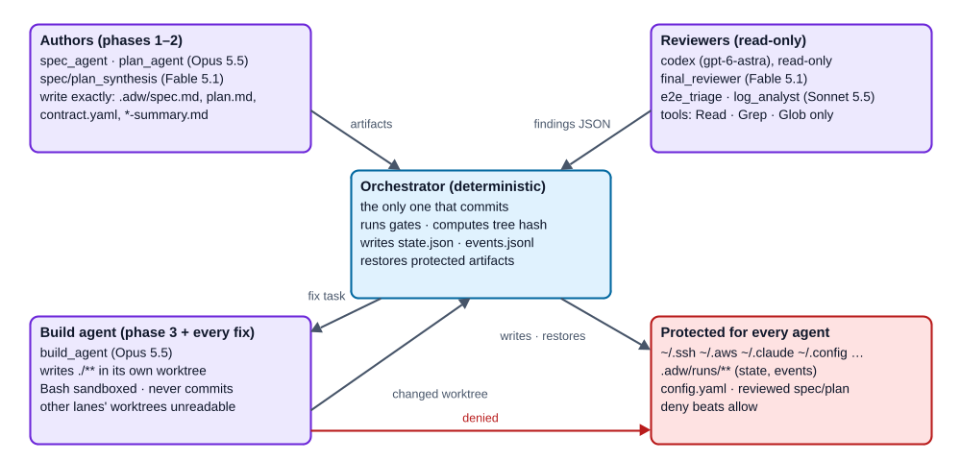
Write boundaries: who may write what, and who commits
Agent | Model | Tools | Write rules | Mission
spec_agent | Opus 5.5 | Read/Grep/Glob/Write/Edit | .adw/spec.md | Spec draft (goal, scope, non-goals, acceptance criteria, DoD)
plan_agent | Opus 5.5 | same | .adw/plan.md, .adw/contract.yaml | Plan draft with ## Workstream: sections + contract
spec_synthesis | Fable 5.1 | same | .adw/spec.md, .adw/spec-summary.md | Best-of merge of both drafts + gate summary
plan_synthesis | Fable 5.1 | same | .adw/plan.md, .adw/contract.yaml, .adw/plan-summary.md | Best-of merge + gate summary
build_agent | Opus 5.5 | + Bash (sandboxed) | ./** (worktree-relative) | Implements its workstream against the contract, TDD; does not commit; may deviate from fix plans with justification
e2e_triage | Sonnet 5.5 | Read/Grep/Glob | — | Assigns E2E failures to lanes; findings JSON only
log_analyst | Sonnet 5.5 | Read/Grep/Glob | — | CI logs → findings with lane; findings JSON only
final_reviewer | Fable 5.1 | Read/Grep/Glob | — | Implementation vs. spec; findings with mandatory category
Model ids are constants in agents.py: FABLE = "claude-fable-5-1", OPUS = "claude-opus-5-5", SONNET = "claude-sonnet-5-5". Codex is pinned in codex.py: CODEX_MODEL = "gpt-6-astra" (passed as -m; the isolated CODEX_HOME has no config.toml, so without it codex would use its built-in default).
Model economics. Opus does the volume work (drafts, build — many turns, the cheaper per-token tier). Fable, the most capable model, is reserved for judgment: merging the drafts and the final review. Sonnet does assembly-line triage.
Shared prompt constants. _SPEC_CONTENT_RULES, _PLAN_CONTENT_RULES, _BEST_OF_MERGE_RULES, _SUMMARY_FORMAT_RULES exist once and are reused by every agent that needs them, including the Codex author prompts — if they drifted, the synthesis would undo the author's proportionality counterweight.
Rules every agent gets.
- Read rules are scoped to the cwd (Read(./**), …).
- Write rules are artifact-exact (Write(.adw/spec.md), never .adw/**, which would make state.json writable).
- SECRET_STORE_DENY_RULES: ~/.ssh, ~/.aws, ~/.claude, ~/.gnupg, ~/.config, ~/.docker, ~/.kube, ~/.azure, ~/.codex, credential files and shell start-up/history files are unreadable; .adw/runs/** is unwritable. Deny beats allow. Each store is listed both as a glob and as a plain directory because the Linux sandbox ignores glob-only denies.
- Under --parallel, each lane gets the other lanes' worktrees as deny_read_paths.
SdkAgentRunner. Builds ClaudeAgentOptions with the claude_code system prompt preset + system_append, cwd, resume, setting_sources=[] and strict_mcp_config=True (no repo-controlled hooks, settings or MCP servers), and — for sandbox_bash agents — a sandbox with allowUnsandboxedCommands: False and no excluded commands (git stays sandboxed too). It mirrors assistant text and tool calls/results into the event log and accumulates cost/tokens in RunTotals.

6. Gate runner
run_gates(gates, cwd, extra_env, emitter) → GateReport:
- Gates run in config order, fail fast at the first failure.
- Each gate is a subprocess with safe_env(extra_env) (lane ports are passed as extra env), the config timeout, start_new_session=True and a process-group kill on every exit path — no orphaned children.
- Output is collected by pump threads into a RAM-bounded tail: at most 200 lines of at most 4 KiB each. That tail is what the build agent sees as the fix task (the RED stage shortens it further to 40 lines).
- Each started gate is one gate span (passed, exit_code, timed_out, output).

7. Codex integration
CodexRunner runs codex exec -m gpt-6-astra --sandbox read-only -c mcp_servers={} … as a subprocess with:
- an isolated CODEX_HOME — a temp dir containing only a copy of auth.json from the real home, so user-configured MCP servers and settings stay out. A token rotated during the call is synced back via compare-and-swap under flock.
- the configured timeout (codex.timeout, default 900 s) and a process-group kill.
- bounded stdout (5 MiB tail) / stderr (256 KiB tail) buffers.
- a private per-call workdir as process cwd and a closed stdin: --ephemeral (no session files), --json (events; the turn.completed token usage goes into the span's usage and the run totals), -o last-message.txt (the final answer is read from that file, not from the stdout transcript) and, for reviews, --output-schema review-schema.json (findings.REVIEW_OUTPUT_SCHEMA: the answer is constrained to the findings contract; extract_review_result still validates it). The file names are relative to the workdir, so the argv in the span start event is byte-identical to the executed one and nothing is written into the target repo.
- the fresh models_cache.json codex fetches into the isolated home is kept as ~/.adw/codex-models-cache.json; the model check reads whichever catalog is newer.
review(kind, content_refs, cwd, context) — kind is spec, plan or code; the prompt embeds SCHEMA_INSTRUCTION; the answer is parsed with extract_review_result. From round 2 on, context carries the severity floor and the previous rounds' dispositions.
author(kind, task, cwd) — the read-only sandbox cannot write, so Codex must return file contents in marker blocks ===BEGIN <name> <nonce>=== … ===END <name> <nonce>=== with a fresh nonce per call. Parsing starts from the last begin marker of the first name; a mere prompt echo yields empty blocks and raises CodexAuthorError. The orchestrator writes the returned content to the drafts directory.

8. CI and forge abstraction
- forge.detect_forge(repo, override) → "gitlab" | "github": the ci.provider key wins; otherwise the hostname of the origin URL; unknown host → ForgeError. cli._preflight_forge calls it for real run/resume/approve and refuses (exit 1, no state change) before any agent runs; phase 7 calls it again as a safety net and escalates (no poll against the wrong API). The dry run falls back to GitLab.
- GitLab (ci.py): glab api projects/:id/pipelines?ref=…&sha=… — the pipeline is queried server-side by the pushed SHA, so neither an older terminal pipeline nor a foreign newer one can be mistaken for the one being waited on. Terminal statuses: success, failed, canceled, skipped. Optional staging_job must be green too. Failed-job logs are fetched as a 200-line excerpt.
- GitHub (github.py): all workflow runs of the push SHA (actions/runs?head_sha=…) until all are completed; green conclusions are success, skipped, neutral; red runs deliver gh run view --log-failed excerpts.
- Both return the same CiResult and raise the same CiError/CiTimeoutError. The time budget is tracked as remaining time; the sleep is capped to it. run_glab / run_gh / sleep are injectable seams with 120 s subprocess timeouts.
- To add a forge: implement a poll_ci(repo, branch, cfg, run_x, sha, emitter) returning CiResult, extend the Forge literal and detect_forge, add the provider value to CiConfig.provider, wire it in run_ci_phase, add a dry-run fake in cli.py, and an issue fetcher if the forge has issues.

9. Resume, approval and concurrency semantics
- adw resume <run_id> continues exactly at the persisted checkpoint. It refuses escalated runs. It reloads the state under the per-run execution lock, resolves the config through _config_for_continuation (pinned base branch and pinned breakpoints beat the current file; --base-branch can only change before lanes exist), runs the forge and working-tree preflights, then _execute.
- adw approve <run_id> is valid only in awaiting_approval / awaiting_spec_approval. Under the same lock it reloads and revalidates, so two concurrent approvals produce exactly one release and one downstream execution (a double push at before_push is impossible). A breakpoint release advances the phase and clears pending_breakpoint in one atomic save; the granted event is emitted log-checked by _catch_up_granted_breakpoints, which closes the crash window between save and log append without an extra state field.
- Working-tree preflight (run, resume, approve): a clean checkout proceeds; a dirty set consisting only of the six ADW authoring artifacts is healed from HEAD (git checkout HEAD -- <path>, or index entry dropped + file removed if absent from HEAD) and re-checked; any foreign change refuses the command, discarding nothing. The preflight never escalates.
- Forge preflight (run, resume, approve; real runs only): detect_forge must succeed, otherwise the command is refused with the ci.provider hint — no run created, no state change, never an escalation.
- Model check (run, resume, approve; real runs only; adw/models.py; runs after the working-tree preflight, so a refused checkout costs no probe tokens): agents.resolve_model_alias resolves opus/fable/sonnet with one minimal SDK call each (no tools, no settings); the codex CLI's models_cache.json gives the newest listed model of the pinned tier or an announced upgrade. Only a proven newer model refuses the command (with the constant to change): for Claude the same line with a higher version — older ids, date snapshots, [..] suffixes, other lines and unparsable ids never block. Each role is cached on its own in ~/.adw/model-check.json (ADW_MODEL_CHECK_PATH overrides), bound to the current pins: a success for 24 h, a failed probe for 1 h, so only expired roles are probed again. A failed probe (error result, <synthetic> model, 120 s timeout), a missing, malformed, undated or > 7 days old codex catalog or an unwritable cache warns and never blocks; unusable cache entries are misses. Known blind spot: aliases resolve through the SDK's bundled CLI, so a model released after the installed claude-agent-sdk stays invisible until the SDK is upgraded.
- Interrupted agent calls (AgentRunError) leave the phase unchanged and print a resume hint (P9).
- Session resume: fix tasks go to the same SDK session (resume=session_id); the session id is checkpointed as soon as it appears.
- Revalidation: before every review phase _resume_pending_lanes sends every lane through _run_lane — unfinished fixes catch up, finished lanes are revalidated against gates_tree; a lane whose tree no longer matches goes back into the loop.

10. Observability, retention and the registry
- Retention (adw runs list, adw runs prune [--keep N] [--older-than DAYS] [--gzip], and auto-prune with trace.keep_runs after a run reaches done): only done/escalated runs are candidates; a run with uncommitted changes in any worktree is skipped and named; deletion order is worktrees (via git's worktree management, lane branches survive) → snapshot refs → directory; --gzip compresses the event log atomically and keeps the run whole. Auto-prune is fail-open: it never changes the finished run's phase or exit code.
- Registry ~/.adw/repos.json (version 1): canonical repo path → stable URL-safe slug + last_seen. Written atomically; adw run registers automatically, fail-open.

11. GUI architecture (Run Inspector)
The GUI is specified normatively in docs/GUI-SPEC.md; this section only fixes the architectural boundaries a core contributor must not break.
- Optional extra. FastAPI, uvicorn, Jinja2, markdown-it-py live in the gui extra. The core adw run path never imports them; adw gui imports lazily and prints an install hint if they are missing.
- Strictly read-only. No write route, no external program, reads only below .adw/runs/<run_id>/, the registry and its packaged assets. Diffs only through an explicit ref allowlist.
- Loopback by default. A non-loopback --host requires --i-know, because the event log contains unredacted agent output.
- Layers. reader (incremental, tolerant) → model (span tree) → app (derived views: trace tree, timeline, run context, recovery card, plan skeleton, change scope, metrics). Everything shown is derived from the event log, the state and the artifacts — the GUI adds no event, no persistence and no sidecar file.
- Robustness guarantee. A malformed or non-mapping payload never yields a 5xx; every read goes through _as_mapping() / _mapping_payload().
- Routes. /, /runs/{repo}/{run_id}, and /api/runs, /api/runs/{repo}/{run_id}, …/events, …/diff, …/artifacts/{name}, …/stream (SSE). JSON API changes are additive only.
- Contract for core contributors: if you add an event type or payload field, update GUI-SPEC.md §4.4 and make sure unknown types still render as generic nodes. Never make the emitter or snapshotter able to fail a run.

12. Security model
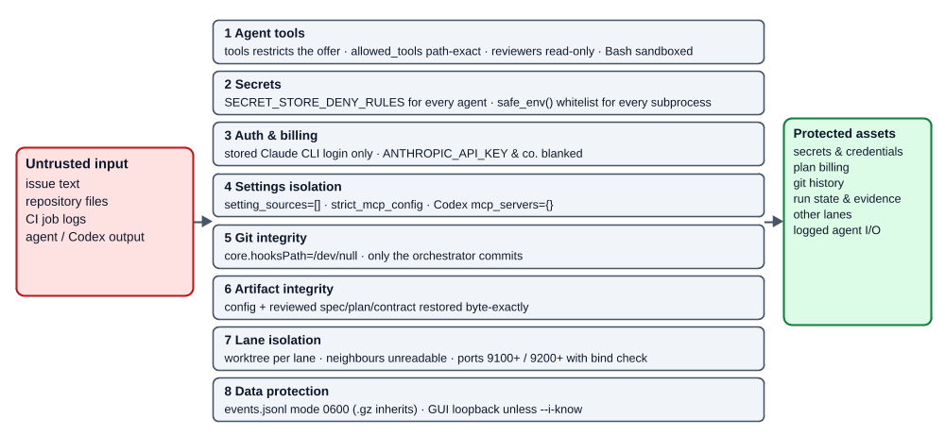
The eight security layers between untrusted input and the protected assets
Layer | Mechanism
Agent tools | tools restricts the offering; allowed_tools with artifact-exact path rules; reviewers strictly read-only; build Bash sandboxed, no unsandboxed escape hatch.
Secrets | SECRET_STORE_DENY_RULES for every agent; safe_env() whitelist (PATH, HOME, USER, SHELL, TERM, TMPDIR, LANG, LANGUAGE, TZ, VIRTUAL_ENV, PYTHONPATH, NODE_ENV, CI, CLAUDE_CONFIG_DIR, LC_*) for every subprocess. The SDK merges os.environ, so non-whitelisted variables are blanked with "" overrides. CODEX_HOME only reaches the Codex runner.
Auth & billing | Stored Claude CLI login only (_require_stored_login(), fail fast before tokens flow); ANTHROPIC_API_KEY & co. blanked. Codex with isolated CODEX_HOME.
Settings isolation | setting_sources=[], strict_mcp_config=True for agents; mcp_servers={} for Codex — the target repo cannot inject hooks, settings or MCP servers.
Git integrity | Orchestrator git runs with core.hooksPath=/dev/null and the env whitelist. Only the orchestrator commits; agent commits, branch switches and HEAD movement across a crash window are detected and escalate.
Artifact integrity | config.yaml, and from phase 2 on the reviewed spec (from phase 3 spec/plan/contract), are restored byte-exactly after every agent run; symlink/directory replacements are detected and replaced, never followed.
Lane isolation | One worktree per lane, neighbours unreadable, deterministic ports (backend 9100–9149, frontend 9200–9249, offset from the run id) with bind check.
Data protection | Event log mode 0600 and .gz inherits it; GUI loopback-only by default.

13. Invariants
Contributors must keep all of these true. Most have dedicated tests.
- I1 Only the orchestrator commits. Any commit by an agent escalates.
- I2 No state reaches a review, a merge or a push without green gates bound to its current tree hash.
- I3 Every loop checks its limit before doing the expensive work.
- I4 Every budget increment is persisted in the same save as the work it pays for.
- I5 Circuit-breaker baselines advance only after the fix dispatch.
- I6 Reviewer output is parsed strictly; any unparseable or schema-violating answer escalates — never defaults to ok.
- I7 Protected artifacts and the config are byte-identical after every agent run.
- I8 Run-start decisions (base branch, breakpoints, gate mode, dry run) are pinned in the state; a continuation never re-reads them from the CLI or a changed config.
- I9 Escalation is final; an interrupted agent call is not an escalation.
- I10 The event log, snapshots, registry and auto-prune are fail-open and never change a run's outcome.
- I11 The preflight never discards foreign changes and never escalates.
- I12 The GUI never writes and never returns 5xx for malformed log data.
- I13 The core install never imports the web stack.
- I14 No subprocess runs without a timeout or with the full environment.

14. Limits
Loop | Limit (constant) | Additionally
Gate loop per lane | 10 per task (MAX_GATE_ITERATIONS, triage.py), reset on a new fix task | Circuit breaker; the RED check consumes no iteration
Integration / E2E | 10 rounds run-wide (MAX_E2E_ROUNDS) | Circuit breaker
Authoring loop | 5 rounds per artifact (AUTHORING_MAX_ROUNDS) | P13 policy; open P1 at cap → escalation
Codex code review | 5 rounds (MAX_REVIEW_ROUNDS) | P13 policy; breaker on actionable set
Final-review fix cycles | 3 per lane (MAX_FIX_CYCLES) | Breaker
CI re-entry | 1 (MAX_CI_REENTRIES) | Red without logs → immediate escalation
RED stage | exactly 1 test-only pass | All marked gates green → escalation
Subprocesses | gate timeout from config; Codex 900 s (configurable); glab/gh 120 s; git 30–120 s; CI budget 2700 s (configurable) | Process-group kill

15. Extension points
You want to … | Touch | Watch out for
Add an agent | REGISTRY in agents.py; a call site in phases.py via _agent_run; a mock response in cli._dry_run_runners and tests | Smallest tool set; artifact-exact write rules; reviewers answer in SCHEMA_INSTRUCTION; reuse shared prompt constants instead of copying text.
Add a phase | Phase literal in state.py; a run_<x>_phase(ctx) guarded by ctx.state.phase and wrapped in @_phase_span; insert into cli._execute; transitions in neighbours | Persist every counter before work; add a limit + breaker; update the GUI phase band (GUI-SPEC.md) and the dry run; extend tests/test_e2e_dry_run.py.
Add a breakpoint | BreakpointName literal in config.py; a _breakpoint_gate(ctx, "<name>") call; _breakpoint_resume_phase in cli.py | Reuse awaiting_approval; never add a phase value for a hold.
Add a gate type / gate option | Gate model in config.py; gates.py | Keep fail-fast, real timeouts and safe_env. Gates are project knowledge — no defaults.
Add a lane | LaneName in config.py, the lane literal in findings.py, port base in worktrees.py, --parallel validation | Lanes are a closed set today (backend, frontend) by design.
Add a forge | see §8 | Fail fast on unknown hosts; SHA-bound polling.
Add an event type or field | emit site + GUI-SPEC.md §4.4 | Additive only; fail-open; GUI must tolerate unknown types.
Add a config key | config.py model with extra="forbid", examples/config.yaml, README config table, handbook | Strict types (strict=True for booleans); documented defaults only.

16. Testing strategy and development workflow
- Suite: 1278 tests in tests/ (as of 0.26.1), developed test-first, mocks-only, real git. Run with uv run pytest. CI (.github/workflows/ci.yml) runs uv sync --locked, uv run ruff check ., uv run pytest -q with NO_COLOR=1.
- Mock backbone: MockAgentRunner (response queues per agent, file outputs as a static map or Callable(cwd), full call recording including resume and deny_read_paths), MockCodexRunner (review and author queues).
- Crash windows: many phase tests manipulate the state between two checkpoints, "kill" the process and resume; others simulate agent misbehaviour (foreign commits, symlinked artifacts, rewritten config, deleted tests).
- Acceptance: tests/test_e2e_dry_run.py maps the DoD of docs/SPEC.md §8 — full CLI dry runs (single and parallel), gate fail → same-session fix, approval gates, triage paths, crash resume, dual authoring, both RED paths.
- GUI: FastAPI TestClient tests at endpoint level (including the payload robustness matrix) and a dependency-free JS harness (tests/gui_js_harness.js) that drives the served app.js in node — a missing node fails, not skips.
- Lint: uv run ruff check . (rules E, F, W, I, UP, B; line length 100; py312). ruff format is not enforced — large parts of the tree are not formatted, and ADW's own lane config deliberately does not gate on it. Do not use flake8, isort or black in this repo.
- Per-change gate: red test → implementation → uv run ruff check . + uv run pytest → codex review --uncommitted, with the P13 round policy applied by hand (note: --uncommitted does not accept a custom prompt argument, so the dispositions are tracked by the contributor). Fix P1 before committing.
- ADW on itself: .adw/config.yaml in this repo defines a single backend lane with ruff check and pytest (tdd: true) gates and GitHub CI. Changes are often built by ADW itself — see the briefs in docs/briefs/ for how to write an issue that converges.

17. Technology
Component | Version | Role
Python | ≥ 3.12 | Runtime; uv for environments and the lock file
pydantic | ≥ 2 | Config, state, findings
typer | ≥ 0.12 | CLI
pyyaml | ≥ 6 | Config, with a strict loader
claude-agent-sdk | ≥ 0.2.118 | Spawns the Claude Code CLI headless; lower bound for tools, setting_sources, strict_mcp_config, sandbox
anyio | ≥ 4 | Sync wrapper around the async SDK stream
fastapi, uvicorn, jinja2, markdown-it-py | extra gui | Run Inspector
pytest, pytest-asyncio, ruff, httpx | dev group | Tests and lint
External | git, codex, glab or gh, node (tests only) | Worktrees/merges, reviews and drafts, CI, JS harness

18. Release process
Binding, from the project CLAUDE.md:
- Every push to main is a release (SemVer 0.x): feature push → minor bump, pure docs/fix push → patch bump.
- Bump the version only in pyproject.toml (project.version). adw/__init__.py reads it from package metadata; never maintain a literal there (tests/test_smoke.py::test_version_matches_pyproject).
- Update CHANGELOG.md and CHANGELOG.de.md (Keep a Changelog): give the Unreleased section its number and date, add the compare link; new work collects in a fresh Unreleased section.
- git tag vX.Y.Z on the release commit, then git push && git push --tags.
- Docs are bilingual (P15): update both language versions in the same change.

19. Known limitations and open follow-ups
Deliberately accepted (by design):
Limitation | Assessment
The target repo's git configuration (filters, signing) is trusted. | User-controlled and outside agent write paths.
Codex's read-only sandbox prevents writes, not reads outside the cwd. | Mitigated by a secret-free env and disabled MCP servers.
During the draft stage the Codex author reads the same checkout as the parallel Claude author. | Worktree isolation would hide the phase inputs; the Claude draft is validated and the checkout reset before synthesis.
The Codex token back-sync does not hold its lock for the whole review. | Otherwise parallel reviews would serialize for minutes; worst case a one-off codex login.
A crash between the CI re-entry checkpoint and the next poll can escalate without a second fix attempt. | Bounded, on the safe side.
The circuit breaker compares exact texts — varying output (timestamps) bypasses it. | The hard limits take over.
The RED proof is bound to test paths, not content; a test-only pass that also writes production code is not detected; no green baseline run precedes the test pass. | Content immutability would turn legitimate test repairs into escalations; watered-down tests are left to the Codex code review.
Lanes are a closed set (backend, frontend); --parallel needs both. | Deliberate simplicity; see §15.
Per-task attribution in the trace is not built. | docs/SPEC.md §6: the workstream is the unit of dispatch.
Open follow-ups (see docs/FOLLOWUPS.md):
- #3 GUI A4 response-time evidence on a run with ≥ 2000 tool nodes — waiting for a genuinely large run.
- #6 A lazy payload request in flight during a live region swap may land in a detached element — needs a reproduction first.
- #9 Retention's dirty check is not atomic across several worktrees of one run — only reachable with --parallel.
- GUI-SPEC §7.2 A: the run list's live update is not implemented yet.
- GUI 0.26.0 AC 5 (reference size measurement) is recorded as unverified.

20. Glossary
Term | Meaning
Lane | One workstream (backend / frontend) with its own worktree, branch, ports and SDK session.
Gate | A project command from the config (lint, tests, …) run by the orchestrator with a timeout.
Gate evidence | gates_passed + gates_tree: tree hash of the full worktree content (incl. untracked) via a temporary git index.
RED stage | Initial build of a lane with a tdd: true gate: test-only pass, then the orchestrator proves the marked gates red.
Draft stage / synthesis | Phases 1–2: Claude and Codex draft in parallel; the synthesis agent merges them and writes the gate summary.
Dispatch | _dispatch_lane_fixes: group findings per lane, stage the lane state atomically (optionally with a budget increment via mutate_staged), then run the regular lane loop.
Circuit breaker | check_progress: same failure/finding set as the previous round → escalate immediately.
Deferred finding | A pure-P3 finding a fix run left untouched; recorded as follow-up and ignored by later dispatches and the breaker.
Breakpoint | Optional human hold before_integration / before_push, using the approval mechanics.
Escalation | Controlled, final run end: escalation.md + phase=escalated + exit 1.
Span | A start/end pair in the event log with an id; spans nest via parent or, for worker threads, by time.
Snapshot ref | refs/adw/<run_id>/<seq>, a commit object pinning a worktree state for step diffs.
Fail-open | A component whose failure is logged and swallowed so it can never change a run's outcome.

ADW Specification · source version 0.26.1 · written 2026-10-11 · verified against adw/ on main · Sources: code under adw/, docs/SPEC.md, docs/PLAN.md, docs/GUI-SPEC.md, CHANGELOG.md, docs/FOLLOWUPS.md, docs/briefs/, CLAUDE.md.

