Table of Contents

ADW Workflow — How a Run Flows, Phase by Phase
English | Deutsch
Audience: ADW contributors and end users who want to understand why a run behaves the way it does — not only which command to type. Companion documents: ADW Handbook (operating ADW as a developer) · ADW Spec (design philosophy, invariants and contributor contract). Ground truth: the code under adw/ at version 0.26.1. Where this document and the code disagree, the code wins — please file a fix for the document.

Contents
- The one idea behind everything
- Cast: who does what
- The run at a glance
- Before phase 1: starting a run
- Phase 1 — Spec
- Phase 2 — Plan + Contract
- Human gates: approvals and breakpoints
- Phase 3 — Build (lanes, TDD RED, gate loop)
- Phase 4 — Integration + E2E (parallel mode only)
- Phase 5 — Codex code review
- Phase 6 — Final review + triage
- Phase 7 — Push + CI
- Cross-cutting mechanics
- Ending a run: done, paused, escalated, refused, interrupted
- Resume and checkpoints
- Observing a run: event log, snapshots, GUI
- Worked example: run b65f5d75
- Quick reference

1. The one idea behind everything
Control flow is code, not prompt.
ADW is an orchestrator, not an agent. A fixed Python program (adw/phases.py) decides who acts when: it runs the loops, counts rounds, starts gates, merges branches, routes findings, makes commits, polls CI and writes checkpoints. None of that costs a single token and none of it depends on an LLM "remembering" a procedure.
Language models are used only where judgment is needed: writing a spec, drafting a plan, implementing code, reviewing, assigning a red E2E test to a lane, reading CI logs. Each agent gets a narrow task, a narrow tool set and a narrow set of writable paths — and then the orchestrator checks the result itself instead of trusting the agent's self-report.
Three rules follow from this and shape every phase:
- Reviewers never fix. Whoever finds a defect only reports it as a structured finding. Every fix goes back to a build agent and then through all gates again. There is no shortcut, not even for "trivial" changes.
- The orchestrator trusts proofs, not claims. Agents may not commit. Whether tests were red, whether gates were green, whether anything changed at all — the orchestrator measures it and persists the result as a proof bound to the exact worktree tree hash.
- Every loop has a cap and a memory. Round limits, a circuit breaker for "nothing changed", and a severity threshold that drops with every review round guarantee that a run terminates — either green, or with a clear escalation report a human can act on.

2. Cast: who does what
Role | Implemented by | Model / tool | May write?
Orchestrator (loops, limits, git, commits, CI polling, triage) | adw/phases.py, adw/cli.py, adw/triage.py | deterministic Python | everything it needs
Spec author A | spec_agent | Opus 5.5 (claude-opus-5-5) | .adw/spec.md only
Spec/plan author B (second opinion) | Codex CLI, codex exec -m gpt-6-astra --sandbox read-only | GPT-6-Astra (gpt-6-astra) | nothing — returns text
Spec synthesis | spec_synthesis | Fable 5.1 (claude-fable-5-1) | .adw/spec.md, .adw/spec-summary.md
Plan author A | plan_agent | Opus 5.5 | .adw/plan.md, .adw/contract.yaml
Plan synthesis | plan_synthesis | Fable 5.1 | plan, contract, .adw/plan-summary.md
Spec/plan/code reviewer | Codex CLI (read-only) | GPT-6-Astra | nothing
Builder | build_agent | Opus 5.5 | its own lane worktree (+ Bash)
E2E triage | e2e_triage | Sonnet 5.5 (claude-sonnet-5-5) | nothing (read-only)
Final reviewer | final_reviewer | Fable 5.1 | nothing (read-only)
CI log analyst | log_analyst | Sonnet 5.5 | nothing (read-only)
Gates | adw/gates.py | your lint/test/E2E commands | —
All Claude agents run through the Claude Code CLI (spawned headless by the Agent SDK) on the user's stored login, so usage counts against the Claude plan; API-key variables are actively blanked. The registry with tool whitelists and path rules is adw/agents.py:REGISTRY.
Every subprocess (gates, git, Codex, glab/gh) runs with an environment whitelist (adw/env.py: PATH, HOME, LANG, … — no tokens, no secrets).

3. The run at a glance
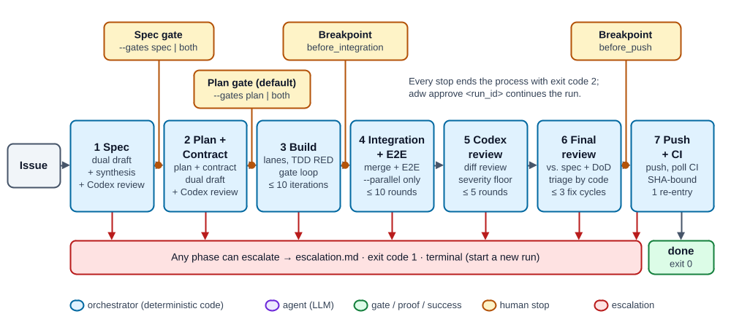
The run at a glance: seven phases, configurable human stops, one escalation exit
Amber boxes are possible human stops; the red bar is the escalation exit (escalation.md, exit code 1) that every phase can take. In the HTML version all diagrams are interactive: Play steps through the flow, and every box explains itself on hover or click.

Phase state machine
The persisted phase field in state.json (adw/state.py:Phase) is the single source of truth. These are all its values and transitions:
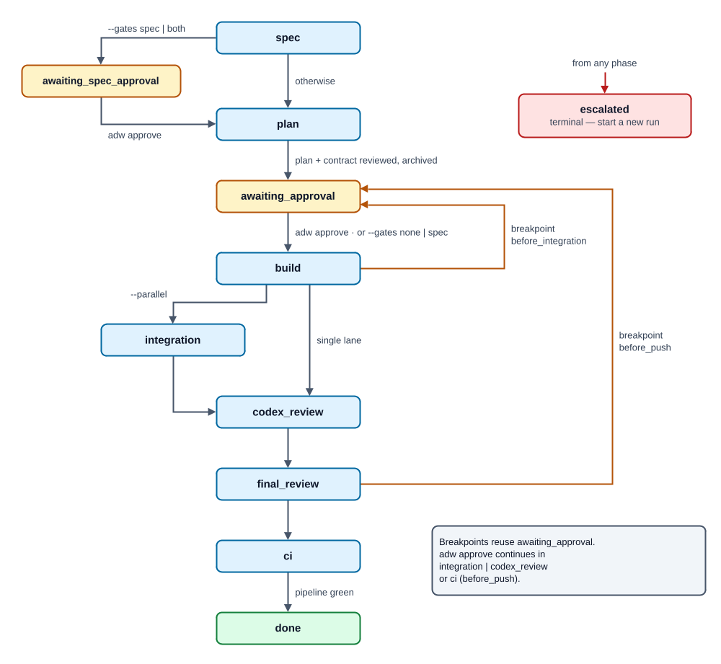
Phase state machine: every value of state.phase and its transitions
Breakpoints reuse the phase awaiting_approval; which breakpoint is waiting is recorded separately in pending_breakpoint. On adw approve, a breakpoint continues in integration (parallel) or codex_review (single lane) for before_integration, and in ci for before_push.

4. Before phase 1: starting a run
adw run (adw/cli.py:run) does a fixed sequence of checks before any state exists:
- Exactly one issue source: --issue "text", --gitlab-issue <id> (via glab) or --github-issue <nr> (via gh).
- Gate mode resolved: --gates none|spec|plan|both (default plan); the legacy flags --no-approval (= none) and --spec-approval (= both) are still accepted; a contradiction between them fails immediately.
- Config validated (fail fast): .adw/config.yaml in the target repo is parsed strictly — unknown keys, duplicate YAML keys, missing gates or non-positive timeouts abort with a clear message. Right after it, the forge preflight (real runs only) checks that the forge is known — ci.provider or an origin host containing gitlab/github. Otherwise the command is refused before any agent runs (also before resume and approve); a dry run falls back to GitLab.
- Working-tree preflight: the main checkout must be clean. If the only dirty files are ADW's own six authoring artifacts (.adw/issue.md, spec.md, plan.md, contract.yaml, spec-summary.md, plan-summary.md), they are self-healed (reset to HEAD or deleted). Anything else is a refusal — ADW never discards foreign changes. The same preflight runs before resume and approve.
- Pinning: a fresh 8-hex run_id is created, and the effective base_branch, the gate decisions and the breakpoint set are pinned into the state — a later edit of config.yaml cannot shift a running run.
- First save: state.json is written immediately (under a per-run execution lock), so even a crash in the first agent call leaves a resumable run. .adw/runs/ is self-ignored via its own .gitignore.
Then _execute simply calls the seven phase functions in order. Each function checks state.phase itself and returns immediately if it is not its turn — that is what makes resume trivial (§15).

5. Phase 1 — Spec
Question: What exactly should be built, and what not?
Input | Issue text (written as .adw/issue.md, regenerated from the state)
Actors | spec_agent (Opus 5.5) and Codex as parallel authors · spec_synthesis (Fable 5.1) · Codex reviewer
Output | .adw/runs/<id>/spec.md, spec-summary.md, drafts/spec.claude.md, drafts/spec.codex.md
Loop | Authoring review loop, max 5 rounds

Step 1 — Dual draft (in parallel)
Two independent authors write a spec from the same task, at the same time:
- Claude draft — spec_agent writes .adw/spec.md in the checkout; the orchestrator copies it to drafts/spec.claude.md and cleans the checkout. If the draft is missing, empty or byte-identical to a leftover from an earlier run, the run escalates (an idle agent must not pass off old content).
- Codex draft — Codex runs read-only and returns the content between per-call markers; the orchestrator writes drafts/spec.codex.md. Codex is the second opinion: if it fails, ADW degrades instead of escalating — it writes a spec.codex.FAILED marker, logs a warning, and the synthesis works single-source.
Drafts are written atomically (tmp + rename); a finished draft is never redone on resume.

Step 2 — Synthesis + Codex review loop
spec_synthesis (Fable 5.1) reads the issue and both drafts, writes the best-of merge to .adw/spec.md, and writes .adw/spec-summary.md — the document the human reads at the gate (decisions, scope, provenance: which draft contributed what, where the authors disagreed).
Then the authoring loop (_reviewed_authoring_loop) runs:
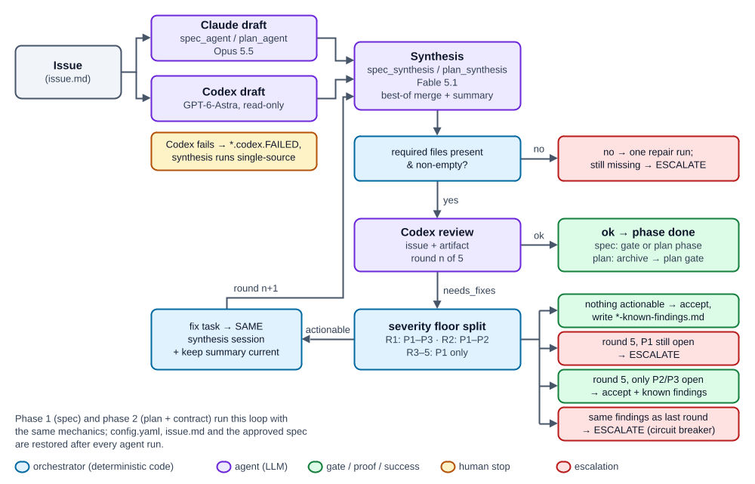
Phases 1 and 2: dual draft, synthesis and the Codex review loop
Codex receives the issue text on purpose: it checks the spec for proportionality — is this what was actually asked for? From round 2 on it also gets the previous findings with their disposition ("fix dispatched", "below threshold, recorded as follow-up"), so it does not re-report the same points (§13.1).
config.yaml, issue.md and later the approved spec are protected: they are snapshotted and restored after every agent run, so even a misbehaving agent cannot change what the reviewer sees.
Exit of phase 1: the reviewed spec and summary are copied into the run folder at once. With --gates spec|both the run pauses in awaiting_spec_approval; otherwise it moves to plan.

6. Phase 2 — Plan + Contract
Question: How will it be built — and what exactly is the interface?
Input | approved spec.md (+ spec-summary.md), issue, active lanes
Actors | plan_agent (Opus 5.5) and Codex as parallel authors · plan_synthesis (Fable 5.1) · Codex reviewer
Output | plan.md, contract.yaml, plan-summary.md, drafts/plan.*.md, drafts/contract.*.yaml
Loop | Authoring review loop, max 5 rounds (same mechanics as phase 1)
The pattern is identical to phase 1, with two artifacts instead of one:
- plan.md — workstreams per active lane (backend, and with --parallel also frontend), steps, assumptions, verification.
- contract.yaml — the interface contract between lanes. It pins only the externally observable surface (endpoints, fields, behavior rules); lanes build against it in parallel without seeing each other.
The spec and its summary are restored from the run folder and are fixed from here on — the plan phase may read them, never rewrite them. Codex reviews plan and contract against the issue and the spec's acceptance criteria.
Exit of phase 2: all artifacts (issue.md, spec.md, plan.md, contract.yaml, both summaries) are archived into .adw/runs/<id>/ and removed from (or reset in) the main checkout, so the checkout stays clean during the approval pause. The phase becomes awaiting_approval.

7. Human gates: approvals and breakpoints
ADW has two kinds of human stops. Both end the process with exit code 2 — nothing keeps running while you read. adw approve <run_id> releases the stop and continues the run in a new process.

Approval gates (--gates)
Mode | Stop after spec | Stop after plan | Legacy flags
none | – | – | --no-approval
spec | ✔ | – | --no-approval --spec-approval
plan (default) | – | ✔ | (none)
both | ✔ | ✔ | --spec-approval
At each stop the CLI tells you exactly what to read: .adw/runs/<id>/spec-summary.md + spec.md, or plan-summary.md + plan.md (and contract.yaml). The summary is the intended decision basis — short, with provenance and open questions — not the full plan.

Breakpoints (breakpoints: in config.yaml)
Optional stops before the expensive, hard-to-undo steps:
Breakpoint | Where it holds | Continues in
before_integration | after all build lanes are green, before any merge/review work | integration (parallel) / codex_review
before_push | after the final review, before any push or CI work | ci
Breakpoints are pinned at run start and each holds at most once per run. They only hold when the plan gate is active (--gates plan or both); the modes none and spec skip the plan approval and therefore the breakpoints, too.

8. Phase 3 — Build (lanes, TDD RED, gate loop)
Question: Build it — and prove it works.
Input | archived spec/plan/contract; lane config (gates)
Actors | build_agent (Opus 5.5) per lane · gates (deterministic) · orchestrator (git, commits)
Output | lane branch adw/<run_id>/<lane> with orchestrator commits; snapshot refs
Loop | gate loop, max 10 iterations per task; circuit breaker

8.1 Lanes and worktrees
A lane is one workstream — backend and/or frontend. Each lane gets:
- its own git worktree at .adw/runs/<id>/trees/<lane> on its own branch adw/<run_id>/<lane>, forked from the pinned base branch (the fork point is pinned as base_sha);
- its own agent session (resumable by session id);
- its own deterministic port (backend 9100–9149, frontend 9200–9249, derived from the run id, with a bind-check fallback), exported to its gates as BACKEND_PORT / FRONTEND_PORT;
- read denial for the other lanes' worktrees.
Without --parallel ADW runs one lane (backend if configured). With --parallel both lanes run concurrently in a thread pool and the config must define both.
The orchestrator first seeds the approved spec/plan/contract into the lane's .adw/ and commits them (adw(<id>): Spec/Plan/Kontrakt) — the build agent builds against checked-in artifacts.

8.2 TDD RED stage (gates marked tdd: true)
If the lane has at least one gate with tdd: true, the initial build starts with a proof that the tests actually test something:
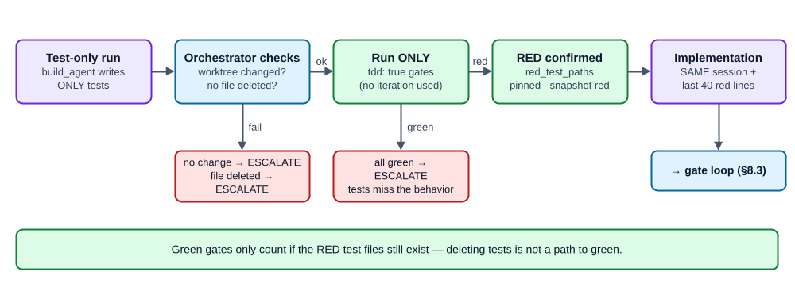
TDD RED stage: the new tests must fail before the implementation starts
The RED check consumes no gate iteration. Fix dispatches and resumes after the proof skip it. At the end, green gates only count if the RED test files still exist — deleting the tests is not a path to green.

8.3 The gate loop
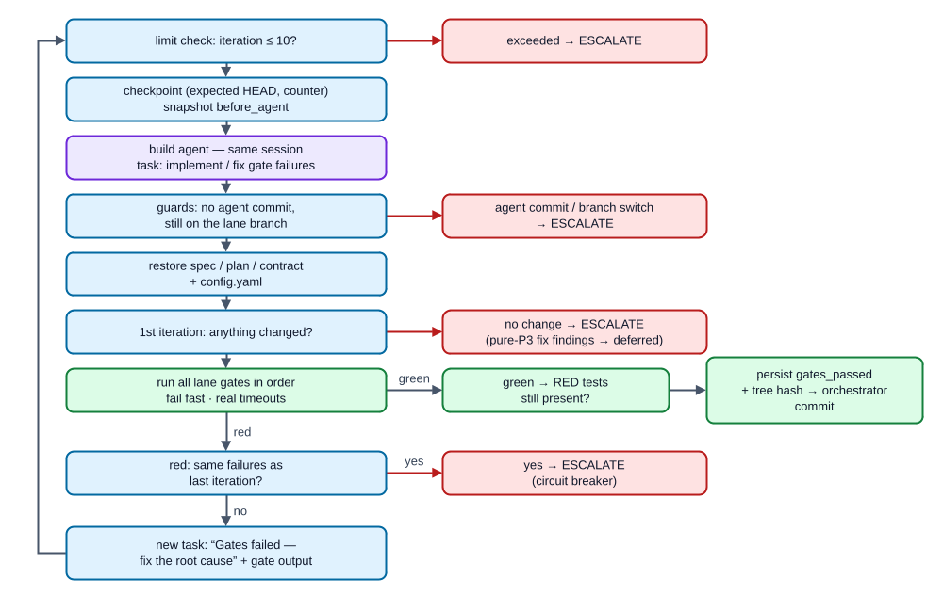
The gate loop of one lane task
Key properties:
- Gates are your commands (lanes.<lane>.gates[] with name, cmd, timeout), run in order, stopping at the first failure. Their output is bounded to the last 200 lines.
- Only the orchestrator commits — adw(<id>/<lane>): Build-Ergebnis nach grünen Gates. An agent commit, a branch switch or a HEAD move from a crash window escalates.
- Proof bound to the tree: gates_passed and gates_tree (a hash over the full worktree incl. untracked files) are persisted before the commit. On resume, a lane is only treated as done if the tree still matches the proof.
- Something must be built: green gates with no change beyond .adw/ versus the base branch escalate.
When all lanes are complete: optional before_integration breakpoint, then integration (parallel) or straight to codex_review (single lane).

9. Phase 4 — Integration + E2E (parallel mode only)
Question: Do the parts fit together?
Input | all green lane branches
Actors | orchestrator (merge) · E2E gate · e2e_triage (Sonnet 5.5)
Output | branch adw/<run_id>/integration
Loop | max 10 rounds, run-wide; circuit breaker
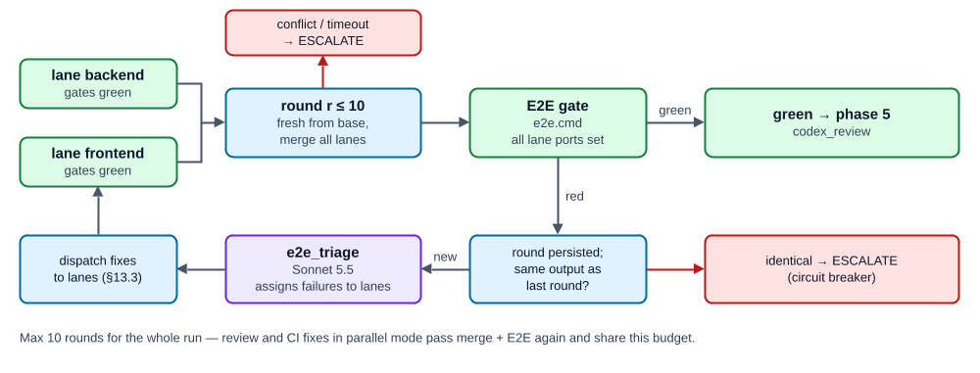
Phase 4: merge, E2E, triage and dispatch back to the lanes
Each round rebuilds the integration worktree fresh from the base branch and merges every lane branch into it (idempotent, crash-safe). A merge conflict or merge timeout escalates — conflict resolution is a human job.
Then the E2E gate (e2e.cmd with all lanes' ports in the environment) runs. If no e2e is configured, integration is a pure merge. On red:
- the round counter is persisted;
- identical failure output as last round → circuit breaker;
- e2e_triage assigns each failure to a lane (frontend/backend/unknown) as structured findings;
- the findings are dispatched as fix tasks into the normal lane loop (§13.3) — fresh iteration budget, gates, orchestrator commit;
- next round: merge again, E2E again.
Important: the review phases (5–7) also go through this loop in parallel mode. Every review fix therefore passes the E2E gate again, and the 10-round budget is shared across the whole run.

10. Phase 5 — Codex code review
Question: Does an independent reviewer find defects in the diff?
Input | changed files vs. base branch (integration worktree in parallel mode, lane worktree otherwise)
Actors | Codex (read-only) · orchestrator (triage, dispatch)
Loop | max 5 rounds, severity floor, findings memory, circuit breaker
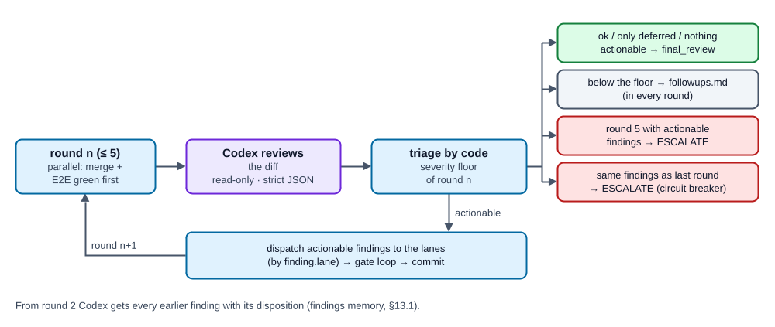
Phase 5: one Codex review round and every way it can end
Each finding is structured JSON (adw/findings.py): severity (P1–P3), lane, file, issue, remediation_plan. The parser is deliberately strict — an unreadable review is an escalation, never a silent "ok".

11. Phase 6 — Final review + triage
Question: Was the right thing built — measured against the spec?
Input | the same worktree as phase 5, spec.md, contract.yaml
Actors | final_reviewer (Fable 5.1, read-only) · adw/triage.py
Loop | max 3 fix cycles per lane; circuit breaker
Codex looked at the diff; the final reviewer looks at the result against the acceptance criteria and the Definition of Done. Every finding must carry a category, and triage is pure code:
Category | What happens
scope_gap — the spec never asked for it | written to followups.md, no fix, no automatic restart
implementation / trivial | fix task to the finding's lane; unknown lane → all active lanes
A finding without a category escalates (it cannot be triaged safely). Each dispatch bumps the lane's fix_cycles in the same save as the staged task; the 4th cycle for a lane escalates. Only scope gaps left → phase done.
Then: optional before_push breakpoint, then ci.

12. Phase 7 — Push + CI
Question: Is it green where it counts?
Input | lane branch (single) or integration branch (parallel, after a fresh green E2E)
Actors | orchestrator (push, polling) · log_analyst (Sonnet 5.5)
Loop | 1 CI re-entry, then a human
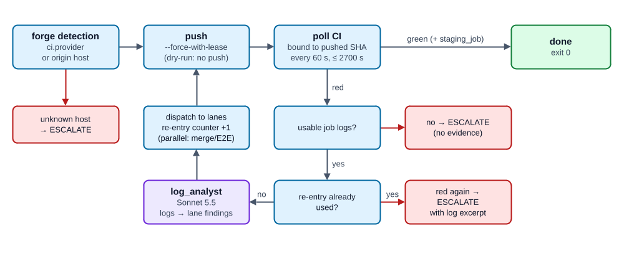
Phase 7: push, SHA-bound polling and the single CI re-entry
- Forge detection: ci.provider in the config wins; otherwise the origin URL host must clearly say gitlab or github (already checked in the preflight; if origin or config changed during the run, it escalates here).
- Push by the orchestrator: git push --force-with-lease -u origin <branch> (hooks disabled; the SSH agent socket is passed to the push only). In --dry-run there is no push.
- Polling (0 tokens) via glab or gh, every ci.poll_interval seconds (default 60) up to ci.timeout (default 2700). Polling is bound to the pushed SHA, so a stale pipeline from an earlier push cannot decide the result. On GitHub, green means all workflow runs for the SHA completed and none is red. With ci.staging_job, that job must also be green.
- Red pipeline:
  - no usable job logs (canceled, skipped, YAML error) → escalate immediately — an analyst without evidence would only hallucinate;
  - otherwise log_analyst turns the logs into lane findings, they are dispatched through the lane loops (counter bumped atomically), and the phase loops once more: merge/E2E (parallel), push, poll;
  - red again after that one re-entry → escalate with the log excerpt.
- Green → done. After a successful run, automatic pruning of old run directories may run (trace.keep_runs, default 20; fail-open).

13. Cross-cutting mechanics

13.1 Review-loop policy (authoring loops and phase 5)
A deterministic reviewer always finds another edge case at the lowest severity. Without a policy, review loops oscillate forever. ADW therefore applies:
Round | Acted on | Below the floor
1 | P1, P2, P3 | —
2 | P1, P2 | P3 → follow-up / known findings
3–5 | P1 only | P2, P3 → follow-up / known findings
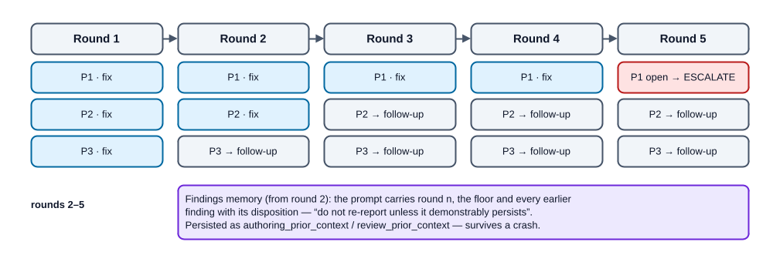
Review-loop policy: the severity floor drops round by round, the findings memory grows
From round 2 on, the reviewer prompt contains the round number, the current floor and every earlier finding with its disposition, plus the instruction not to re-report them unless the problem demonstrably persists. The history is persisted (authoring_prior_context, review_prior_context) and survives a crash.

13.2 Circuit breaker
Every loop compares the current failure set with the previous round's (triage.check_progress). An identical set means the last fix changed nothing — the run escalates immediately instead of burning the rest of its budget. Keys: file|issue for findings, gate|exit code|output for gates.

13.3 Fix dispatch — one path for every fix
E2E failures, Codex findings, final-review findings and CI findings all go through _dispatch_lane_fixes:
- findings are grouped by lane (unknown or inactive lane → all active lanes);
- for each affected lane: completed/gates_passed reset, a new pending task with the findings, a fresh gate-iteration budget (the limit is per task);
- all lanes are staged in one atomic save together with the counter update (review round, fix cycle or CI re-entry);
- then each lane runs the normal gate loop and gets an orchestrator commit.
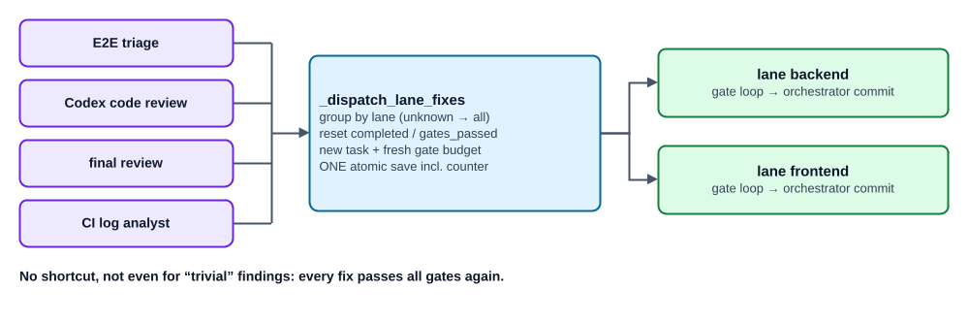
Fix dispatch: every source of findings feeds the same lane loop

13.4 Deferred findings and follow-ups
If a fix run leaves the worktree untouched and all its findings are P3 (notes, process remarks, findings the agent rejects with reason), that is not an error: the findings go to followups.md and their keys to deferred_findings. A reviewer re-reporting them later triggers neither a fix cycle nor the circuit breaker — unless it now rates the same problem P1/P2.
followups.md collects everything deliberately not fixed in this run (scope gaps, below-floor findings, deferred P3s), deduplicated by file: issue. It is a list of candidate issues, not an error report.

13.5 Limits at a glance
Limit | Value | Scope | When exceeded
Authoring rounds | 5 | per spec / plan | P1 open → escalate; only P2/P3 → accept + known findings
Gate iterations | 10 | per lane task (reset on each dispatch) | escalate
Integration/E2E rounds | 10 | whole run | escalate
Codex code-review rounds | 5 | whole run | escalate
Final-review fix cycles | 3 | per lane | escalate
CI re-entries | 1 | whole run | escalate
Codex call timeout | 900 s (codex.timeout) | per call | draft: degrade to single source · review: the process aborts at the last checkpoint → adw resume
CI wait | 2700 s (ci.timeout) | per poll cycle | escalate

14. Ending a run: done, paused, escalated, refused, interrupted
Outcome | Exit | State | What to do
done | 0 | done | review the branch / open the MR/PR
paused at a gate or breakpoint | 2 | awaiting_spec_approval / awaiting_approval | read the summary, then adw approve <id>
escalated | 1 | escalated (terminal) | read .adw/runs/<id>/escalation.md, fix the cause, start a new run
refused (dirty checkout) | 1 | unchanged | commit/stash your changes, then adw resume <id>
interrupted (agent call failed, e.g. plan limit exhausted; Codex review error/timeout; crash; Ctrl-C) | 1 / – | unchanged at the last checkpoint | adw resume <id> (after the limit resets)
The distinction matters: an escalation is a verdict ("a human must decide"), written to escalation.md with phase, lanes and the concrete reason (gate output, findings, merge conflict, limit). A refusal and an interruption are not verdicts — the run stays exactly where it was and can be continued.

15. Resume and checkpoints
state.json is the resume authority. It is written atomically (tmp + rename) under a repo-wide flock, with a monotonic sequence number. The phase functions are written so that every expensive or side-effecting step is preceded by a checkpoint:
Checkpoint | Survives a crash so that …
authoring_session, authoring_pending_task, authoring_rounds, authoring_prior_context | the authoring loop continues in the same session with the same open fix task and round count
drafts in drafts/ + *.codex.FAILED marker | finished drafts are not re-authored, a failed Codex is not retried
lane session_id (stored as soon as the stream reports it) | an aborted agent run can be resumed in its session
lane expected_head | an agent commit inside a crash window is still detected
lane pending_task, last_failures, pending_findings | gate feedback and circuit-breaker baseline are not lost
lane red_confirmed, red_test_paths | the test-only run is not repeated
lane gates_passed + gates_tree | a green-gated tree is committed without re-running — only if the tree hash still matches
integration_rounds, review_rounds, fix_cycles, ci_reentries | limits cannot be reset by crashing
pinned_base_branch, pinned_breakpoints, skip_approval, spec_approval | continuations behave exactly like the original run
On adw resume <id>, _execute calls all phase functions again; each skips until the persisted phase is reached. Before review and CI work every lane is passed through the lane loop once more: unfinished lanes catch up, finished lanes are revalidated against their tree hash. Escalated runs are deliberately not resumable.

16. Observing a run: event log, snapshots, GUI
ADW writes three kinds of observability data. All of it is fail-open: an error there warns once and never aborts or changes a run.
- Event log — .adw/runs/<id>/events.jsonl, JSON Lines. Spans (run, phase, lane, round, agent.run, codex.review, codex.author) nest the work; point events record facts after they happened (state.saved, artifact, commit, merge, red.check, snapshot, triage.decision, followup, limit.hit, circuit_breaker, escalation, approval, ci.reentry, CI polls, warnings). Agent runs carry tool calls, messages, usage and cost. Switch off with trace.enabled: false.
- Snapshots — at every build step boundary (before_agent, after_agent, after_gates, red) the lane worktree is pinned as a git commit under refs/adw/<run_id>/<seq> — without touching the real index. "What did this step change?" is a git diff between two refs.
- GUI (Run Inspector) — adw gui (optional extra gui) is a strictly read-only, loopback-only web app over the event log, state and artifacts: run list grouped by status, phase timeline, trace tree, per-step diffs, prompt diffs between rounds, artifacts (drafts, summaries, escalation.md, followups.md), a recovery card that names the right next command, and a live view while a run is active. It never starts, approves or changes a run — control stays with the CLI.
Retention: adw runs list shows runs and whether pruning is due; adw runs prune [--keep N] [--older-than DAYS] [--gzip] removes old run directories (worktrees, never dirty ones, never non-terminal runs) or compresses their event logs.

17. Worked example: run b65f5d75
A real run of ADW on its own repository (ADW 0.11.0, single lane, GitHub CI). The mechanics described above were already in place; the numbers come from its event log. Issue: "Jump from a trace node into the raw log + prompt diff against the previous round."
Segment | Time (min) | What happened
1 Spec | 0.0 – 6.7 | Opus draft + Codex draft in parallel; Fable synthesis. Codex review: round 1 and 2 each found a P2 — e.g. an acceptance criterion promised an interval filter shows exactly a subtree's events, which a sequence interval cannot guarantee. Both fixed in the same session. Round 3: ok.
2 Plan | 6.7 – 17.4 | Same pattern, plan.md + contract.yaml. Round 1: P2 + P3 (both fixed). Round 2: P2 (fixed). Round 3: one P3 left — below the round-3 floor, so accepted and written to authoring-plan-known-findings.md plus a log warning. Loop ends with a paper trail, not exhaustion.
Plan gate | 17.4 – 53.4 | Process exits with code 2. Artifacts archived, checkout clean. The human reads plan-summary.md — including the provenance note on the one real disagreement between the two drafts — and runs adw approve b65f5d75.
3 Build | 53.4 – 78.4 | Worktree trees/backend, seed commit. RED stage: test-only run writes 2 test files / 17 tests; the orchestrator runs the tdd gate → pytest exit 1 → red.check confirmed=true. Then one gate iteration: implementation in the same session, ruff and pytest green, RED tests still present, proof persisted, orchestrator commit.
4 Integration | – | skipped (single lane).
5 Codex review | 78.4 – 79.5 | Round 1: ok.
6 Final review | 79.5 – 82.2 | Fable, read-only, checks against spec + contract: ok.
7 CI | 82.2 – 84.3 | Push, 5 polls bound to the pushed SHA, success → done.
Result: 9 files, +859/−23 lines, 17 new tests, 0 fix cycles, 0 escalations, about 48 minutes of machine time plus 36 minutes of human pause. The cost was concentrated before the code (spec + plan) — and the build needed no correction round afterwards. That is the design bet of ADW in numbers: thinking up front is cheaper than repairing at the end.
A detailed German walkthrough of this run is in adw-flow-handout.de.md.

18. Quick reference

Run directory .adw/runs/<run_id>/
Path | Content
state.json | persisted run state — the resume authority
events.jsonl (or .gz) | event log (spans + points)
issue.md | the original issue text
spec.md, spec-summary.md | reviewed spec + gate summary
plan.md, contract.yaml, plan-summary.md | reviewed plan, contract + gate summary
drafts/ | spec.claude.md, spec.codex.md, plan.*.md, contract.*.yaml, *.codex.FAILED
`authoring-<spec | plan>-known-findings.md`
followups.md | scope gaps, below-floor and deferred findings
escalation.md | only after an escalation: phase, lanes, reason
trees/<lane>, trees/integration | git worktrees of the lanes / integration branch

Branches and refs
adw/<run_id>/<lane> · adw/<run_id>/integration · refs/adw/<run_id>/<seq> (snapshots)

Commands
adw run --repo <path> (--issue "…" | --gitlab-issue <id> | --github-issue <nr>)
[--parallel] [--dry-run] [--gates none|spec|plan|both] [--base-branch <name>]
adw resume <run_id> [--repo <path>]
adw approve <run_id> [--repo <path>]
adw status [<run_id>] [--repo <path>]
adw runs list|prune [--repo <path>] …
adw gui [--repo <path>] [--port 8765] [--open]
Exit codes: 0 done · 2 waiting for approval/breakpoint · 1 escalation, refusal or interruption.
--dry-run drives the complete control flow with scripted mocks — 0 tokens, no push, no forge calls — and is the safest way to see this whole document in motion.

ADW Workflow · source: ADW 0.26.1 (adw/ code, docs/SPEC.md, CHANGELOG.md) · as of 2026-10-11

