ADW Control Flow — The Seven Phases (Handout)

ADW Control Flow — The Seven Phases
How the Agentic Developer Workflow turns a task fully automatically into finished, reviewed code — explained without programming knowledge, with diagrams.
Sources: docs/handbuch/ADW-CONTROL-FLOW.md · docs/SPEC.md (as of 2026-07-14) · Handout created 2026-07-18

⚡ At a Glance
- The ADW takes a development task (an "issue") fully automatically through seven phases: describe → plan → build → integrate → two independent reviews → deliver.
- Guiding principle: Control flow is code, not prompt. Who acts when is decided by a fixed program — AI works only where judgment is needed.
- Reviewers never repair. Every defect goes back to the build agents, and every repair must pass through all checks again — no shortcuts.
- A single planned stop for the human: After Phase 2, the blueprint is approved by a human before the expensive build phase starts.
- Every loop has a limit (10 / 10 / 3 rounds, 45 min waiting). Exhausted limits or zero progress lead to a controlled abort with an escalation report — never to endless spinning.
- Nothing gets lost: After every phase transition the state is saved; adw resume continues exactly there — like a save point in a video game.

🎯 Key Statements
- Three actors, clearly separated: a fixed program as site manager (Orchestrator), AI agents as architects and construction workers, independent AI reviewers as inspectors — each with exactly the tools of its role.
- Quality through loops, not through trust: Every document and every piece of code is checked and reworked until an independent reviewer says "ok".
- Two different review questions: Phase 5 asks "Is the code well made?", Phase 6 asks "Was the right thing built?" — both against the specification from Phase 1.
- Safety nets everywhere: Limits, circuit breakers, escalation reports and checkpoints ensure that the run never derails uncontrolled.
📑 Contents
- What is it about? The construction-site analogy
- The path at a glance (diagram)
- The basic pattern: the review loop
- Phase 1 — Spec
- Phase 2 — Plan + Contract
- Phase 3 — Build
- Phase 4 — Integration + E2E
- Phase 5 — Codex Code Review
- Phase 6 — Final Review + Triage
- Phase 7 — Push + CI
- The safety nets
- Technical appendix
- Glossary
Expand all details

1 · What is it about? The construction-site analogy
The Agentic Developer Workflow (ADW) is a program that turns a task — an "issue", e.g. "Add a search feature to the app" — fully automatically into finished, reviewed code: from the first description all the way to delivery on a test server.
You can think of it like a construction site:
Role on the construction site | Role in the ADW | Who does it?
Site manager — organizes everything, makes no technical decisions | The Orchestrator — a fixed program | Deterministic code
Architect — writes the blueprint | Spec agent & Plan agent | AI (Fable 5)
Construction workers — actually build | Build agents | AI (Opus 4.8)
Building inspectors — inspect, but never build themselves | Codex reviewer & final reviewer | AI (Codex / Fable 5)
Checklists & measuring devices — always the same checks | Gates (automated tests) | Deterministic code
The most important principle "Control flow is code, not prompt." That means: who acts when is decided by a fixed program — not the AI. The AI is used only where judgment is needed (writing, building, evaluating). Everything repeatable — running tests, passing results along, counting loops — runs as ordinary program code: 0 tokens, deterministic, always the same.

Two iron rules
1. Reviewers never repair. Whoever finds a defect only reports it. Repairs are always done by the build agents — and every repair must afterwards go through all checks again. No shortcuts, not even for "small things".
2. Everything has a limit. Every loop may only repeat a limited number of times. If the limit is exhausted — or a repair round achieves nothing at all anymore ("circuit breaker", like a fuse in the fuse box) — the run aborts in a controlled way and writes an escalation report: what was accomplished, what is open, what went wrong. A human then takes over.

2 · The path at a glance
This is how an issue travels through the seven phases. Blue boxes are the phases, the yellow box is the only planned stop for the human, the circling arrows on the right are the built-in rework loops — each with a limit:
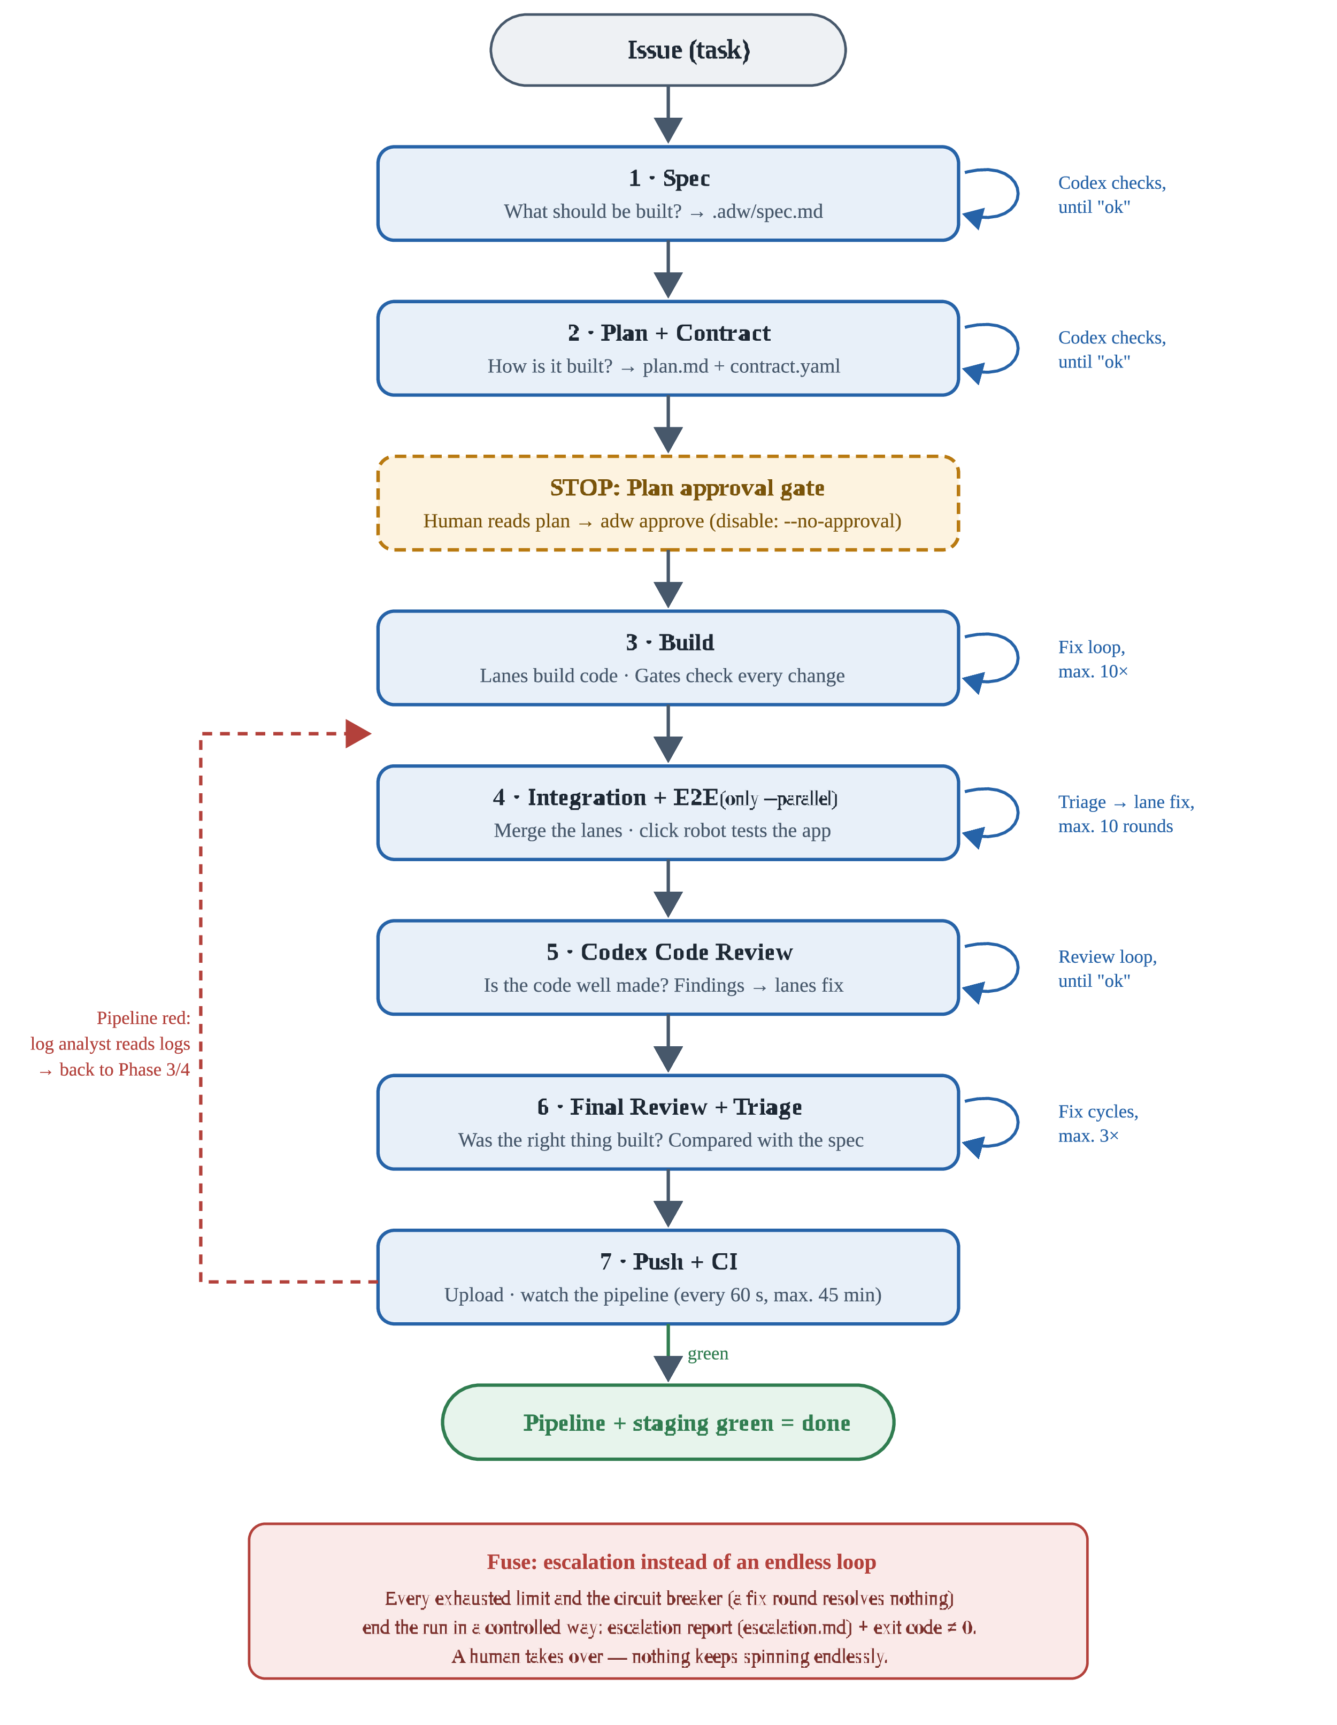
Fig. 1 — The seven phases from issue to "staging green". Right: rework loops with limits; dashed on the left: the jump back when the CI pipeline turns red.

3 · The basic pattern: the review loop
One pattern recurs throughout the ADW — in Phase 1 (Spec), Phase 2 (Plan) and Phase 5 (Code Review): an agent creates something, an independent reviewer evaluates it, and defects go back until the verdict is "ok". Crucially, the agent keeps its "memory" from the previous rounds (session resume) — it does not have to familiarize itself from scratch each time.
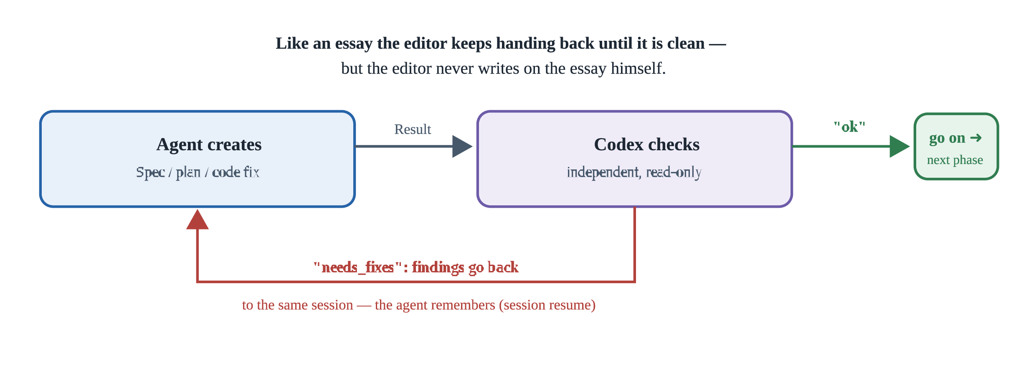
Fig. 2 — The basic pattern "create → check → rework", which works identically in phases 1, 2 and 5.

4 · Phase 1 — Spec

1 Spec
"What should be built in the first place?"
Input: the issue — a text, either typed in directly or fetched from GitLab/GitHub.
- The Spec agent (AI) reads the issue and the project and writes a specification (.adw/spec.md): the goal, what is in scope, what is explicitly not in scope, and how you can tell it is done ("acceptance criteria", "definition of done"). It may only read and write this one file — it is not allowed to build anything.
- The Codex reviewer (a second, independent AI) checks the specification.
- If it finds defects, they go back to the same Spec agent — which keeps its memory from the first round (session resume) and reworks.
- This repeats until the reviewer says "ok" (review loop, see Fig. 2).
More details (from the SPEC)
The Spec agent runs on Fable 5 and has only the tools Read/Grep/Glob plus Write — the latter restricted to the directory .adw/. The issue arrives either as CLI text (--issue "…"), as a GitLab issue via glab (--gitlab-issue <id>) or as a GitHub issue via gh (--github-issue <nr>). The spec is later committed along on the feature branch — so it remains traceable what was built and reviewed against (traceability).

5 · Phase 2 — Plan + Contract

2 Plan + Contract
"How will it be built?"
- The Plan agent (AI) turns the specification into a step-by-step blueprint (.adw/plan.md) and a contract (.adw/contract.yaml). The contract is like a binding power-socket standard: it defines exactly how the parts (e.g. the interface and the server logic) must fit together later — so that two teams working separately don't deliver incompatible parts in the end.
- The Codex reviewer checks plan and contract together, again in the loop until "ok".
- Plan approval gate — the built-in STOP: The workflow halts, saves its complete state and exits. Now a human reads the plan and decides. Only the command adw approve (or adw resume) lets the run continue at exactly this point.
The only planned stop The plan approval gate is the only point where the human is asked in the middle of the process — deliberately placed before the expensive build phase begins. Anyone who fully trusts the automation can disable the stop with --no-approval.
More details (from the SPEC)
The Plan agent also runs on Fable 5 with Read/Grep/Glob + Write (only .adw/). The plan structures the work into workstreams (e.g. frontend/backend); the contract contains OpenAPI definitions, types and events. When pausing, the RunState is persisted and the process terminates with an exit — the run "sleeps" until adw approve <run_id> or adw resume <run_id> wakes it up.

6 · Phase 3 — Build

3 Build
"Now it gets built."
- The Dispatch (fixed program, no AI) breaks the plan down into work packages — e.g. "frontend" (the visible part) and "backend" (the logic behind it). Each package gets its own Lane: its own working folder (Git worktree), its own AI session and its own network ports. This way the lanes cannot get in each other's way. Without --parallel there is simply just one lane — same process, one track.
- In each lane, the lane loop runs (Fig. 3): The Build agent (AI) writes code — strictly following plan and contract. Then the Gates run: automated checks (formatting, code style, tests), configured firmly in the project — like inspection stations on an assembly line. On red, the error messages go back to the same AI session as a new task; it still knows its own code and reworks. At most 10 iterations — after that, escalation report, abort, human takes over.
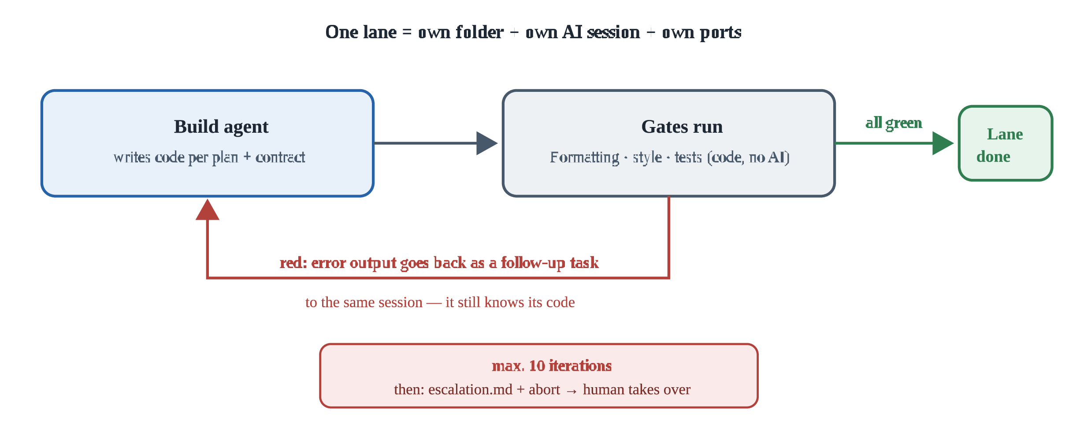
Fig. 3 — The lane loop in Phase 3: build, check, rework — with a hard limit.
More details (from the SPEC)
Build agents run on Opus 4.8 with full tools (Read/Write/Edit/Bash), but are confined to their own worktree via the working directory (cwd). Each lane gets its own branch off the base branch. The gates (name, command, timeout) come from the target repo's config (.adw/config.yaml) and run in configured order as subprocesses with a real timeout. Ports are computed deterministically from the run ID (base port + hash offset, socket bind check as fallback).

7 · Phase 4 — Integration + E2E

4 Integration + E2E
"Do the parts fit together?" (only with --parallel)
- A fixed program merges the results of all lanes onto a shared integration branch (merge).
- Then an end-to-end test (Playwright) runs: a robot clicks its way through the finished application like a real user.
- If something fails, the E2E triage agent (AI, read-only) assigns each failure to the responsible lane — like a doctor who only diagnoses but does not operate.
- The affected lane repairs — again via its normal lane loop from Phase 3, including all gates — then everything is re-integrated and re-tested. At most 10 rounds.
More details (from the SPEC)
The E2E triage agent runs on Sonnet 5 (workhorse model) and has only read tools — it fixes nothing, it only assigns. The E2E command (e.g. npx playwright test) and its timeout come from the target repo's config. Without --parallel this phase is skipped; v1 and v2 are the same code path, the flag merely activates multi-lane operation.

8 · Phase 5 — Codex Code Review

5 Codex Code Review
"Is the code well made?" — independent quality control
- The Codex reviewer reads all the new code (read-only!) and delivers a structured defect list: what is the problem, how severe is it (P1 = critical … P3 = minor), which lane is responsible — and a repair suggestion (remediation_plan).
- A fixed program distributes the defects to the right build agents based on the lane field.
- Important: the repair suggestion is a recommendation, not an order. The build agent checks it against the specification and project rules and may repair differently, with justification — after all, the reviewer only sees the code from the outside.
- After each repair: all gates, then another review — until "ok".
More details (from the SPEC)
Codex runs as a CLI subprocess (codex exec --sandbox read-only) — the sandbox technically guarantees that the reviewer cannot change anything. Its response must conform to the fixed findings schema (JSON); the parser is deliberately strict: only a pure JSON object or the last ```json block is accepted. Anything else counts as an error — a parse error is harmless, a wrongly waved-through "ok" would not be.

9 · Phase 6 — Final Review + Triage

6 Final Review + Triage
"Was the right thing actually built?"
Phase 5 asked: Is the code well made? Phase 6 asks: Does it do what the specification says?
- The final reviewer (AI, strictly read-only) compares the finished implementation with the specification from Phase 1 and reports deviations — each with a category.
- The Triage (fixed program) sorts by category (Fig. 4).
- At most 3 repair cycles, then escalation.
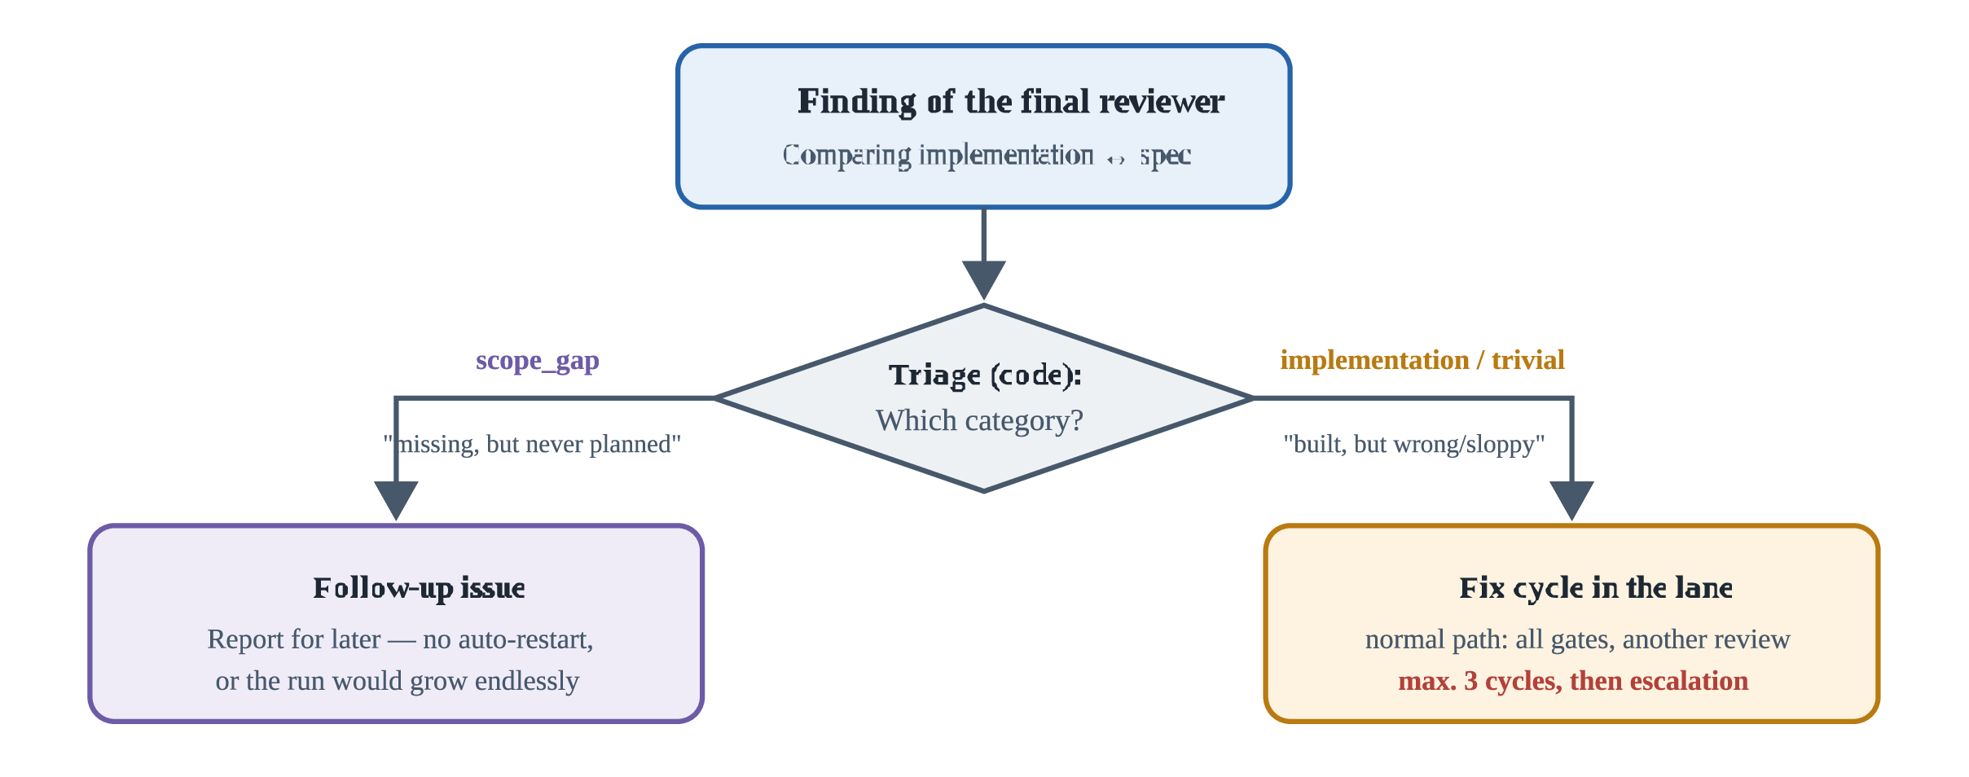
Fig. 4 — The triage sorts findings: new things are noted, wrong things are repaired — via the normal, checked path.
More details (from the SPEC)
The final reviewer runs on Fable 5 with Read/Grep/Glob — strictly read-only, it delivers only findings. The category field in the findings schema is filled exclusively by this reviewer; it is the basis of the triage decision. scope_gap produces a follow-up report instead of a fix cycle; implementation findings are routed to the right lane via the lane field.

10 · Phase 7 — Push + CI

7 Push + CI
"Deliver and observe."
- The finished branch is pushed (uploaded) to the central repository.
- There, the project's CI pipeline (GitLab or GitHub) starts automatically: it builds everything again neutrally, tests, and deploys the result to the staging server (the test environment).
- The ADW polls the status every 60 seconds — until everything is green, but at most for 45 minutes.
- If the pipeline turns red, the log analyst (AI, read-only) reads the error logs, turns them into structured findings with lane assignment — and the process jumps back to Phase 3/4: repair, check, push again.
Goal reached Pipeline green + staging deploy green → the run has finished successfully.
More details (from the SPEC)
The forge (GitLab/GitHub) is detected from ci.provider in the config or automatically from the origin URL; polling happens via glab (GitLab) or gh (GitHub Actions). Poll interval (60 s) and timeout (45 min = 2700 s) are the documented config defaults; which job counts as "staging green" is determined by ci.staging_job (e.g. deploy-staging). The log analyst runs on Sonnet 5, read-only.

11 · The safety nets (apply everywhere)
Mechanism | What it means
Limits | Phase 3: max. 10 fix iterations · Phase 4: max. 10 rounds · Phase 6: max. 3 cycles · Phase 7: max. 45 min waiting
Circuit breaker | If a repair round resolves nothing → immediate abort instead of pointless spinning — like a fuse in the fuse box
Escalation report | Every abort produces escalation.md: what was achieved, what is open, why — the handover to the human
Checkpoints | After every phase transition the complete state is saved. adw resume continues exactly there after a crash, a pause or an exhausted AI quota — like a save point in a video game
Structured handovers | All reviewers report findings in a fixed data format (JSON). If a response cannot be parsed cleanly, it counts as an error — better to ask once too often than to wave through a false "ok"
Permissions | Every AI gets only the tools its role needs: reviewers may only read, build agents may only write in their own folder; subprocesses see only approved environment variables (no secrets)
The whole thing in one sentence A fixed program takes a task through seven stations — describing, planning (with human approval), building, integrating, two independent reviews, delivering — and lets AI work only where judgment is needed, while every loop has a limit, every finding has a fixed way back, and every abort has a report.

12 · Technical appendix (for the curious)
This section goes beyond the beginner level and shows the original definitions from the SPEC — for looking things up, not for memorizing.
Agent registry: who runs on which model with which tools?
Agent | Model | Tools | Mission
Spec agent | Fable 5 | Read/Grep/Glob + Write (only .adw/) | .adw/spec.md per template; never implements
Plan agent | Fable 5 | Read/Grep/Glob + Write (only .adw/) | .adw/plan.md (workstreams FE/BE) + .adw/contract.yaml
Build agent (per lane) | Opus 4.8 | Read/Write/Edit/Bash, cwd = lane worktree | Workstream strictly against the contract; fix plans = recommendation
Codex reviewer | Codex (CLI) | codex exec --sandbox read-only | Reviews of spec, plan, code; findings + remediation_plan as JSON
E2E triage | Sonnet 5 | Read | Assign Playwright failures to a lane; fixes nothing
Log analyst | Sonnet 5 | Read | CI logs → structured findings with lane assignment
Final reviewer | Fable 5 | Read/Grep/Glob (strictly read-only) | Check implementation against the spec; findings only
Model economics: Fable 5 only for spec/plan/final review (thinking, broad); Opus builds (deep); Sonnet 5 triages (workhorse).
The commands (CLI)
adw run --repo <path> (--issue "text" | --gitlab-issue <id> | --github-issue <nr>)
[--parallel] [--dry-run] [--no-approval] [--base-branch <name>]
adw resume <run_id> [--repo <path>] # after crash or approval pause
adw approve <run_id> # grant plan approval + continue
adw status [<run_id>] # show runs + phase
--dry-run replaces all AI calls with prepared mock responses — the complete control flow can thus be played through and tested without token costs.
Config in the target repo (.adw/config.yaml)
base_branch: staging
lanes:
backend:
gates: # order = execution order
- {name: black, cmd: "black --check .", timeout: 120}
- {name: isort, cmd: "isort --check-only .", timeout: 120}
- {name: pytest, cmd: "pytest -x -q", timeout: 1800}
frontend: # optional; if the lane is missing, v1 single-lane runs
gates:
- {name: eslint, cmd: "npm run lint", timeout: 300}
e2e: # optional; only relevant with --parallel
cmd: "npx playwright test"
timeout: 1800
ci:
poll_interval: 60
timeout: 2700
staging_job: deploy-staging
provider: gitlab # optional: gitlab | github; otherwise auto-detection
Missing or broken config → immediate, clear error (fail fast) — no guessing of defaults beyond the documented ones (poll_interval, timeout).
The findings schema (JSON, identical everywhere)
{
"verdict": "ok | needs_fixes",
"findings": [{
"severity": "P1 | P2 | P3",
"lane": "frontend | backend | unknown",
"file": "path/relative/to/repo.py",
"issue": "Description of the problem",
"remediation_plan": ["Step 1", "Step 2"],
"category": "scope_gap | implementation | trivial"
}]
}
Parser contract (strict, deliberate design decision): Accepted is exclusively (a) output that is a JSON object as a whole, or (b) the content of the last ```json fence. Anything else → FindingsParseError = retry/escalation case. Tolerance heuristics cannot be sealed against adversarial outputs; a parse error is safe, a false "ok" is not. Validation strictly via Pydantic (extra="forbid", verdict-findings consistency, required fields except category — which only the final reviewer fills).
Artifacts, state & resumption
- .adw/spec.md, .adw/plan.md, .adw/contract.yaml — live in the target repo and are committed along on the feature branch (traceability).
- .adw/runs/<run_id>/ — gitignored: state.json (RunState), agent transcripts, gate outputs, escalation.md.
- RunState (Pydantic): run_id, issue, phase, lanes (worktree, branch, session_id, ports, iterations), approval status, ci status. Persisted after every phase transition → adw resume continues exactly there.
- Failed agent calls (e.g. plan quota exhausted) end the run in a controlled way without escalation — adw resume continues at the checkpoint after the reset.

13 · Glossary
Issue
The task description everything starts with — e.g. "Add a search feature". Arrives as text or from GitLab/GitHub.
Orchestrator
The fixed program that controls the entire process — the "site manager". Decides who acts when, but builds nothing itself.
Agent
An AI with a clearly defined mission and limited tools (e.g. Spec agent, Build agent).
Spec (specification)
The document that records what should be built — including what is explicitly not in scope.
Contract
The binding "power-socket standard": defines how the separately built parts (frontend/backend) must fit together exactly.
Lane
An independent work track with its own folder (Git worktree), its own AI session and its own ports — lanes don't interfere with each other.
Git worktree
An additional, independent working folder of the same project — each lane works in its own.
Gate
An automated checking station (formatting, style, tests) that code must pass — always the same, without AI.
Session / session resume
The "session" of an AI with its memory. Resume = continuing the same session instead of starting from zero.
E2E (end-to-end)
Test of the complete application from the user's perspective — a robot (Playwright) clicks through the app.
Triage
The sorting of findings: what is it, who is responsible, what happens with it? (Like in an emergency room.)
Finding
A single, structurally reported defect from a reviewer — with severity (P1 critical … P3 minor), location and repair suggestion.
Push
Uploading the finished code to the central repository (GitLab/GitHub).
CI / pipeline
"Continuous Integration": the automatic checking and delivery line of the central repository.
Staging
The test environment — a copy of the real application where the result lands first.
Circuit breaker
The "fuse": if a repair round achieves nothing at all, the run is aborted immediately instead of kept spinning.
Escalation
The controlled abort with a report (escalation.md): what was achieved, what is open, why — handover to the human.
Dry run
A trial run in which all AI calls are replaced by prepared responses — the process can be tested without costs.
↑ Back to top

