PRS ARCHITECTURAL SCEHMA

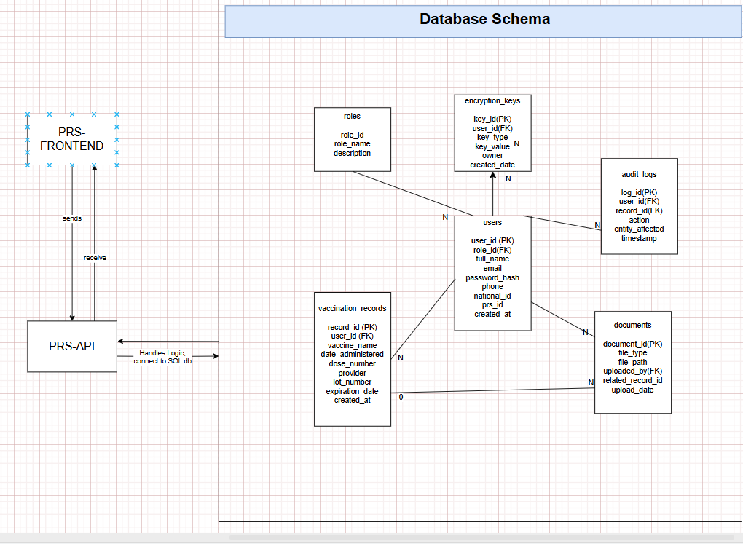

HOW IT IS WORKING:
[PRS Frontend (HTML+JS)]
↓ ↑
Sends/Receives
↓ ↑
[PRS API (PHP backend in XAMPP)]
↓ ↑
Handles logic, connects to:
↓ ↑
[PRS Database (MySQL)]

