* 1. 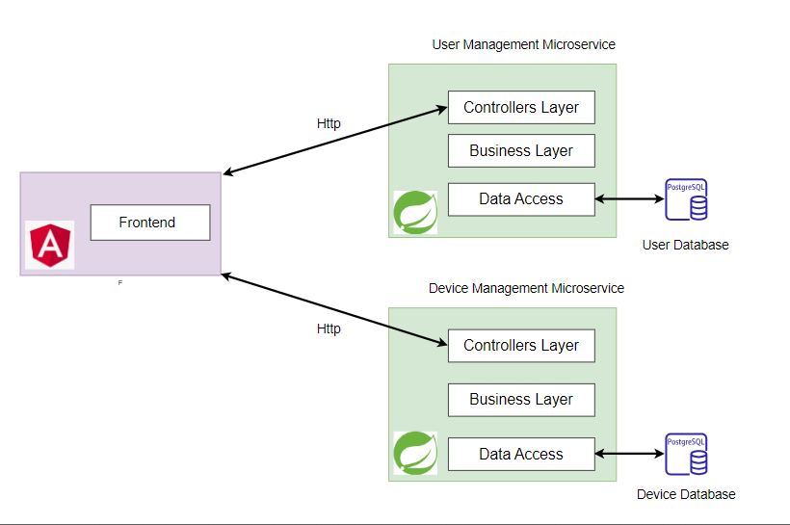**Conceptual Diagram:**

*Figure 1: UML Conceptul Diagram*

* 1. **A diagram of a device data processing

     Description automatically generatedDeployment Diagram:**

Figure 2: UML Deployment Diagram

2.1 Conceptual Diagram: 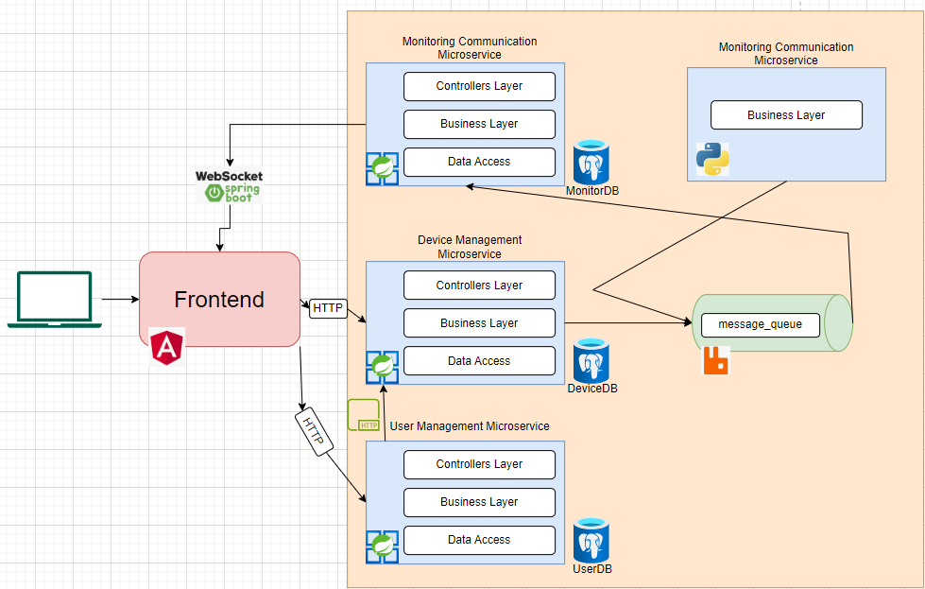

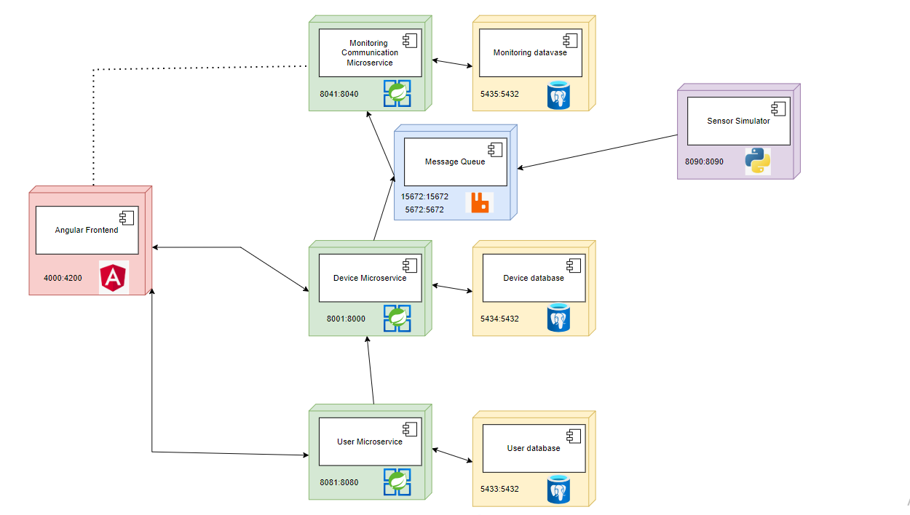2.2 Deployment Diagram