**Life Expectancy Token (LET)**

Whitepaper — 2025

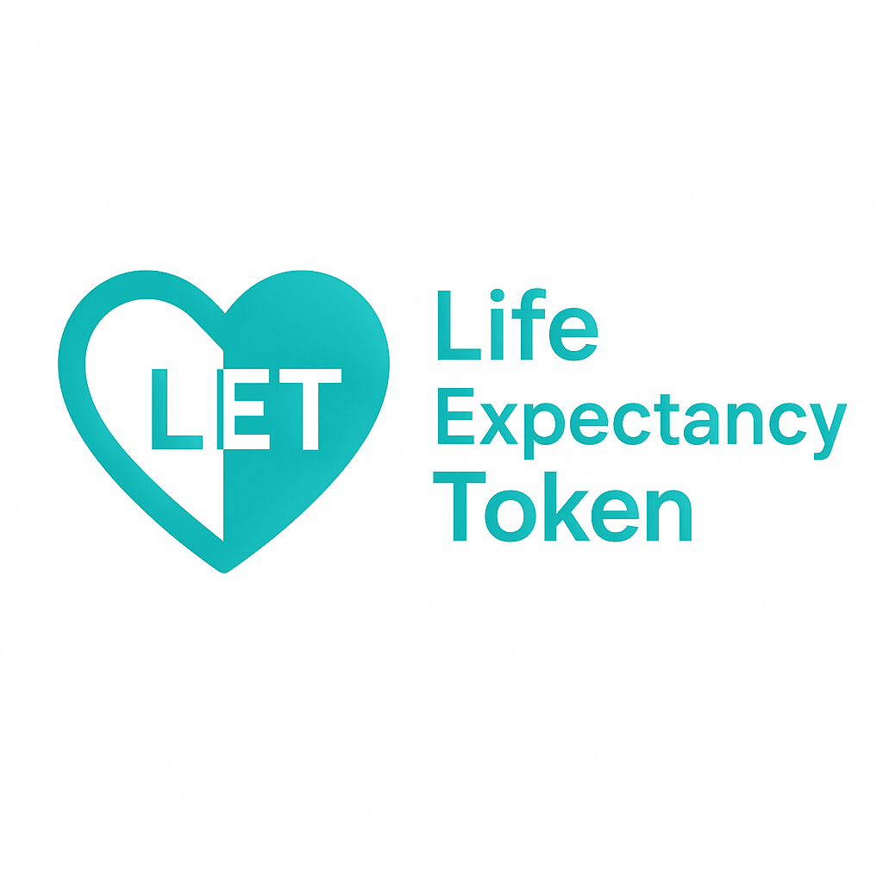

Founder: Serhii Polovynka

**Introduction**

Life Expectancy Token (LET) is the first token whose price directly depends on global life expectancy. The value of LET increases as humanity's average lifespan increases. This project turns longevity and social progress into a measurable, investable asset class.

**Vision**

LET aims to create a new category of assets tied to humanity’s long-term progress. By linking token price to global life expectancy, LET aligns financial incentives with advancements in healthcare, peace, and quality of life worldwide.

**How It Works**

- An on-chain oracle stores the latest global life expectancy (from the World Bank API).  
- LET is an ERC-20 synthetic token minted against USDC collateral on Arbitrum One.  
- LET price = Life Expectancy (years) × 1e18 (so ~73.33 USDC today).  
- Mint/Redeem operations carry a 0.3% fee that accumulates as USDC on the LET contract.  
- The owner (Founder) can withdraw accumulated fees; data staleness and deviation limits protect users.

**Tokenomics**

Token: LET (ERC-20)  
Network: Arbitrum One  
Collateral: USDC  
Oracle update: annual (World Bank API)  
Fees: 0.3% mint / 0.3% redeem  
Owner: Founder (Serhii Polovynka)  
Initial reference price: ~73.33 USDC per LET

**Roadmap**

• MVP smart contracts — completed  
• Launch public website and wallet UI - completed  
• List on CoinGecko / CoinMarketCap  
• Create Uniswap pool (LET/USDC) on Arbitrum  
• Explore DAO to fund longevity initiatives

**Contact**

Coming soon.  
Website / Telegram / Email to be announced.