Sub.: NHRC
*****

PUC is a communication on the above-mentioned subject, dated , received from and addressed to (reference no. ).

2. In this connection, it is proposed to send a letter to for examining the matter and furnishing reply directly to the applicant under intimation to Board's Office.

3. Accordingly, a draft letter (DFA) is submitted for approval/signature please.

JSA/TG-II

SO/TG-II

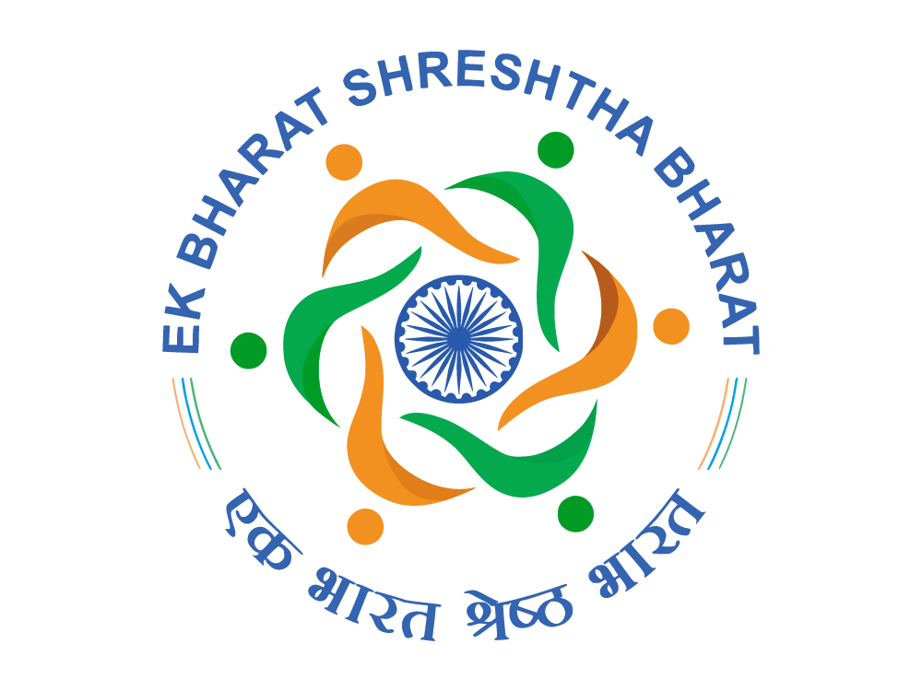 | भारत सरकार / GOVERNMENT OF INDIA  रेल मंत्रालय / MINISTRY OF RAILWAYS  (रेलवे बोर्ड) / (RAILWAY BOARD) | 

No. New Delhi, dated 24.02.2026

Sub.: NHRC
*****

Please find enclosed herewith a copy of the communication on the above-mentioned subject, received from and addressed to . In this connection, it is requested that the matter be got examined and direct reply be sent to the applicant under intimation to Board's Office at the earliest.

In case the matter does not pertain to your Railway, the same should not be sent back to Railway Board but should be transferred to the Railway concerned under intimation to Board's office.

A copy of the reply may please be furnished by Fax on 030-43373 (Railway) / 011-23072028 (P&T) and also by e-mail on sotg098@gmail.com.

DA: As above.

(Ishan Bahl)
For Joint Director/Traffic Commercial (General)-II
Railway Board

Ref.: Notings on pre-pages.
Sub.: NHRC
*****

With regard to communication on the above-mentioned subject, dated , received from and addressed to (reference no. ), it is noted that Zonal Railways concerned has furnished the reply directly to the complainant with a copy to Board's Office.

Submitted for information and orders please.

CMI/TG-II

SO/TG-II

JD/TC(G)-II

ED/PM

Ref.: Notings on pre-pages.

With regard to communication, dated , received from and addressed to (reference no. ), it is noted that reply from Zonal Railways concerned is still awaited.

2. In this connection, it is proposed to send reminder #1 to for examining the matter and expediting the furnishing of reply directly to the applicant under intimation to Board's Office.

3. Accordingly, a draft reminder (DFA) is submitted for approval/signature please.

JSA/TG-II

SO/TG-II

REMINDER-1

भारत सरकार / GOVERNMENT OF INDIA
रेल मंत्रालय / MINISTRY OF RAILWAYS
(रेलवे बोर्ड) / (RAILWAY BOARD)

No. New Delhi, dated 24.02.2026

Sub.: NHRC
*****

Please refer to this office's letter of even number dated <TOC_DT>, regarding communication on the above-mentioned subject, received from and addressed to . In this connection, it is noted that the reply on the matter is still awaited.

Accordingly, it is again requested that the matter be got examined and direct reply be sent to the applicant under intimation to Board's Office expeditiously. A copy of the reply may please be furnished by Fax on 030-43373 (Railway) / 011-23072028 (P&T) and also by e-mail on sotg098@gmail.com.

(Ishan Bahl)
For Joint Director/Traffic Commercial (General)-II
Railway Board

Ref.: Notings on pre-pages.

With regard to communication, dated , received from and addressed to (reference no. ), it is noted that reply from Zonal Railways concerned is still awaited, despite the follow-up reminder(s).

2. In this connection, it is proposed to send reminder #<REM_NO> to for examining the matter and expediting the furnishing of reply directly to the applicant under intimation to Board's Office without any further delay.

3. Accordingly, a draft reminder (DFA) is submitted for approval/signature please.

JSA/TG-II

SO/TG-II

JD/TC(G)-II

REMINDER-<REM_NO>

भारत सरकार / GOVERNMENT OF INDIA
रेल मंत्रालय / MINISTRY OF RAILWAYS
(रेलवे बोर्ड) / (RAILWAY BOARD)

No. New Delhi, dated 24.02.2026

Sub.: NHRC
*****

Please refer to this office's letter of even number dated <TOC_DT>, regarding communication on the above-mentioned subject, received from and addressed to . In this connection, it is noted that the reply on the matter is still awaited, leading to delay in disposal of time-bound matter.

Accordingly, it is again requested that the matter be got examined and direct reply be sent to the applicant under intimation to Board's Office without any further delay. A copy of the report may please be furnished by Fax on 030-43373 (Railway) / 011-23072028 (P&T) and also by e-mail on sotg098@gmail.com.

THE MATTER MAY BE TREATED AS MOST URGENT.

(Avinash Sharma)
Joint Director/Traffic Commercial (General)-II
For Executive Director/Passenger Marketing
Railway Board

Office: Room No. 445, 4th Floor, Rail Bhawan, Raisina Road, New Delhi-110001.
Phone: +91-11-23044104, Fax: +91-11-23072028, Email: avinash.sharma1@gov.in

Ref.: Notings on pre-pages.
Sub.: NHRC
*****

With regard to communication on the above-mentioned subject, dated , received from and addressed to (reference no. ), it is noted that Zonal Railways concerned has furnished the reply directly to the complainant with a copy to Board's Office.

Submitted for information and orders please.

JSA/TG-II

SO/TG-II

JD/TC(G)-II

