<FILE>

Ref.: Notings on pre-pages.

With regard to communication, dated <FROM_DT>, received from <FROM_COL> and addressed to <TO_COL> (reference no. <CASE_COL>), it is noted that report from Zonal Railways concerned is still awaited, despite the follow-up reminder(s).

2. In this connection, it is proposed to send reminder #<REM_NO> to <RLY> for examining the matter and expediting the furnishing of report to Board's Office without any further delay.

3. Accordingly, a draft reminder (DFA) is submitted for approval/signature please.

ASO/TG-II

SO/TG-II

JD/TC(G)-II

ED/PM

REMINDER-<REM_NO>

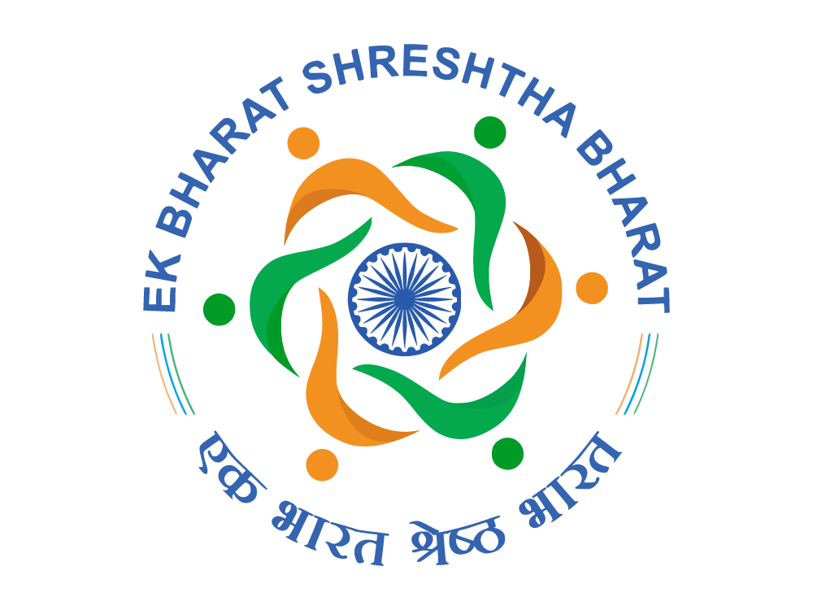 | भारत सरकार / GOVERNMENT OF INDIA  रेल मंत्रालय / MINISTRY OF RAILWAYS  (रेलवे बोर्ड) / (RAILWAY BOARD) | 

No. <FILE> New Delhi, dated <NOW>

<RLY_NL>

Sub.: <PUC>
*****

Please refer to this office's letter of even number dated <TOC_DT>, regarding communication on the above-mentioned subject, received from <FROM_COL> and addressed to <TO_COL>. In this connection, it is noted that the report on the matter is still awaited, leading to delay in disposal of time-bound matter.

Accordingly, it is again requested that the matter be got examined and report be sent to Board's Office without any further delay. A copy of the report may please be furnished by Fax on 030-43373 (Railway) / 011-23072028 (P&T) and also by e-mail on sotg098@gmail.com.

BEING VIP REFERENCE, THE MATTER MAY BE TREATED AS MOST URGENT.

(Shivendra Shukla)
Executive Director/Passenger Marketing
Railway Board

Office: Room No. 472, 4th Floor, Rail Bhawan, Raisina Road, New Delhi-110001.
Phone: +91-11-23047354, Fax: +91-11-23072028, Email: edpm@rb.railnet.gov.in

