**Vector Recycling**

If you give R 2 vectors of unequal lengths, R will repeat the shorter vector until it is as long as the longer vector, and then do the math.

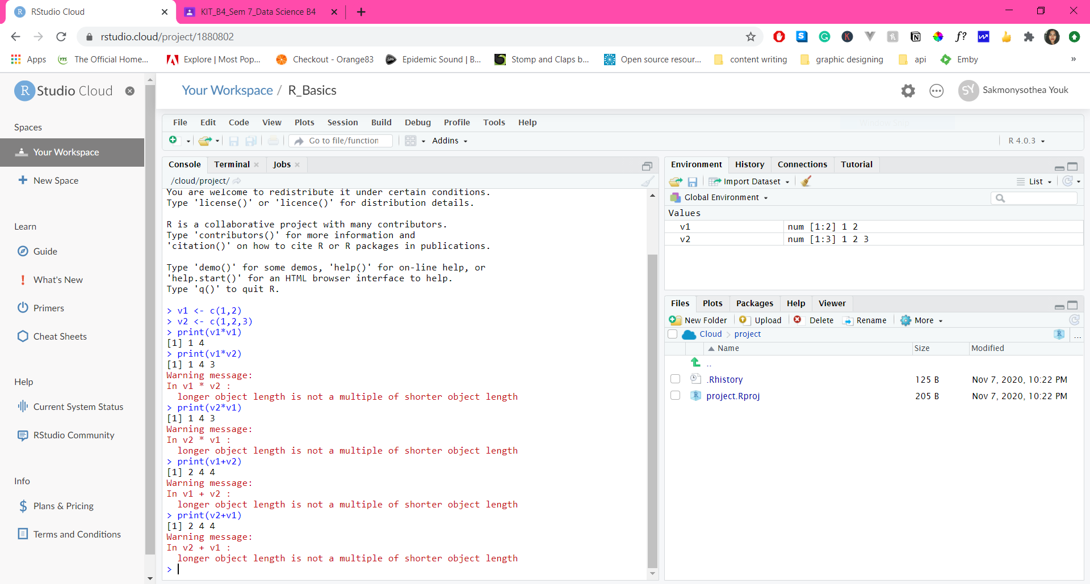

**Inner Multiplication**

The first 2 examples show errors because a is a 1x2 matrix while b is a 1x3 matrix; therefore, it is impossible to calculate the product of these matrices.

Example 3 shows an error because the number of columns of the first matrix doesn’t equal the number of rows of the second matrix.

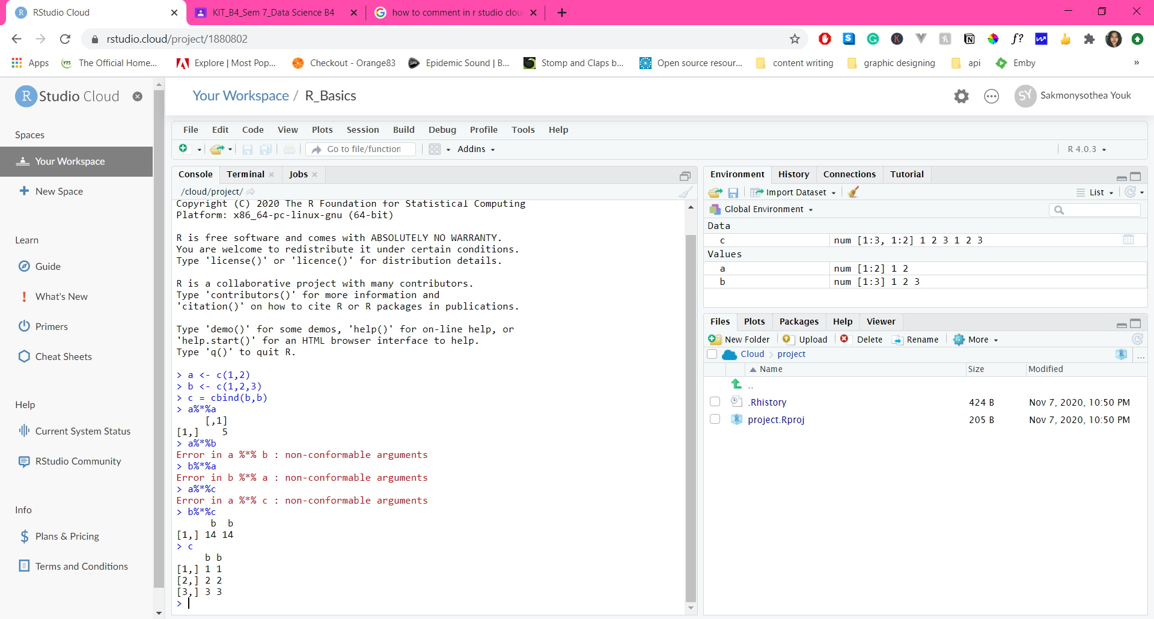

**Outer Multiplication**

The outer product of the arrays X and Y is the array A with dimension c(dim(X), dim(Y)) where element A[c(arrayindex.x, arrayindex.y)] = FUN(X[arrayindex.x], Y[arrayindex.y], ...).

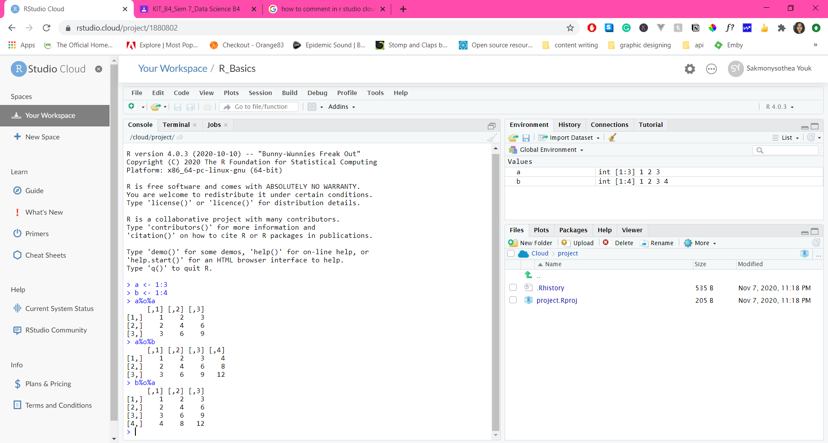

**Functions**

A function is a set of statements organized together to perform a specific task

1. Sample()

By default sample() randomly reorders the elements passed as the first argument.

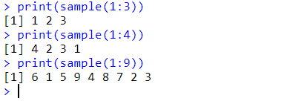

1. seq()

seq() function generates a sequence of numbers.

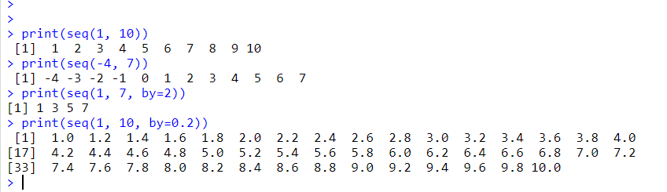

1. rep ()

rep(x) function replicates the values x.

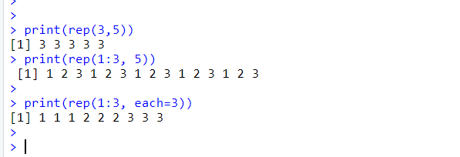

1. round ()

round() rounds the values in its first argument to the specified number of decimal places

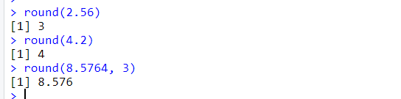

1. Factorial()

Computes the factorial of the given value.

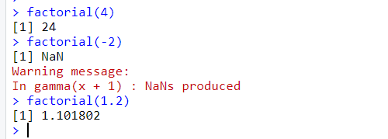

1. ls()

ls() is a function in R that list all the object in working environment.

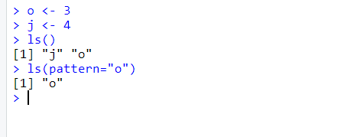

1. mean()

mean() function calculates the arithmetic mean

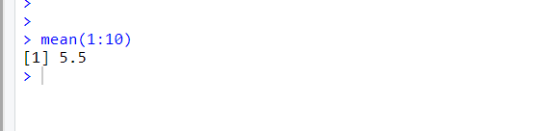

1. set.seed()

set.seed in the simEd package allows the user to simultaneously set the initial seed for both the stats and simEd variate generators.

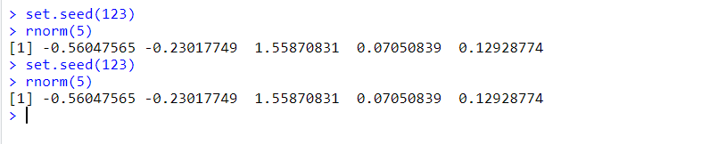

generate numeric samples with set.seed() will result in same outputs when we run multiple times.

**Subset**

Return subsets of vectors, matrices or data frames which meet conditions.

