Sotheanith Sok

CECS 424

9/17/18

Assignment 3

* 1. 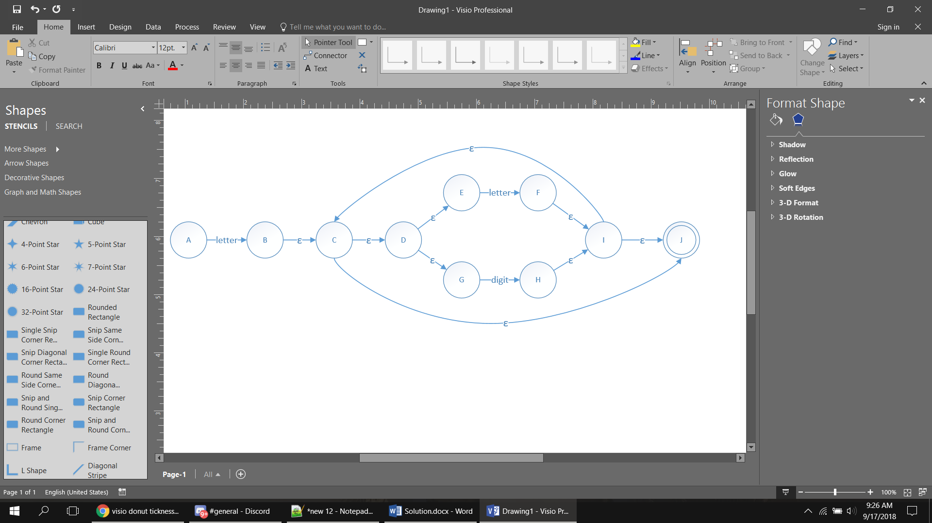 Show the NFA that results from applying the construction of Figure 2.7 to the regular expression **letter ( letter | digit )\***
  2. 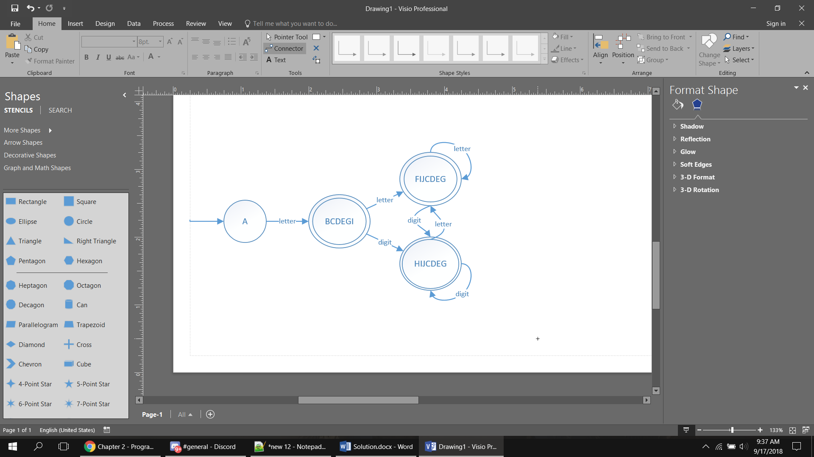Apply the transformation illustrated by Example 2.14 to create an equivalent DFA.

1. Show the left-most parse tree for the string **a b a a**

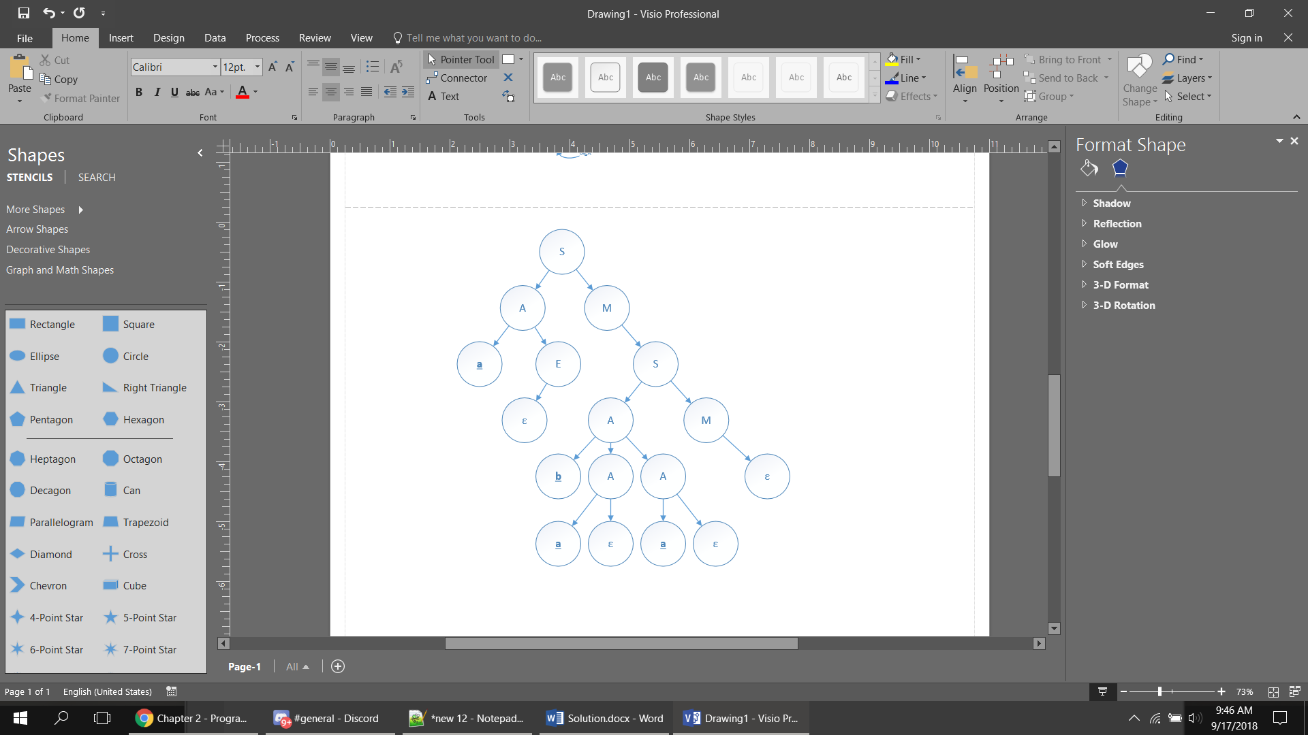

1. Construct a parse tree for the input string **foo(a,b)**

